Technical Report Documentation Page
1. Report No. | 2. | 3. Recipients Accession No.
MN 2021-XX
4. Title and Subtitle |  | 5. Report Date
Evaluation of Work Zone Safety Using the SHRP2 Naturalistic Driving Study Data – Volume 1 Toolbox of Work Zone Countermeasures |  | October 2021
 |  | 6.
7. Author(s) |  | 8. Performing Organization Report No.
Shauna Hallmark, Guillermo Basulto-Elias, Nicole Oneyear, Omar Smadi, Susan Chrysler, and Gerald Ullman
9. Performing Organization Name and Address |  | 10. Project/Task/Work Unit No.
Institute for Transportation
Iowa State University
2711 South Loop Drive, Ames, IA 50010
 |  | 11. Contract (C) or Grant (G) No.
 |  | (c) 1003320 (wo) 8
12. Sponsoring Organization Name and Address |  | 13. Type of Report and Period Covered
Minnesota Department of Transportation and SHRP2 Implementation Assistance Program (Federal Highway Administration)  Office of Research & Innovation  395 John Ireland Boulevard, MS 330  St. Paul, Minnesota 55155-1899 |  | Final Report
 |  | 14. Sponsoring Agency Code
15. Supplementary Notes
https://www.mndot.gov/research/reports/2021/2021XX.pdf
16. Abstract (Limit: 250 words)
This toolbox is one of the deliverables for the culmination of several phases of a project, which evaluated driver behavior in work zones using the SHRP2 Naturalistic Driving Study (NDS) data. The toolbox summarizes information about work zone traffic control devices, countermeasures, and work zone features that have a demonstrated impact on speed in work zones. Features were identified through a survey of the literature. Additional information for some of the features and countermeasures was gained through the various analyses of SHRP2 data conducted through this project. Guidance from the work zone traffic control manuals for various states was summarized when appropriate. Recommendations for use of each feature or countermeasure relevant to addressing speed in work zones was developed by the team and reviewed by work zone experts and the project panel.
17. Document Analysis/Descriptors |  | 18. Availability Statement
driver behavior, SHRP 2 Naturalistic Driving Study, speed management, traffic safety, work zone |  | No restrictions. Document available from: National Technical Information Services, Alexandria, Virginia 22312
19. Security Class (this report) | 20. Security Class (this page) | 21. No. of Pages | 22. Price
Unclassified | Unclassified | 91

Evaluation of Work Zone Safety Using the SHRP2 Naturalistic Driving Study Data – Volume 1 Toolbox of Work Zone Countermeasures
FINAL REPORT

Prepared by:
Shauna Hallmark, Guillermo Basulto-Elias, Nicole Oneyear, Omar Smadi
Institute for Transportation at Iowa State University
Susan Chrysler, Gerald Ullman
Independent Contractors
October 2021

Published by:
Minnesota Department of Transportation
Office of Research & Innovation
395 John Ireland Boulevard, MS 330
St. Paul, Minnesota 55155-1899

This report represents the results of research conducted by the authors and does not necessarily represent the views or policies of the Minnesota Department of Transportation or the Institute for Transportation at Iowa State University]. This report does not contain a standard or specified technique.
The authors, the Minnesota Department of Transportation, and the Institute for Transportation at Iowa State University do not endorse products or manufacturers. Trade or manufacturers’ names appear herein solely because they are considered essential to this report.

ACKNOWLEDGMENTS
The research team would like to thank the Minnesota Department of Transportation (MnDOT) and the Federal Highway Administration (FHWA) and American Association of Highway and Transportation Officials (AASHTO) Implementation Assistance Program (IAP) for funding this project using Second Strategic Highway Research Program (SHRP2) naturalistic driving study (NDS) data.
We would like to thank Ken Johnson (MnDOT Assistant State Traffic Engineer) and Brad Estochen (former MnDOT State Traffic Safety Engineer) for serving as the project monitors over the 3 phases of this project. We would also like to thank the Technical Advisory Panel members for their oversight and assistance. Additionally, we would like to thank the Virginia Tech Transportation Institute and the Center for Transportation Research and Education at Iowa State University for providing data.
Technical Advisory Panel Members include:
- Ken Johnson, MnDOT Assistant State Traffic Engineer
- Brad Estochen, former MnDOT State Traffic Safety Engineer
- Ron Rauchle, MnDOT Metro District Work Zone Engineer
- Jeffrey Morey, MnDOT Work Zone Standards Specialist
- Steve Blaufuss, Statewide Maintenance Work Zone & Operations Specialist
- Jason Spilak, FHWA Project Development Engineer
- Ted Ulven, MnDOT Work Zone Safety Training Supervisor
- Derek Leuer, MnDOT Administrative Engineer
- Michelle Moser, MnDOT State Work Zone Engineer
- Tiffany Dagon, Metro District Work Zone Engineer
- Ken Hansen; District Traffic Engineer for District 3

TABLE OF CONTENTS
CHAPTER 1: Executive Summary 8
1.1 Introduction 8
1.2 Background 8
1.3 1.2 Overview of Project 9
1.4 Description of the SHRP2 Analyses Conducted in This Research 9
1.4.1 SHRP2 Data Utilized 9
1.4.2 Summary of Analyses Conducted 11
1.5 Effectiveness of work zone traffic control devices in addressing safety 12
1.6 State Practices for Work Zone Traffic Management Plans 12
1.7 Overview of Toolbox 12
CHAPTER 2: Introduction 1
2.1 Summary 1
2.2 Background 1
2.3 Characteristics of Work Zone Crashes 2
2.3.1 Type of Crash 2
2.3.2 Work Zone Characteristics 3
2.3.3 Environmental Conditions 4
2.3.4 Work Zone Duration 6
CHAPTER 3: Driver Behavior 7
3.1 Summary 7
3.2 Background 7
3.3 Summary of Relevant Driver Behavior Studies 8
3.4 Summary of Relevant Project Findings 10
3.4.1 Back of Queue Safety Critical Events 10
3.4.2 Speed Profile Analysis 11
3.5 Recommendations for Addressing Driver Behavior 14
CHAPTER 4: Changeable Message Signs 16
4.1 Summary 16
4.2 Background 16
4.3 Summary of Other Relevant Studies for CMS 17
4.4 Summary of Relevant Project Findings for CMS 18
4.5 Recommendations for CMS 19
CHAPTER 5: Dynamic Speed Feedback Signs 21
5.1 Summary 21
5.2 Background 21
5.3 Summary of Other Relevant Studies for DSFS 22
5.4 Summary of Relevant Project Findings for DSFS 24
5.5 Recommendations for DSFS 24
CHAPTER 6: Temporary Transverse Rumble Strips 26
6.1 Summary 26
6.2 Background 26
6.3 Summary of Other Relevant Studies for TTRS 28
6.4 Summary of Project Findings for TTRS 29
6.5 Recommendations for TTRS 29
CHAPTER 7: Speed Limit Signs 31
7.1 Summary 31
7.2 Background 31
7.3 Summary of Other Relevant Studies for Speed Limit Signs 32
7.4 Summary of Relevant Project Findings for Speed Limit Signs 33
7.5 Recommendations for Speed Limit Signs 34
CHAPTER 8: “Higher Fines” Signs 35
8.1 Summary 35
8.2 Background 35
8.3 Summary of Other Relevant Studies for “Higher Fines” Signs 35
8.4 Summary of Relevant Project Findings for “Higher Fines” Signs 36
8.5 Recommendations for “Higher Fines” Signs 36
CHAPTER 9: Variable Speed Limits 37
9.1 Summary 37
9.2 Background 37
9.3 Summary of Other Relevant Studies for VSL 37
9.4 Summary of Relevant Project Findings for VSL 38
9.5 Recommendations for VSL 38
CHAPTER 10: Other Static Warning Signs 39
10.1 Summary 39
10.2 Summary of Relevant Information for Other Static Warning Signs 39
10.3 Recommendations for Other Static Warning Signs 40
CHAPTER 11: Work Zone Configuration 41
11.1 Summary 41
11.2 Background 41
11.3 Summary of Other Relevant Studies for Work Zone Configuration 42
11.4 Summary of Relevant SHRP2 Work Zone IAP Project Findings for Work Zone Configuration 42
11.5 Recommendations for Work Zone Configuration 44
CHAPTER 12: Work Zone Barriers 45
12.1 Summary 45
12.2 Background 45
12.3 Summary of Other Relevant Studies for Work Zone Barriers 45
12.4 Summary of Relevant SHRP2 Work Zone IAP Project Findings for Work Zone Barriers 46
12.5 Recommendations for Work Zone Barriers 48
CHAPTER 13: Glare Screens 50
13.1 Summary 50
13.2 Background 50
13.3 Summary of Other Relevant Studies for Glare Screens 51
13.4 Summary of Relevant Project Findings for Glare Screens 51
13.5 Recommendations for Glare Screens 52
CHAPTER 14: Arrowboards 53
14.1 Summary 53
14.2 Background 53
14.3 Summary of Other Relevant Studies for Arrow Boards 53
14.4 Summary of Relevant Project Findings for Arrow Boards 53
14.5 Recommendations for Arrow Boards 53
References 55
APPENDIX A: Summary of State Practices for Work Zone Traffic Management Plans A-1
A.1 Alaska A-1
A.2 California A-2
A.3 Colorado A-2
A.4 Florida A-3
A.5 Idaho A-4
A.6 Iowa A-5
A.7 Kansas A-5
A.8 Louisiana A-5
A.9 Missouri A-5
A.10 New York A-6
A.11 Oregon A-6
A.12 Texas A-7
A.13 Vermont A-10
A.14 Virginia A-10
A.15 Washington A-10
A.16 Wisconsin A-11

LIST OF FIGURES
Figure 1.1. Work zone sign 8
Figure 2.1. Changeable message sign 1
Figure 2.2. Schematic of work zone 3
Figure 2.3. Speed by environmental conditions for multi-lane work zones 5
Figure 3.1. Distracted driver 7
Figure 3.2. Relationship between cell phone use and safety critical events 10
Figure 3.3. Relationship between cell phone use and following behavior 11
Figure 3.4. Speed by glances duration for work zones on 4-lane roadways 12
Figure 3.5. Speed by glances for work zones on multi-lane roadways 12
Figure 3.6. Speed by cell phone use for work zones on 4-lane roadways 13
Figure 3.7. Speed by cell phone use for multi-lane work zones 13
Figure 4.1. Changeable message sign 16
Figure 4.2. Changeable message sign 16
Figure 4.3. Change in speed and 95% confidence interval for electronic work zone traffic control devices 19
Figure 5.1. Dynamic speed feedback sign 21
Figure 5.2. CMS displaying speed message 23
Figure 6.1. Temporary rumble strip 26
Figure 7.1. Work zone speed limit sign 31
Figure 7.2. Work zone speed limit sign 32
Figure 7.3. Change in speed and 95% confidence interval for static work zone traffic control devices 34
Figure 8.1. Higher Fines sign 35
Figure 9.1. Variable speed limit trailer 37
Figure 10.1. Work zone signs 39
Figure 11.1. Work zone sign 41
Figure 11.2. Speed by type of work zone closure for work zones on 4-lane roadways 43
Figure 11.3. Speed by type of work zone closure for work zones on multi-lane roadways 44
Figure 12.1. Work zone barrier 45
Figure 12.2. Speed by type of median upstream and barrier within the work zone for 4-lane roadways 47
Figure 12.3. Speed by type of median upstream and barrier within the work zone for multi-lane roadways 47
Figure 13.1. Glare screens 50
Figure 14.1. Arrowboard 53

LIST OF TABLES
Table 3.1. Summary of results for driver behavior 7
Table 4.1. Summary of results for CMS 17
Table 5.1. Summary of results for DSFS 22
Table 6.1. Summary of effectiveness of temporary transverse rumble strips 27
Table 7.1. Summary of effectiveness of speed limit signs 32
Table 11.1. Summary of impact of work zone configuration 41
Table 11.2. Impact of work zone configuration on crashes 42
Table 12.1. Summary of impact of work zone barriers 45
Table 12.2. Summary of work zone configuration impacts on speed 47
Table 13.1. Summary of impact of glare screens 50

Executive Summary

Introduction
• This toolbox is one of several deliverables for an Implementation Assistance Program (IAP) that is a joint effort of the Federal Highway Administration (FHWA) and the American Association of Highway and Transportation Officials (AASHTO) conducted by MnDOT
• This project evaluated driver behavior in work zones using the Second Strategic Highway Research Program (SHRP2) naturalistic driving study (NDS) data
• This document summarizes information about various work zone features and countermeasures gained from project analyses and a review of other available literature about speed or safety impacts
• This document also provides recommendations
Duntrune Studios, Shutterstock
Figure 1.1. Work zone sign

Background
In 2017, a total of 710 fatal work zone crashes occurred and these crashes accounted for 1.7% of all roadway fatal crashes in the US (710 of 42,231). Additionally, 94,000 total crashes and 25,000 injury crashes occurred in work zones in 2017 and work zone fatalities on US roads increased by 3.2% from 2016 to 2017 (NWZSIC 2019). Work zone crashes are not only a problem for the traveling public, but they are also a serious concern for highway workers who are injured or killed by errant vehicles. A total of 132 work zone worker fatalities occurred in 2017 (NWZSIC 2019) and 60% of worker fatalities were struck by vehicles in the work zone (CDC 2020). The Associated General Contractors of America (AGC 2019) reported 67% of highway contractors reported motor vehicles had crashed into their work zone during the past year. Consequently, addressing work zone crashes is critical for both the traveling public and highway workers. Statistics are provided for 2017 since that is the most recent year for which all of the above reported statistics were consistently available.

1.2 Overview of Project
This toolbox is one of the deliverables for the culmination of several phases of a project which evaluated driver behavior in work zones using the SHRP2 Naturalistic Driving Study (NDS) data.
The project was funded by the Federal Highway Administration Implementation Assistance Program and was managed and co-sponsored by the Minnesota Department of Transportation (MnDOT). Phase I conducted a proof of concept using the SHRP2 data to assess driver behavior in work zones. Phase II collected data for a variety of work zones on 4-lane and multi-lane roadways and developed models to evaluate driver behaviors such as speed and reaction point. Phase III increased the sample of drivers who were using cell phones and finalized analyses. Phase III also focused on implementation.
In addition to the analyses conducted using the SHRP2 data, a literature review was conducted to identify impacts of different work zone traffic control devices. Work zone traffic control manuals for various states were also reviewed to identify common countermeasures, configurations, and practices.
This report (Volume 1) summarizes analyses from all three phases, synthesizes information about work zone features and countermeasures from other the literature, and makes recommendations. A more detailed description of the research results is provided in Volume 2.
Information from the analysis, other research studies, and work zone traffic control manuals was used to develop recommendations for use of various traffic control devices in work zone to address speed and safety.

Description of the SHRP2 Analyses Conducted in This Research
The following briefly describes the various analyses conducted using the SHRP2 data. A detailed description of how work zones were identified, work zone extents were defined, data were reduced, and analyses conducted was provided in Volume 2.

SHRP2 Data Utilized
The second Strategic Highway Research Program (SHRP2) Naturalistic Driving Study data is the largest dataset of its kind. Kinematic vehicle data and videos were collected through instrumentation of naïve drivers’ vehicles. Over 30 million data miles were recorded for 3,400 participants over the three years of the study. The study took place in Florida, Indiana, New York, North Carolina, Pennsylvania, and Washington.
The data acquisition system (DAS) included a variety of sensors such as radar, GPS, and video cameras. The sensor arrays collected information about vehicle kinematics (i.e., speed, acceleration, position). The camera arrays included a forward roadway view, rear roadway view, drivers face view, and over the shoulder views. As a result, environmental conditions, current road conditions, and traffic characteristics (e.g., density, headway) can be determined, along with driver behaviors such as cell phone use and eating while driving.
Vehicle position was collected through GPS. As a result, a vehicle’s position during a particular driving trace can be linked with roadway databases. This allows roadway and roadside characteristics to be determined, such as driveway density, land use, or objects in the right-of-way. Work zone characteristics, such as traffic control devices, barriers, and configuration were also extracted through the forward video view.
The SHRP2 Roadway Information Database (RID) was collected simultaneously with the SHRP2 NDS study. Mobile data collection was conducted along with integration of existing roadway and supplemental data acquired from public and private sources. 511 data, construction projects data, and traffic volume were also collected.
Work zone events were identified in the SHRP2 data primarily through use of 511 data which was collected and archived in the RID. The 511 system allows drivers to receive real-time traffic information on road closures, accidents, route detours, weather alerts, etc. The 511 data were queried for construction related terms such as “construction”, “lane closure”, “road work”, “maintenance” for the time period when the SHRP2 NDS was active (2011 to 2013). Data were obtained for active work zones that were in place for more than three days. Three days was used as a threshold because it was unlikely that enough NDS time series traces would be available for short-duration work zones. An active work zone was defined as a one having a shoulder or lane closure. This avoided work zones where only a few barrels or other work zone TCDs were present which were unlikely to significantly impact driver behavior.
Driving events were obtained from Virginia Tech Transportation Institute (VTTI) for the identified work zones. Each event consisted of a time series trace which included vehicle kinematic data (i.e., speed, acceleration, brake position) at 0.1 second intervals and a forward roadway video associated with the driving trace. Beginning and end points of each work zone were identified through a review of the forward video. Roadway characteristics (i.e., number of lanes, type of barrier, shoulder type) and work zone configuration (i.e., type of barrier, lane, or shoulder closures) and presence of traffic control devices were coded by the research team using the forward roadway video view. Environmental conditions including time of day (i.e., day/night) and weather (raining/not raining) were also coded using the forward roadway view. GPS position was also available which allowed the traces to be linked to corresponding roadway segments.
VTTI behavioral analysts coded driver glance location and distraction for a set of events. Glance location was coded as locations where a driver was attending to the roadway task (i.e., forward, rear view mirror) or not attending to the roadway task (i.e., down, back, passenger). Distractions- such as eating, drinking, texting- were coded when they were associated with a glance away from the roadway task. Cell phone use was included in this set of distractions. Cell phone activities were also coded as a separate variable and did not need to be associated with a glance away from the driving task. Cell phone use included dialing, talking, texting, or handling a cell phone. Distraction, glance data, and cell phone were joined to the corresponding time series trace using time stamps.

Summary of Analyses Conducted
Four different analyses were conducted using the SHRP2 data.

Reaction Point
The first analysis using the SHRP2 NDS data identified the point upstream of each included traffic control device where a particular driver had a demonstrated change in speed of ≥ 3 mph within a deceleration rate in the range of 0.01 to 0.2g (see Volume 2 of this report for more detail). The intent of this analysis was to determine which TCD drivers reacted to and where they began reacting.
Work zone traffic control devices in the area upstream of the active work zone were identified for each time series trace and a response point was identified for each TCD. A mixed effect logistic model was developed to assess the relationship between driver response and work zone characteristics. A total of 299 time series traces for 142 drivers in 25 unique work zones on 4-lane roadways were used in the analysis.

Back of Queue Safety Critical Events
The second analysis evaluated back of queue safety critical events (crash/near-crash) to assess what driver behavior and roadway characteristics contributed to these events in work zones. Safety critical events (SCE) which occurred in work zones were identified. This included crashes and near crashes (hard braking and evasive maneuvers). Events where a driver encountered a back of queue and stopped, slowed, or otherwise safely avoided the back of queue were also included as baseline events. Work zone characteristics (i.e., lane or shoulder closure, type of barrier) and driver characteristics (speed, cell phone use, and glance location) were included in the analysis.
A mixed effects logistic regression model was developed with probability of a SCE as the response variable. The analysis included 46 safety critical events (SCE) and 283 “normal” events which were used as controls.

Speed Profile
The third analysis used the SHRP2 NDS data to evaluate speed profiles through work zones. A set of active work zones on 4-lane and multi-lane roads were identified and time series data obtained for a range of drivers. Separate models were developed for each type of roadway. Time series traces (879) representing 407 unique drivers over 112 different work zones on multi-lane and 4-lane roadways were evaluated. Speed profiles at five points upstream and within work zones (1,640 and 820 feet upstream, at the work zone start point, 820 and 1,640 m downstream) were developed and compared across relevant characteristics using a multivariate regression model.

Change in Speed
The final analysis evaluated driver change in speed as they encountered various work zone traffic control devices. Time series data were used to assess change in speed for 380 drivers over 104 unique work zones on 4-lane or multi-lane roadways. Legibility distance was determined for each work zone sign using a legibility index of 30 feet per inch of letter height. This was also compared with the Manual on Uniform Traffic Control Devices (MUTCD). The following legibility distances were used:
• Speed limit: 450 ft based on height of speed limit letters
• DSFS, CMS, Arrow board: 600 feet based on MUTCD nighttime standard for CMS
• Static signs with regular text: 180 feet based on MUTCD
Change in speed was estimated using a linear mixed-effect model. Speed was extracted around 164 feet upstream of the legibility distance for each TCD. Speed at this point represented a driver’s speed choice before encountering the TCD. Speed was also extracted 164 feet downstream of each TCD. The 164 feet distance downstream was selected to account for drivers who slow after passing the sign. Change in speed was the difference between the upstream and downstream speeds. The legibility distances for each traffic control device were determined in order to identify the influence area for each sign.

Effectiveness of work zone traffic control devices in addressing safety
A review of the literature was conducted to summarize information from studies, which have assessed the safety impacts of work zone traffic control devices and other work zone features such as type of work zone configuration. In most cases, crash evaluations were not available, researchers primarily relied on safety surrogates such as changes in speed, improved lane position, better merging behavior, etc. Results from the literature and the research conducted using the SHRP2 data were incorporated into the corresponding sections as appropriate.

State Practices for Work Zone Traffic Management Plans
Work zone traffic control manuals for 16 states were reviewed to identify common countermeasures, configurations, and practices. Guidance on use of traffic control devices in state DOT work zone traffic management plans was summarized including any information about guidance on use of a particular TCD. The summary of state practices is outlined in Appendix A.

Overview of Toolbox
Chapter 2 provides a general summary of factors related to work zone crashes based on a survey of the literature. When relevant, project findings were incorporated.
Chapter 3 summarizes driver behaviors that contribute to work zone crashes based on a survey of the literature and project findings. Additional information from the literature about the impact of driver behavior on crashes in general was also provided since studies specific to work zones is limited. Recommendations for addressing these driver behaviors were developed by the team and reviewed by work zone experts and the project panel.
Chapters 4 to 13 summarizes information about work zone traffic control devices, countermeasures, and work zone features that have a demonstrated impact on speed in work zones. Features were identified through a survey of the literature. Additional information for some of the features and countermeasures was gained through the various analyses of SHRP2 data conducted through this project. Guidance from the work zone traffic control manuals for various states was summarized when appropriate. Recommendations for use of each feature or countermeasure relevant to addressing speed in work zones was developed by the team and reviewed by work zone experts and the project panel.

Introduction

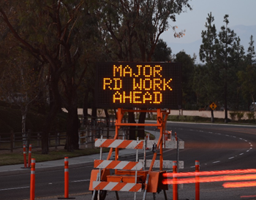
Summary
• 710 fatal work zone crashes in the US
• 25,000 injury crashes in work zones
• 132 work zone worker fatalities
• Work zone crashes are primarily read-end, sideswipe, and head-on
• Other characteristics of work zone crashes are summarized

Timothy OLeary, Shutterstock
Figure 2.1. Changeable message sign

Background
In 2017, a total of 710 fatal work zone crashes occurred and these crashes accounted for 1.7% of all roadway fatal crashes in the US (710 of 42,231). Additionally, 94,000 total crashes and 25,000 injury crashes occurred in work zones in 2017 and work zone fatalities on US roads increased by 3.2% from 2016 to 2017 (NWZSIC 2019). Work zone crashes are not only a problem for the traveling public, but they are also a serious concern for highway workers who are injured or killed by errant vehicles. A total of 132 work zone worker fatalities occurred in 2017 (NWZSIC 2019) and 60% of worker fatalities were struck by vehicles in the work zone (CDC 2020). The Associated General Contractors of America (AGC 2019) reported 67% of highway contractors reported motor vehicles had crashed into their work zone during the past year. Consequently, addressing work zone crashes is critical for both the traveling public and highway workers. Statistics are provided for 2017 since that is the most recent year for which all of the above reported statistics were consistently available.
Several studies found an increase in crash rates during road construction. Garber and Woo (1990) found a 57% increase in crashes on multi-lane highways and a 168% increase in crashes on two-lane urban highways when work zones were in place in Virginia. Nemeth and Migletz (1978) also found that crash rates during construction increased significantly compared to crash rates in the period before construction. Hall and Lorenz (1989) found that crashes during construction increased by 26% compared to crashes in the same period in the previous year when no construction was occurring. Similarly, Rouphail et al. (1988) found that the crash rates during construction increased by 88% compared to crash rates before long-term work zones were in place. Council et al. (2000) compared crash rates in work zones and found crash rates within a work zone were 21.5% higher than for a comparable pre-work area. They also found that work zone duration and length contributed the most when crash frequency was consistent.

Characteristics of Work Zone Crashes
The following sections summarize characteristics of work zone crashes. An understanding of the factors that contribute to work zone crashes or safety critical events (SCE) can be used to develop countermeasure to target unsafe behaviors and reduce work zone crashes.

Type of Crash
Rear end crashes have been noted as one of the main types of crashes in work zones. Rear end crashes tend to be a result of the following driver not providing enough time and space to adequately slow for the vehicle ahead. Sideswipe and head-on are also predominant types of work zone crashes.
Nemeth and Migletz (1978) analyzed 151 crashes identified from traffic crash reports and construction diaries for work zones on the rural Interstate system of Ohio. Results showed that the most frequently occurring accidents were rear-end, single vehicle, and fixed-object crashes.
Li and Bai (2008) modeled work zone crash severity outcomes. They found head-on collisions were the main type of fatal crash type and rear-end collisions were the dominant injury crash type.
Weng and Meng (2011) evaluated rear-end crashes at work zone areas. Based on work zone trafﬁc data in Singapore, the investigators developed rear-end crash risk models to examine the relationship between rear-end crash risk in the activity area and its contributing factors. Model results indicated that rear-end crash risk at work zone activity area increases with heavy vehicle percentage and lane trafﬁc ﬂow rate. They also found the lane closest to the work area was prone to higher rear-end crash risk. Additionally, they noted the expressway work zone activity area had much larger crash risk than arterial work zone activity area. Encouraging vehicles to merge early, they suggested, could be the most effective method to reduce rear-end crash risk at work zone merging area.
Another study by Garber and Zhao (2002) found that rear-end crashes were the predominant type of crash. The results also indicated that the proportion of sideswipe same direction crashes in the transition area of a work zone was significantly higher than in the advance warning area. Work zone crashes was found to be involved with higher proportion of multi-vehicle crashes and fatal crashes than non–work zone crashes.
Sisiopiku et al. (2014) conducted a simple analysis of work zone crashes in Alabama from 2008 to 2018. They found rear end collisions accounted for 32% of work zone crashes followed by 8% due to sideswipe. Single vehicle crashes made up 15%.
Johnson (2105) noted that 29% of severe work zone and 51% of all work zone crashes in Minnesota were rear end followed by 21% of severe work zone crashes being right angle. They also reported the main contributing factors for severe work zone crashes were inattention/distraction (13%), failure to yield (13%), and illegal/unsafe speed (9%).
Ullman et al. (2018) conducted an in-depth evaluation of work zone crash narratives from the Virginia DOT crash database and reported:
• 18.1% were rear-end
o 64.7% of rear end were due to slowing/stopping due to work zone presence,
o 11.8% were due to slowing/stopping for flagger, police office, or work zone TTC,
o 8.5% due to changing lanes in work zone
• 15.1% were angle crashes
• 18.8% were sideswipe same direction
• 66.2% were fixed object ROR
o 14.6% of those were avoiding crash with another vehicle or object
• 24.1% of all crashes was due to stopping/slowing due to congestion.
They also analyzed the National Motor Vehicle Crash Causation Survey (NMVCCS) and found 45.5% of freeway and interstate crashes were rear-end. They estimated 65% of freeway/intestate crashes were rear-end crashes and the majority of those occurred at or near the back of queue

Work Zone Characteristics
Crashes can occur in any area of the work zone, but the advance warning and transition areas are particularly problematic since drivers are confronted with multiple competing pieces of information which require action (i.e., need to slow, merge, pay attention to workers). Figure 2.2 shows the areas of a work zone.
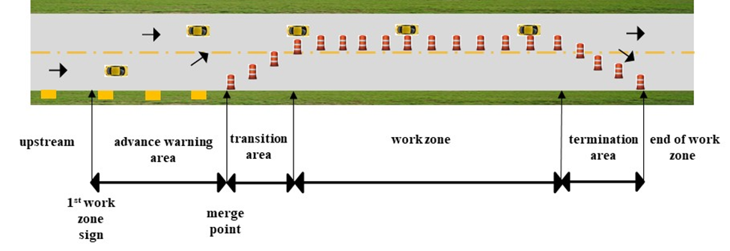
Figure 2.2. Schematic of work zone
Pigman and Agent (1988) developed a severity index for work zone crashes. They found a higher proportion of high-severity crashes in the advance warning zone compared to the transition area or activity area (2.46 vs. 1.94 and 2.28). Jin and Saito (2009) evaluated five-mile sections upstream and downstream of work zone activity areas for work zones in Utah. They found the transition area upstream of the activity area had the highest number of crashes regardless of traffic control type. Within the activity area, entry and exit points were the most problematic.
Another study by Garber and Zhao (2002) investigated the characteristics of work zones crashes in Virginia from 1996 to 1999. The number of police crash records were analyzed at different sections in work zones: advance warning, transition, buffer areas, activity, and termination. The study found more crashes in the activity area compared to other locations. However, they did not account for section length which may skew results towards the activity area since they tend to be significantly longer than the advance warning or transition areas.
Work zone crashes occur at different rates in different types of work zones. Akepati and Dissanayake (2011) determined that 37% of work zones crashes in two Midwestern states occurred during a lane closure; 18% occurred during work on the shoulder or median; 15% occurred when there was a lane shift, crossover, and/or head-to-head traffic; and 8.7% occurred at intermittent or moving work zones.

Environmental Conditions
Time of day was noted as a factor by several researchers. Additionally, results of the SHRP2 Work Zone IAP Project found an impact of time of day and weather. Relevant studies are summarized in the following sections.

Summary of Other Relevant Studies
Various driver, environmental, and roadway factors are associated with work zone crashes. Several researchers have noted that work zone crashes are more likely to occur during the daytime (Akepati and Dissanayake 2011, Yang et al. 2013). Nemeth and Migletz (1978) found crashes during daylight hours were more severe than those at night or at dawn and dusk. Sisiopiku et al. (2015) conducted a simple analysis of work zone crashes in Alabama from 2008 to 2018. They reported the highest number of crashes occurred from 3 to 4 pm (9%) with 7% occurring noon to 1 pm. Crashes from midnight to 6 am accounted for less than 8% of crashes. They also reported 76.2% of crashes occurred during daylight. The majority of crashes occurred with dry roads (84.3%) with 14.3% on wet roads.
However, Harb et al. (2008) found that nighttime conditions or conditions with low visibility increased the likelihood of a work zone crash. In their investigation of the characteristics of freeway work zone crashes using the Florida Crash Records Database from 2002 to 2004, Harb et al. (2008) used conditional logistic regression along with stratiﬁed sampling and multiple logistic regression models to model work zone freeway crash traits. According to the results, roadway geometry, weather conditions, age, gender, lighting conditions, and driving under the inﬂuence of alcohol and/or drugs were the most signiﬁcant factors associated with work zone crashes. Some studies concluded that nighttime crashes were especially concentrated at the transition area (Richard et al. 1981). Ha and Nemeth (1989) also found that night crashes were more likely to be crashes struck by fixed object and that single-vehicle crashes were more predominant at night. Pigman and Agent (1990) also found that crashes during darkness were more severe.

Summary of Relevant Project Findings
One of the analyses conducted for the SHRP2 Work Zone IAP Project evaluated speed profiles through work zones (see Hallmark et al. 2020 for additional details). A set of active work zones on 4-lane and multi-lane roads was identified and time series data for those work zones which contained data for at least 1,640 feet upstream and downstream were extracted. This resulted in 879 unique time series traces (281 for work zones on 4-lane roadways model and 418 for the work zones on multi-lane roadways) over 112 different work zones with 407 unique drivers. A profile of vehicle speeds was developed at five points within the work zones (1,640 and 820 feet upstream, at the work zone start point, 820 and 1,640 feet downstream) and speed was modeled using a multivariate normal regression with mixed effects for each type of roadway.
The best-fit model for work zones on multi-lane roadways indicated environmental conditions were statistically significant as shown in Figure 2.3.
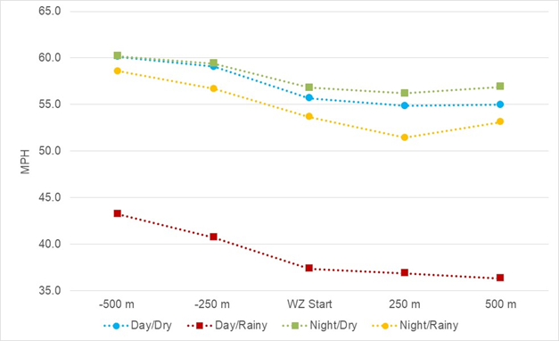
Figure 2.3. Speed by environmental conditions for multi-lane work zones
Four categories were used to describe conditions in terms of time of day and weather. Traces were coded as Day/Dry, Day/Rainy, Night/Dry, and Night/Rainy. Drivers behaved similarly for night and daytime when dry conditions prevailed (Night/Dry and Day/Dry). Upstream speeds were 59.1 to 60.2 mph with reductions within the work zone of up to 4.0 mph.
Speeds upstream of the work zone were significantly lower during the day when rain was present (Day/Rainy) than for any other time/weather combination. Speeds were between 40.7 to 43.3 mph with reductions of up to 6.9 mph as drivers encountered the work zone. The speed profile for nighttime and rain (Night/Rainy) was slightly lower than for dry conditions (Day/Dry or Night/Dry) with speeds between 56.7 to 58.6 mph and a 5.5 mph decrease. Lower speeds and higher speed reduction during daytime rain events compared to similar night events may be due to higher volumes.

Work Zone Duration
Khattak et al. (2002) investigated the effects of presence of work zones on injury and non-injury crashes. The study created a dataset of California freeway work zones that included crash data (crash frequency and injury severity), road inventory data (average daily trafﬁc) and urban/rural character), and work zone related data (duration, length, and location). Crash rates and crash frequencies in the pre-work zone and during-work zone periods were compared. Crash frequencies were modeled using negative binomial models, which showed that frequencies increased with increasing work zone duration, length, and ADT. The important ﬁnding from the study suggested that longer work zone duration signiﬁcantly increased both injury and non-injury crash frequencies.

Driver Behavior

Summary
• Driver behavior is a major contributor to work zone crashes
• Speeding, inattentiveness, and aggressiveness contribute to safety issues in work zones
• Countermeasures such as rumble strips and advance traveler notification may direct attention back to the roadway
• Efficacy of hands free or cell phone laws in work zone is reinforced
Flashon Studio, Shutterstock
Figure 3.1. Distracted driver

Background
Driver behavior is a major contributing factor to work zone crashes. This includes speeding, inattentiveness, and impairment. Several studies have discussed these relationships. Additionally, results of the SHRP2 Work Zone analyses conducted for this project (additional information is provided in Hallmark et al. 2020) found impact of driver behavior on safety critical events. Relevant studies are summarized in the following sections. A summary of the various findings is provided in Table 3.1.
Table 3.1. Summary of results for driver behavior
Metric | Results | Source
Speeding | 9% of severe work zone crashes (MN) | Johnson 2015
 | 25% of fatal work zone crashes (KS) | Li and Bai 2008
Following too closely | 4% of fatal and 18% of injury work zone crashes (KS) | Li and Bai 2008
 | Increased risk of BOQ SCE by 2.9 times | Project findings
Inattention | 53% of fatal and 51% of injury crashes (KS) | Li and Bai 2008
 | increased the risk of SCE by 29 times* | Bharadwaj et al. 2019
Cell phone | slower to respond, narrows eye scanning behavior, less likely to check their mirrors in a lane change* | Muttart et al. 2007
 | Locating/answering increased SCE by 3.7 times* | Fitch et al. 2013
 | Each additional text increases crash rate by 0.6%* | Atwood et al. 2018
 | Simple statistics showed cell phone use increased risk of BOQ SCE by 2.5 times | Project findings
 | Higher speeds upstream and within work zones (4-lane) | Project findings
 | Lower speeds upstream and within work zone (multi-lane) | Project findings
Eyes-off-roadway | Doubles risk of crash/near-crash* | Klauer et al. 2006
 | performing a non-driving related secondary task for more than 6 seconds increase the risk of a SCE by 5.5 times* | Bharadwaj et al. 2019
 | Eyes-off-road for 1+ sec 3.8 times more likely to be involved in BOQ SCE | Project findings
 | Slower speeds upstream and within work zones but no speed reductions entering work zones (4-lane) | Project findings
 | Higher speeds upstream and within work zone but similar speed reductions (multi-lane) | Project findings
*General statistics (not just related to work zones)

Summary of Relevant Driver Behavior Studies
Speeding has been noted as a contributor to work zone crashes. MnDOT noted the main contributing factors to severe work zone crashes were inattention/distraction (13%), failure to yield (13%), and illegal/unsafe speed (9%) (Johnson 2015). Li and Bai (2008) evaluated crashes in Kansas highway work zones and found 25% of fatal and 18% of injury crashes were coded as “too fast for conditions” or “speeding” as the main contributing factor.
Benekohal et al. (1993) collected speeds along a four mile–long construction work zone using two video cameras. The researchers found more than 70% of automobiles and 55% of trucks exceeded the work zone posted speed limit of 45 mph.
Unsafe driver behaviors such as failure to yield, aggressive behavior, and distraction are major contributors to work zone crashes. For instance, Li and Bai (2008) evaluated crashes in Kansas highway work zones and found:
• 53% of fatal and 51% of injury crashes were related to inattention
• 4% of fatal and 18% of injury crashes were following too closely
• 21% of fatal and 10% of injury crashes disregarded traffic signs, signals or marking
• 10% of fatal and 8% of injury crashes failed to yield right of way
In another study, drivers’ attitudes, and beliefs about sources of distraction in work zones were gathered in conjunction with a driving simulator study (Valdes et al. 2019). Over half of drivers admitted to engaging in distracting activities in work zones despite knowing the risks. Drivers reporting being less likely to perform these activities if workers are present.
Human factors research in simulated work zones has shown that drivers talking even hands-free were slower to respond, narrowed their eye scanning behavior, and were less likely to check their mirrors in a lane change (Muttart et al. 2007) suggesting a greater likelihood of crashes in work zones when talking on the phone, even hands-free.
Only a few studies have evaluated driver behavior in work zones as noted above. Since little information was available specific to driver behavior in work zones, the safety impact of driver distraction and inattention from naturalistic driving studies in general were reviewed and summarized.
Klauer et al. (2006) investigated the impact of driver inattention on safety critical events (SCE) which included crash and near crash events from a 100-car Naturalistic Driving Study (NDS). Crash/near-crashes were compared to baseline driving data and risk of involvement. The result showed the odds of a crash/near-crash were four to six times higher with drowsy driving. Visually and manually complex task were three times more likely to result in a crash/near-crash. The study also concluded that glances of more than 2 seconds away from the roadway doubles the risk of a crash/near-crash.
Bharadwaj et al. (2019) conducted an evaluation of safety critical events which included crash and near-crashes in the SHRP2 NDS database. Driver face video was used to identify glances away from the forward roadway and engagement in secondary tasks. They used logistic regression and found that performing a non-driving related secondary task for more than 6 seconds increase the risk of a SCE by 5.5 times. They also found driver inattention increased the risk of SCE by 29.1 times.
Fitch et al. (2013) used naturalistic driving study data to find the effect of cell phone usage on the driving performance and SCE. Data were collected for 204 drivers who indicated they talked on a cell phone while driving at least once per day. Participant vehicles were instrumented with a data acquisition system which collected kinematic vehicle data as well as a forward roadway and driver face video view. Participants provided their cell phone records. Data were collected on average for 31 days. They found around 28% of the participants’ phone calls and 10% of text messages coincided with periods when participants were driving. Using the cell phone records and confirmation using the driver face video, researchers estimated that drivers were talking on a cell phone 10.6% of the time. They reported that locating/answering a cell phone increased SCE risk by 3.65 times. Use of a handheld cell phone was associated with a 1.39 times increase in SCE risk. Results for Portable Hands-free (PHF) and Integrated Hands-Free (IHF) cell phone were not associated with increased risk.
Atwood et al. 2018 evaluated cell phone call and text records for 564 participants in the SHRP2 NDS. Cell phone records were overlain with the time series data and a negative binomial regression model was developed to determine the crash rate associated with cellphone use. On average participants made 1.6 texts and 1.2 calls per hour of driver with younger drivers (16 to 29) texting over 2.5 times per hour. The result showed that crash rate increases as the rate of texting increases. An increased risk of 0.58% resulted for each additional text per day. They did not find that crash rate was significantly affected by increase in the call rate.

Summary of Relevant Project Findings
Several different analyses were conducted using the SHRP2 NDS data (described in more detail in Volume 2). Relevant information is provided below. A summary of findings includes the following:

Back of Queue Safety Critical Events
One analysis identified back of queue events related to work zones in the SHRP2 NDS. Speed, cell phone use, distraction, and glance location were available and included in the analysis. Work zone characteristics such as type (i.e., lane or shoulder closure) and type of barrier present were also included.
A Mixed-Effects Logistic Regression model was developed with probability of a SCE as the response variable. The model included 46 safety critical events (SCE) and 283 “normal” events which were used as controls. SCE were defined as crash or near -crash events as classified by VTTI and includes events where a deceleration of 0.5 g or higher and/or an evasive maneuver occurred. A “normal” back of queue event was a scenario where the subject driver encountered a queue or slowdown but were able to safely react.
The model indicated that glances away from the roadway tasks (eyes-off-roadway) was correlated to an increased risk of a back of queue SCE (see Figure 3.2).
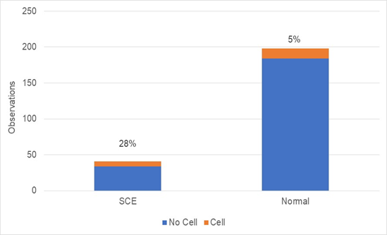
Figure 3.2. Relationship between cell phone use and safety critical events
When a driver engages in eyes-off-roadway for 1 or more seconds second within 6 seconds before or after encountering the back of queue, they were 3.8 times more likely to be involved in a back of queue SCE. Drivers who were following closely (< 2 second gap) were 2.9 times more likely to be involved in a back of queue SCE than drivers who were not following another vehicle (> 3 second gap).
Average speed was negatively correlated to crash risk. This is counterintuitive since in most cases, it is expected that higher speeds are related to back of queue crashes. In most cases, work zone speed limit could not be determined nor could the speed of prevailing traffic. As a result, whether the vehicle was over the posted work zone speed limit or was traveling too fast for prevailing conditions could not be determined. As a result, the relationship between speeding and increased work zone safety risk could not be determined from the model.
The impact of cell phone use could not be detected using the model, likely due to small sample size. As noted in Figure 3.2, the sample of cell phone use was small for both SCE and normal events (n = 42).
Although not statistically significant, a simplistic comparison indicates 28% of drivers involved in a back of queue SCE were using a cell phone compared to 5% of drivers in “normal” events. Hence, drivers involved in an SCE were more than 2.5 times more likely to be engaged in a cell phone task as those involved in a “normal” back of queue event when the driver successfully slowed down in time.
Although the sample size was not large enough to assess interactions between cell phone use and following behavior, a simple analysis was conducted to evaluate the interaction. Figure 3.3 shows this relationship.
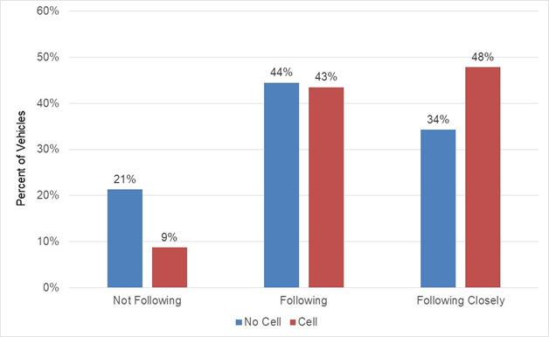
Figure 3.3. Relationship between cell phone use and following behavior
As noted, 9% of drivers engaged in a cell phone task were not following (gap > 3 seconds) while 21% of drivers not engaged in a cell phone task were not following prior to a back of queue event. Similar behavior was noted for both categories of drivers for following behavior (43% versus 44%). Drivers who were engaged in a cell phone task were much more likely to be following closely (< 2 seconds) than drivers not engaged in a cell phone task (34% versus 48%).

Speed Profile Analysis
Another analysis using the SHRP2 NDS data evaluated speed profiles through work zones (see Hallmark et al. 2020 for more details). A set of active work zones on 4-lane and multi-lane roads were identified and time series data obtained for a range of drivers. Separate models were developed for each type of roadway. Time series traces (879) representing 407 unique drivers over 112 different work zones on multi-lane and 4-lane roadways were evaluated. Instantaneous speed at five points upstream and within work zones (500 and 250 m upstream, at the work zone start point, 250 and 500 m downstream) were developed and compared across relevant characteristics using a multivariate regression model.
The best-fit model for both types of roadway indicated glance location was relevant. The predictor variable was the driver having one or more glances of 1 second or longer (1+ sec) away from the roadway task (eyes-off-roadway). Distraction was also tested in the model but was not statistically significant.
The 4-lane model found drivers with one or more eyes-off-roadway events of 1+ seconds showed speeds that were 2.4 to 3.5 mph lower than drivers who did not engage in glances. However, these drivers also increased speeds from the upstream section to within the work zone (up to 1.6 mph) compared to non-glancing drivers who maintained speeds from the upstream to work zone as shown in Figure 3.4.
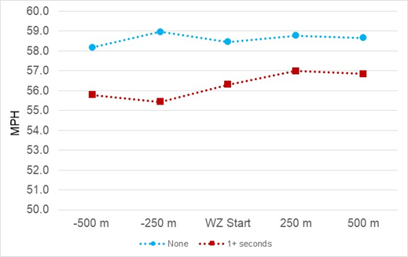
Figure 3.4. Speed by glances duration for work zones on 4-lane roadways
Conversely, the multi-lane model indicated that drivers who engaged in eyes-off-roadway of 1+ sec had speeds that were around 1 mph higher than drivers who did not have similar eyes-off-roadway events as shown in Figure 3.5.
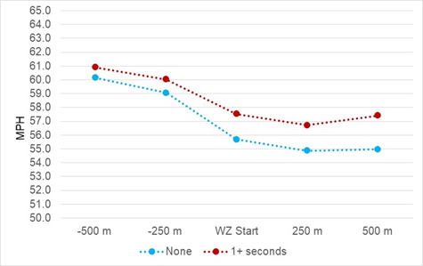
Figure 3.5. Speed by glances for work zones on multi-lane roadways
Both sets of drivers reduced speeds as they entered the work zone. However, drivers who had eyes-off-roadway for 1+ seconds had lower speed reductions (up to 4.2 mph) than drivers who did not glance away (up to 5.3 mph).
Cell phone use was also statistically significant in the final models (see Figure 3.6 for 4-lane roadways and Figure 3.7 for multi-lane roadways).
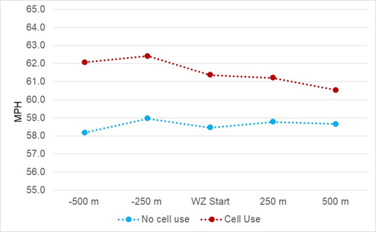
Figure 3.6. Speed by cell phone use for work zones on 4-lane roadways
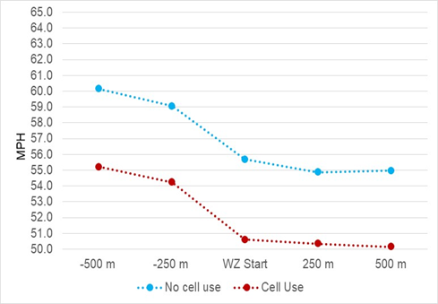
Figure 3.7. Speed by cell phone use for multi-lane work zones
Cell phone use included any activity involving a cell phone (talking, dialing, texting) whether or not it involved a glance away from roadway tasks. In the model for work zones on four-lane roadways, drivers who engaged in any cell phone task travelled at higher speeds (up to 62.4 mph) than drivers who did not engage in a cell phone tasks who travelled around 58.2 to 59.0 mph. Drivers engaged in a cell phone tasks were more likely to decrease their speed from the upstream section to within the work zone (up to 1.9 mph) compared to those not engaged in a cell phone task who slowed less than 1 mph. The greater decrease for those engaged in cell phone tasks was likely due to higher speeds entering the work zone.
Cell phone use was also statistically significant in the final model. Drivers who were not engaged in any cell phone task travelled at higher speeds (59.1 to 60.1 mph) than drivers engaged in a cell phone tasks who travelled 54.2 to 55.2 mph. Both sets of drivers decreased speed from the upstream section to within the work zone in a similar manner (5.1 mph for those using a cell phone and 5.3 for those not engaged in a cell phone task).
Although drivers engaged a cell phone task in this model has lower speeds than those not engaged, the results suggest cell phone use alters a driver’s behavior. Lower speed may be a result of drivers not attending as closely to the driving task which could have significant negative consequences in a work zone which contains many changes in the driving environment.

Recommendations for Addressing Driver Behavior
Speeding, generally defined as exceeding the posted speed limit or traveling too fast for conditions, has been universally noted as having a correlation to work zone crashes. As a result, countermeasures to manage speeding should be a consideration in work zone traffic control plans.
Aggressive driving has also been correlated to crash risk. As noted, drivers who were following closely were almost 3 times more likely to be involved in a back of queue crash or near crash.
Results for the SHRP2 analysis indicated that both long off-road glances and cell phone use impacted driver behavior. Drivers engaged in eyes-off-roadway (1+ sec) events on 4-lane roadway had lower speeds upstream of work zones than drivers not engaged in eyes-off-roadway. However, those drivers increased speeds as they entered the work zone. Drivers engaged in a cell phone tasks were more likely to travel at higher speeds on 4-lane roads than drivers who were not engaged in cell phone tasks.
While lower speeds are not a direct safety concern, the pattern of lower speeds coupled with drivers focused away from the roadway suggests inattention. Since work zones on 4-lane roadways were more likely to be in rural areas, this may suggest the need the direct driver’s attention back to the roadway in advance of work zones in more rural settings. As a result, treatments such as rumble strips or audible traveler notifications (i.e., Waze) may be effective.
Rumble strips or audible traveler notification systems may direct drivers engaged in cell phone tasks in rural work zones inattention back to the driving task
Unlike drivers on 4-lane roadways, drivers on work zones on multi-lane roadways traveled at higher speeds when they engaged in glances away from the roadway task than drivers who did not glance away. Since multi-lane roadways are more likely to be in urban areas, work zones along these roadways are more likely to have queues and slowdowns. This is particularly problematic if drivers are both speeding and not paying attention. Since countermeasures such as temporary rumble strips are usually not appropriate in these settings, other dynamic countermeasures such as dynamic speed feedback signs or audible traveler notifications may be effective.
DSFS or audible traveler notification systems may direct inattentive drivers in urban work zones inattention back to the driving task
Driver outreach campaigns, which include encouraging drivers to check for work zone locations or turn on navigation app alerts, may also be useful
Although the sample size was small, evidence from the SHRP2 analyses suggested that drivers who were engaged in cell phone tasks were more likely to be involved in back of queue crashes or near crashes. The analyses also reinforce the concept that drivers engaged in glances away from the roadway tasks or cell phone tasks drove differently in work zones. Coupled with the body of work that has indicated distraction and cell phone use to negatively impact driver behavior, the efficacy of hands free or cell phone laws in work zones is reinforced.

Changeable Message Signs

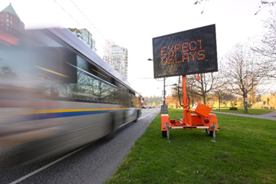
Summary
• CMS display different messages to alert drivers of unusual driving conditions including changing conditions within work zones
• Moderate to large reductions in speed were noted for both trailer mounted and overhead CMS
• CMS refers to variety of electronic message signs (i.e., variable message sign, dynamic message signs)
SHUBIN.INFO, Shutterstock
Figure 4.1. Changeable message sign

Background
Changeable message signs (CMS) or variable message signs (VMS) display different messages to drivers to alert them to unusual driving conditions (see Figure 4.2).
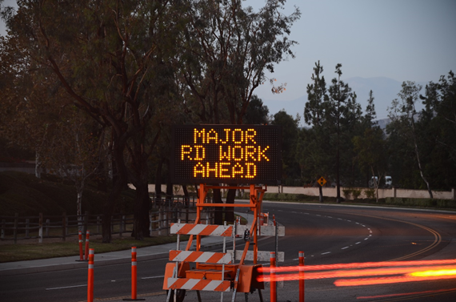
Timothy OLeary, Shutterstock
Figure 4.2. Changeable message sign
CMS can convey information that is difficult to relay with static signing and is used to supplement other required signing (Opiela 2003). The terms VMS and CMS are often used interchangeably. The term used by the researchers for each study summarized in the literature review was used consistent to that study. Otherwise, the term CMS is used and applies to both permanent and trailer-mounted signs. A summary of studies related to CMS is provided in Table 4.1.
Table 4.1. Summary of results for CMS
Metric | Results | Source
Speed | 7 mph decrease in average speed (when CMS was active) | Thompson 2002
 | Overhead CMS resulted in 1.2 mph reduction (when active) | Project findings
 | Trailer mounted CMS resulted in 2.2 mph reduction (when active)
Reaction to sign | 87% reacted when they saw CMS compared to 68% who reacted for regular static work zone sign | Project findings
 | Drivers reacted 374 feet before CMS compared to 223 feet for regular work zone signs
Stated behavior | 66% said they slowed when they saw CMS | King et al. 2004
In some cases, CMS include as Dynamic Speed Feedback Signs (DSFS). However, this function is not included in this Chapter. Studies for DSFS are described in Section 5.

Summary of Other Relevant Studies for CMS
Researchers at the Texas A&M Transportation Institute studied CMS using laboratory simulations. It was found that drivers strongly preferred alphanumeric formats (83%) to numeric formats (17%) for conveying calendar-date information. Recognition levels were also 20% higher for alphanumeric formats. Drivers could best comprehend and remember information from two screens and four units (Ullman et al. 2005).
Several studies evaluated the effectiveness of CMS. For an example, a study by Thompson (2002) found 7 mph decrease in average speed due to the presence of a changeable message sign (CMS) when the activation was on compared with activation-off of the CMS.
King et al. (2003) investigated user acceptance and understanding of VMS. The study used interviews and mail-in surveys to gather data from drivers at several locations downstream of a work zone. The study found that although almost all drivers could understand the message, only 78% were able to read the entire message. The researchers suggested that either traffic in adjacent lanes partially blocked the sign or the sign did not change quickly enough. The survey results were used to examine the influence of age and other demographic characteristics on driver response to VMS. A total of 66% of respondents said that the signs caused them to slow down. It was found that respondents under the age of 25 included the lowest percentage of people who slowed down. However, driver age did not seem to affect the perception of danger.
Huebschman et al. (2004) studied reduced speed limits in work zones and evaluated the effectiveness of a combination of fixed and dynamic signs advising motorists of number of work zone tickets issued and enforcement activity. The study concluded that the dynamic signs had no significant effect. It indicated that the “Construction Zone Traffic Fines” panel sign resulted in a statistically significant reduction of the mean speeds of motorists in the heart of the work zone, where construction activity was underway, and workers were present. The study also indicated that the VMSs displaying the number of traffic tickets issued to date in the work zone, and updates to this message, produced no meaningful reduction in the mean speeds of motorists. The authors had hypothesized that motorists who traveled through the work zone on a regular basis would notice increases in the number of traffic tickets issued and would decrease their speeds to avoid paying traffic fines themselves.

Summary of Relevant Project Findings for CMS
Two different analyses were conducted using the SHRP2 data which indicated the impact of speed limit signs.
The first analysis evaluated where drivers reacted by a change in speed of ≥ 3 mph within a deceleration rate in the range of 0.01 to 0.2g (see Volume 2 of this report for more detail). Results indicated that drivers reacted sooner for CMS than for regular static work zone signs. For instance, 87% of drivers reacted between the legibility distance location and the actual location of the CMS sign while only 68% reacted before the sign location for regular static signs. On average drivers reacted 374 feet before the CMS while they reacted an average of 223 feet ahead for regular static work zone signs. A logistic regression analysis was also conducted and indicated drivers were 2.42 times more likely to react when an active CMS was present compared to a regular static work zone sign. When the CMS was inactive, drivers were 1.45 times more likely to react, but the difference was not statistically significant.
A second analysis evaluated driver change in speed as they encountered various work zone traffic control devices. Time series data were used to assess change in speed for 380 drivers over 104 unique work zones on 4-lane or multi-lane roadways. A more in-depth description of the analysis is provided in Section 1.3.2. Change in speed was estimated using a linear mixed-effect model. Speed was extracted around 164 feet upstream of the legibility distance for each TCD. Speed at this point represented a driver’s speed choice before encountering the TCD. Speed was also extracted 164 feet downstream of each TCD. The 164 feet distance downstream was selected to account for drivers who slow after passing the sign. Change in speed was the difference between the upstream and downstream speeds. The legibility distances for each traffic control device were determined to identify the influence area for each sign. Legibility distance was determined using a legibility index of 30 feet per inch of letter height. This was also compared with the Manual on Uniform Traffic Control Devices. The following legibility distances were used:
• Speed limit: 450 ft based on height of speed limit letters
• DSFS, CMS, Arrow board: 600 feet based on MUTCD nighttime standard for CMS
• Static signs with regular text: 180 feet based on MUTCD
Figure 4.3 illustrates the change in speed and 95% confidence interval for the various electronic work zone signs, which were statistically significant in the final model.
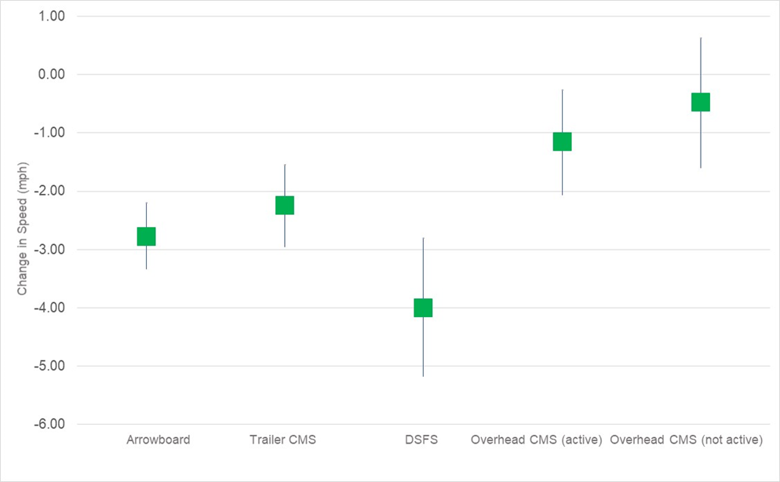
Figure 4.3. Change in speed and 95% confidence interval for electronic work zone traffic control devices
Decreases of 2.2 mph were estimated for trailer mounted changeable message signs. Due to video quality, sign status (“active” versus “blank”) could not be determined.
The status of overhead changeable message signs (active versus not active) was modeled separately. Overhead message signs are not necessarily related to the work zone (e.g., Message Monday) but were included since it was felt it may have an impact on speed. When an overhead CMS was active, a reduction of 1.2 mph was noted and when not active a reduction of 0.5 mph resulted. The results for “not active” were not statistically significant but were presented for completeness since the results for active were significant.

Recommendations for CMS
Several studies including the SHRP2 analyses have indicated changeable message signs reduce speeds. Although, their use is not specifically for speed management, strategic placement, when possible, may facilitate reductions in key locations.
Work zone traffic control manuals were reviewed for 16 states. Several of the states mention CMS but do have not specific guidance (Washington, Idaho, Iowa, New York, and Kansas). Several have specific guidance including:
• California: Policy requires that permanent CMS that are five miles or less in advance of an active work zone should advise the public with message such as: “WORK ZONE AHEAD WATCH FOR HIGHWAY WORKERS.” Portable CMS (PCMS) can be placed at key locations to notify motorists of lane closures, alternate routes, delay, and upcoming road closures. Sign placement is included in project plans. PCMS are usually utilized as part of project signing but may be used as a TMP strategy when warranted based on factors such as roadway geometry or proximity to interchanges (CALTANS 2015)
• Colorado: CMS are used to notify travelers of incidents, travel time information, construction/road closures, and other potential hazards in or around the work zone. They suggest careful placement at locations where drivers can adjust their routes to account for the information. They suggest placement when the condition of the work zone is changing, and static signs are not sufficient (CDOT 2014, CDOT 2008).
• Florida: CMS are used as a supplement (does not replace) other required signs or other devices and is used to inform drivers about construction schedules, alternate routes, delays, detours/diversions/lane shifts (FDOT 2018).
• Virginia: use of CMS follows MUTCD guidance. Additionally, they note temporary CMS are most frequently used on high-density urban freeways but have applications in locations where highway alignment, road user routing problems, or other conditions require advance warning and information. CMS have a wide variety of applications in work zones including roadway, lane, or ramp closures; advisories on work scheduling, road user management and diversion, and speed control or reductions (VDOT 2011).

Dynamic Speed Feedback Signs

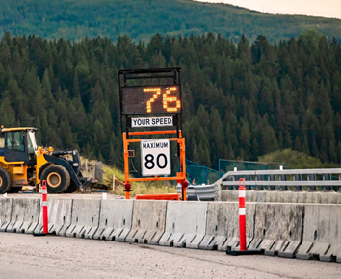
Summary
• DSFS measure and display speed or other message to drivers
• Can be customized to target drivers at a specific speed threshold
• Have been shown to be very effective in reducing speeds in work zones

Note: values are metric
Valmedia, Shutterstock
Figure 5.1. Dynamic speed feedback sign

Background
Dynamic speed feedback sign (DSFS) systems are a traffic control device used to reduce vehicle speeds. DSFS consist of a speed measuring device (i.e., radar) and a message sign that displays feedback to those drivers who exceed a predetermined speed threshold. The feedback may be the driver’s actual speed, a message such as “SLOW DOWN,” or activation of some warning device, such as a beacon.
The utility of this traffic control device is that these systems specifically target drivers who are speeding rather than affecting the entire driving population. In this way, the system “interacts” with an individual driver and may lead to better compliance since the message appears to be more personalized. A summary of studies is shown in Table 5.1.
Table 5.1. Summary of results for DSFS
Metric | Results | Source
Speed | 7 mph decrease in average speed (when CMS was active) | Thompson 2002
 | Overhead CMS resulted in 1.2 mph reduction (when active) | Project findings
 | Trailer mounted CMS resulted in 2.2 mph reduction (when active) | Project findings
Reaction to sign | 87% reacted when they saw CMS compared to 68% who reacted for regular static work zone sign | Project findings
 | Drivers reacted 374 feet before CMS compared to 223 feet for regular work zone signs
Stated preference | 66% said they slowed when they saw CMS | King et al. 2003
In work zones, DSFS are similar to changeable message signs. However, use of the term DSFS in this report specifically refers to devices which measure a driver’s speed and display a message based on speed.

Summary of Other Relevant Studies for DSFS
The Maryland State Highway Administration (MDSHA 2005) evaluated two DSFS placed in advance of a work zone along the Baltimore Beltway (I-695). The signs were placed 4,165 and 1,200 ft upstream of the work zone. When vehicles were traveling 20 to 52 mph, the DSFS displayed “Entering Work Area” and then “Stay Alert.”. For vehicles traveling 57 to 85 mph, the CMS displayed the messages “YOUR SPEED __ MPH” and “OBEY SPEED LIMIT 50 MPH.”
They found average speeds were reduced by 4.5 to 7.8 mph one week after the signs were installed, and then speeds increased over time. The study also found a 45 to 59% decrease in the percentage of vehicle exceeding the posted speed limit by 10 mph. The reduction also decreased over time, but at seven weeks a 21% reduction was still noted.
Thompson (2002) studied the effect of trailer-mounted radar activated DSFS which was placed at the end of taper for a left lane closure along an interstate in Maine. The DSFS displayed either the speed limit when the vehicle was not speeding or “YOU ARE SPEEDING!!!” when the vehicle was speeding. The percentage of speeding vehicles decreased from 65% to 54% and average speed decreased by 7 mph. Mean speed was reduced from 55 mph to 48 mph.
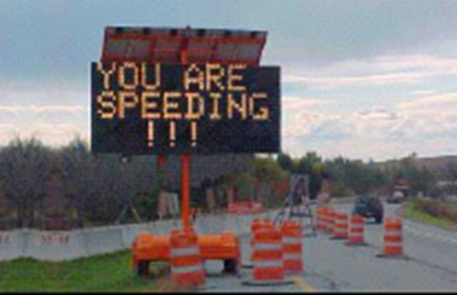
FHWA
Figure 5.2. CMS displaying speed message
Brewer et al. (2006) investigated the use of DSFS, and work zone speed limit signs surrounded by orange reflective tape in work zones on a rural highway and on a U.S. highway within a small community. The DSFS displayed “GIVE US A BRAKE” if the driver was not speeding or “SLOW DOWN” and “YOUR SPEED __” if the driver was speeding. Later in that study, posted speed limit signs with reflective tape were installed instead of the DSFS. The researchers found that the posted speed limit sign with a reflective orange board was less effective than the DSFS in reducing vehicle speeds and the DSFS showed greater effectiveness when two signs were present in the work zone. Presence of the two signs reduced the 85th percentile speed of passenger cars by 2 mph and trucks by 1 mph, and both speeds were statistically significant at the 95% confidence level.
Fontaine (2017) evaluated displays on trailers which showed the approaching vehicle speed and activated a strobe light when the vehicle was 5 mph over the speed limit in a work zone at four sites (2 at lane closures on 4-lane divided highways and 2 on two-lane roads where traffic was diverted to the shoulder). They found an average decrease of 5.2 mph for both passenger vehicles and trucks before the taper and 3.9 mph for passenger cars and 2.4 for trucks in the activity area. Additionally, they found a 6.9% decrease in passenger vehicles exceeding the speed limit and 15.7% reduction for trucks exceeding the speed limit in the taper and 4.4% decrease for passenger cars and 11.6% decrease for trucks in the activity area.
McCoy et al. (1995) evaluated the effectiveness of speed monitoring display in a work zone on an interstate highway in South Dakota. Mean speed of vehicles was reduced by 4 to 5 mph. The sign was also able to reduce the percentage of vehicles exceeding the advisory speed limit by 20 to 40%.
Carlson et al. (2000) studied upstream and work zone areas to assess the effectiveness of speed display trailers. Four work zones on two lane highways and five work zones on multi-lane highways with single lane closures were used for the study. LIDAR guns and piezoelectric sensors were used to track the speed of vehicles approaching to work zones. In work zones with lane closures, vehicles were found to reduce their speed between 2 to 7.5 miles per hour upstream and 3 to 6 miles within the work zone.
Meyer (2003) evaluated an effect of radar actuated speed display. The evaluation was done on a two-lane rural commuter routes on the west of Lawrence, Kansas and data were collected for about 8 weeks. Both mean and 85th percentile speed was decreased by about 5 miles per hour. Percentage of drivers speeding above 5 mph dropped from 30% to less than 5%.
A study conducted by Sorrell et al. (2007) at four work zones in South Carolina tried to determine the effectiveness of different messages. A default message of “STAY ALERT/WORK ZONE” was followed by one of four messages:
- “YOU ARE SPEEDING/SLOW DOWN”
- “YOUR SPEED IS __ MPH/SLOW DOWN”
- “YOUR SPEED __ MPH,” and “THANKS FOR NOT SPEEDING” or “SLOW DOWN”
- “YOU ARE SPEEDING/MINIMUM FINE $200”
Speed data were collected in two phases: phase 1 involved all message sequences and phase 2 involved further testing of sequences 3 and 4. They found 85th percentile speeds decreased by 2 to 9 mph in Phase I. Phase 2 evaluated messages 3 and 4. Results for phase 2 concluded that the average 85th percentile speed dropped about 10 mph from upstream to downstream of the CMS and mean speed decreased 8 to 11 mph.

Summary of Relevant Project Findings for DSFS
Two different analyses were conducted using the SHRP2 data which indicated the impact of DSFS.
The first analysis evaluated where drivers reacted as demonstrated by a change in speed of a certain magnitude. A logistic regression analysis was used to evaluate the odds of a driver reacting to a particular sign in comparison to reacting to a typical static work zone sign. Drivers were 5.07 times more likely to respond when a dynamic speed feedback sign was present than for a regular static work zone sign.
A second analysis evaluated driver change in speed as they encountered various work zone traffic control devices. A description of the analysis was provided in Section 1.3.2. Figure 4.2 (see section 4.2) illustrates the change in speed and 95% confidence interval for the various electronic work zone signs which were statistically significant in the final model. As noted DSFS resulted in the most significant reduction of all types of electronic signs with an average speed reduction of 4.0 mph

Recommendations for DSFS
DSFS have been shown to be very effective in work zones as noted in multiple studies and project findings. Reductions in mean speeds (up to 7.8 mph), 85th percentile speeds (up to 2 mph), as well as percent of vehicles traveling over the posted speed limit were noted (up to 40%).
Work zone traffic control manuals were reviewed for 16 states. Several of the states mention DSFS but do not have specific guidance (Idaho, Iowa, Kansas). Several have specific guidance which includes the following:
• California: allows use of either fixed sign or trailer mounted DSFS to encourage motorists to comply with the speed limit and reduce speed variance (CALTRANS 2015);
• Colorado: Notes DSFS are used to advise motorists of their speed and reduce speed and speed variation. DSFS should be placed with a speed limit sign at or near the panel (CDOT 2018)
• Florida: DSFS displays driver speed and is used in conjunction with the posted speed mounted above the panel (FDOT 2018)

Temporary Transverse Rumble Strips

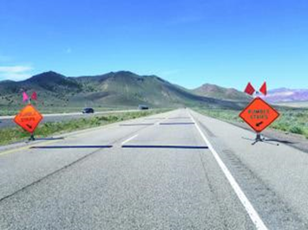
Summary
• TTRS are placed across travel lanes to alert driver of changing condition
• Provide audible and tactile warning
• Large reductions in speed and braking have occurred
• May be particularly effective for getting attention of distracted drivers

www.roadsbridges.com/nevada-tests-temporary-portable-rumble-, © 2021 Scranton Gillette Communications. All Rights Reserved, Roads&Bridges August 31, 2018
Figure 6.1. Temporary rumble strip

Background
Transverse rumble strips (TRS) are placed across travel lanes to alert drivers of changing conditions. They provide an audible and tactile warning to drivers. Temporary transverse rumble strips (TTRS) have been used in work zones by a number of agencies. As noted by the American Traffic Safety Services Association (ATTSA 2013), since there is no specific message associated with rumble strips they can be used to alert drivers to a variety of conditions such as lane closures, changes in alignment, conditions requiring a reduction in speed or stop, etc.
Results of the various studies are presented in the following sections. Table 6.1 summarizes the studies presented. No additional information was available from the project findings.
Table 6.1. Summary of effectiveness of temporary transverse rumble strips
TTRS | Roadway Type | Location | Key Findings | Source
removable black | 2-lane | Iowa | - up to 26% braking upstream compared to 9% with no TTRS  - 1% drove around TTRS  - speeds around 3 mph lower with TTRS  - little impact on 85th percentile speed | Hawkins and Knickerbocker 2017
removable black | 4-lane | New Jersey | - up to 19.3% reduction in 85th percentile speeds  - up to 49.5% fewer drivers traveling over the posted speed limit  - up to 26.6% increase in braking | Yang et al. 2013
removable orange | 2-lane | Kansas | - up to 2.3 mph reduction in speed | Meyer 2003
portable plastic | 2-lane | Missouri | - 10% increase in braking  - 3.7 mph decrease in mean speed  - 2.9% increase in speed compliance  - 8.8% increase in lane crossovers | Sun et al. 2011
removable orange | 2-lane | Texas | - up to 7.2 mph decrease in truck speeds  - minor impact on passenger vehicles | Fontaine and Carlson 2001
removable orange | 4-lane interstate | Missouri | - up to 26 mph reduction in speed for non-passenger vehicles | Bernhardt et al. 2001
removable rubber | 2-lane | Canada | - 5.9 mph reduction in 85th percentile speed | Hildebrand et al. 2003
portable plastic | 2-lane | Florida | - over 8 mph reduction in speed when several sets were successively placed nearer to the work zone | McAvoy et al. 2015
removable black | Freeway | Texas | - CMF = 0.89 (p = 0.77) for non-queuing scenarios  - CMF = 0.34 (p = 0.23) for queues | Ullman et al. 2018

Summary of Other Relevant Studies for TTRS
Several studies are available which have evaluated TTRS. Hawkins and Knickerbocker (2017) evaluated two different patterns of TTRS at temporary flagger operations in Iowa. At one configuration they found 18% of drivers braked before the rumble strips and at the second pattern 26% braked compared to 9% of drivers braking at the work zone with no rumble strips. Similarly, 11% and 8% braked after the two rumble strip patterns compared to 10% with no rumble strips. They also found 1% of drivers drove around the rumble strips. Mean speeds were 53.0 mph at one pattern and 53.3 mph at the second compared to 50.8 mph at the location with no TTRS. Little difference in 85th percentile speeds was noted with 60.1 and 60.4 mph at the 2 TTRS patterns and 60.0 at the locations with no TTRS.
Meyer (2003) evaluated removable orange transverse rumble strips at a signal-controlled bridge repair work zone in Kansas. The road was 2-lane with 1,440 vpd and posted speed of 30 mph within the work zone (65 mph normal speed limit). They compared standard asphalt rumble strips (1/2 to ¾ inch thick) to removable rumble strips (1/8 inch thick). They found the audible and tactile effects of the removable TRS were weaker. They reported reductions in vehicle speeds up to 2.3 mph.
Sun et al. (2011) evaluated two TTRS patterns at a bridge work zone. One set was perpendicular, and one set was placed at a 60-degree angle to the direction of traffic. The normal speed limit was 50 mph and reduced to 40 mph in the work zone. The researchers found deployment of rumble strips increased braking by 10%, decreased mean speed by 3.7 mph, increased speed compliance by 2.9% and increased lane crossovers by 8.8%. They found no significant differences between the two patterns in braking and speed but found a higher number of lane crossovers with the perpendicular patterns.
Yang et al. (2013) evaluated portable plastic rumble strips (RoadQuake2). This type of TTRS is weighted so that fasteners or adhesives are not required. They evaluated three different patterns of this TTRS at eight short-term work zone locations. The researchers reported a 0.4 to 19.3 percent reduction in 85th percentile speeds when the TTRS were present compared to not being present. They also found 4.2 to 49.5% fewer drivers traveling over the posted speed limit. Additionally, they reported 4.4 to 26.6% more drivers braking for the TTRS. Most of the changes were statistically significant.
Fontaine and Carlson (2001) evaluated rumble strips at work zones on 2-lane low volume high speed road (70 mph) roadways. They evaluated pre-cut temporary portable rumble strips which were bright orange. Data were collected before work zone traffic control was present and after the treatment was installed. When compared against normal work traffic control, they noted little impact in mean speed between configurations with normal traffic control or rumble strips for passenger vehicles. Truck speeds were reduced by 2 to 7 mph in the advance warning area and by 3 to 4 mph in the activity area for trucks. The percentage of passenger vehicles exceeding the posted speed limit was reduced by 1 and 7%.
Ullman et al. 2018, evaluated end of queue warning systems (EOQWS) and portable rumble strips (PRS) at a 7-year project in central Texas along the I-35 corridor. The EOQWS used radar speed sensors which were linked wirelessly to a central data processing unit along with one or more portable changeable message signs. The system logic assessed sensor status and automatically displayed an appropriate queue warning message based on the distance from the sign to the location of the closest sensor. They also used black portable transverse rumble strips. They compared crashes against work zones in 2012 where no countermeasures were deployed. They conducted a simplistic analysis and developed the following crash modification factors:
• Portable transverse rumble strips only
o CMF = 0.89 (p = 0.77) for non-queuing scenarios
o CMF = 0.34 (p = 0.23) for queues
• EOQWS and PRS
o CMF = 0.72 (p = 0.42) for non-queuing scenarios
o CMF = 0.47 (p = 0.08) for queues

Summary of Project Findings for TTRS
No instances of work zones with temporary transverse rumble strips were encountered in the project analyses.

Recommendations for TTRS
Several studies noted the impact of portable rumble strips. Large reductions in speed and braking were reported. Rumble strips may be particularly effective for distracted drivers to direct their attention back to the roadway in advance of situations where drivers need to reduce speed or pay particular focus to the roadway environment.
The American Traffic Safety Services Administration (2013) provided guidance for use of TTRS in work zones. They noted the following disadvantages:
• Potential for erratic or avoidance maneuvers
• Potential rough ride for motorcyclists or bicyclists
• Noise
• Potential for movement of temporary TTRS if not installed or used properly.
They also note the following advantages:
• Ease of installation and removal compared to permanent rumble strips
• Potential for reuse of rumble strips
• Increased driver awareness of upcoming conditions and compliance with other traffic control devices
• Increased braking and reduced speeds
Work zone traffic control manuals were reviewed for 17 states. Two of the states mention temporary transverse rumble strips but do have specific guidance (Wisconsin and Idaho). Texas has guidance for temporary transverse rumble strips which includes the following (also provided in Appendix A):
• Each rumble strip array should consist of 3 rumble strips placed center to center
• Removal of temporary rumble strips should be accomplished before removing advance warning signs
• Temporary rumble strips should not be used on horizontal curves, loose gravel, soft or bleeding asphalt, heavily rutted pavements, or unpaved surfaces
• Temporary rumble strips may be used on freeways or expressways depending on engineering judgement

Speed Limit Signs

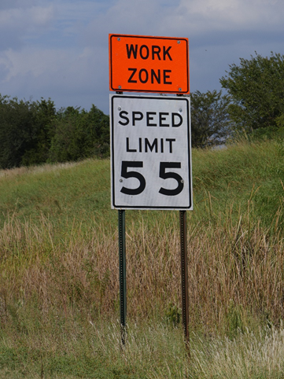
Summary
• Project findings suggest drivers reduce speeds (albeit slightly) when they encounter a speed limit sign
• Strategic placement of signing could be used in locations where speed reductions are important
• Type of work zone speed limit sign utilized may also have an impact
• Chapter discusses whether drivers change their behavior when they see a speed limit sign (i.e., slow); implications of choosing a particular speed limit are not included in the discussion

RaksyBH, Shutterstock
Figure 7.1. Work zone speed limit sign

Background
Speed limits in work zones are set to encourage appropriate speeds. Work zone signs are first placed where the change in speed is desired and then at intervals throughout a work zone to remind drivers. MnDOT (2010) notes work zone speed limit signs are usually placed in the area where workers are working. Work zone speed limit signs are used to reduce speeds overall. An individual speed limit sign is not typically used to reduce speed at a particular point. However, several sources have noted some speed reductions in the vicinity of speed limit signs as summarized in Table 7.1 and discussed in the sections below.
Table 7.1. Summary of effectiveness of speed limit signs
Metric | Results | Source
speed | Reductions around 3 mph from upstream to downstream of work zone speed zone signs | Finley et al. 2008
 | 12% of passenger vehicles and 23% of trucks reduced speeds after first speed limit sign | Benekohal et al. 2010
 | 2.3 mph decrease when drivers encounter either regular speed limit or work zone speed limit sign | Project findings

Summary of Other Relevant Studies for Speed Limit Signs
Finley et al. (2008) evaluated speeds in various work zones where reduced work zone speed limits were present. Speed data for passenger vehicles were collected using handheld LIDAR speed equipment at various locations within 12 work zones in Texas. The sites had either a 5 or 15 mph speed reduction. In general, they found speeds up to 10 mph over regardless of the posted speed limit. They noted the 85th percentile speed varied from 60 to 68 mph in 60 mph zones, 67 to 75 in 65 mph zones, and 70 to 76 mph in 70 mph zones.
They also compared speed upstream and downstream of work zone speed limit signs. Among locations where no enforcement was present, they found the change in speed was 0 to 6 mph (avg = 3 mph). They also reported 85th percentile speeds decreased downstream of the work zone speed limit signs, but operating speeds were still 9 to 16 mph over the work zone speed limit.
The researchers also compared standard work zone speed limit signs to use of a CMS electronically displaying the speed limit and roll up speed limit signs at an interstate work zone. Mean speeds were reduced by 4.3 mph with the standard sign, 6.4 mph with the roll up speed limit, and 7.1 mph for the electronic speed limit sign.
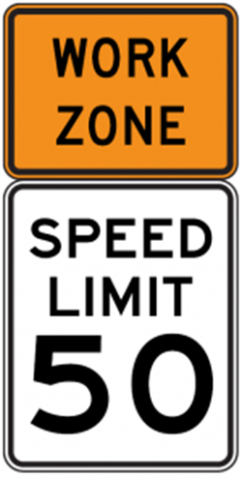
Shutterstock
Figure 7.2. Work zone speed limit sign
Benekohal and Wang (1993) evaluated speed profiles in a highway work zone with a lane closure on Interstate 57 in Illinois. The speed limit was 65 mph outside the work zone and 45 mph within the work zone. They measured changes in upstream speed to a point just downstream of the first work zone speed limit sign. They found speeds decreased by 3.4 mph for passenger cars and 2.9 mph for trucks. It should be noted the work zone speed limit sign was just past the merge point. As a result, this may have affected speeds as well.
Benekohal et al. (2010) also evaluated speed profiles for the work zone closure on Interstate 57 in Illinois. They measured changes in upstream speed to several points within the work zone and found the following:
• Around 12% of passenger vehicle drivers and 23% of trucks reduced speeds around the first speed limit sign and maintained speeds until after main work zone area
• 13% of passenger vehicle and 8% of truck drivers did not reduce speeds at the first work zone speed limit sign but reduced speeds at main work zone area
• 11% of passenger vehicle maintained a speed of 60+ mph through the work zone and 10% of truck drivers maintained a speed of 50 to 60 mph throughout the work zone

Summary of Relevant Project Findings for Speed Limit Signs
Two different analyses were conducted using the SHRP2 data which indicated the impact of speed limit signs.
The first analysis evaluated where drivers reacted as demonstrated by a change in speed of a certain magnitude. Results indicated that drivers were more likely to react sooner for speed limit signs than for regular static work zone signs. For instance, 78% of drivers reacted before the speed limit sign while only 68% of drivers reacted before other static work zone signs. The category of “Other” includes static work zone sign such as “Work Zone Ahead”, “Work Zone Ends”, “Lane Shift”, “Shoulder Work.” On average, drivers reacted 279 feet before the speed limit sign while they reacted an average of 187 feet ahead for other static work zone signs. A more in-depth analysis was conducted using a logistic regression model and the result indicated that drivers were 6.04 times more likely to respond when a work zone speed limit sign was present sign than for a regular static work zone sign.
A second analysis evaluated driver change in speed as they encountered various work zone traffic control devices. Time series data were used to assess change in speed for 380 drivers over 104 unique work zones on 4-lane or multi-lane roadways. Change in speed was estimated using a linear mixed-effect model. Speed was extracted around 164 feet upstream of the legibility distance for each TCD. Speed at this point represented a driver’s speed choice before encountering the TCD. Speed was also extracted 164 feet downstream of each TCD. The 164 feet distance downstream was selected to account for drivers who slow after passing the sign. Change in speed was the difference between the upstream and downstream speeds. The legibility distances for each traffic control device were determined in order to identify the influence area for each sign. Legibility distance was determined using a legibility index of 30 feet per inch of letter height. This was also compared with the Manual on Uniform Traffic Control Devices. The following legibility distances were used:
• Speed limit: 450 ft based on height of speed limit letters
• DSFS, CMS, Arrow board: 600 feet based on MUTCD nighttime standard for CMS
• Static signs with regular text: 180 feet based on MUTCD
Figure 7.3 illustrates the change in speed and 95% confidence interval for the various static work zone signs, which were statistically significant in the final model.
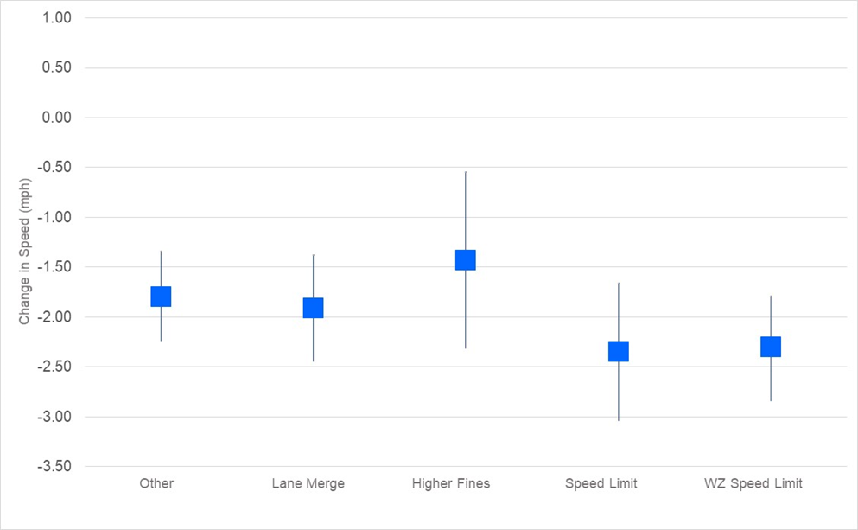
Figure 7.3. Change in speed and 95% confidence interval for static work zone traffic control devices
Both regular speed limit and work zone speed limit signs resulted in a 2.3 mph decrease in speeds.

Recommendations for Speed Limit Signs
Work zone speed limit signs are used to reduce speeds overall within the speed limit zone rather than reduce speeds at a particular point. However, as described above, some reduction in speeds do occur at the specific point where work zone speed limit signs are placed. When drivers encounter a speed limit sign, 2 to 3 mph reductions in speed have occurred as noted by Finley et al. (2008) and project findings.
As a result, strategic use may assist in reducing speeds in the vicinity of the sign. MnDOT (2010), for instance, suggests placing work zone speed limit signs in the area where workers are working. Work zone speed limit signs could also be strategically be placed in areas where queuing is likely to form.
A study by Finley et al. (2008) suggests the type of work zone sign utilized may also have an impact. They found both electronic speed limit signs and roll up signs resulted in slightly greater speed reductions than did the standard static sign.

“Higher Fines” Signs

Summary
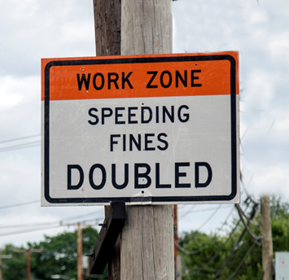
• “Higher Fines” policies are used to reduce speeds overall within work zones, individual “Higher Fines” signs are not a speed management technique per se
• Project findings suggest drivers reduce speeds by a small amount when they encounter a sign displaying “Higher Fines”
• Placement of “Higher Fines” signs could be done in consideration of locations where a reminder to drivers is advantageous
• Chapter discusses implications of “Higher Fines” signs rather than impact of “Higher Fines” policies

Solomon Kraner, Shutterstock
Figure 8.1. Higher Fines sign

Background
According to the Governors Highway Safety Association (GHSA 2020), all states have laws that increase penalties for speeding or committing other traffic violations in work zones. The objective of increased penalties overall is to encourage drivers to slow down in work zones and thus reduce crashes.
This chapter summarizes the impact of individual “Higher Fines” signs on driver behavior when encountering those signs (i.e., slowed down or reacted). This chapter does not summarize the effectiveness of “Higher Fines” programs. The interested reader is referred to Ullman et al. (1997) who evaluated the effectiveness of the overall program in reducing crashes

Summary of Other Relevant Studies for “Higher Fines” Signs
No other relevant studies were evaluated which specifically evaluated how drivers reacted when seeing “Higher Fines” signs.

Summary of Relevant Project Findings for “Higher Fines” Signs
Two different analyses were conducted using the SHRP2 data which indicated the impact of static “Higher Fines” signs.
The first analysis evaluated where drivers reacted as demonstrated by a change in speed of a certain magnitude. Results when a “Higher Fine” sign was present, 100% of drivers reacted compared to 58 to 86% for typical work zone signs such as “Construction Ahead,” “Lane Merge Ahead,” ”Work Zone Ends,” “Lane Shift,” or “Shoulder Work.” Additionally, drivers reacted on average 285 feet before the sign while drivers reacted 184 to 279 feet for other types of signs. A more in-depth description of the analysis is provided in Section 1.3.
A second analysis evaluated driver change in speed as they encountered various work zone traffic control devices (see Section 1.3.2). Figure 3.3 (Section 3.2.1) illustrates the change in speed and 95% confidence interval for the various static work zone signs which were statistically significant in the final model. As noted a reduction of 1.4 mph occurred when a driver encountered a “Higher Fines” sign. This category included any sign which indicated penalties such as “Fines Doubled” or “Speeding Fines Increased.”

Recommendations for “Higher Fines” Signs
Project findings indicated a small change in speed when drivers encounter a “Higher Fines” sign. As a result, placement of individual “Higher Fines” signs could be done in consideration of locations where a reminder to drivers is advantageous. For instance, “Higher Fines” signs could be placed near the start of the work zone speed limit zone and additional signs placed just before locations where queueing may occur.
As noted, the impact is simply due to a driver encountering an individual “Higher Fines” sign. The impact of “Higher Fines” policies on speed and crashes were not evaluated.

Variable Speed Limits

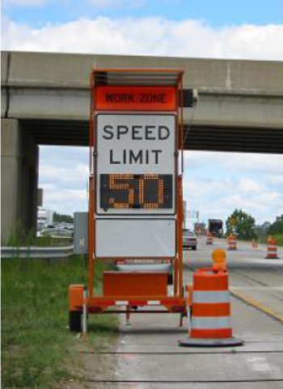
Summary
• Variable speed limits have been used in situations where speed limits are appropriate for one scenario but not others
• Only a few studies were available, but VSL results are mostly positive
• Main advantage is they can be used to decrease speed when work is occurring and raised when work zone is not active, ideally leading to better compliance

FHWA 2003
Figure 9.1. Variable speed limit trailer

Background
Variable speed limits (VSLs) change to reflect current road and environmental conditions. The intent is to keep drivers at a constant safe speed that reflects current conditions

Summary of Other Relevant Studies for VSL
A study conducted in Michigan evaluated trailer-mounted CMS displaying variable speed limits in work zones which were deployed for four short duration times (Lyles et al. 2004). Although mixed results were found, the researchers concluded that the average speed of vehicles increased, travel time decreased, and percentage of vehicles traveling at high speeds decreased while the system was operating.
Another study in Utah (Van Jura et al. 2018) evaluated the impact of a portable variable speed limit technology near active work zones. The system displayed work speed limits when the work zone was active and raised speed limits when workers were not present. They found mean speeds were 15 to 25 mph lower near the active work zones compared to the original roadway posted speed limit. Results showed statistically significant decreases in speed (3–10 mph) during nighttime with the use of a VSL sign as opposed to a standard static sign. Daytime speeds were also reduced, but the effect of the variable speed limit sign alone could not be determined due to potential impacts of congestion. The sign also resulted in a 1.0 to 4 mph decrease in speed variance during the nighttime.
A study by Edara et al. (2013) observed an average speed reduction of 2.2 mph on a roadway of 50 mph speed limit with and without Variable Advisory Speed Limit Sign in an uncongested traffic flow.

Summary of Relevant Project Findings for VSL
A sufficient sample of variable speed limit signs was not available in the SHRP2 data to assess their use.

Recommendations for VSL
Although only a few studies have assessed the impact of VSL in work zones, the results appear to be positive. One of the main advantages is the ability to decrease speed when the work zone is active and restore speeds when not active which can be effective if drivers perceive the speed limit to be appropriate to the situation.

Other Static Warning Signs

Summary
• Impact of general static work zone signs (non-enforcement) on speed reduction were identified
• Not a speed reduction countermeasure per se
• Project findings indicate small but statistically significant reduction in speed when drivers encountered these signs

FHWA 2003

infinity21, Shutterstock
Figure 10.1. Work zone signs

Summary of Relevant Information for Other Static Warning Signs
The impacts of speed reductions due to static enforcement signs (i.e., speed limit and higher fines) were examined in Sections 7 and 8. Other static work zone signs (i.e., “ROAD WORK AHEAD,” “RIGHT LANE CLOSED AHEAD,” “LANE ENDS”) are not used as speed reduction measures. However, drivers may reduce speed when they encounter these signs because they are made aware of the work zone or changing conditions.
No information was available from the literature about this topic.
Two types of static work zone signs were included in the various analyses using the SHRP2 data for this project. “LANE ENDS” signs were included as one category and all other non-enforcement static signs were included as “Other.” This group included signs such as “Work Zone Ahead”, “Work Zone Ends”, “Lane Shift”, “Shoulder Work,” etc.
A description of the analysis was provided in Section 1.3.2. Figure 7.1 (see Section 7.2) illustrates the change in speed and 95% confidence interval for the various static work zone signs, which were statistically significant in the final model. A reduction of 1.8 mph was noted when “Other” static work zone signs were present. “LANE ENDS” signs resulted in a reduction of 1.9 mph.

Recommendations for Other Static Warning Signs
The SHRP analysis indicated that drivers reduce their speed on average by up to 2 mph when they encounter static non-enforcement work zone signs such as “RIGHT LANE CLOSED AHEAD,” “LANE SHIFT,” LANE ENDS,” etc. However, these types of work zone signs are used for a specific purpose (i.e., alert drivers of a closed lane). As a result, they are not expected to be used as a speed management strategy.

Work Zone Configuration

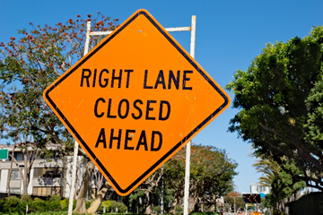
Summary
• Work Zone configuration impacts speed
• Some configurations are more likely to have higher speed profiles and less speed reduction as drivers enter the work zone
• As a result, some configurations may need additional speed reductions measures
Johnny Habell, Shutterstock
Figure 11.1. Work zone sign

Background
Work zone configuration is not used as a countermeasure per se. However, driver behavior is impacted by configuration since drivers may need to change lanes and decreased lane or shoulder width may also impact speed selection. The impact of work zone configuration based on the literature and project findings are described below. A summary of studies on the impact of work zone configuration is shown in Table 11.1.
Table 11.1. Summary of impact of work zone configuration
Metric | Results | Source
Stated response | 3% of driver independently state they would slow in work zone with lane closure | Finley et al. 2008
 | 98% when prompted stated they would slow with a lane closure
 | 1% of driver independently state they would slow in work zone with lane shift
 | 96% when prompted stated they would slow with a lane shift
Speed on 4-lane roadways with work zones | Largest decreases from upstream to work zone with right lane closure (up to 7 mph) | Project findings
 | Shoulder closures and configurations with left lane/right shoulder closure showed little change in speed from upstream to work zone
 | Left lane closures exhibited reductions of up to 2.3 mph from upstream to work zone
Speed on multi-lane roadways with work zones | Largest decrease from upstream to work zone occurred for left lane closures (up to 4.2 mph) | Project findings
 | No reductions in speed for right lane closure

Summary of Other Relevant Studies for Work Zone Configuration
Finley et al. (2008) conducted a survey of drivers at Texas Department of Public Safety offices in four Texas cities. Participants were asked what work zone conditions would cause them to slow down. Respondents were provided with an opportunity to respond independently about factors that would cause them to slow down as well as being prompted about a particular feature. Around 3% of drivers independently noted they would slow when a lane closure was present, whereas 98% indicated they would slow for a lane closure after being prompted. Around 1% of drivers independently reported they would slow for a lane shift while 96% responded in the affirmative when prompted.
Ullman et al. (2018) assessed crash data for work zones in New York State. They summarized daytime crashes in daytime work operations nighttime crashes with nighttime work operations as noted in Table 11.2.
Table 11.2. Impact of work zone configuration on crashes
Type of Work Zone | Daytime Crashes/Daytime  Work Zone Operations | Nightime Crashes/Nightime  Work Zone Operations
Lane Closure | 50.4 | 57.6
Shoulder Closure | 5.4 | 0.9
Flagging operation | 8.0 | 3.2
Minor traffic control | 25.5 | 17.1
Traffic control setup or takedown | 3.1 | 14.2
Other | 7.6 | 7.0
Source: Ullman et al. 2018
The majority of crashes in active work zones occurred with lane closures (50.4% for daytime crashes and 57.6% for nighttime crashes). Work zones with minimal traffic control accounted for 25.5% of daytime work zone crashes and 17.1% of nighttime. Shoulder closures only accounted for 5.4% of daytime crashes in daytime work zones and 0.9% for nighttime. The work zone duration and traffic volume were not accounted for. However, the results indicate work zone crashes are most likely in lane closures.

Summary of Relevant SHRP2 Work Zone IAP Project Findings for Work Zone Configuration
One of the analyses for the SHRP2 Work Zone IAP Project evaluated speed profiles through work zones. A set of active work zones on 4-lane and multi-lane roads were identified and time series data for 879 unique time series traces (281 for work zones on 4-lane roadways model and 418 for the work zones on multi-lane roadways) over 112 different work zones with 407 unique drivers were used to create speed profiles. A profile of vehicle speeds was developed at five points within the work zones (500 and 250 m upstream, at the work zone start point, 250 and 500 m downstream) for each trace and speed was modeled using a multivariate normal regression with mixed effects for each type of roadway. The best fit model for both types of roadway indicated work zone configuration was relevant.
As noted in Figure 11.2, work zones with both a left lane and right shoulder closure resulted in the least variation of speeds as drivers progressed through the work zone.
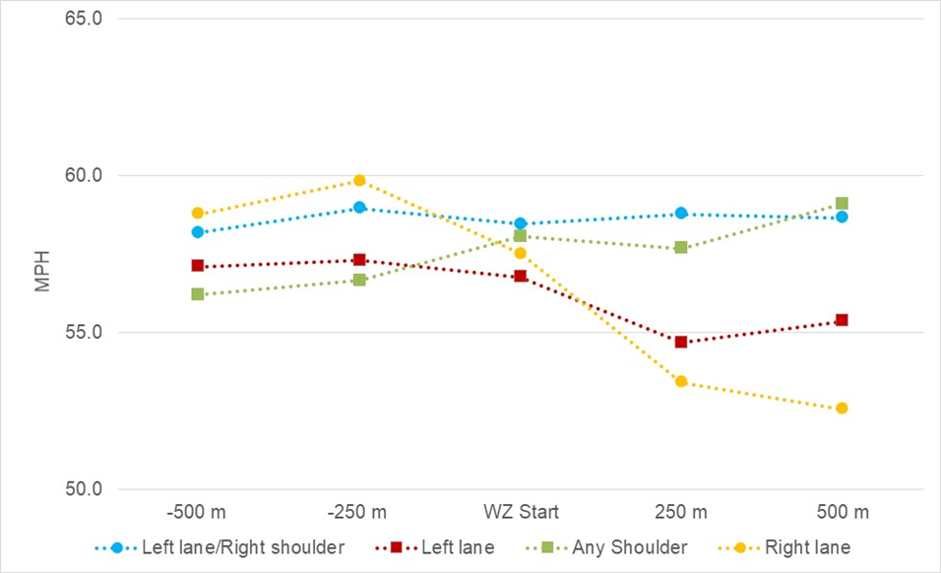
Figure 11.2. Speed by type of work zone closure for work zones on 4-lane roadways
The speed at any point varied only by 0.8 mph (58.2 to 59.0 mph). When a right lane closure was present, the highest speeds upstream were noted (between 58.8 to 59.8 mph) but dropped significantly as the driver entered the work zone to between 52.6 and 53.4 mph. A similar situation was noted for a left lane closure, but speeds were slightly lower upstream of the work zone (around 57 mph) dropping to between 54.7 to 55.4 mph within the work zone. When only a shoulder closure was present (either right or left) initial speeds were around 56.2 to 56.7 mph upstream but increased as the driver progressed through the work zone (to up to 59.1 mph).
Work zone configuration for multi-lane roadways is shown in Figure 11.3.
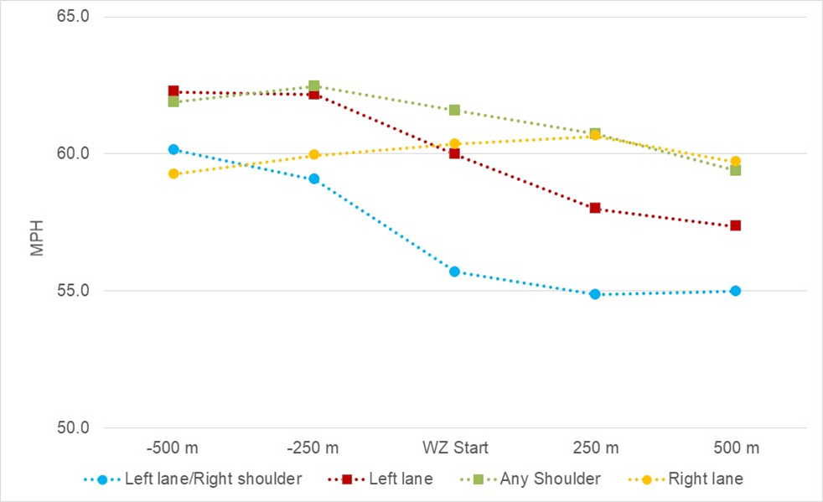
Figure 11.3. Speed by type of work zone closure for work zones on multi-lane roadways
As indicated, work zones with a left lane closure and work zones with a shoulder closure had the highest speeds upstream of the work zone (up to 62.5 mph). Speeds for left lane closures decreased by up to 4.2 mph within the work zone but only decreased by up to 1.7 mph for work zones with either a left or right shoulder closure. When a left lane and right shoulder were both closed, speeds were slightly lower upstream than a left lane closure only (up to 60.1 mph) with decreases of up to 4.2 mph noted within the work zone. When a right lane closure was present, speeds were slightly lower upstream than other configurations (up to 60.0 mph) but speeds within the work zone increased by up to 0.7 mph.

Recommendations for Work Zone Configuration
Work zone configuration is determined based on type and location of road work. However, as noted above, results indicated some types of configurations are more likely to have higher speed profiles and less reductions as drivers enter the work zone. As a result, it suggests some configurations may need additional speed reductions measures. For instance, shoulder closure and left lane/right shoulder closures on 4-lane roadways showed no reductions in speed from the upstream segments to within the work zone. This suggests these types of work zones may benefit from speed reduction countermeasures in the advance warning area.
Left lane only and shoulder closures had the highest speeds for work zones on multi-lane roadways. Right lane closures also exhibited no decreases in speed from the upstream section to within the work zone. Consequently, these types of work zone configurations on multi-lane roadways (which tend to be urban areas) may benefit from speed reduction countermeasures upstream of the work zone start.

Work Zone Barriers

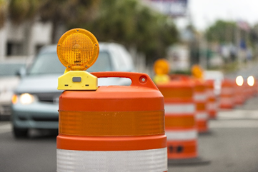
Summary
• Positive protection is primarily used to protect road workers from errant vehicles, shield vehicles from hazards, or provide delineation
• Speed selection is impacted by type of barrier

Kent Weakley, Shutterstock
Figure 12.1. Work zone barrier

Background
Positive protection is primarily used to protect road workers from errant vehicles, shield vehicles from hazards, or provide delineation. Typical barrier configurations are barrels, concrete barrier, vertical panels, and cones. Type of barrier is selected for a variety of reasons such as traffic volume, location of workers in relationship to roadway, etc. Although types of barriers are not selected to impact speeds, drivers may adjust speed differently based on type of barrier present. A summary of findings on the impact of work zone barriers is shown in Table 12.1.
Table 12.1. Summary of impact of work zone barriers
Metric | Results | Source
Deviation from center of lane | 0.65 feet for concrete barriers | Reyes and Khan 2008
 | 0.60 feet for metal barriers
 | 0.50 feet for cones
Average speed | 55.1 mph with concrete barriers with less variability than other barrier types
 | 52.9 mph with drums

Summary of Other Relevant Studies for Work Zone Barriers
Banerjee and Jeihani (2019) investigated the impact of different work zone barriers (cone pylons, concrete jersey barriers, and metal barriers) on driver behavior on using a medium-fidelity full-scale driving simulator. A freeway work zone was simulated using traffic volumes based on level of service (LOS) C. The study included 65 individual participants. An analysis of variance (ANOVA) indicated that there was a statistically significant difference between mean vehicle speeds across all barrier types as well as mean vehicle speeds across metal barriers for age groups 35 and above versus other age groups. An interesting observation was that drivers tend to deviate from the center of the lane away from concrete jersey barriers on freeways.
Reyes and Khan (2008) conducted a high-fidelity simulator experiment which evaluated driver behavior with several different work zone interventions including type of barrier for a lane closure (speed limit was 55 mph). Several barrier types were evaluated: cone pylons, concrete jersey, and metal barriers. Higher average lane deviation was found with concrete jersey barriers compared to cones and the difference was statistically significant. The average lane center deviation was 0.65 feet for concrete barriers, 0.60 for metal barriers, and 0.5 for cones.
Additionally, drivers aged 35+ drove slower across all barrier types. For instance, drivers aged 35+ had an average speed of around 55 mph compared to 57 mph for drivers aged 26 to 35 and 58 mph for drivers aged 18 to 25. They found drivers drove the fastest (55.1 mph) with less speed variability when concrete barriers were present than with channelizers (52.4 mph) or drums (52.9 mph).
Finley et al. (2008) conducted a survey of drivers at Texas Department of Public Safety offices in four Texas cities. Participants were asked what work zone conditions would cause them to slow down. Respondents were provided an opportunity to respond independently as well as being prompted about a particular feature. Around 43% of drivers independently noted they would slow when workers were present. When prompted, about 95% noted they would slow when workers were present behind a barrier compared to 95% who indicated they would slow if workers were in or near the roadway. Seven percent independently responded they would slow when a concrete barrier was present. It is not known if they would slow if other types of barriers were present.

Summary of Relevant SHRP2 Work Zone IAP Project Findings for Work Zone Barriers
One of the analyses for the SHRP2 Work Zone IAP Project evaluated speed profiles through work zones. A set of active work zones on 4-lane and multi-lane roads were identified and time series data for those work zones which contained data for at least 1,640 feet upstream and downstream were extracted. This resulted in 879 unique time series traces (281 for work zones on 4-lane roadways model and 418 for the work zones on multi-lane roadways) over 112 different work zones with 407 unique drivers. A profile of vehicle speeds was developed at five points within the work zones (1,640 and 820 feet upstream, at the work zone start point, 820 and 1,640 feet downstream) and speed was modeled using a multivariate normal regression with mixed effects for each type of roadway.
The best fit model for both types of roadway indicated the combination of median type upstream and type of barrier within the work zone was significant with results summarized in Table 12.2 and graphically in Figure 12.2 and Figure 12.3.
Table 12.2. Summary of work zone configuration impacts on speed
Median Type Upstream/in Work Zone | Highest speed upstream |  | Largest change upstream  to within work zone
 | 4-lane | Multi-lane | 4-lane | Multi-lane
Concrete/Concrete | 59.0 | 60.1 | -0.5 | -5.2
Concrete/Other | 61.1 | 61.9 | -3.8 | -6.6
Other/Concrete | 62.1 | 70.1 | -5.9 | -5.4
Other/Other | 59.5 | 61.8 | -2.6 | -2.7
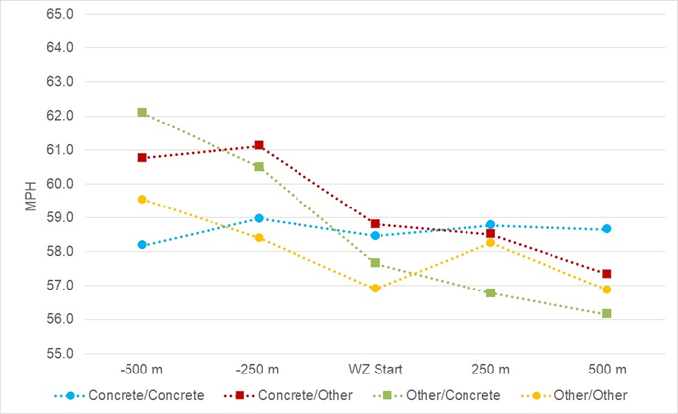
Figure 12.2. Speed by type of median upstream and barrier within the work zone for 4-lane roadways
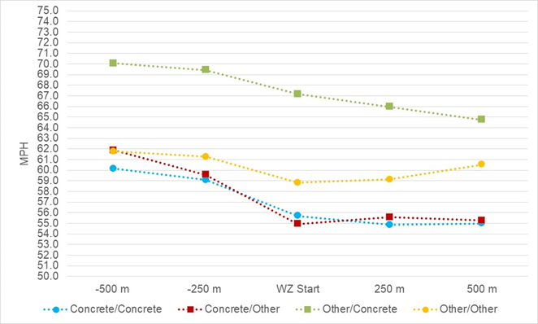
Figure 12.3. Speed by type of median upstream and barrier within the work zone for multi-lane roadways
Speeds were highest in the upstream section for both 4-lane and multi-lane roadways when “Other” median type (which included grass, flush) was present in the upstream section and a concrete median barrier was present within the work zone. Speeds were lowest in the upstream section for both roadway types when a concrete median was present upstream, and a concrete barrier was present in the work zone.
The largest decrease in speed from the upstream section to within the work zone on multi-lane roadways occurred when a concrete median was present upstream and “Other” type of barrier was present in the work zone (6.6 mph).
The largest decrease in speed from the upstream section to within the work zone on 4-lane roadways occurred when “other” median type was present upstream, and a concrete barrier median was present in the work zone (5.9 mph).
As a result, having a concrete median/barrier in one area but not the other appeared to alter driver behavior the most in terms of reducing speed within the work zone. This may be due to having what feels like an abrupt change in side friction for drivers.

Recommendations for Work Zone Barriers
Several studies have indicated that the type of barrier affects driver speed and lane position. The main conclusion is that drivers behave differently with a concrete barrier as compared to other barrier types. One study found higher lane deviation with concrete barriers. Another found higher speeds and less speed variability with concrete. Project findings indicated having the combination of a concrete median upstream and non-concrete barrier within the work zone (i.e., cones, barrels) OR having a grass or flush median upstream and concrete barriers within the work zone appeared to result in the highest speed reductions within the work zone. This may be due to having what feels like an abrupt change in side friction for drivers.
The type of barriers used in a work zone is based on several factors, primarily safety of construction workers or to minimize head on-collision. Cost is also a factor since concrete is more expensive than most other types of work zone barrier. Although, type of barrier is not a speed management device per se, when the median upstream of a work zone was grass or flush, presence of a concrete barrier within the work zone appears to result in greater speed reductions than other types of barriers. However, no specific recommendations are appropriate.
Work zone traffic control manuals were reviewed for 16 states. Several of the states mention barrier or positive protection but do not have specific guidance (Washington, Wisconsin, Oregon) and a few have specific guidance:
• Alaska: summarized scenarios for use of positive protection, which is based on factors such as duration, traffic volume, worker hazards, speed but does not suggest or preclude use of any particular work zone traffic control device (Alaska DOT 2012).
• Colorado: used to physically separate traffic and construction workers. No specifications for type are made but a range from a bituminous island with delineator’s tubes to concrete barriers are listed. They suggest concrete barriers are for moderate to long-term duration work zones (CDOT 2008)
• Florida: has recommendations for Type III barricades (FDOT 2018).
• Idaho: has an analysis tool to assist in determining when and what type of positive protection is needed. Input includes AADT, distance from traffic to worker, number of work shifts, expected costs and benefits, time of day, and other factors (IDT 2012).
• New York: has guidance on channelizing devices (NYSDOT 2015, NYSDOT 2017).
• Oregon: has guidance for positive protection in work zones (concrete, steel, and other work zone barriers including tubular markers, drums (ODOT 2017, ODOT 2019).

Glare Screens

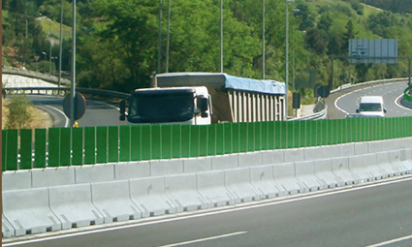
Summary
• Glare screens block glare from on-coming traffic
• May also reduce distraction and rubbernecking in work zones

s-steel.com/delineators, TRINITY Highway Products
Figure 13.1. Glare screens

Background
Work zone lane configurations often result in decreased shoulder and median width, which could increase the likelihood of glare from the headlights of oncoming vehicles. This is particularly true in taper and lane shift areas. Glare causes the pupils to constrict resulting in discomfort and disability. Discomfort glare can result in frequent blinking, averting one’s eyes from the roadway, and production of tears. Disability glare causes temporary reduction in contrast sensitivity, the ability to detect differences in brightness. This disability could cause drivers to not see objects in the roadway such as equipment, channelizing devices, and workers. Blocking the line of sight to oncoming headlights through the use of screening materials can reduce the debilitating effects of glare.
In addition to reducing glare from on-coming vehicles, several studies suggest use of glare screens reduces distractions and rubbernecking from work zone activities. A summary of findings on the impact of glare screens is shown in Table 13.1.
Table 13.1. Summary of impact of glare screens
Metric | Results | Source
Stated response | 7% of drivers independently stated they would slow with concrete barrier | Finley et al. 2008
Reduction in speed for work zones on 4-lane roadways | Largest changes from upstream to work zone for grass/flush median upstream and concrete barrier within work zone (5.9 mph) | Project findings
 | Smallest change upstream to within work zone for concrete median upstream and concrete barrier within work zone (0.5 mph)
Reduction in speed for work zones on multi-lane roadways | Largest changes from upstream to work zone for concrete median upstream and barrels/cones/other within work zone (6.6 mph) | Project findings
 | Smallest change upstream to within work zone for grass/flush median upstream and barrels/cones/other barrier within work zone (2.7 mph)

Summary of Other Relevant Studies for Glare Screens
A recent NCHRP synthesis on glare screen approaches for permanent installations suggests geometrics of curvature and median width, vegetation, berms, and glare screens as potential countermeasures (Johnson and McDonald 2019). For work zone applications glare screens are the most common method. An earlier synthesis of glare screen practices conducted in 1979 identified three types of glare screens (NRC 1979):
• Type I: Continuous solid screens that block light from all angles, typically achieved by using “tall walls” – concrete median barriers at greater heights.
• Type II: Continuous screens that appear opaque between 0 and 20 degrees but are transparent beyond 20 degrees. These are typically mesh materials, fencing, or fabric.
• Type III: Screens comprised of paddles or other individual elements that block light between 0 and 20 degrees. The 2019 synthesis identifies this as the most common type of glare screen.
A 1984 evaluation of paddle-type glare screen conducted for the Pennsylvania DOT demonstrated that after five years of service, the paddle median glare screen reduces headlight glare and was more cost-effective than a mesh (Type II) alternative used previously (Mauer 1984). This evaluation further found that paddle-type glare screens used in taper areas of work zones was beneficial in reducing headlight glare. This evaluation could not confirm that the glare reduced “rubbernecking”, i.e., drivers distracted by looking at work zone activity beyond the barrier. The ITE Handbook cites the reduction in gawking (i.e., rubbernecking) as one benefit of glare screens in work zones (ITE 2016).
The recent NCHRP synthesis report documents design and use details from 20 states. Several states noted that in addition to reducing glare, one of the goals of screening is to reduce rubbernecking. Some states consider length of the work zone and speed in determining where to place glare screens. Warrants for installing glare screens in permanent locations are cited for only a few states. Most of the states surveyed have recommendations for use in temporary applications as well. These specifications include mounting height and cutoff angles for visibility.

Summary of Relevant Project Findings for Glare Screens
Glare screens were noted in several of the work zones analyses evaluated using the SHRP2 data. However, the impact of glare screens was not detected in any of the models.

Recommendations for Glare Screens
The impact of glare screens on driver behavior was statistically significant in any of the analyses conducted for this project. As a result, the impact on speed or crashes could not be determined. Information is available from other sources which primarily discus placement.
The AASHTO Green Book recommends some antiglare treatment for median barriers for permanent installations (AASHTO 2004). The MUTCD offers guidance on placement of glare screens in Section 6F-8. The MUTCD cautions that glare screen should be placed so as not to reduce sight distance (FHWA 2019). The AASHTO Roadside Design Guide recommends glare screen devices for work zones both the reduce glare and to reduce rubbernecking. Chapter 9, Section 9.5.1 contains installation recommendations and design parameters for work zones (AASHTO 2011).
A recent NCHRP synthesis summarizes information for 20 states and may be the most comprehensive source of information about glare screens (journals.sagepub.com/doi/abs/10.1177/0361198118823201).
Work zone traffic control manuals were reviewed for 16 states. Several of the states mention glare screens but do have not specific guidance (Washington). Several have specific guidance which includes:
• CALTRANS: glare screens can be utilized to block motorist view of work zone activities to prevent driver distraction. They are placed on top of temporary traffic barriers (CALTRANS 2015).
• Colorado: glare screens are used to minimize glare from oncoming traffic and restrict motorists view of the construction activity and reduce delay due to rubbernecking (CDOT 2018).
• Oregon: differentiates between temporary glare screens (used between traffic lane and work zone) and glare shields (used between opposing lanes of traffic) (ODOT 2019).

Arrowboards

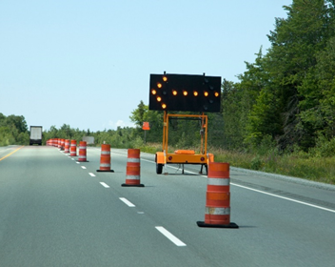
Summary
• Used to indicate merge rather than reduce speeds
• However, some evidence that arrow boards may reduce speed

rustycanuck, Shutterstock
Figure 14.1. Arrowboard

Background
Arrow boards are typically used to indicate vehicles need to merge. No studies were found in the literature which assessed the effectiveness of the devices. However, the impact was noted in one of the SHRP2 analyses which indicated a reduction in speed of almost 3 mph.

Summary of Other Relevant Studies for Arrow Boards
No additional information was found in the literature about the effectiveness on arrow boards on driver behavior.

Summary of Relevant Project Findings for Arrow Boards
One analysis using the SHRP2 data evaluated change in speed as drivers encountered various work zone traffic control devices. A description of the analysis was provided in Section 1.3.2. Figure 4.2 (see Section 4.2) illustrates the change in speed and 95% confidence interval for the various electronic work zone signs which were statistically significant in the final model. As noted, arrowboards resulted in a 2.8 mph decrease in speed.

Recommendations for Arrow Boards
A moderate reduction in speed was noted with electronic arrow boards (2.8 mph). Although arrow boards are not used for speed management, the results do suggest drivers slow for the device which may suggest a dynamic sign is more effective than a static sign when speed reductions are desired.
Work zone traffic control manuals were reviewed for 16 states. Several of the states mention arrow boards but do not have specific guidance (Washington and Idaho) (IDT 2012, WSDOT n.d). New York and Florida had specific guidance, but it was the same as the MUTCD.

References
Includes references for Volumes 1 and 2.
AASHTO. A Policy on Geometric Design of Highways and Streets: The Green Book. American Association of State Highway and Transportation Officials. Washington, DC. 2004.
AASHTO. Roadside Design Guide. American Association of State Highway and Transportation Officials, Washington, D.C. 2011.
AGC. Sixty-Seven Percent of Nation’s Road Contractors Experienced Vehicle Crashes at Work Sites, Putting Motorists’ and Workers’ Lives at Risk. Associated General Contractors of America. May 23, 2019.
Af Wåhlberg, A. E. Driver Deceleration Behavior and Accidents – An Analysis. Theoretical Issues in Ergonomics Science. Vol. 9 (5). 2008. pp. 383–403.
Akepati, S. R. and S. Dissanayake. Characteristics and Contributory Factors of Work Zone Crashes. Proceedings of the 90th Annual Meeting of the Transportation Research Board, January 23–27, Washington, DC. 2011.
Alaska DOT. Alaska Highway Preconstruction Manual. Highway Work Zone Safety & TCPs. Chapter 14. Highway Work Zone Safety and Traffic Control Plan. Alaska Department of Transportation. January 30, 2012.
Allen, T. M., F. N. Dyer, G. M. Smith, and M. H. Janson. Luminance Requirements for Illuminated Signs. Highway Research Record. No. 179. 1967. pp. 16–37.
Aoki, H., M. Aga, Y. Miichi, Y. Matsuo, S. Tanaka. Safety Impact Methodology (SIM) for Effectiveness Estimation of a Pre-Collision System by Utilizing Driving Simulator Test and EDR Data Analysis. SAE Technical Paper 2010-01-1003. 2010.
ATTSA. Guidance for the Use of Temporary Rumble Strips in Work Zones. American Traffic Safety Services Administration, Federal Highway Administration. September 2013.
Atwood, J., F. Guo, G. Fitch, and T. A. Dingus. The driver-level crash risk associated with daily cellphone use and cellphone use while driving. Accident Analysis & Prevention. Vol. 119. October 2018. pp. 149-154.
Bach, K. M., M. G. Jæger, M. B. Skov, and N. G. Thomassen. Evaluating Driver Attention and Driving Behavior: Comparing Controlled Driving and Simulated Driving. British Computer Society-HCI ’08 Proceedings of the 22nd British HCI Group Annual Conference on People and Computers: Culture, Creativity, Interaction, Liverpool, UK. Volume 1. 2008. pp. 193–201.
Banerjee, Snehanshu and Mansoureh Jeihani. Influence of mobile work zone barriers on driver behavior on freeways: A driving simulator study. International Conference on Transportation and Development 2019: Smarter and Safer Mobility and Cities. June 2019. pp 235-246.
Benekohal R. F., A. Hajbabaie, J. C. Medina, M. Wang, and M. V. Chitturi. Speed Photo-Radar Enforcement Evaluation in Illinois Work Zones. Illinois Center for Transportation, University of Illinois at Urbana-Champaign, Urbana, IL. 2010.
Benekohal, R.F., and L. Wang. Speed Change Distribution of Vehicles in a Highway Work Zone. Journal of the Transportation Research Board. No. 1409. 1993. pp. 42-51.
Bernhardt, Kristen L. Sanford, Mark R. Virkler, and Nawaz M. Shaik.. Evaluation of Supplementary Traffic Control Measures for Freeway Work-zone Approaches. Proceedings of the 80th Annual Meeting of the Transportation Research Board. January 2001.
Bharadwaj, Nipyoti, Praveen Edara, and Carlos Sun. Risk Factors in Work Zone Safety Events: A Naturalistic Driving Study Analysis. Journal of the Transportation Research Board. Vol. 2673. 2019. pp. 379-387.
Brewer, M., W. Schneider IV, and G. Pesti. Identification and Testing of Measures to Improve Work Zone Speed Limit Compliance. Federal Highway Administration and Texas Transportation Institute, Texas A&M University System, College Station, Texas. TX-06/0-4707-1. 2005.
Brewer, William, John W. Shaw, Madhav V. Chitturie, Andrea Bill, and David A. Noyce. Guidelines for Work Zone Designers – Positive Protection. University of Wisconsin, Madison, Wisconsin. May 2019.
Brewer, M. A., Pesti, G., Schneider, W. VI Improving compliance with work zone speed limits – Effectiveness of selected devices. Journal of Transportation Research Board. No. 1948. 2006. pp. 67 – 76.
Caltrans. Transportation Management Plans Guidelines. California Department of Transportation, Division of Traffic Operations, Office of Traffic Management. November 2015.
Campbell, K. L. The SHRP 2 Naturalistic Driving Study: Addressing Driver Performance and Behavior in Traffic Safety. TR News. No. 282. 2012.
Carlson, P.J., M.D. Fontaine, and H.G. Hawkins Jr. Evaluation of Traffic Control Devices for Rural High-Speed Maintenance Work Zones. Texas Transportation Institute. The Texas A&M University System College Station, Texas. Report FHWA/TX-00/1879-1. October 2000.
CDC. Highway Work Zone Safety. The National Institute for Occupational Safety and Health. Centers for Disease Control and Prevention. www.cdc.gov/niosh/topics/highwayworkzones/default.html. Accessed March 2020.
Chen, Z., J. Yu, Y. Zhu, Y. Chen, and M. Li. D³: Abnormal Driving Behaviors Detection and Identification using Smartphone Sensors. 12th Annual IEEE International Conference on Sensing, Communication, and Networking. Seattle, WA. 2015. pp. 524–532.
CDOT. Work Zone Safety and Mobility Rule Procedures Document. Colorado Department of Transportation. July 2014, Revised March 2018.
CDOT. Guidelines for Developing Traffic Incident Plans for Work Zones. Colorado Department of Transportation. 2008.
Council, F.M., A.J. Khattak, and A.J. Khattak. Effects of Work Zone presence on injury and non-injury crashes. Accident Analysis and Prevention. Vol. 34. 2000. pp. 19-29.
Dingus, T. A., J. M. Hankey, J. F. Antin, S. E. Lee, L. Eichelberger, K. Stulce, D. McGraw, M. Perez, L. Stowe. 2014. Naturalistic Driving Study: Technical Coordination and Quality Control. Virginia Tech Transportation Institute. Blacksburg, VA.
Dissanayake, Sunanda and Sreekanth Reedy Akepati. Identification of Work Zone Crash Characteristics. Smart Work Zone Deployment Initiative. Institute for Transportation, Iowa State University. September 2009.
Edara P., C. Sun, and Y. Hou. Evaluation of Variable Advisory Speed Limits in Work Zones. Midwest Smart Work Zone Deployment Initiative, Iowa State University, Ames, IA. 2013.
FHWA. Managing Speeds. Public Road, Federal Highway Administration. January 2003.
FHWA. 2019. Manual on Uniform Traffic Control Devices for Streets and Highways (MUTCD). Federal Highway Administration, Washington, DC.
Finley M. D., L. Theiss, N. D. Trout, and G. L. Ullman. Studies to Improve the Management of Regulatory Speed Limits in Texas Work Zones. Texas Transportation Institute, College Station, TX. 2008.
Finley M. D., J. Jenkins, and D. McAvoy. Evaluation of Ohio Work Zone Speed Zones Process. Ohio Department of Transportation, Columbus, OH. 2014.
Fitch, G.M., S.A. Soccolich, F. Guo, J. McClafferty, Y. Fang, R. L. Olson, M. A. Perez, R. J. Hanowski, J.M. Hankey, and T.A. Dingus. The Impact of Hand-Held and Hands-Free Cell Phone Use on Driving Performance and Safety-Critical Event Risk. National Highway Traffic Safety Administration, Washington, DC. April 2013.
FDOT. Florida DOT Design Manual. Florida Department of Transportation. January 2018.
Fontaine, Michael D. Innovative Traffic Control Devices for Improving Safety at Rural Short-Term Maintenance Work Zones. Texas Transportation Institute. College Station, Texas. 2017.
Fontaine, M. D., and Carlson, P. J. Evaluation of speed displays and rumble strips at rural-maintenance work zones. Journal of the Transportation Research Record. Vol. 1745. 2001. pp. 27–38.
Fryzlewicz, P. Wild Binary Segmentation for Multiple Change-Point Detection. Annals of Statistics. Vol. 42. 2014. pp. 2243–2281.
Garber, N.J., and H. Woo. Accident Characteristics at Construction and Maintenance Zones in Urban Areas. Virginia Transportation Research Council, Charlottesville, VA. 1990.
Garber, N. J., and M. Zhao. Crash characteristics at work zones. Virginia Transportation Research Council, Charlottesville, VA. VTRC 02–R12. 2002.
Garvey, P. M., and D. M. Mace. Changeable Message Sign Visibility. Federal Highway Administration, Washington, DC. FHWA-RD-94-077. 1996.
GHSA. Work Zones. Governors Highway Safety Association. www.ghsa.org/state-laws/issues/work%20zones. Accessed April 2020.
Ha, T., and Nemeth, Z. Detailed Study of Accident Experience in Construction and Maintenance Zones. Journal of the Transportation Research Record. Vol. 1509. 1989. p.p. 38-45.
Hall, J. W., and V. M. Lorenz. Characteristics of Construction-Zone Accidents. Journal of the Transportation Research Board. Vol. 1230. 1989. pp. 20–27.
Harb, R., E. Radwan, X. Yan, A. Pande, and M. Abdel-Aty. Freeway Work-Zone Crash Analysis and Risk Identification Using Multiple and Conditional Logistic Regression. Journal of Transportation Engineering. Vol. 134 (5). 2008. pp. 203–214.
Hawkins, N., and S. Knickerbocker. Field Measurements on the Effect of Temporary Rumble Strips in Work Zone Flagging Operations. Center for Transportation Research and Education, Institute for Transportation. Ames, Iowa. May 2017.
Hildebrand, E. D., F.R. Wilson, J.J. Copeland. Speed management strategies for rural temporary work zone. Proceedings of the Canadian Multidisciplinary Road Safety Conf. XIII, Canadian Association of Road Safety Professionals, Ottawa. 2003.
Hsieh, E. Y., G. L. Ullman, G. Pesti, and R. E. Brydia. Effectiveness of End-of-Queue Warning Systems and Portable Rumble Strips on Lane Closure Crashes. Journal of Transportation Engineering, Part A: Systems. Vol. 143 (11). November 2017.
Huebschman, C. R., C. Garcia, D. Bullock, and D. Abraham. Compliance with reduced speed limits in work zones. Proceedings of the 83rd Annual Transportation Research Board Meeting, Washington, DC. January 2004.
IDT. Work Zone Safety and Mobility Program. Idaho Transportation Department. January 2012.
Iowa DOT. Transportation Systems Management and Operations Program Plan. Iowa Department of Transportation. February 2016.
ITE. Traffic Engineering Handbook, 7th ed. Institute of Transportation Engineers. John Wiley & Sons, Inc., Hoboken, N. J. 2016.
Jacobs, R. J., A. W. Johnston, and B. L. Cole. The Visibility of Alphabetic and Symbolic Traffic Signs. Australian Road Research. Vol. 5 (7). 1975. pp. 68–86.
Jin, T.G. and M. Saito. Spatial and Temporal Analyses of Crashes at Two Work
Zones with Different Traffic Control Devices: Barrels and Jersey Barriers. Proceedings of the 88th Annual Meeting of the Transportation Research Board. 2009.
Johnson, C. Work Zone Crash Report. Minnesota Department of Transportation, Office of Traffic, Safety, and Technology. July 2015.
Johnson, D.R. and D.R. McDonald. Glare Screen Use in Road Design: A Synthesis of the Practice. Journal of the Transportation Research Board. Vol. 2673 (8). 2019. pp. 25–35.
KDOT. Kansas Work Zone Safety and Mobility Processes and Procedures. Kansas Department of Transportation, Bureau of Transportation Safety and Technology. July 2008.
Khattak, AJ, AJ Khattak, and FM Council. Effects of work zone presence on injury and non-injury crashes. Accident Analysis and Prevention. Volume 34 (1). January 2002. pp.19-29.
King, T.W., C.C. Sun, and M.R. Virkler. Evaluation of a Freeway Work Zone Advance Speed Advisory System Using Multiple Measures. Proceedings of the Transportation Research Board 83rd Annual Meeting Compendium, Washington, D.C. 2004.
Kircher, K. and C. Ahlstrom. Minimum Required Attention: A Human-Centered Approach to Driver Inattention. Human Factors. Vol. 59 (3). 2017. pp. 471–484.
Klauer, S. G., T. A. Dingus, V. L. Neale, J. D. Sudweeks, and D. J. Ramsey. Comparing Real-World Behaviors of Drivers with High versus Low Rates of Crashes and Near-Crashes. National Highway Traffic Safety Administration, Washington, DC. DOT HS 811 091. February 2009.
Klauer, S. G., T. A. Dingus, V. L. Neale, J. D. Sudweeks, and D. J. Ramsey. The Impact of Driver Inattention on Near-Crash/Crash Risk: An Analysis Using the 100-Car Naturalistic Driving Study Data. National Highway Traffic Safety Administration, Washington, DC. DOT HS 810 594. April 2006.
Kusano, K. D. and H. Gabler. Method for Estimating Time to Collision at Braking in Real-World, Lead Vehicle Stopped Rear-End Crashes for Use in Pre-Crash System Design. SAE International, Warrendale, PA. 2011. www.sbes.vt.edu/gabler/publications/Kusano-Gabler-SAE-TTC_EDRs-2011-01-0576.pdf.
LADOTD. Part III: Guidelines for Conducting a Safety Analysis for Transportation Management Plans and Other Work Zone Activities. Louisiana Department of Transportation and Development. April 2012.
Li, Y., and Y. Bai. Fatal and Injury Crash Characteristics in Highway Work Zones. Proceedings of the 2008 Annual Meeting of the Transportation Research Board, Washington, DC. 2008.
Lyles, R.W., W.C. Taylor, D. Lavansiri, and J.A. Grossklaus. Field Test and Evaluation of Variable Speed Limits in Work Zones. Proceedings of the 86th Annual Meeting of the Transportation Research Board, Washington, DC. 2004.
Mauer, D. A. Paddle-Type Glare Screen. Final Evaluation Report. Pennsylvania Department of Transportation. FHWA-PA 84-006. 1984.
McAvoy, D., K. Schattler and T. Datta. Driving simulator validation for nighttime
construction work zone devices. Journal of the Transportation Research Board. Vol. 2015. 2007. pp. 55-63.
McGehee D.V., M. Raby, C. Carney, J. D. Lee, and M. L. Reyes. Extending parental mentoring using an event-triggered video intervention in rural teen drivers. Journal of Safety Research. Vol. 38. 2007. pp. 215–227.
McCoy, P.T., J.A. Bonneson, and J.A. Kollbaum. Speed Reduction Effects of Speed Monitoring Displays with Radar in Work Zones on Interstate Highways. Journal of the Transportation Research Board. Vol. 1509. 1995. pp. 65–72.
MDSHA. Use of Speed Display Trailers in Work Zones. Maryland State Highway Administration. August 2005.
Meyer, E. Long-Term Effects of Radar-Activated Speed Displays. Midwest Smart Work Zone Deployment Initiative, Iowa State University, Ames, IA. 2003.
Miyajima, C., Y. Nishiwaki, K. Ozawa, T. Wakita, K. Itou, K. Takeda, and F. Itakura. Driver Modeling Based on Driving Behavior and Its Evaluation in Driver Identification. Proceedings of the IEEE. Vol. 95(2). 2007. pp. 427–437.
MnDOT. Work Zone Speed Limit Guidelines. Minnesota Department of Transportation, Office of Construction and Innovative Contracts and Office of Traffic, Safety, and Technology. December 2010. safety.fhwa.dot.gov/speedmgt/ref_mats/fhwasa1304/resources2/11%20-%20Work%20Zone%20Speed%20Limit%20Guidelines.pdf.
MoDOT. Transportation Systems Management and Operations (TSMO) Strategic Plan. Missouri Department of Transportation. June 2018.
MoDOT. Category:616 Temporary Traffic Control. Missouri Department of Transportation http://epg.modot.org/index.php/Category:616_Temporary_Traffic_Control). Accessed January 2020.
Muggeo V. M. R. Segmented: R Package to Fit Regression Models with Broken-Line Relationships. R News. Vol. 8(1). 2008. pp. 20–25.
Muttart, J. W., D.L. Fisher, M. Knodler, and A. Pollatsek. Driving without a clue: Evaluation of driver simulator performance during hands-free cell phone operation in a work zone. Journal of the Transportation Research Board. Vol. 2018 (1). 2007. pp. 9-14.
Nemeth Z. A. and D. J. Migletz. Accident Characteristics Before, During, and After Safety Upgrading Projects on Ohio’s Rural Interstate System. Journal of the Transportation Research Board. 1978. Vol. 672. pp. 19–23.
NYDOT. Work Zone Traffic Control. New York State Department of Transportation. Office of Traffic Safety and Mobility. February 2015.
NYDOT. Chapter 16 – Maintenance and Protection of Traffic in Highway Work Zones. Highway Design Manual. New York State Department of Transportation. April 2017.
NSRC. Glare Screen Guidelines, Synthesis of Highway Practice. National Research Council. Transportation Research Board, National Research Council, Washington, D.C. 1979.
NWZSIC. Work Zone Fatal Crashes and Fatalities. National Work Zone Safety Information Clearinghouse. https://www.workzonesafety.org/crash-information/work-zone-fatal-crashes-fatalities/#national. Last accessed September 2019.
ODOT. Transportation Management Plan (TMP), 2nd Edition, Project Level Guidance Manual. Oregon Department of Transportation. April 2017.
ODOT. Traffic Control Plans Design Manual. 14th Edition. Oregon Department of Transportation. , Jan. 2019.
Pigman, J. G. and K. R. Agent. Highway Accidents in Construction and Maintenance Work Zone. Journal of the Transportation Research Board. Vol. 1270. 1990. pp. 12-21.
Paniati, J. F. Legibility and Comprehension of Traffic Sign Symbols. Proceedings of the Human Factors Society—32nd Annual Meeting. Vol. 32 (10). October 1988. pp. 568–572.
Paolo, P. and D. Sar. Driving Speed Behaviour Approaching Road Work Zones on Two-Lane Rural Roads. Procedia - Social and Behavioral Sciences. Vol. 53. 2012. pp. 672-681.
Paulsen, R. J., J. C. Glennon, and J. L. Graham. Traffic Safety in Construction Zones. Rural and Urban Roads. Vol. 16(10-71). 1978.
Perez, W. A., M. A. Bertola, and B. Philips. Active Traffic Management: Comprehension, Legibility, Distance, and Motorist Behavior in Response to Selected Variable Speed Limit and Lane Control Signing. Federal Highway Administration. FHWA-HRT-16-037. 2016.
Pigman, J. G., and R. A. Kenneth. Analysis of accidents in construction and maintenance work zones. Kentucky Transportation Research Program. UKTRP-88-13. June 1988.
Raub, R.A., O.B. Sawaya, J.L Schofer, and A. Ziiaskopoulos. Enhanced Crash Reporting to Explore Workzone Crash Patterns. Proceedings of the Annual Meeting of the Transportation Research Board. Washington, DC. January 2001.
Rakotonirainy, A., S. Demmel, A. Watson, M.M. Haque, J. Fleiter, B. Watson, and S. Washington. Prevalence and Perception of Following Too Close in Queensland. Proceedings of the 2017 Australian Road Safety Conference, Perth, Australia. 2017.
Reyes, M.L. and S.A. Khan. Examining Driver Behavior in Response to Work Zone Interventions: A Driving Simulator Study. Public Policy Center, University of Iowa. 2008.
Richards, S. H., and M. S. Faulkner. An Evaluation of Work Zone Traffic Accidents Occurring in Texas Highways in 1977. Texas Transportation Institute, College Station, Texas. FHWA-TX-81-263. 1981.
Rouphail, N. M., Z. S. Yang, and J. Frazio. Comparative Study of Short- and Long-Term Urban Freeway Work Zones. Journal of the Transportation Research Board. Vol. 1163. 1988. pp. 4–14.
Sayer, J. R., J. M. Devonshire, and C. A. C. Flannagan. Naturalistic Driving Performance during Secondary Tasks. Proceedings of the 4th International Driving Symposium on Human Factors in Driver Assessment, Training, and Vehicle Design: Driving Assessment, Stevenson, WA. . July 2007. pp. 224–230.
Simons-Morton, B. G., M. C. Ouimet, J. Wang, S. G. Klauer, S. E. Lee, and T. A. Dingus. Hard Braking Events Among Novice Teenage Drivers by Passenger Characteristics. Fifth International Driving Symposium on Human Factors in Driver Assessment, Training, and Vehicle Design. Big Sky, Montana. June 2009. pp. 236–242.
Sisiopiku, V.P., O.E. Ramadan, M.I. Eltaher Ismail, and O. Cavusoglu. Analysis of Crash Causes, Costs, and Countermeasures, in Alabama Work Zones. Proceedings of the 2014 Road Safety and Simulation International Conference. Orlando, Florida. December 2014.
Sorrel M. T., W. A. Sarasua, W. J. Davis, J. H. Ogle, and A. Dunning. Use of Radar-Equipped Portable Changeable Message Sign to Reduce Vehicle Speed in South Carolina Work Zones. 86th Annual Meeting of the Transportation Research Board. Washington, DC. January 2007.
Strawderman et al. 2012 where the study found compliance with the speed reduction signs placed farther away from the work zone
Sun, C., P. Edaram, and K. Ervin. Elevated-Risk Work Zone Evaluation of Temporary Rumble Strips. Journal of Transportation Safety and Security. Vol. 3(3). 2011. pp. 157–173.
Texas DOT. Temporary Rumble Strips. WZ(RS)-15. Texas Department of Transportation, Traffic Operations Division Standard. November 2012.
Thompson, B. Evaluation of Radar-Activated Changeable Message Sign for Work Zone Speed Control. Maine Department of Transportation, Transportation Research Division. Technical Report 01-16. 2002.
Ullman, Gerald, Brooke R. Ullman, Conrad L. Dudek, Alicia Williams, and Geza Pesti. Advanced Notification Messages and Use of Sequential Portable Changeable Message Signs in Work Zones. Texas Department of Transportation, Austin, Texas. FHWA/TX-05/0-4748-1 July 2005.
Ullman, G.L., M. Pratt, M.D. Fontaine, R.J. Porter, and J. Medina. NCHRP Web-Only Document 240: Analysis of Work Zone Crash Characteristics and Countermeasures. National Cooperative Highway Research Program; Transportation Research Board; National Academies of Sciences, Engineering, and Medicine. 2018.
Ullman, Gerald L., Paul J. Carlson, Nada D. Trout, and J. Alan Parham. Work Zone-Related Traffic Legislation: A Review of National Practices and Effectiveness. Texas Department of Transportation, Austin, Texas. FHWA/TX-98/1720-1. September 1997.
Valdes, D., C. Lopez del Puerto, B. Colucci, A. Figueroa, R.G. Rosario, E.C. Torres, and M.X.R. Ibarra. Comparative Analysis between Distracted Driving Texting Laws and Driver’s Behavior in Construction Work Zones. Journal of Legal Affairs and Dispute Resolution in Engineering and Construction. Vol. 11 (4). 2019.
Van Jura, J., D. Haines, and A. Gemperline. Use of Portable and Dynamic Variable Speed Limits in Construction Zones. Journal of the Transportation Research Board. Vol. 2672. 2018. pp. 35-45.
VTRANS. Work Zone Safety & Mobility Guidance Document. Vermont Agency of Transportation. August 2007.
VDOT. Virginia Work Area Protection Manual, Standards and Guidelines for Temporary Traffic Control. Virginia Department of Transportation. 2011.
WSDOT. Work Zone Safety and Mobility, Chapter 1010. Washington State Department of Transportation. No Date.
Weng, J. and Q. Meng. Analysis of Driver Casualty Risk for Different Work Zone Types. Accident Analysis and Prevention. Vol. 43 (5). 2011. pp. 1811–1817.
Wierwille, W.W., S. E. Lee , M. DeHart, and M. Perel. Test road experiment on imminent warning rear lighting and signaling. Human Factors. Vol. 48. 2006. pp. 615–626.
WisDOT. Facilities Development Manual, Chapter 11 Design Section 50 Traffic Control, Work Zone Policy Statement. Wisconsin Department of Transportation. May 2019.
WisDOT. Temporary Traffic Control, Part 6. Wisconsin Department of Transportation. No date.
Wood, J., and S. Zhang. Evaluating Relationships between Perception-Reaction Times, Emergency Deceleration Rates, and Crash Outcomes Using Naturalistic Driving Data. Mountain-Plains Consortium. 2017.
Yang, H., K. Ozbay, O. Ozturk, and M. Yildirimoglu. Modeling Work Zone Crash Frequency by Quantifying Measurement Errors in Work Zone Length. Accident Analysis and Prevention. Vol. 55. 2013. pp. 192–201.
Zwahlen, H. T., X. Hu, M. Sunkara, and L. M. Duffus. Recognition of Traffic Sign Symbols in the Field During Daytime and Nighttime. Proceedings of the Human Factors Society 35th Annual Meeting. Vol. 35(15). 1991. pp. 1058–1062.

APPENDIX A: Summary of State Practices for Work Zone Traffic Management Plans
Work zone traffic control manuals for several states were reviewed to identify common countermeasures, configurations, and practices. The following summarizes guidance on use of traffic control devices in state DOT work zone traffic management plans.

A.1 Alaska
Alaska has a highway preconstruction manual which contains a chapter on work zone safety and traffic control plans (Alaska 2012). Every State and Federally funded project and work on State Highways project must have a Transportation Management Plan (TMP) which includes a Traffic Control Plan (TCP) and may contain a Transportation Operations Plan and a Public Information Plan. The list is essentially a reiteration of requirements included in 23 CFR 630 Subpart K.
Use of positive protection devices is based on:
• Project scope and duration
• Anticipated speeds through the work zone
• Anticipated volumes
• Vehicle mix
• Type of work
• Distance between traffic and workers, and degree of worker exposure
• Escape paths available for workers to avoid vehicle intrusion into the workspace
• Time of day the work occurs
• Work area restrictions (including impact on worker exposure)
• Consequences from/to road users resulting from roadway departure
• Potential hazard to workers and road users presented by device itself and during device placement and removal
• Geometrics that may increase crash risks (e.g., poor sight distance and sharp curves)
• Access to/from workspace
• Impacts on project cost and duration
Particular consideration should be given to installation of positive protection devices (PPD’s) for:
• Work zones provide workers no means of escape from motorized traffic (e.g., bridges)
• Long duration work zones (2+ weeks)
• Projects with anticipated operating speeds of 45 mph or greater, especially when combined with high traffic volumes
• Work operations that place workers close to travel lanes open to traffic
• Roadside hazards (e.g., drop-offs, unfinished bridge decks)
Additionally, they suggest consideration of truck-mounted attenuators for short duration or mobile work on roads with a posted speed of greater than 45mph and other areas as appropriate.
The document does not suggest or preclude use of any particular work zone traffic control device.

A.2 California
Information about Caltrans (2015) suggested traffic control devices for work zones are included in their transportation management plan guidelines. In general, the document is more about planning for work zones. Caltrans does include guidance for use of TCD to provide information to the public. They mention consideration for the use of the following work zone traffic control devices but does not provide information about preferred TCD:
• Changeable Message Signs (CMS): Caltrans policy requires that permanent CMS that are five miles or less in advance of an active work zone should advise the public with message such as: “WORK ZONE AHEAD WATCH FOR HIGHWAY WORKERS”
• Portable Changeable Message Signs (PCMS): PCMS can be placed at key locations to notify motorists of lane closures, alternate routes, delay, and upcoming road closures. Sign placement is included in project plans. PCMS are usually utilized as part of project signing but may be used as a TMP strategy when warranted based on factors such as roadway geometry or proximity to interchanges.
• Dynamic Speed Feedback Signs: either fixed sign or trailer mounted DSFS can be used with the objective of encouraging motorists to comply with the speed limit and reduce speed variance.
• Automated Work Zone Information System (AWIS): used to inform motorists about upcoming slow traffic by collecting intelligent transportation system elements that are used to give real time information to travelers using PCMS.
• Traffic “Gawk” Screens: can be utilized to block motorist view of work zone activities to prevent driver distraction. They are placed on top of temporary traffic barriers.
• Temporary Traffic Signals: temporary signals may be used instead of stop signs or flaggers to improve traffic flow.

A.3 Colorado
Colorado DOT (2018) uses the Work Zone Safety and Mobility Rule Procedures Document to describe general information for developing a Traffic Control Plan. They also have a process for reviewing traffic control. Colorado DOT does not specify use of specific traffic control devices, but temporary traffic control plan strategies include the following (in most cases the countermeasures are listed but no specific guidance for their use is provided):
• Changeable/dynamic/variable message signs (CMS/DMS/VMS): used to notify travelers of incidents, travel time information, construction/road closures, and other potential hazards in or around the work zone. They suggest careful placement at locations where drivers can adjust their routes to account for the information.
• Advance construction signing: they suggest advance signing should be used to notify motorists of the upcoming work zone as well as options for alternative route.
• Fines Double Signs: signs are used to notify motorists about work zone fines.
• Flashing arrow signs: signs intended to notify motorist to navigate around and merge in work zones. Their use is supplemental to convention traffic control.
• Signing & striping enhancements: are placed to guide motorists;
• Traffic screens: used to minimize glare from oncoming traffic and restrict motorists view of the construction activity and reduce delay due to rubbernecking;
• Late merge: used to encourage motorists to use all available lanes until the merge point;
• Temporary signs: are used to improve traffic flow;
• Changeable, dynamic, or variable message signs: CMS/DMS/VMS are used to notify motorist’s incidents, travel time, construction or road closures, or other hazards around the work zone. They suggest placement when the condition of the work zone is changing, and static signs are not sufficient;
• Crash Cushion: mobile or fixed crash cushions are placed at a specific location to prevent errant vehicles from entering a work zone or encountering a hazard;
• Intrusion Alarms: used to alert workers that a vehicle has entered the area between travel lanes and construction worker;
• DSFS: sign or trailer mounted to advice motorists of their speed and reduce speed and speed variation. Should be placed with a speed limit sign at or near the panel.
• Temporary rumble strips: placed across a travel lane to alert motorists about a change in roadway conditions or a hazardous curve, slow traffic, or other hazard.
• Temporary traffic signals: used to improve traffic flow;
• Temporary traffic barriers: used to physically separate traffic and construction workers. No specifications for type are made but a range from a bituminous island with delineator’s tubes to concrete barriers are listed. They suggest concrete barriers are for moderate to long-term duration work zones.
• Warning lights: warning lights on barricades or signs to delineate a barrier or warn motorists of upcoming conditions
• Smart Work Zone Technologies: include automatic sensors to measure traveler travel time or delay and display this information via PCMAs, HARs, the Internet, and other means in “real-time” conditions

A.4 Florida
Florida DOT uses the Florida DOT Design Manual (2018). General information for traffic management (TSMO) is provided. Some guidance is also provided about which devices can be used including:
• Advance signing: includes “ROAD WORK AHEAD” or “ROAD WORK ONE MILE”. Indicates sequence for advance signing should be general to specific: road work ahead → left lane closed ahead → Merge right
• Arrow boards: used as a supplement to other devices, do not use on lane shifts, refer to MUTCD
• Portable changeable message sign: used as a supplement (does not replace) other required signs or other devices and is used to inform drivers about construction schedules, alternate routes, delays, detours/diversions/lane shifts
• Channelizing devices: include cones, tubular markers, or drums; Type 1 or II barricades, vertical panels, longitudinal channelizing devices
• Type III Barricades: used to block off, close, or partially close a road or ramp
• Markings: has specs on material and placement
• RPM: used as a supplement to lane lines
• Portable regulatory signs: a portable trailer with the regulatory speed sign mounted with flashing lights is used to highlight the regulatory work zone speed;
• Radar speed display unit: displays driver speed, used in conjunction with the posted speed mounted above the panel

A.5 Idaho
The Idaho Transportation Department uses Work Zone Safety and Mobility Program (IDOT 2012). The guide provides a general overview of traffic control plans. The following list of traffic control devices are mentioned but no guidance is provided. Instead, readers are referred to the MUTCD.
Traffic control devices listed include:
• Temporary signs
o Warning
o Regulatory
o Guide/ information
• Channelizing devices
o Longitudinal traffic barriers
• Positive Protection Devices
o Attenuators
• Temporary pavement markings
• Arrow panels
• Changeable Message Signs (CMS)
• Temporary traffic signals
• Lighting devices
Work zone safety management TCD listed include:
• Changeable Message Signs (CMS)
• Temporary traffic signals
• Temporary traffic barrier
• Crash-cushions
• Temporary rumble strips
• Intrusion alarms
• Warning lights
• Speed Radar Trailers
Idaho has an analysis tool to assist in determining when and what type of positive protection is needed. Input includes AADT, distance from traffic to worker, number of work shifts, expected costs and benefits, time of day, and other factors (see Work Zone Positive Protection Guidance form at https://apps.itd.idaho.gov/Apps/FormFinder2DMZ.

A.6 Iowa
The Iowa Department of Transportation uses Transportation Systems Management and Operations Program Plan (Iowa DOT 2015). The guide provides information about management of work zone devices such as cameras, detectors, data, etc. Although the guide does not specifically mention countermeasures, the Iowa DOT utilizes:
• Portable DMS
• Speed display Trailers
• Overhead dynamic message signs
• Intersection collision warning systems
• Side mounted dynamic message signs

A.7 Kansas
The Kansas Department of Transportation uses the Kansas Work Zone Safety and Mobility Processes and Procedures (KDOT 2008). The document covers Significant Project, Transportation Management Area (TMA), Transportation Management Plan (TMP), Work Zone Mobility, and Work Zone Safety.
The only traffic control devices listed are temporary traffic signals, changeable message signs, and dynamic speed message signs.

A.8 Louisiana
The Louisiana Department of Transportation and Development has a useful set of Guidelines for Conducting a Safety Analysis for Transportation Management Plans and Other Work Zone Activities (LADOTD 2012). It provides useful guidance on how to do analyses that help dictate where work zone safety countermeasures may be needed.

A.9 Missouri
The Missouri DOT uses the Transportation Systems Management and Operations (MoDOT 2018) Strategic Plan.” The document provides TSMO strategies and benefits of Work Zone Management Systems. The document does not specifically discuss traffic control devices or common practices. Missouri also has a document in their policy library on temporary traffic control (MoDOT 2020)

A.10 New York
The New York State Department of Transportation uses the Work Zone Traffic Control (NYSDOT 2015). The document has detailed instructions for determining taper length and buffer spaces as well as general information about work zone traffic control.
The document provides guidance for proper signing including the following:
• Work zone warning signs: one or more should be used whenever the work results in a changed condition which may require a higher level of driver caution. Signs must be adequately spaced to allow time for the driver to read each one.
• General warning signs: limit to the first sign of a series (i.e., “Road Work XX Ft”);
• Advance warning signs: should be located to consider exiting and entering traffic. Advance posting distances indicated in the MUTCD and WZTCM are starting points and should be adjusted as appropriate for site specific conditions.
• Single advance warning signs: use on ramps or minor intersecting roads such use “Ahead” rather than a specific distance since it is easier to adapt to site conditions and reduces sign inventory needs;
• Warning signs: must be located to provide adequate visibility distance to drivers.
• Channelizing devices: use to warn, alert, and guide road users drivers of work zone conditions and protect workers;
• Flashing arrow panels: should NEVER be used on two-lane, two-way roads;
• Advance Warning Arrow Display specifications are provided;
• Portable Variable Message Signs (PVMS): provide supplemental warning and real time information concerning changing conditions.
New York also uses Chapter 16 of the New York Highway Design Manual which provides guidance on use of police in work zones, accelerated contracting provisions, speed limit reductions, etc. (NYSDOT 2017).

A.11 Oregon
The Oregon Department of Transportation uses Transportation Management Plan (ODOT 2017) and the Traffic Control Plans Design Manual (ODOT 2019). The Traffic Control Plans Design Manual provides an introduction to the standards, practices, devices and technologies that serve as the foundation for the temporary traffic control discipline.
The following relevant traffic control devices are mentioned (unless otherwise stated, additional guidance is not provided):
• Positive protection: temporary traffic delineation may be accomplished using tubular markers, conical markers, plastic drums, temporary flexible pavement markers, or even temporary paint (depending on the facility type and timing between temporary delineation and placement of permanent markings);
• Sign and device spacing: specific instructions are provided
• Pavement markings and markers: specific guidance is provided
• Tubular & Conical Markers
o Standard tubular markers - orange plastic with silver-white reflective bands
o Surface mounted tubular markers – similar to a standard tubular marker but installed with an adhesive base to restrict movement of the device.
o ‘Blue’ tubular markers - blue plastic with blue reflective bands. Used to delineate selective business accesses within a work zone.
• Temporary plastic drums
• Temporary delineators
• Pavement markings
o Reflective Pavement Markers (commonly known as, “buttons”)
o Flexible Overlay Pavement Markers (commonly known as, “tabs” or “stick-n-stomps”)
o Flexible Oiling Pavement Markers (with a disposable plastic cover protecting the reflector)
• Type I, II & III Barricades
• Signs & lights on barricades
• Pedestrian channelizing devices
• Bicycle channelizing devices
• Temporary concrete barrier
• Temporary steel barrier (placement, blunt end protection)
• Temporary glare shields
• Temporary glare screens
• Reflective barrier panels
• Temporary impact attenuator
• Temporary barrier, guardrail connections & guardrail terminals
• Other barrier systems (movable “zipper” concrete barrier, mobile barrier system)
• Temporary electrical signs (sequential arrows, radar, PCMS)
• Temporary traffic signals
• Portable traffic signs
• Automated flagger assistance Devices (AFAD)
• Over height vehicle warning system (OVWS)

A.12 Texas
The Texas Department of Transportation recently developed their Smart Work Zone Guidelines to assist in decisions about what smart work zone functions to specify in their projects. A go/no-go spreadsheet decision tool to help with the decision making was also developed.
The Texas DOT uses the following standard for Temporary Rumble Strips (Texas DOT 2012).
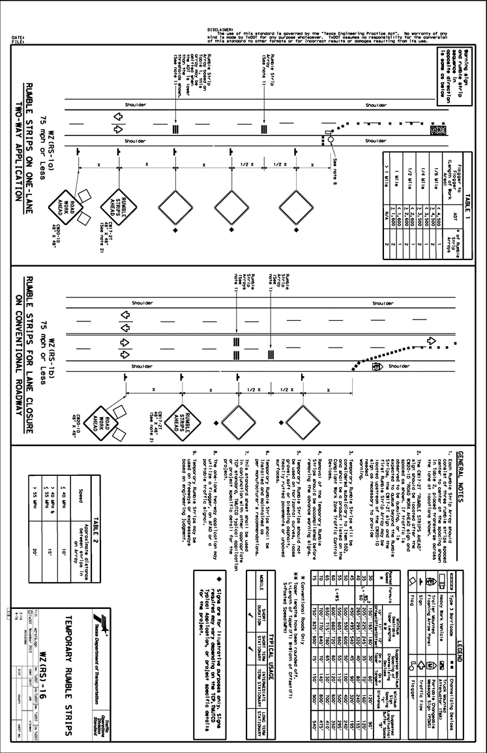
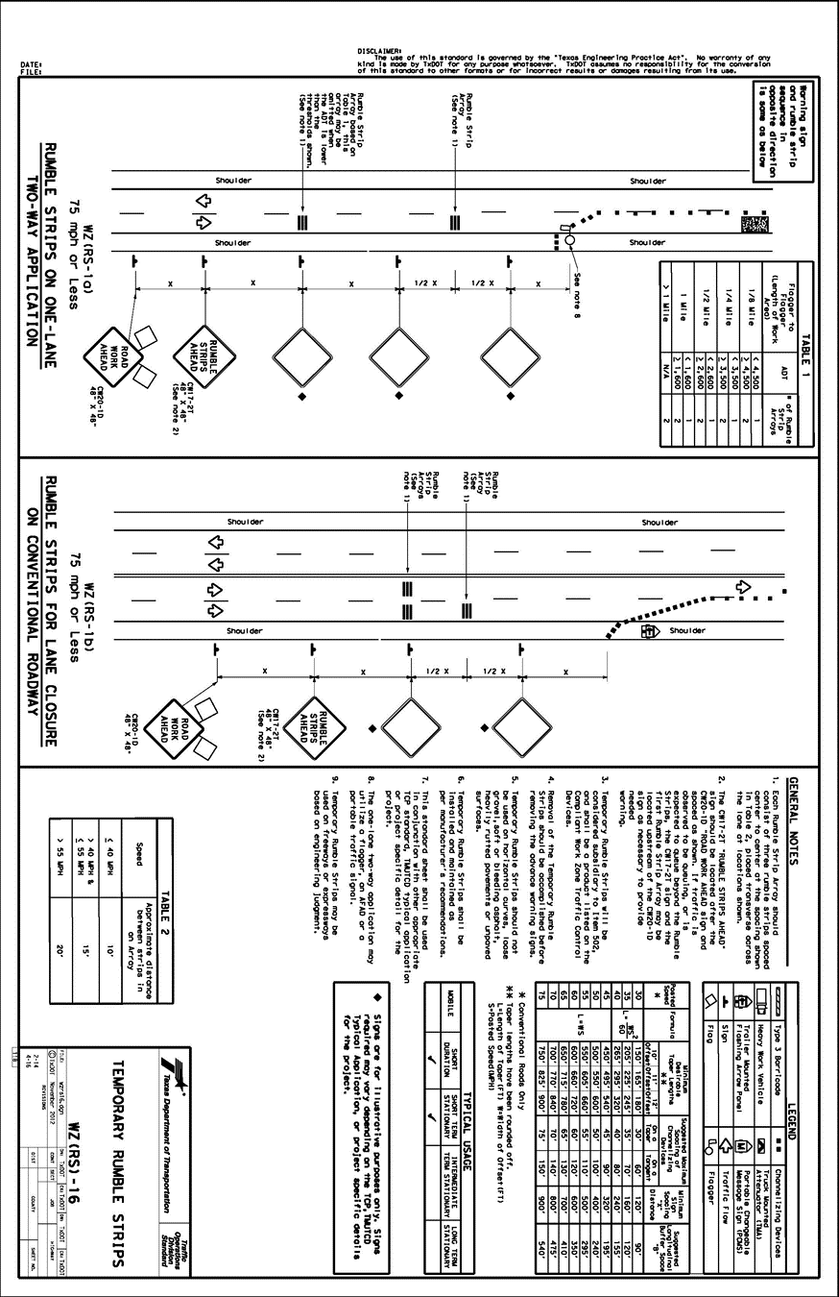

A.13 Vermont
The Vermont Agency of Transportation uses the Work Zone Safety & Mobility Guidance Document (VTRANS 2007). The purpose of the Work Zone Safety and Mobility Guidance document is to allow VTrans to better anticipate the impacts associated with individual projects. The document does not list specific traffic control devices.

A.14 Virginia
The Virginia DOT uses the VDOT Work Area Protection Manual (VDOT 2011). The manual is consistent with the MUTCD but includes supplemental info on certain devices and procedures. Includes guidance on when to use positive protection, police enforcement in work zones, and portable changeable message signs.

A.15 Washington
The Washington State Department of Transportation uses Work Zone Safety and Mobility (WSDOT n.d.). The document describes use of temporary traffic control, transportation operations, and public information. Traffic control devices include the following (no specific guidance was provided):
• Temporary signing,
• Changeable message signs,
• Arrow boards,
• Temporary signals,
• Temporary pavement markings.
• Speed limit reductions,
• Automated flagger assistance devices.
• Channelizing Signs
• Warning Lights
• Arrow Boards
• PCMS
• Portable temporary traffic control signals
• Positive protective devices
• Temporary barriers
o Temporary concrete barriers
o Movable barriers
o Portable steel barriers
• Impact attenuators
• Transportable attenuators
• Pavement delineation
• Screening
• Illumination
• Signals

A.16 Wisconsin
The Wisconsin DOT uses the Facilities Development Manual (WISDOT 2019) and Temporary Traffic Control (WISDOT n.d.) Relevant traffic control devices mentioned include the following (no specific guidance was provided):
• Signing
• Pavement markings
• Channelizing devices
o Drums
o Flexible tubular markers
o Barricades
o Traffic control cones
o Concrete barrier
• Vertical panels
• Light on devices
• Temporary lane separators
• Temporary portable rumble strips
• Pavement drop-off protection

