STATEWIDE AND UPPER MIDWEST SUMMARY OF DEER-VEHICLE CRASH AND RELATED DATA FROM 1993 TO 2003

Final Report

Principal Investigator
Keith K. Knapp, P.E., Ph.D.
Engineering Professional Development Department
Department of Civil and Environmental Engineering
University of Wisconsin-Madison
Director – Deer-Vehicle Crash Information Clearinghouse
Midwest Regional University Transportation Center

Graduate Research Assistants

Cara Kienert

Adrian Witte

Midwest Regional University Transportation Center

Submitted to the Wisconsin Department of Transportation

Completed as part of the Deer-Vehicle Crash Information Clearinghouse Initiation
Project for the Wisconsin Department of Transportation
SPR Project Number 0092-01-11
Report Number DVCIC - 03

Midwest Regional University Transportation Center
Deer-Vehicle Crash Information Clearinghouse
University of Wisconsin-Madison
1415 Engineering Drive
Madison, WI 53706-1791
Telephone: 608-263-2655
Fax: 608-263-2512
http://www.mrutc.org
http://www.deercrash.com

December 2005
ACKNOWLEDGEMENT
The Statewide and Upper Midwest Summary of Deer-Vehicle Crash and Related Data from 1993 to 2003 was prepared as part of the Deer-Vehicle Crash Information Clearinghouse (DVCIC) Initiation Project. The authors would like to thank the Wisconsin Department of Transportation and the Midwest Regional University Transportation Center for their continued support of this project.
The authors would also like to thank the DVCIC technical advisory committee and board, and the following organizations for providing the data for this report and/or its preparation:
- Illinois Department of Natural Resources
- Illinois Department of Transportation
- Iowa Department of Natural Resources
- Iowa Department of Transportation
- Michigan Department of Natural Resources
- Michigan Department of Transportation
- Minnesota Department of Natural Resources
- Minnesota Department of Transportation
- Wisconsin Department of Natural Resources
- Wisconsin Department of Transportation

DISCLAIMER

This research was funded by the Wisconsin Council on Research of the Wisconsin Department of Transportation and the Federal Highway Administration under SPR Project 0092-01-11. The contents of this report reflect the views of the authors who are responsible for the facts and the accuracy of the data presented herein. The contents do not necessarily reflect the official views of the Wisconsin Department of Transportation or the Federal Highway Administration at the time of publication.

This document is disseminated under the sponsorship of the Department of Transportation in the interest of information exchange. The United States Government assumes no liability for its contents or use thereof. This report does not constitute a standard, specification, or regulation.

The United States Government does not endorse products or manufacturers. Trade and manufacturers’ names appear in this report only because they are considered essential to the object of the document.

Technical Report Documentation Page
- Report No.  DVCIC – 03 |  | - Government Accession No |  | - Recipient’s Catalog No
- Title and Subtitle  Statewide and Upper Midwest Summary of Deer-Vehicle Crash and Related Data from 1993 to 2003 |  |  |  | 5. Report Date  December 2005  6. Performing Organization Code
- Authors  Keith K. Knapp, Cara Kienert, and Adrian Witte |  |  |  | - Performing Organization Report No.  DVCIC – 03
- Performing Organization Name and Address  Midwest Regional University Transportation Center  Deer-Vehicle Crash Information Clearinghouse  University of Wisconsin-Madison  1415 Engineering Drive  Madison, WI 53706-1791 |  |  |  | - Work Unit No. (TRAIS)  - Contract or Grant No.  SPR 0092-01-11
12. Sponsoring Agency Name and Address  Wisconsin Department of Transportation  Hill Farms State Transportation Building  4802 Sheboygan Avenue  Madison, WI 53707-7910 |  |  |  | - Type of Report and Period Covered  Final  April 2004-October 2005  14. Sponsoring Agency Code
- Supplementary Notes
Research performed in cooperation with the Wisconsin Department of Transportation and the U.S. Department of Transportation, Federal Highway Administration.
Research Study Title: Deer-Vehicle Crash Information Clearinghouse Initiation Project
- Abstract
This document contains a summary and discussion of deer-vehicle crash (DVC) and DVC-related data from five states in the Upper Midwest of the United States. These data were obtained from Departments of Transportation, Public Safety and/or Natural Resources in Illinois, Iowa, Michigan, Minnesota, and Wisconsin. More specifically, annual police-reported total crashes and DVCs (or animal-vehicle crashes (AVCs) in Iowa), annual vehicle-miles-traveled, DVC or AVC fatalities and injuries, deer population estimates, and carcass removal data were primarily provided by these agencies for the time period from 1993 to 2003. Some of these data are plotted and described directly in this report and others have been used to calculate the percentage of total crashes represented by DVCs/AVCs and a DVC/AVC crash rate. The trends observed in these safety measures from 1993 to 2003 for each of the five states and the overall region are presented. The limitations and defining criteria for each dataset are also noted, as appropriate, in the figures and text. This information is needed when interpreting the statewide and regional trend discussion, conclusions, and recommendations contained in this report. This type of 11-year data trend summary is not completed by most states, and a detailed regional summary of this type of data has never been attempted in the past. The data show that total reported crashes in the region were relatively stable between 1993 and 2003, but that the annual vehicle-miles-traveled steadily increased. The annual number of DVCs/AVCs in the region has also increased as have their proportion of total crashes. These trends have resulted in a regional DVC/AVC rate that has been relatively stable between 1993 and 2003. Overall, the regional number of annual DVC/AVC fatalities and injuries has ranged from 12 to 45 and 3,888 to 5,324. The regional deer population estimates show a cyclical pattern of increases and decreases several years long. Regionally, the percentage of total crashes represented by DVCs/AVCs (when data from all five states were available) ranged from 9.2 to 10.9 percent. However, on average, approximately twice as many deer carcasses are removed from the roadside as DVCs/AVCs reported.
- Key Words  Deer-Vehicle Crash, Data Collection, Crash Summary, Safety Trend Analysis |  |  | - Distribution Statement  No restriction. This document is available to the public through the National Technical Information Service  5285 Port Royal Road  Springfield, VA 22161
- Security Classif. (of this report)  Unclassified | - Security Classif. (of this page)  Unclassified |  |  |  | - No. of Pages  101 | - Price
Form DOT F 1700.7 (8-72) Reproduction of completed page authorized

TABLE OF CONTENTS

EXECUTIVE SUMMARY vi

INTRODUCTION 1
REPORT CONTENT 1
GENERAL DATABASE DESCRIPTION 2
DEFINING DATA CRITERIA 4

STATEWIDE DATA SUMMARIES 6
ILLINOIS DATA EVALUATION 6
Total Crashes and Annual Vehicle-Miles-Traveled 7
Total and Percent Deer-Vehicle Crashes 8
Deer-Vehicle Crash Injuries and Fatalities 11
Deer-Vehicle Crash Rate 12
Deer Population Estimates and Roadside Carcass Removal Data 14
Illinois Summary 14
IOWA DATA EVALUATION 15
Total Crashes and Annual Vehicle-Miles-Traveled 15
Total and Percent Animal-Vehicle Crashes 17
Animal-Vehicle Crash Injuries and Fatalities 19
Animal-Vehicle Crash Rate 20
Deer Population Estimates and Roadside Carcass Removal Data 21
Iowa Summary 24
MICHIGAN DATA EVALUATION 25
Total Crashes and Annual Vehicle-Miles-Traveled 26
Total and Percent Deer-Vehicle Crashes 27
Deer-Vehicle Crash Injuries and Fatalities 29
Deer-Vehicle Crash Rate 30
Deer Population Estimates and Roadside Carcass Removal Data 32
Michigan Summary 33
MINNESOTA DATA EVALUATION 34
Total Crashes and Annual Vehicle-Miles-Traveled 35
Total and Percent Deer-Vehicle Crashes 37
Deer-Vehicle Crash Injuries and Fatalities 38
Deer-Vehicle Crash Rate 39
Deer Population Estimates and Roadside Carcass Removal Data 41
Minnesota Summary 43

WISCONSIN DATA EVALUATION 45
Total Crashes and Annual Vehicle-Miles-Traveled 45
Total and Percent Deer-Vehicle Crashes 46
Deer-Vehicle Crash Injuries and Fatalities 48
Deer-Vehicle Crash Rate 49
Deer Population Estimates and Roadside Carcass Removal Data 51
Wisconsin Summary 53

REGIONAL AND NATIONAL DEER-VEHICLE CRASH SUMMARIES 55
REGIONAL DATA EVALUATION 55
Total Crashes and Annual Vehicle-Miles-Traveled 55
Total and Percent Deer-Vehicle Crashes 57
Deer-Vehicle Crash Injuries and Fatalities 60
Deer-Vehicle Crash Rate 61
Deer Population Estimates and Roadside Carcass Removal Data 63
Regional Summary 66
NATIONAL DATA ESTIMATES 68
Total Deer-Vehicle Crashes 68
Fatal and Non-Fatal Animal-Vehicle Crashes 70

CONCLUSIONS AND RECOMMENDATIONS 72
CONCLUSIONS 72
RECOMMENDATIONS 75

REFERENCES 78

APPENDIX A-1: Illinois Deer-Vehicle Crash and Related Data (1993 to 2003) 80
APPENDIX A-2: Iowa Animal-Vehicle Crash and Related Data (1993 to 2003) 82
APPENDIX A-3: Michigan Deer-Vehicle Crash and Related Data (1993 to 2003) 84
APPENDIX A-4: Minnesota Deer-Vehicle Crash and Related Data (1993 to 2003) 86
APPENDIX A-5: Wisconsin Deer-Vehicle Crash and Related Data (1993 to 2003) 88
APPENDIX A-6: Regional Deer- or Animal-Vehicle Crash and Related
Data (1993 to 2003) Illinois, Iowa, Michigan, Minnesota, and
Wisconsin 90
EXECUTIVE SUMMARY

This document contains a detailed summary and description of the deer-vehicle crash (DVC) problem between 1993 and 2003 in the states of Illinois, Iowa, Michigan, Minnesota, and Wisconsin. Several different types of DVC-related data were obtained from the Department of Transportation, Department of Public Safety and/or the Department of Natural Resources in each of these states. More specifically, the University of Wisconsin Deer-Vehicle Crash Information Clearinghouse (DVCIC) were provided the annual total number of police reported crashes, vehicle-miles-traveled, reported DVCs or animal-vehicle crashes (AVCs) (from Iowa), and DVC/AVC injuries and fatalities. Annual deer population estimates were also obtained from four states and deer carcass removal numbers from three. All of these DVC- or AVC-related data were also combined, where appropriate, to summarize and describe this problem for the Upper Midwest region of the United States. Overall, this document describes the DVC/AVC problem in more detail than generally accomplished by individual states within the United States. A regional summary of this issue has not been attempted in the past.

The proper evaluation and combination of DVC- or AVC-related data requires a complete understanding of the defining criteria for the data used. These criteria can change from year to year and be different from state to state. The criteria are noted, as appropriate, in the figures, tables, and text of this document. The criteria of primary interest include the minimum property damage reporting thresholds year to year in each state, the type of data collected (DVCs or AVCs), how much of the state is summarized within the data (e.g., does it include large cities), and what time period do the deer population estimates represent (pre-hunt or post-hunt). In some cases the data for a particular year in a particular state were also questionable and not used. These reductions in data are noted where appropriate. The general trends in the DVC/AVC data collected from each state and in the region are described in this executive summary. Specific DVC or AVC details about each state and the region can be found in their individual data descriptions, figures, and summaries provided throughout the body of this document. The data used to produce the figures in this report are included in Appendices A-1 to A-6.
Overall, the total number of crashes reported in the Upper Midwest region from 1993 to 2003 has remained relatively stable. Several of the states in the region have experienced a stable or increased level of reported crashes and Iowa’s total has generally decreased. The AVMT has increased steadily in all five states and regionally from 1993 to 2003.

The annual number of reported crashes in the Upper Midwest region has been relatively stable, but the annual number of reported DVCS or AVCs (in Iowa) increased by approximately 21 percent between 1993 and 2003. The regional growth in reported DVCs/AVCs was relatively quick from 1993 to 1995 and then at a slower rate from 1995 to 2003. The reported DVC/AVC trends in each state, however, were somewhat different than that shown by a combination of the data for the region. For example, the number of reported DVCs/AVCs in Illinois has increased overall and this occurred from 1993 to 1996 in Iowa and Michigan. However, the data from Minnesota shows a decrease in reported DVCs from 1993 to 1997 and then an increase. The number of reported DVCs in Wisconsin, on the other hand, has been relatively stable. In several states there have generally been some time periods in which reported DVCs/AVCs have decreased or been relatively stabile.

The percentage of reported crashes represented by DVCs or AVCs has generally increased or remained stable in each of the five Upper Midwest states considered. In Illinois, Iowa, and Michigan this percentage has increased, but it has been relatively stable in Wisconsin. In Minnesota the percentage of all crashes represented by DVCs decreased from 1993 to 1996 and then increased. Regionally, the DVC/AVC percentage increased from 9.2 to 10.9 percent between 1993 and 2002 (the last year when data from all five states were available). This change represents an increase of approximately 18.5 percent in 10 years.

The annual number of DVC/AVC injuries and fatalities reported in the Upper Midwest region has varied from state to state. In Iowa and Michigan an increase was observed from 1993 to 1997/1998 and then a decrease. In Minnesota the number of DVC/AVC injuries and fatalities has increased from 1993 to 2002. Illinois and Wisconsin have experienced increases from 2000 to 2003 and 1993 to 1994, respectively, but otherwise have reported annually variable or stable data. Overall, the annual number of DVC/AVC fatalities in the regional ranged from 12 to 45 (not including those data excluded and noted in the appropriate figures), and annual DVC/AVC injuries ranged from 3,888 to 5,324.

An annual DVC or AVC rate per HMVMT was calculated for each state and the region from 1993 to 2003. Not surprisingly, statewide DVC/AVC rates generally follow the same pattern as the total number of reported DVCs/AVCs in the state. The DVC rate in Illinois increased from 1993 to 2003, and this also occurred from 1993 to 1996 in Iowa and Michigan. The DVC rate in Minnesota decreased from 1993 to 1997 and was then relatively stable. The rate in Wisconsin remained relatively stable from 1993 to 2003. Regionally, the DVC/AVC crash rate has also remained relatively stable, despite the consistent annual increase in regional AVMT. The stability of this measure (despite the AVMT increase) results from a general increase in reported DVCs/AVCs.

Four states (Iowa, Michigan, Minnesota, and Wisconsin) in the region provided annual deer population estimates, but only three states (Iowa, Minnesota, and Wisconsin) provided data they had collected on their annual carcass removal activities. The annual deer population estimates in three states increased from 1993 to 2003, but the estimates completed in Michigan increased from 1993 to 1995 and then decreased. Regionally, the annual deer population estimates have been relatively cyclical. An increase in this regional measure is shown from 1993 to 1995, a decrease from 1995 to 1997, and then an increase until about 2000 before an apparent decrease. The annual number of carcasses removed from three of the states, on the other hand, has increased from 1993 to 1996 but remained relatively stable from that point. This pattern could be the result of many factors, including program funding and how the carcass removal data was collected and recorded. Each year there are always more carcasses removed (salvageable and unsalvageable) than DVCs/AVCs officially reported. The annual ratio of carcasses to reported DVCs/AVCs ranged from about 1.4 to 1.6 in Iowa, 1.7 to 2.6 in Minnesota, and 1.6 to 2.3 in Wisconsin. The average ratio regionally was about 2.0.

There have been several attempts at a national quantification of the DVC or AVC problem. It has been estimated, for example, that over one million DVCs occur each year in the United States and these collisions cost the traveling public more than a billion dollars (1). The basis of this estimate appears to be a survey in which the responses were based on police-reported DVC data, roadside carcass data, or some combination of the two. These two datasets can have different defining criteria and their combination to estimate the problem in the United States may not be appropriate. It has also been estimated that the percentage of total crashes represented by AVCs increased from 4.7 percent in 1985 to 8.2 percent in 1991 (8). Between 1994 and 2004 the number of annual AVC fatalities in the United States also increased from 131 (in 1994) to 204 (in 2004), representing a 56 percent increase (11). Finally, the United States Centers for Disease Control and Prevention (CDC) estimated that in 2001 and 2002 AVCs resulted in 26,647 people being non-fatally injured and visiting the hospital.

The recommendations included in the last section of this document focus on improvements in the collection and combination of DVC or AVC data. It is recommended, for example, that the defining criteria and type of DVC/AVC-related data be documented for the entire United States. The time period evaluated should also be expanded to include annual data from pre-1993 and post-2003. It is also recommended that the bureaus or agencies that are collecting DVC/AVC-related data in each state be identified and that one person be assigned the task of obtaining and/or summarizing these data each year. A multi-disciplinary and public-private agency committee or coalition could also be created to consistently educate the driving public about this subject. Finally, it is also recommended that the value, collection, and use of carcass removal data and the police-report details of DVCs/AVCs be investigated further. Among other things, more specific information about carcass removal activities could change how the magnitude of the DVC/AVC problem is defined and where DVC/AVC countermeasures are considered. In addition, a closer examination of DVC/AVC reports may better explain the trends seen in this report. This report concludes with a recommendation that the type and origin of the DVC/AVC-related data used in papers and articles on this subject generally need to be more properly defined in the future. Confusion on this point, in some cases, has limited the value of DVC/AVC-related documents in the past.

INTRODUCTION
Vehicle collisions with white-tailed deer and other large animals are a transportation safety concern throughout most of the United States. Overall, it has been estimated that more than one million deer-vehicle crashes (DVCs) occur each year in the United States and that these collisions cost the traveling public more than one billion dollars (1). However, this type of national DVC estimate can only be a gross approximation because the data collected from state to state vary and are inconsistently defined.

The status of national DVC estimates is discussed further at the end of this report, but the overall focus of this report is the Upper Midwest. A detailed and well-defined summary, trend analysis, and evaluation of DVC-related data from five individual states is completed, and then the data are combined for the first regional DVC analysis of its kind to be completed in the United States. A proper understanding and documentation of the DVC-related data collected by each state and the defining criteria of that data are a necessary prerequisite for valid multi-state summary and trend analysis. The information supplied in this report can be used for educational and funding purposes, to guide future activities in the DVC-related data collection area, and to better understand how the significance of the DVC problem has changed from 1993 to 2003 in the Upper Midwest. It is also hoped that this report may serve as an example for any national estimates of DVC-related data that may be completed in the future.

REPORT CONTENT
This report contains an 11-year summary of the DVC-related data collected by five states in the Upper Midwest area of the United States. It also includes the defining criteria of that data for a proper interpretation of the results documented. The publication of this summary further advances a goal of the University of Wisconsin Deer-Vehicle Crash Information Clearinghouse (DVCIC) to more clearly and properly define the DVC problem in the Upper Midwest region of the United States (i.e., Illinois, Iowa, Michigan, Minnesota, and Wisconsin). Unfortunately, the variability of the DVC-related data collected in this region is similar to that found nationally. If not documented appropriately, this variability can negatively impact the calculation and interpretation of regional and statewide DVC estimates, and the comparison or trend analysis of DVCs from year to year within a particular state. Fortunately, through a previous survey, the DVCIC has already documented the defining criteria of the DVC-related data collected in this region of the United States, and that knowledge is used in this report. The results of that previous survey are summarized in the Regional Survey of Deer Population, Vehicle Travel, and Deer-Vehicle Crash Information Collection and Management report (2).

Eleven years of DVC-related data have been collected from Illinois, Iowa, Michigan, Minnesota, and Wisconsin. These statewide data are described and summarized in this document. A combination of these data, to represent the regional DVC concern, is also included. As appropriate, the criteria that define the data collected in each state is provided. All the data collected, in combination with its defining criteria, are necessary to properly summarize and interpret the DVC problem in each state and the Upper Midwest from 1993 to 2003. A detailed discussion of the national DVC estimates has also been included in this report along with a summary of the research studies that focus on DVCs or animal-vehicle crashes (AVCs) resulting in injuries or fatalities. Finally, a series of conclusions that focus on the statewide and regional DVC-related data trends is provided, and recommendations are made for future DVC-related data collection and summaries. The data summarized for each state and the region are included in Appendices A-1 to A-6.

GENERAL DATABASE DESCRIPTION

DVC-related data from Illinois, Iowa, Michigan, Minnesota, and Wisconsin were collected from their Departments of Transportation, Natural Resources, and/or Public Safety. In most of these states multiple departments, agencies, or bureaus collect or estimate data related to the analysis of DVCs. The annual data collected from each state for 1993 to 2003, and the combined regional data, are included in Appendices A-1 to
A-6. If available and provided, the data collected from each state includes the:

- Total number of police-reported crashes,
- Total annual vehicle-miles-of-travel (AVMT),
- Number of police-reported DVCs or AVCs,
- Number of injuries and fatalities resulting from DVCs or AVCs,
- Post- or pre-hunt deer population estimates, and
- Number of roadside deer carcasses removed.

The motor vehicle crash data collected from each of the states are an annual sum of the collisions reported to the police (or those that were entered into the official statewide crash database in some other manner). In all five of the states considered in this report, crashes that result in one or more fatalities and/or injuries must be reported to the police. In addition, a crash report must be completed if a minimum property damage threshold is exceeded. These thresholds, and when they change, are defined in this report. It should be recognized, however, that there is a large amount of underreporting related to DVCs or AVCs (e.g., sometimes two to three times as many carcasses are collected than crashes reported). This type of underreporting is confirmed for a few of the states in this report by comparing their roadside carcass removals and police-reported DVCs or AVCs. Unfortunately, statewide carcass removal numbers are not normally collected and rarely summarized in the United States.

Some of the data collected from Illinois, Iowa, Michigan, Minnesota, and Wisconsin (e.g., the number of reported DVCs/AVCs and AVMT) are used directly in this report. However, the crash and AVMT data collected from each state are also used to calculate the percentage of total annual crashes represented by reported DVCs or AVCs, and to determine an overall DVC or AVC rate per total 100 million vehicle-miles-traveled (HMVMT). If available and provided, the estimated statewide deer population and the number of roadside deer carcasses removed in a state are also summarized. Overall, no annual deer population estimates were provided by Illinois, and neither Michigan nor Illinois summarize their carcass removals. Minnesota, Iowa, and Wisconsin provided the information they had available about at least some of the roadside carcasses removed in their state.

DEFINING DATA CRITERIA
There are several criteria that define the statewide and regional DVC-related data collected and summarized in this report. All of these criteria also impact how the results in this report can be interpreted, and they are noted in the text where appropriate. One important factor that should be considered when evaluating the data in this report is the minimum amount of property damage a vehicle needs to incur in a state to require the crash to be reported. This minimum amount is typically called the “property damage crash reporting threshold” and it changes from time to time in individual states and can be different from state to state. For example, during the 11-year time period considered in this report, Michigan had the lowest property damage threshold of $400. This threshold, however, changed to $1,000 at the start 2004. A change in the property damage crash reporting threshold could impact the number of reported crashes within a state. Therefore, these thresholds need to be considered when comparing data from year to year in a state, from different states during a specific year, or when combining crash data from multiple states.

A second factor that needs to be considered when interpreting DVC-related data is whether the information summarized is for the entire state or not. For example, sometimes data summarized by a state Department of Transportation (DOT) might be just for those roadways maintained by the state DOT, and in other cases the data reported might be for the entire state. If necessary and known, this type of defining criteria is provided in this report.

Finally, there is a third factor that also impacts the interpretation of the DVC-related data provided by a state. Some state crash reports differentiate between DVCs and other AVCs. Other reports do not allow this differentiation. The state of Iowa, for example, collects and summarizes AVCs. In other words, the data from Iowa includes crashes with any type of animal (wild or domestic), but it is also known that a large percentage of these AVCs are with deer. For the five states summarized in this report, all of these factors are described in more detail within the Regional Survey of Deer Population, Vehicle Travel, and Deer-Vehicle Crash Information Collection and Management report published by the DVCIC (2).

STATEWIDE Data summarIES
The DVC situation in each state is described and the data collected from each state are summarized, plotted, and discussed in the following paragraphs. The data summarized for each state includes the total number of DVCs or AVCs, the number of injuries and fatalities due to DVCs or AVCs, an overall DVC or AVC rate, and the percentage of total crashes represented by DVCs or AVCs in a state. The DVC or AVC rate is reported as the annual number of crashes per 100 million VMT in that state that year. Deer population and/or roadside carcass removal data, if available and provided by a particular state, are also summarized.

ILLINOIS DATA EVALUATION
In Illinois, a crash is defined as an event that originates on a public roadway, involves a moving motor vehicle, and produces death, injury, or property damage in excess of $500 (See http://www.dot.state.il.us/travelstats/final2003crashfacts.pdf ). The minimum property damage crash reporting threshold in Illinois changed from $250 to $500 in January 1992 (previous to the 1993 to 2003 focus of this summary). The annual VMT in Illinois and the total number of crashes are from the crash facts book published by the Illinois Department of Transportation (IDOT) each year. The crash data collected from Illinois are summarized in the following pages, but the raw data are also included in Appendix A-1.

For a number of reasons, the crash data summarized by the IDOT from 1993 to 2003 changed twice. For the purposes of this report, the data provided by the IDOT has been divided into three distinct time periods:

- Data from 1993 to 1995 includes all the reported crashes in Illinois.
- Data from 1996 to 1999 includes reported crashes throughout Illinois except for non-fatal incidents within the City of Chicago. However, reported deer crashes were inconsistently collected during 1996, and when appropriate these data have also been excluded from further consideration.
- Data from 2000 to 2003 includes all the reported crashes in Illinois.
Overall, the data from the first time period (i.e., 1993 to 1995) is comparable to the data from the last time period (i.e., 2000 to 2003). Unfortunately, the 1996 reported deer crash data was removed from this summary because it was not consistently summarized throughout that year. The total crash data and annual VMT data from 1996, on the other hand, seem consistent with the data from adjacent years and are included in the following description.

Total Crashes and Annual Vehicle-Miles-Traveled
The total number of crashes reported in Illinois for the three time periods described are presented in Figure 1. Figure 1 shows a 10.3 percent increase in total crashes from 1993 to 1995, and a slight increase in total crashes from 1996 to 1999. The data from the latter time period does not include non-fatal crashes from the City of Chicago. These types of Chicago crashes represent about two-thirds of those that occur in Illinois. From 2000 to 2003, the total number of crashes reported in Illinois actually decreased by 5 percent. The average total number of reported crashes from 1993 to 1995 and 2000 to 2003 (when all reported crashes were summarized in Illinois) is approximately 445,000.

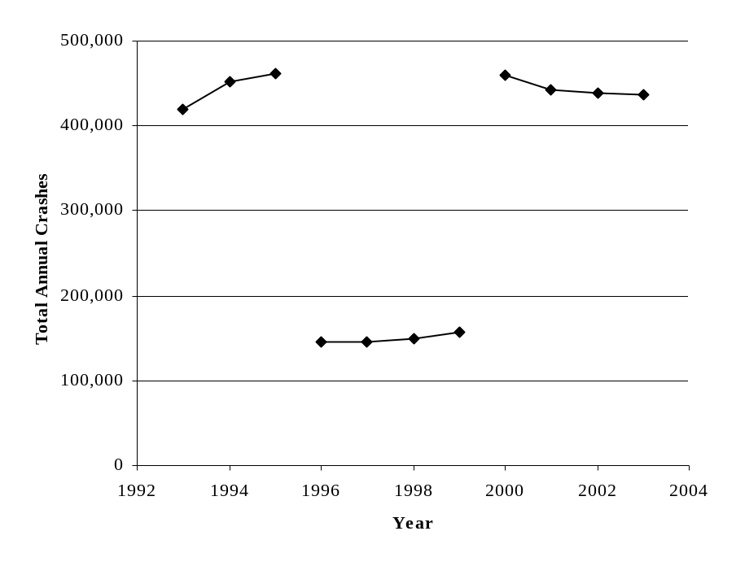
FIGURE 1 Total crashes reported in Illinois (1993 to 2003).
Note: Crash data from 1996 to 1999 does not include non-fatal crashes reported within the City of Chicago.

The total AVMT from 1993 to 2003 is shown in Figure 2. The Illinois AVMT has increased from 89,815 million miles in 1993 to 106,460 million miles in 2003. This difference represents an annual increase of approximately 1.85 percent. These AVMT data and the following reported DVC data were used to calculate the Illinois DVC rate from 1993 to 1995 and 2000 to 2003 (i.e., the time period when all reported crashes in Illinois were summarized).

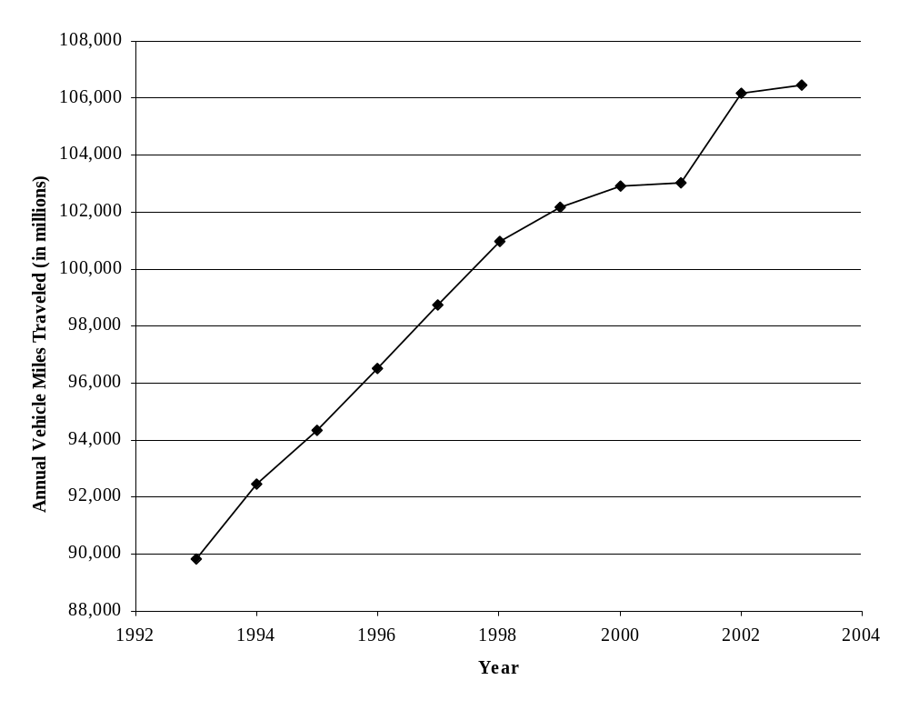
FIGURE 2 Annual-vehicle-miles-traveled in Illinois (1993 to 2003).

Total and Percent Deer-Vehicle Crashes
The DVCs reported and summarized in Illinois between 1993 and 2003 are shown in Figure 3. They are also segmented into the three time periods previously described, but the data from 1996 are excluded due to an inconsistency in the method used by Illinois for its summarization during that year. From 1993 to 1995 the total number of DVCs reported in Illinois increased from 16,504 to 17,573 (a 6.5 percent increase). The average annual number of reported DVCs in this time period was 17,065. From 1997 to 1999 non-fatal DVCs from the City of Chicago were not included in the summary, but the number DVCs reported in Illinois increased from 17,076 in 1997 to 20,468 in 1999 (a 19.9 percent increase). The average annual number of reported DVCs from 1997 to 1999 was 18,537.

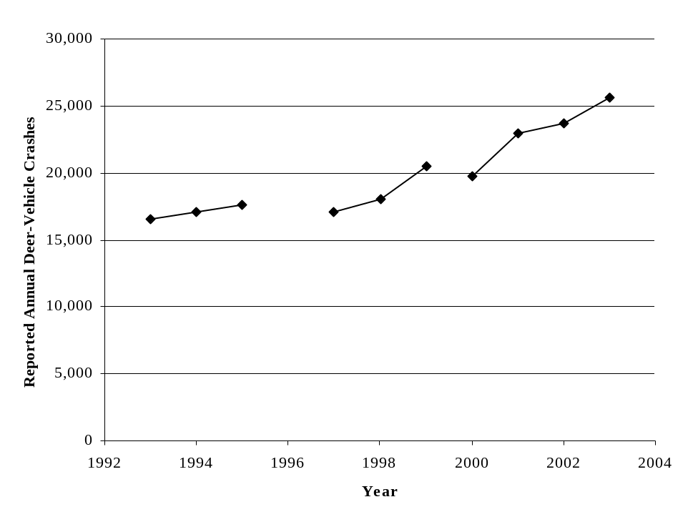
FIGURE 3 Reported deer-vehicle crashes in Illinois (1993 to 2003).
Note: Crash data from 1996 to 1999 does not include non-fatal crashes reported within the City of Chicago.
Data from 1996 also excluded due to inconsistent data summary during that year.

The data from 2000 to 2003, which again includes all the reported DVCs in Illinois (including the City of Chicago), show the number of reported DVCs increasing from 19,731 in 2000 to 25,660 in 2003 (a 30 percent increase). Recall that this is also the same time period during which the total number of reported crashes in Illinois decreased (See Figure 1). The percentage of total crashes represented by reported DVCs, therefore, increased during this time period (See Figure 4). Overall, there was a total increase in the number of DVCs reported in Illinois of approximately 55.5 percent during the decade considered.

The total crash and DVC data from Figures 1 and 3 were used to calculate the percentage of reported crashes represented by DVCs in Illinois (See Figure 4). These calculations were done for the three time periods previously described (excluding 1996 due to questions related to the DVC data). From 1993 to 1995 and 2000 to 2003 all the reported crashes in the state were summarized (See Figure 1). During the first time period (1993 to 1995) the percentage of total crashes represented by DVCs was relatively stable and ranged from 3.78 to 3.94. The average DVC percentage was 3.84 during this time period. From 2000 to 2003, however, DVCs increased from 4.29 to 5.87 percent of all the crashes in Illinois. The average DVC percentage during this time period was 5.18. From 1993 to 2003, the percentage of DVCs in Illinois has increased by approximately 49 percent.

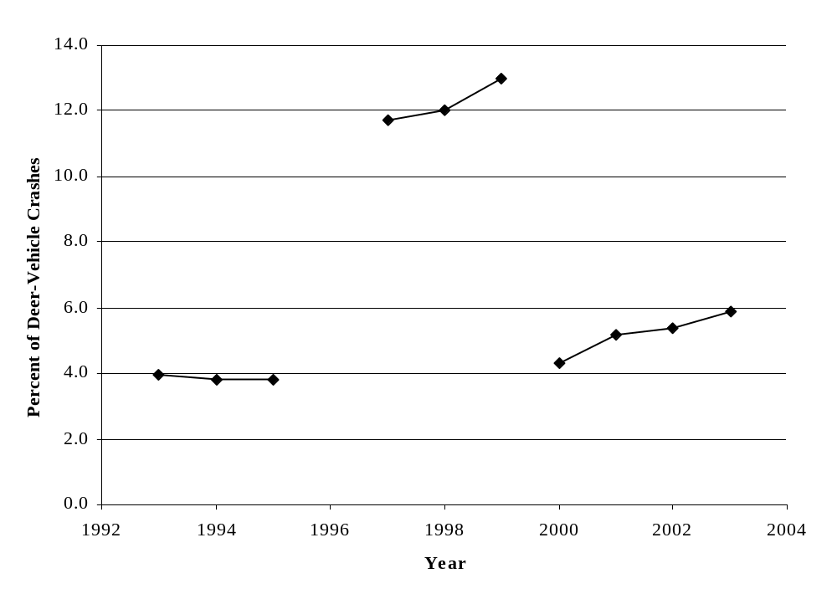
FIGURE 4 Percent deer-vehicle crashes in Illinois (1993 to 2003).
Note: Crash data used in calculations from 1996 to 1999 does not include non-fatal crashes reported within the City of Chicago.
Data from 1996 also excluded due to inconsistent data summary during that year.

From 1996 to 1999 the total crash and DVC data summarized for Illinois did not include non-fatal incidents from the City of Chicago (See Figures 1 and 3). The DVC percentages from 1997 to 1999 (excluding 1996 due to questions in the DVC data), therefore, approximate the percentage of DVCs in Illinois outside the City of Chicago. These percentages range from 11.72 to 12.98, and are about three times greater than what might have been expected during that time period if all the crashes in Chicago would have been summarized. These percentages are not comparable to those from the other two time periods. Not surprisingly, these numbers indicate that few DVCs occur within Chicago, but a large portion of all crashes do occur there.

Deer-Vehicle Crash Injuries and Fatalities
From 1993 to 2003 the number of injuries and fatalities that resulted from DVCs in Illinois each year generally followed the trends shown by the total number of DVCs (See Figure 3). From 1993 to 2003 a total of 36 fatalities were reported as a result of DVCs. This total represents about 3 fatalities per year during the 11 years considered (1993 to 2003, inclusive). The annual number of reported DVC fatalities ranged from one in 1995, 1996, and 1997 to six in 2003. A total of 6,398 injuries were also the result of DVCs from 1993 to 1995 and 2000 to 2003. In other words, there was an average of about 914 DVC injuries per year in Illinois during these seven years. The annual number of DVC injuries during these seven years ranged from 778 in 1994 to 1,245 in 2003. Recall that from 1996 to 1999 Illinois did not summarize property-damage or injury-causing DVCs in the City of Chicago. Overall, the total number of fatalities and injuries due to DVCs (See Figure 5) was 1,251 in 2003 with an increase of 27.9 percent between 2002 and 2003. The actual number of injuries and fatalities summarized in Illinois due to DVCs are shown in Appendix A-1.

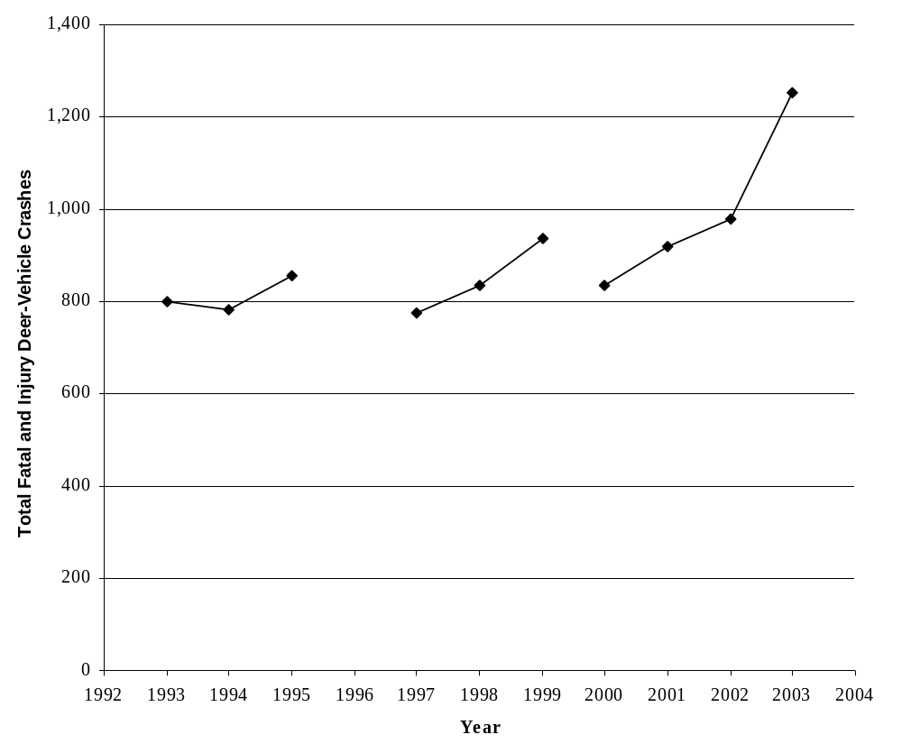
FIGURE 5 Number of deer-vehicle crash fatalities and injuries
in Illinois (1993 to 2003).
Note: Crash data from 1996 to 1999 does not include non-fatal crashes reported within the City of Chicago.
Data from 1996 also excluded due to inconsistent data summary during that year.

Deer-Vehicle Crash Rate
One of the factors related to the occurrence of DVCs is the amount of vehicle travel that occurs in a jurisdiction (e.g. AVMT). A common measure of roadway safety is a crash rate defined by the number of reported crashes per 100 million vehicle-miles-traveled (HMVMT). For this summary the DVC rate was calculated for each year and used statewide AVMT and DVCs previously described (See Figures 2, 3, and 6). It should be recognized that this calculation is a general statewide measure, and should be recalculated when the DVC safety of individual roadway segments (which could have a DVC rate that is very different) are investigated.

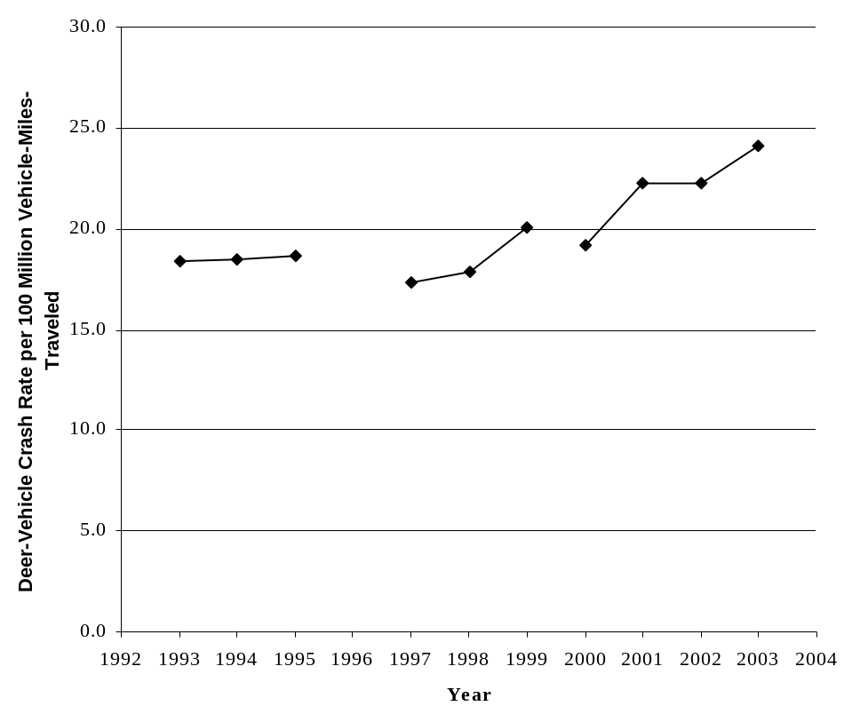
FIGURE 6 Deer-vehicle crash rate per 100 million vehicle-miles-traveled
in Illinois (1993 to 2003).
Note: Crash data used in calculations from 1996 to 1999 does not include non-fatal crashes reported within the City of Chicago.
Data from 1996 also excluded due to inconsistent data summary during that year.

Despite the increasing amount of AVMT in Illinois, Figure 6 also shows an increasing trend in DVC rate from 1993 to 2003. From 1993 to 1995 the DVC rate was relatively stable and only ranged from 18.4 DVCs per HMVMT to 18.6 DVCs per HMVMT. The DVC rate from 1997 to 1999 (which does not include non-fatal DVCs from the City of Chicago), on the other hand, increased (See Figure 6). The DVC rate in 1997 was 17.3 DVCs per HMVMT and it was 20.0 DVCs per HMVMT in 1999. Overall, this difference in DVC crash rate represents a 15.6 percent increase during these three years. The data from 1996 were excluded due to a question about the DVC data summarized during that year (See Figure 3). From 2000 to 2003, the DVC rate continued to increase and ranged from 19.2 DVCs per HMVMT in 2000 to 24.1 DVCs per HMVMT in 2003. This difference represents an increase of 25.5 percent. The average DVC rate from 2000 to 2003 was 22.0 DVCs per HMVMT.

Deer Population Estimates and Roadside Carcass Removal Data
Annual statewide deer population estimates were not provided by Illinois, although these estimates are completed each year. No evidence was found that carcass removals by location are summarized in Illinois.

Illinois Summary
The data provided by Illinois are included in Appendix A-1. Overall, from 2000 to 2003, DVCs represented approximately 5.2 percent of all the crashes reported and summarized in Illinois. The total number of DVCs has also increased during the last decade. An evaluation of the Illinois DVC-related data showed the following general patterns:

- The annual total number of crashes reported and summarized in Illinois has generally increased throughout the decade, but appears to have decreased somewhat from 2000 to 2003 (See Figure 1). The AVMT in Illinois has consistently increased during the study time period (See Figure 2).
- There was an increasing trend in the annual number of DVCs reported in Illinois for the years summarized (See Figure 3). The number of DVCs reported ranged from 16,504 to 25,660 during this time period (a 55.5 percent increase). The increase in reported DVCs from 2000 to 2003 was 30.0 percent. The percentage of total crashes represented by DVCs has also increased (See Figure 4). From 2000 to 2003 this measure increased from 4.29 to 5.87 percent.
- The annual number of fatalities due to DVCs ranged from 1 to 6 between 1993 and 2003. There were a total of 36 DVC fatalities during these 11 years. The number of injuries due to DVCs ranged from 778 to 1,245 for those years in which all non-fatal DVCs in Illinois were summarized (i.e., 1993 to 1995 and 2000 to 2003). The number of fatalities and injuries during the last decade appear to vary from year to year with an increase from 2000 to 2003 (See Figure 5).
- The DVC rate (i.e., the number of DVCs per HMVMT) has also increased from 1993 to 2003 despite the constant increase in AVMT. This measure has ranged from 18.4 DVCs per HMVMT in 1993 to 24.1 DVCs per HMVMT in 2003 (a total increase of about 31 percent).

Iowa DATA EVALUATION
In Iowa motorists must report any motor vehicle crash that involves one or more vehicles and results in death, injury or property damage of at least $1,000. However, this minimum reporting threshold changed from $500 to $1,000 in mid-1997. The total annual number of reported crashes from 1993 to 2003 were collected from the Iowa Department of Transportation (IaDOT) for this summary. In addition, the number of animal-vehicle crashes (AVCs) and AVMT in the state were obtained. Unlike the other four states summarized in this report, the Iowa crash report form does not distinguish between DVCs and AVCs. However, the majority of AVCs in Iowa are believed to be deer. Unfortunately, all the crash data from 2001 had to be excluded from further consideration due to the potential impacts of a safety management procedural change that occurred during that year. All of the data collected from Iowa are provided in Appendix A-2.

White-tailed deer population estimates and roadside carcass removal data from 1993 to 2003 were also collected from the Iowa Department of Natural Resources (IaDNR). Raw deer population and roadside carcass removal data are provided in Appendix A-2. The annual carcass data is the sum of salvaged and unsalvaged kill. Salvaged kill are those roadside carcasses requested by the public through the Iowa “salvage tag” program. These tags are required by Iowa law to possess a deer, and their numbers are recorded by IaDNR conservation officers. Unsalvaged kill, on the other hand, are reported by IaDNR employees and represent deer carcasses removed from the roadway for maintenance purposes.

Total Crashes and Annual Vehicle-Miles-Traveled
The annual total number of crashes reported in Iowa are presented in Figure 7. Overall, the annual total number of crashes has generally decreased from a maximum of 78,360 in 1996 to a minimum of 59,190 in 2003. From 1993 to 1996 the annual total number of crashes reported in Iowa did increase by 6.5 percent, but between 1996 and 2003 this measure decreased by 24.5 percent. A large decrease in the annual number of reported crashes was experienced between 1996 and 1998. Overall, the average number of

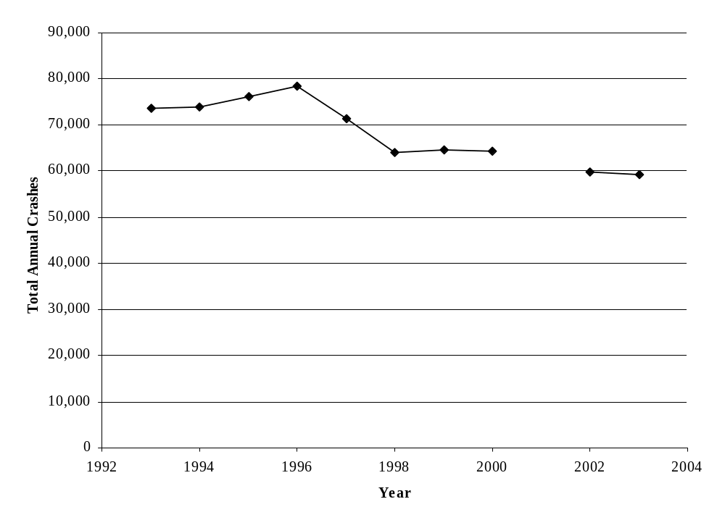
FIGURE 7 Total crashes reported in Iowa (1993 to 2003).
Note: Crash data from 2001 excluded due to a change in safety data management procedures during that year.

Minimum property damage reporting threshold changed from $500 to $1,000 in mid-1997.

crashes reported in Iowa from 1993 to 1995 was 74,617, but the average from 1998 to
2003 was 62,361. As previously noted, however, the data from 2001 was removed from consideration due to the potential impacts from a change in safety data management procedures during that year.

The total AVMT from 1993 to 2003 in Iowa is shown in Figure 8. The number of AVMT in Iowa has increased from 25,396 million miles in 1993 to 31,400 million miles in 2003. This increase has been relatively consistent at 2.4 percent per year (See Figure 8). The average Iowa AVMT from 1993 to 2003 was 28,696 million miles.

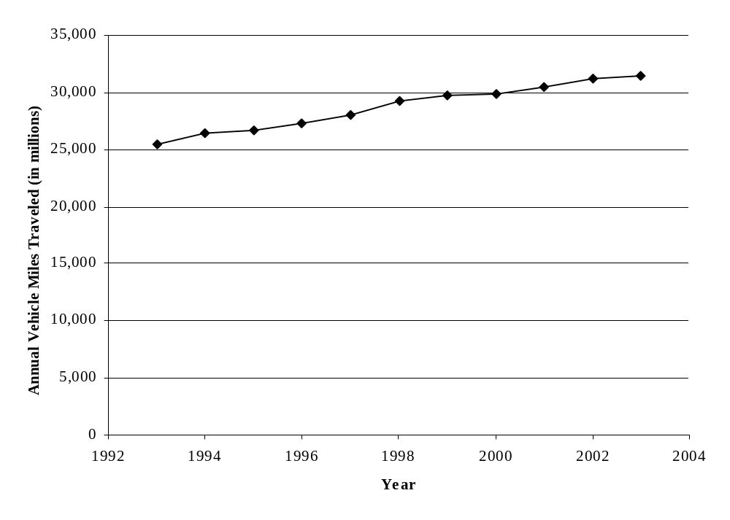
FIGURE 8 Annual vehicle-miles-traveled in Iowa (1993 to 2003).

Total and Percent Animal-Vehicle Crashes
The AVCs reported and summarized in Iowa between 1993 and 2003 are shown in Figure 9. From 1993 to 1996 the number of AVCs reported increased from 7,012 crashes to 8,614 (an increase of 22.8 percent). Between 1996 and 2000, there was a general decrease in the number of reported AVCs in Iowa with a minimum of 7,556 occurring in 2000. The number of reported AVCs increased to 8,641 in 2002 and 8,396 in 2003. The annual number of reported AVCs from 1993 to 2003 are shown in Appendix A-2. However, the data from 2001 are again excluded due to a change in safety data management procedures that occurred during that year. The percentage of total crashes that are AVCs each year in Iowa, however, has increased from 1993 to 2003 and is discussed next.

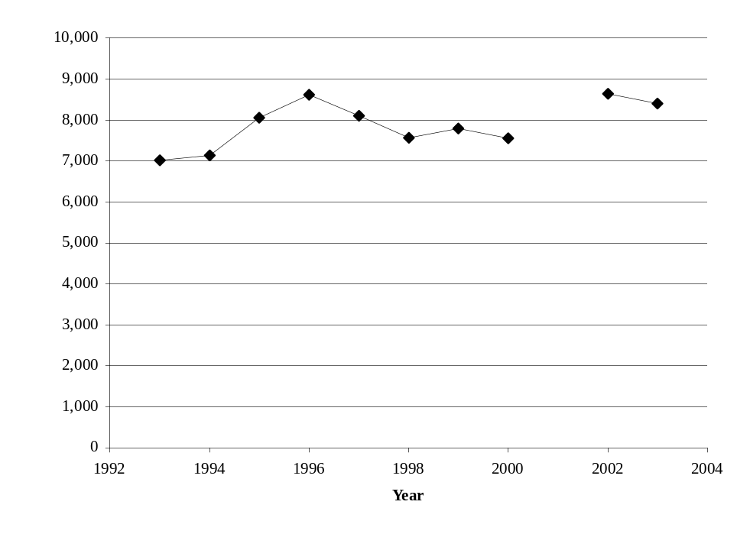
FIGURE 9 Reported animal-vehicle crashes in Iowa (1993 to 2003).
Note: Crash data from 2001 excluded due to a change in safety data management procedures during that year.

Minimum property damage reporting threshold changed from $500 to $1,000 in mid-1997.

The total crash and AVC data from Figures 7 and 9 were used to calculate the percentage of reported crashes represented by AVCs in Iowa (See Figure 10). These calculations were conducted for each year from 1993 to 2003 (excluding 2001 because of questions related to the data). Overall, the percentage of total crashes represented by AVCs has increased in Iowa from 1993 to 2003. The minimum AVC percentage during this time period was 9.5 percent in 1993 and the maximum was 14.5 percent in 2002. This difference represents an increase of 52.6 percent in nine years. The overall average AVC percentage from 1993 to 2003 (excluding 2001) was 11.6 percent and the general increase in annual AVC percentage during this time period was about 49.5 percent.

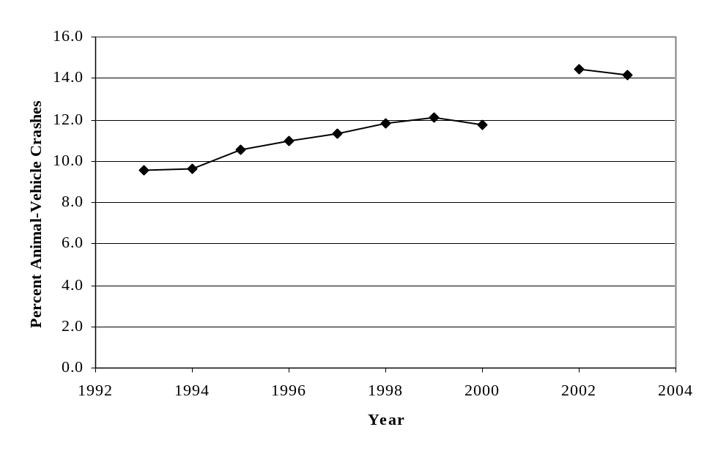
FIGURE 10 Percent animal-vehicle crashes in Iowa (1993 to 2003).
Note: Crash data from 2001 excluded due to a change in safety data management procedures during that year.

Minimum property damage reporting threshold changed from $500 to $1,000 in mid-1997.

Animal-Vehicle Crash Injuries and Fatalities
From 1993 to 2003 the trends in the number of AVC injuries and fatalities in Iowa were similar to those experienced by the total crashes and AVCs in the state (See Figures 7 and 9). The combined total of AVC injuries and fatalities increased from 461 in 1993 to 888 in 1997 (See Figure 11), representing a 93 percent increase. Figure 11 also shows that from 1997 to 2003 the number of AVC injuries and fatalities generally decreased from 888 to 603 (about a 32 percent reduction). The actual number of AVC fatalities and injuries from 1993 to 2003 are shown in Appendix A-2.

Overall, there were a total of 26 AVC fatalities and 6,488 AVC injuries in Iowa from 1993 to 2003 (excluding 2001). The minimum number of annual fatalities and injuries both occurred in 1993. During that year there were no AVC fatalities recorded and only 461 AVC injuries. The greatest number of AVC fatalities, 10 in one year, occurred in 2003, and the greatest annual number of AVC injuries was 884, which occurred in 1997. The average number of annual AVC fatalities for the 11-year period considered (excluding 2001) was 2.6, and the average annual number of AVC injuries was 649.
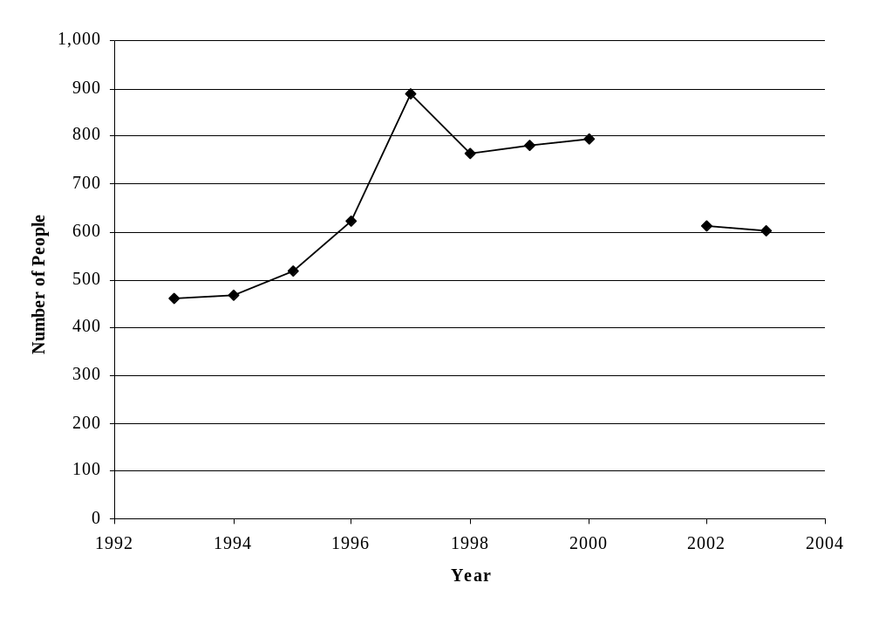
FIGURE 11 Number of animal-vehicle crash fatalities and injuries
in Iowa (1993 to 2003).
Note: Crash data from 2001 excluded due to a change in safety data management procedures during that year.

Animal-Vehicle Crash Rate
One of the factors related to the occurrence of AVCs is the amount of vehicle travel that occurs in a jurisdiction (e.g. AVMT). A common measure of roadway safety is a crash rate defined by the number of reported crashes per 100 million vehicle-miles-traveled (HMVMT). For this summary the AVC rate was calculated for each year and used statewide AVMT and AVCs previously described (See Figures 8, 9, and 12). It should be recognized that this calculation is a general statewide measure, and should be recalculated when the AVC safety of individual roadway segments (which could have an AVC rate that is very different) are investigated.

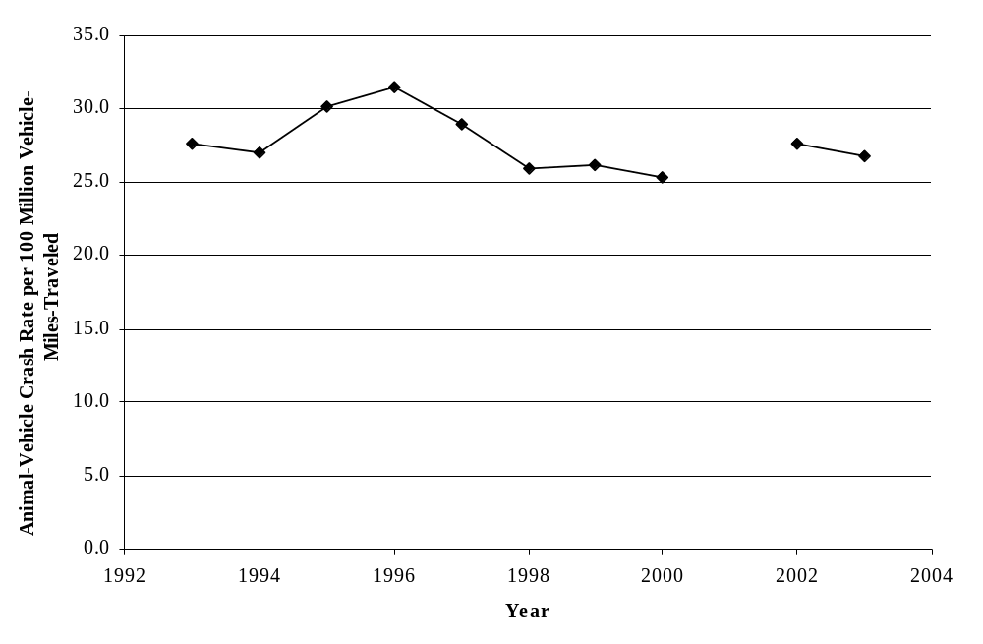
FIGURE 12 Animal-vehicle crash rate per 100 million vehicle-miles-traveled
in Iowa (1993 to 2003).
Note: Crash data from 2001 excluded due to a change in safety data management procedures during that year.

Minimum property damage reporting threshold changed from $500 to $1,000 in mid-1997.

In Iowa, the AVC rate trend is generally the same as that experienced by the total number of reported AVCs (See Figure 9). From 1993 to 1996 the AVC rate increased from 27.6 AVCs per HMVMT to 31.5 AVCs per HMVMT (an increase of 14.1 percent). The latter AVC rate was the maximum rate calculated for the 1993 to 2003 time period considered. Since 1996, however, there has been a general decrease in the AVC rate in Iowa with a minimum of 25.3 AVCs per HMVMT occurring in 2000 (excluding 2001 due to a change in safety data management procedures during that year) and a rate of 26.7 AVCs per HMVMT occurring in 2003. This reduction represents a 15.2 percent decrease in AVC rate from 1996 to 2003. The overall average annual AVC rate from 1993 to 2003 (excluding 2001) was 27.7 AVCs per HMVMT.

Deer Population Estimates and Roadside Carcass Removal Data
Another factor that is related to the occurrence of an AVC is the number, density, and/or movement of the deer population in a jurisdiction. In Iowa, a post-hunt white-tailed deer population is estimated each year. These estimates for 1993 to 2003 are shown in Figure 13 along with the number of AVCs. Overall, the annual deer population estimate for Iowa has increased from 198,589 deer in 1993 to 315,809 deer in 2003 (an increase of 59 percent). During this time, the number of AVCs initially increased and then generally decreased from 1996 to 2000, then increased to 2002 and then decreased to 2003.

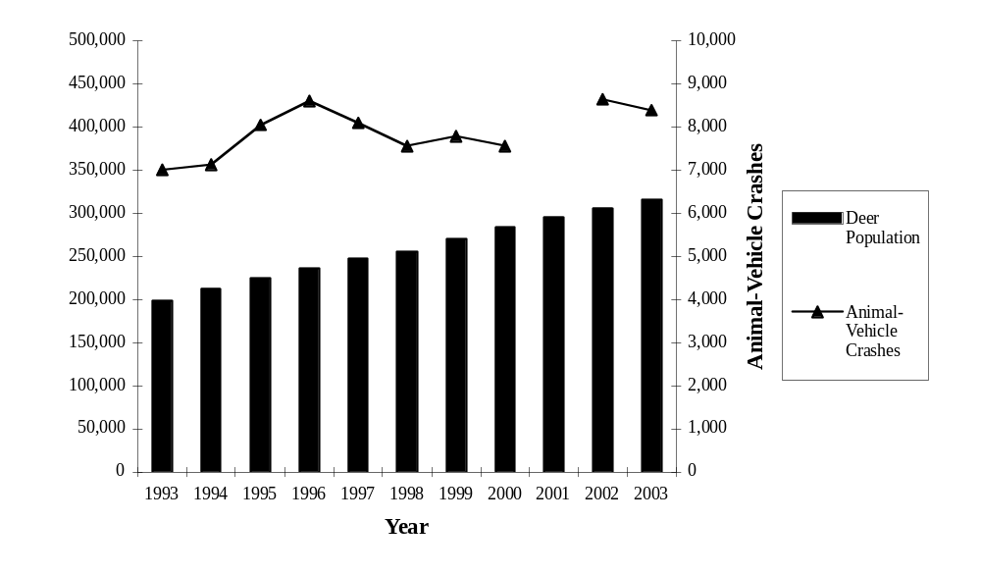FIGURE 13 Post-hunt deer population estimates and animal-vehicle crashes
in Iowa (1993 to 2003).
Note: Crash data from 2001 excluded due to a change in safety data management procedures during that year.

Minimum property damage reporting threshold changed from $500 to $1,000 in mid-1997.

There are typically more DVCs or AVCs occurring in a jurisdiction than the number reported to the police. One method of measuring this difference is to compare the number of reported DVCs or AVCs to the number of roadside carcasses collected. Unfortunately, there are few jurisdictions that summarize the number of carcasses they remove and even fewer that record the location of the removal. Iowa, however, is one state that attempts to summarize at least some of the carcasses it removes from its roadways. Figure 14 shows the number of carcass removals and AVCs reported by Iowa from 1993 to 2003. As indicated previously, the total carcass numbers in Figure 14 represent the sum of unsalvaged deer carcasses removed from the roadway by the IaDNR and the number of permits issued by the IaDNR for public carcass salvage.

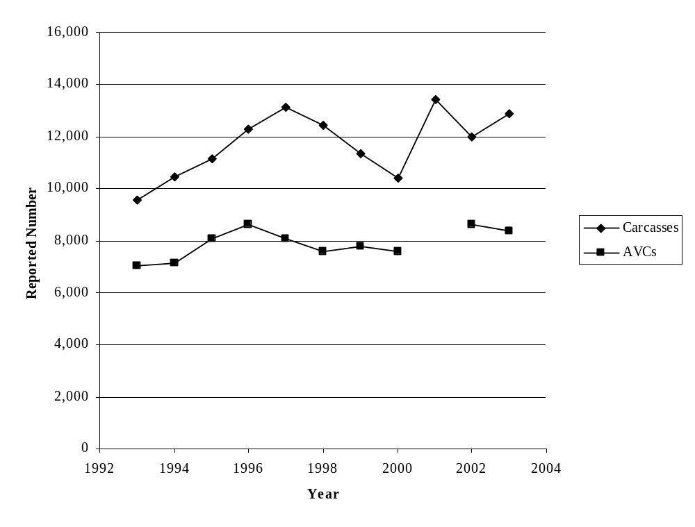
FIGURE 14 Roadside carcass removals and reported animal-vehicle crashes
in Iowa (1993 to 2003).
Note: Crash data from 2001 excluded due to a change in safety data management procedures during that year.

Minimum property damage reporting threshold changed from $500 to $1,000 in mid-1997.

Not surprisingly, Figure 14 shows that there is a difference in the number of reported AVCs and the number of carcasses removed. From 1993 to 2003, the minimum number of carcasses removed was 9,576 in 1993 and the maximum number of carcasses removed was 13,404 in 2001. In general, the number of carcasses collected and summarized increased from 1993 to 1997, decreased from 1997 to 2000, and then increased dramatically from 2000 to 2003. The overall increase from 1993 to 2003 in the number of carcasses collected and summarized in Iowa is about 34.8 percent. The annual average number of carcasses removed from 1993 to 2003 was 11,734.
Figure 14 shows that the annual number of reported AVCs in Iowa was always smaller than the number of roadside carcass removals summarized. Overall, the average number of removals was approximately 3,800 greater than the average number of reported AVCs. The annual ratio of the carcasses removed to the reported number of AVCs ranged from about 1.4 to 1.6 between 1993 and 2003. Overall, there are several reasons the number of reported AVCs and carcasses removed are different. These reasons include, but are not limited to, the consistency of carcass collection and recording between jurisdictions and from year to year, and AVCs that are not reported (for whatever reason) but result in the death of an animal. Changes in these factors can increase or decrease the ratio of reported AVCs to carcasses removed.

Iowa Summary
The data provided by Iowa are included in Appendix A-2. From 1993 to 2000 the average percentage of all crashes reported in Iowa that were AVCs was approximately 11.6 percent. However, the annual total number of reported AVCs increased from 1993 to 1996, decreased until 2000, and then increased from there to 2002/2003. An evaluation of the Iowa AVC-related data showed the following general patterns:

- The annual total number of crashes reported and summarized in Iowa has generally decreased from 1993 to 2003 (See Figure 7). The total annual number of reported crashes was greatest in 1996 at 78,360, but only 59,190 in 2003. The AVMT in Iowa has consistently increased during the study time period (See Figure 8).
- There was an increasing trend in the annual number of AVCs reported in Iowa from 1993 to 1996, a decreasing trend from 1996 to 2000, and an increase from 2000 to 2002/2003 (See Figure 9). However, the percentage of total crashes represented by AVCs has generally increased from 9.5 to 14.2 percent (See Figure 10).
- The annual number of injuries and fatalities due to AVCs ranged from 461 to 888 between 1993 and 2003. There were a total of 30 AVC fatalities during these 11 years. The number of injuries and fatalities due to AVCs increased dramatically from 1993 to 1997 and decreased from 1997 to 2003.
- The AVC rate (i.e., the number of AVCs per HMVMT) increased from 1993 to 1996 and then generally decreased from 1997 to 2003. This measure peaked at 31.5 AVCs per HMVMT in 1996 and was at 26.7 AVCs per HMVMT in 2003.
- Iowa also provided annual deer population estimates and annual carcass removal numbers from 1993 to 2003. Figure 13 shows that the annual deer population estimates have increased from 198,589 in 1993 to 315,809 in 2003 (a 59 percent increase). The number of carcasses removed from the roadside, on the other hand, has been approximately 1.4 to 1.6 times greater than the number of AVCs reported annually. This difference has varied from year to year (See Figure 14).

Michigan DATA EVALUATION
In Michigan a crash must be reported if it involves a motor vehicle in transport on a public traffic-way and results in injury, death or at least $400 in property damage. On January 1, 2004 the minimum property damage reporting threshold was raised to $1,000, and this should be noted if this Michigan data summary is extended from its current 1993 to 2003 focus.

Police-reported motor vehicle crash data were collected from the Michigan Department of Transportation (MDOT) for the time period from 1993 to 2003. The overall number of crashes reported annually and those designated as DVCs were obtained. The number of DVC injuries and fatalities, as well as the state AVMT were also collected from the Michigan crash facts book published annually by the Michigan Office of Highway Safety Planning. Annual deer population estimates from 1993 to 2003 were also received from the Michigan Department of Natural Resources (MDNR). These estimates are prepared by geographical deer management unit based on deer harvest surveys, summer deer observations, check station data, traffic surveys, pellet group surveys, dead deer searches, and DVCs. All of the data collected from Michigan are provided in Appendix A-3.

Total Crashes and Annual Vehicle-Miles-Traveled

The annual total number of crashes reported in Michigan are presented in Figure 15. Overall, the annual total number of crashes has been generally stable from 1993 to 2003. The maximum annual number of reported crashes in Michigan during this time period was 435,477 in 1996 and the minimum was 363,636 in 1993. Overall, the annual total number of crashes from 1993 to 2003 generally fluctuated between 350,000 and 450,000, and the average was approximately 407,000.

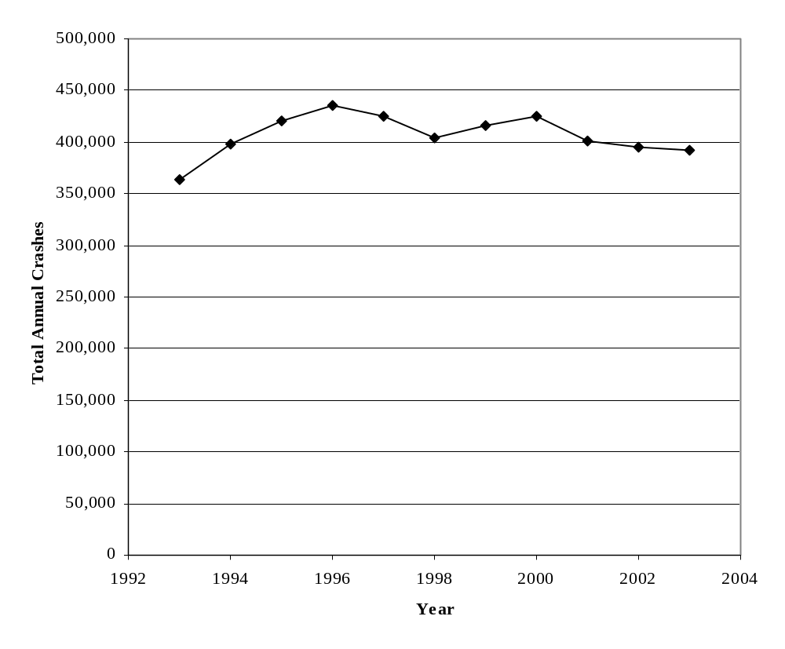
FIGURE 15 Total crashes reported in Michigan (1993 to 2003).

The total AVMT from 1993 to 2003 in Michigan is shown in Figure 16. The number of AVMT in Michigan has increased from a minimum of 85,600 million miles in 1994 to 98,200 million miles in 2003. The AVMT in Michigan was very consistent from 1993 to 1995 and from 2002 to 2003. The increasing trend in AVMT between these two time periods was also relatively steady at about 1.5 percent per year. Figure 16 below shows the trend in AVMT in Michigan over the study period.

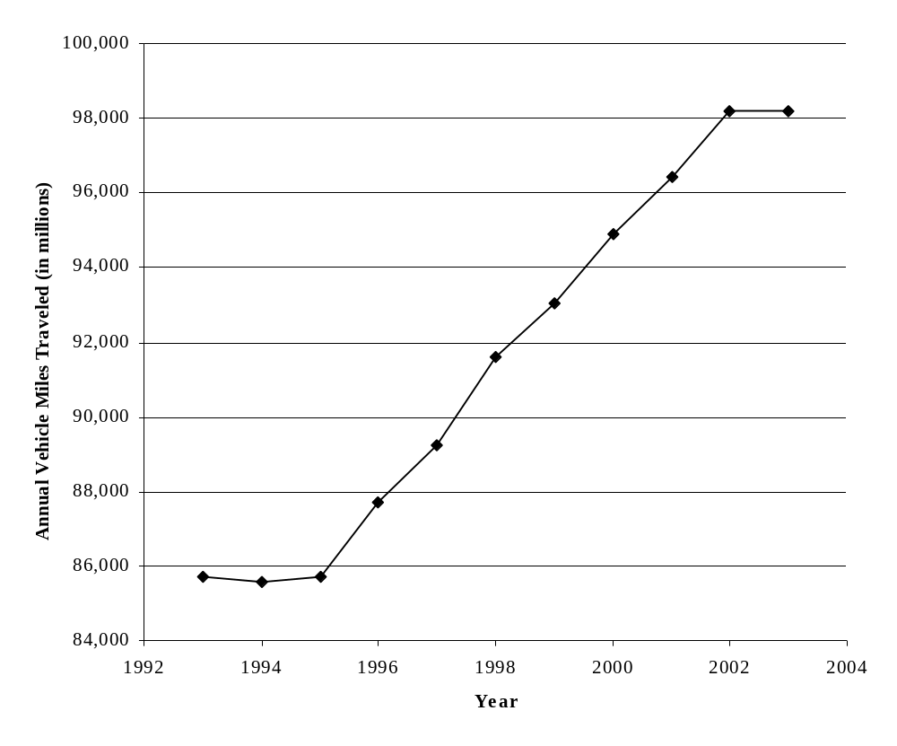 FIGURE 16 Annual vehicle-miles-traveled in Michigan (1993 to 2003).

Total and Percent Deer-Vehicle Crashes
The DVCs reported and summarized in Michigan between 1993 and 2003 are shown in Figure 17. Overall, the annual number of reported DVCs in Michigan increased from a minimum of 47,812 in 1993 to a maximum of 68,233 in 1996. Since 1996, however, the annual number of DVCs reported has been relatively stable with a range between 63,136 and 67,760. The average number of DVCs reported each year from 1996 to 2003 was approximately 66,206 and the overall average for the entire 1993 to 2003 time period was 63,332. The number of DVCs reported each year in Michigan is greater than any of the other four states considered in this report.

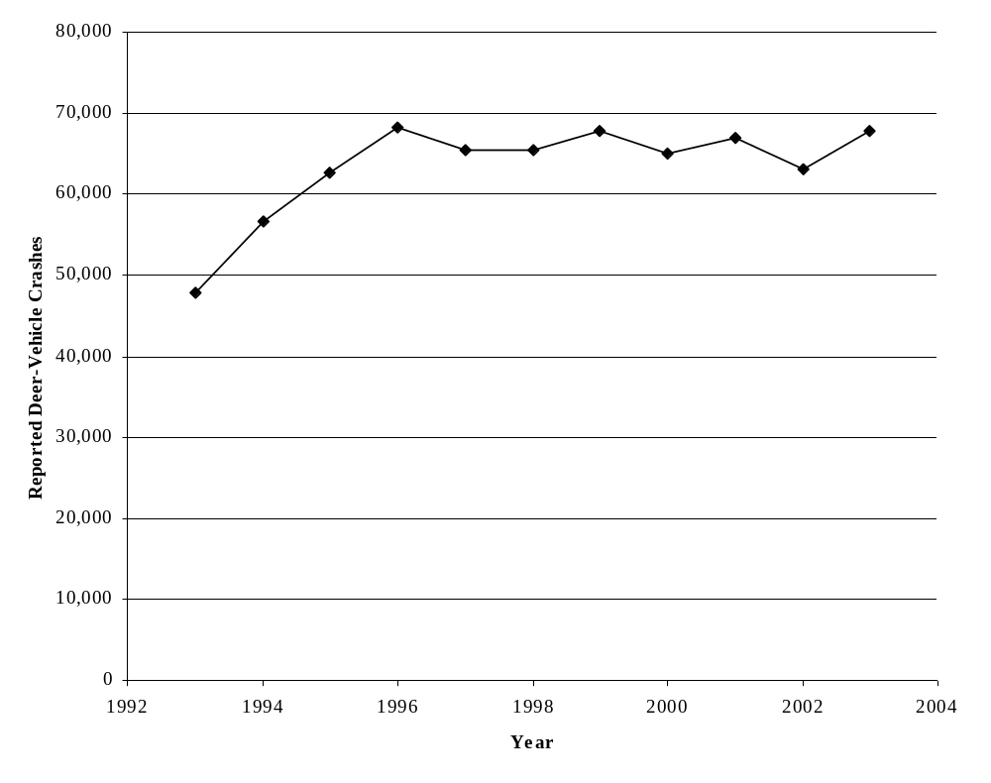
FIGURE 17 Reported deer-vehicle crashes in Michigan (1993 to 2003).

The total crash and DVC data from Figures 15 and 17 were used to calculate the percentage of reported crashes represented by DVCs in Michigan (See Figure 18). These calculations were done for each year from 1993 to 2003. Overall, the percentage of total crashes represented by DVCs has increased in Michigan from 1993 to 2003. The minimum DVC percentage during this time period was 13.2 percent in 1993 and the maximum was 17.3 percent in 2003. This difference represents an increase of 31 percent in 11 years. The overall average DVC percentage from 1993 to 2003 was 15.6 percent.

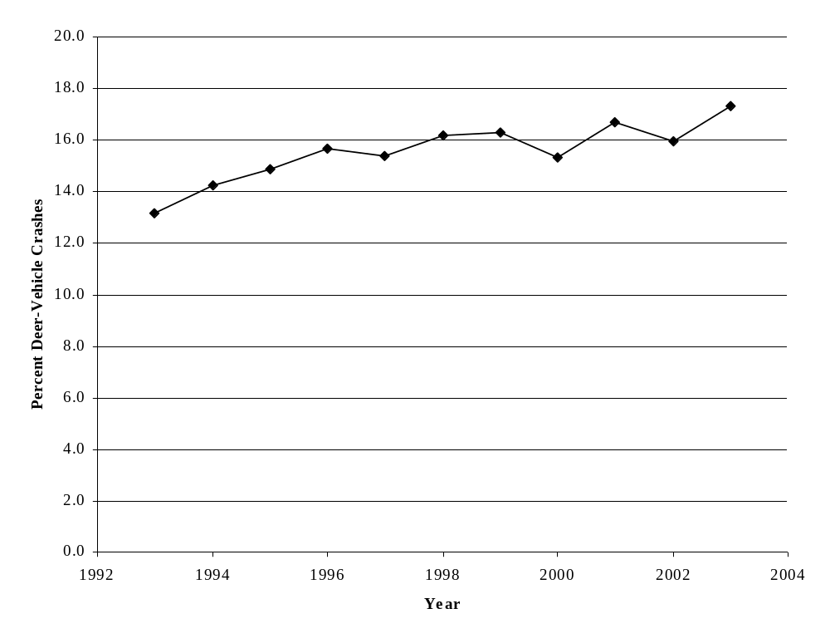
FIGURE 18 Percent deer-vehicle crashes in Michigan (1993 to 2003).

Deer-Vehicle Crash Injuries and Fatalities
The annual number of DVC injuries and fatalities in Michigan from 1993 to 2003 are shown in Figure 19. The combined total of DVC injuries and fatalities increased from 1,717 in 1993 to 2,385 in 1998 (See Figure 19). This difference represents a 38.9 percent increase. Figure 19 also shows that from 1998 to 2003 the number of DVC injuries and fatalities generally decreased from 2,385 to 1,924 (about a 19.3 percent reduction). However, there was somewhat of an increase in 2002. The actual number of DVC fatalities and injuries from 1993 to 2003 are shown in Appendix A-3.

Overall, there were a total of 67 DVC fatalities and 23,399 DVC injuries in Michigan from 1993 to 2003. The minimum number of annual fatalities was 2 and occurred in 2002. However, in each of 2001 and 2003, 11 DVC fatalities were recorded, which
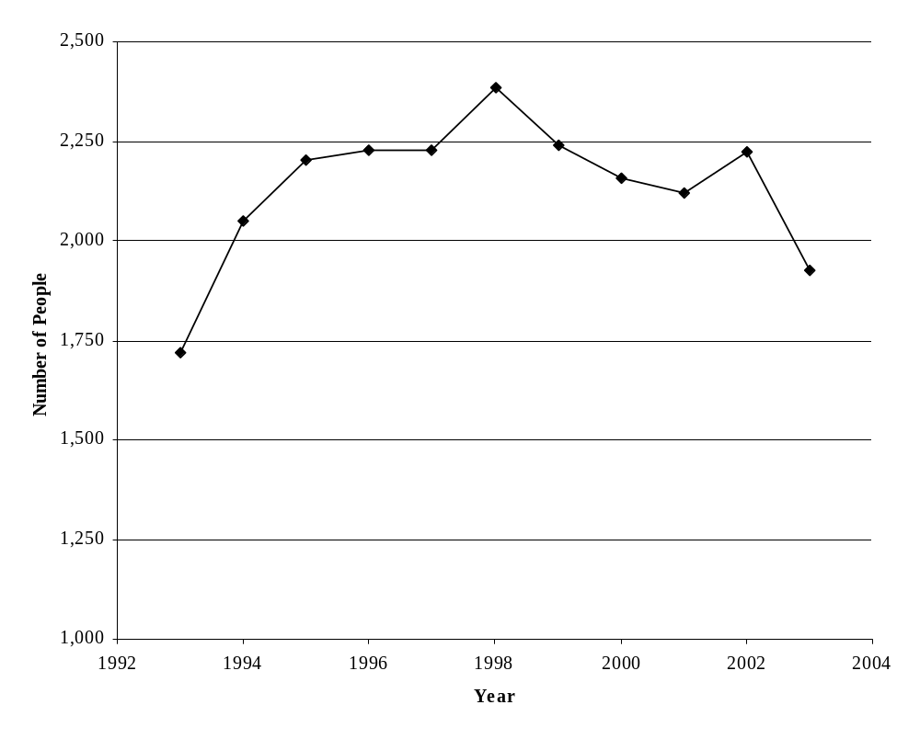
FIGURE 19 Number of deer-vehicle crash fatalities and injuries
in Michigan (1993 to 2003).

represented the largest annual number recorded from 1993 to 2003. The fewest number of DVC injuries recorded was in 1993 with 1,712, and the most in 1998 with 2,381. Overall, there was an average of 6 DVC fatalities and 2,127 DVC injuries reported each year in Michigan from 1993 to 2003.

Deer-Vehicle Crash Rate
One of the factors related to the occurrence of DVCs is the amount of vehicle travel that occurs in a jurisdiction (e.g. AVMT). A common measure of roadway safety is a crash rate defined by the number of reported crashes per 100 million vehicle-miles-traveled (HMVMT). For this summary the DVC rate was calculated for each year and used the statewide AVMT and DVCs previously described (See Figures 16, 17, and 20). It should be recognized that this calculation is a general statewide measure, and should be recalculated when the DVC safety of individual roadway segments (which could have a DVC rate that is very different) are investigated.

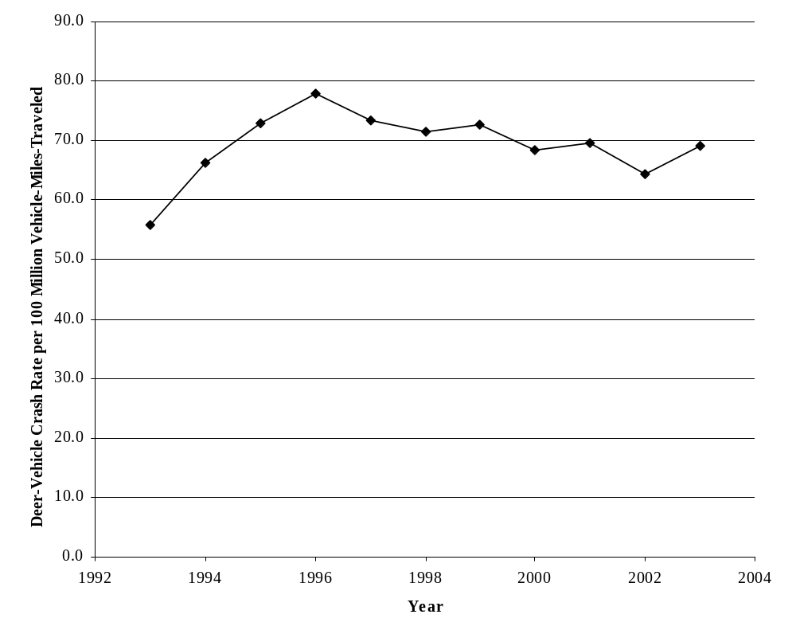
FIGURE 20 Deer-vehicle crash rate per 100 million vehicle-miles- traveled
in Michigan (1993 to 2003).

In Michigan, the DVC rate trend is generally the same as that experienced by the total number of reported DVCs (See Figure 17). The statewide DVC rate increased from 1993 to 1996. However, from 1996 to 2003 the Michigan AVMT continued to increase while the annual number of reported DVCs remained relatively stable. This combination resulted in the DVC rate showing a small decreasing trend during this period. The Michigan DVC rate from 1993 to 2003 has ranged from a minimum of 55.8 DVCs per HMVMT in 1993 to a maximum of 77.8 DVCs per HMVMT in 1996 (a 39.4 percent increase). The DVC rate in 2003 was 69.0 DVCs per HMVMT (representing an 11.3 percent decrease from 1996). Overall, the average DVC rate in Michigan from 1993 to 2003 was 69.2 DVCs per HMVMT. Regionally, the DVC rate in Michigan was the largest of the five states considered in this report.

Deer Population Estimates and Roadside Carcass Removal Data
Another factor that is related to the occurrence of a DVC is the number, density, and/or movement of the deer population in a jurisdiction. In Michigan, a pre-hunt white-tailed deer population is estimated each year. As previously indicated, these estimates are prepared by the MDNR for geographical deer management units based on deer harvest surveys, summer deer observations, check station data, traffic surveys, pellet group surveys, dead deer searches, and DVCs. The MDNR estimates for 1993 to 2003 are shown in Figure 21 along with the number of reported DVCs. Overall, the annual deer population estimate for Michigan has increased from 1,630,000 deer in 1993 to 1,776,000 deer in 2003 (an increase of 9.0 percent). The peak deer population estimate of 2,171,000 occurred in 1995, and then the annual estimates decreased between 1995 and 2003 by about 18.2 percent. The minimum annual deer population estimate was 1,630,000 in 1993. Between 1993 and 2003 the annual number of reported DVCs increased from 1993 to 1996 and then generally stabilized. No data was provided by Michigan about the number of roadside carcasses removed in Michigan, but no evidence was found that this information is summarized by location in Michigan.

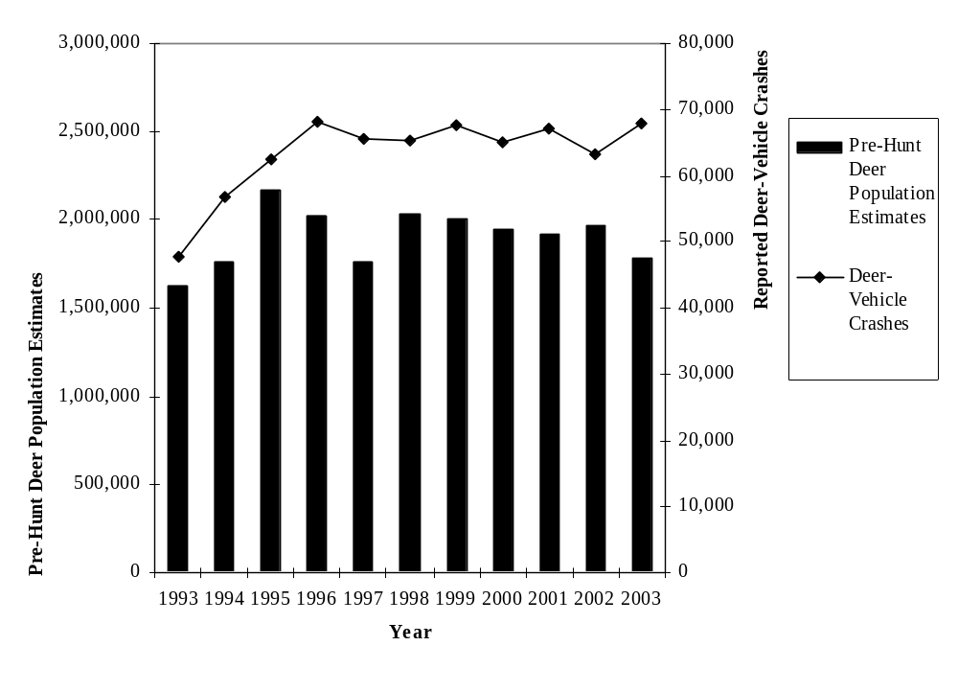
FIGURE 21 Pre-hunt deer population estimates and deer-vehicle crashes
in Michigan (1993 to 2003).

Michigan Summary
The data provided by Michigan are included in Appendix A-3. From 1993 to 2003 the average percentage of all crashes reported in Michigan that were DVCs was approximately 15.6 percent. This is the largest percentage of DVCs found in the five states considered in this report. An evaluation of the Michigan DVC-related data showed the following general patterns:

- The annual total number of crashes reported and summarized in Michigan has been relatively stable between 1993 and 2003 (See Figure 15). This safety measure has fluctuated between 350,000 and 450,000 for this time period. The largest annual number of reported crashes was in 1996 at 435,477, and the smallest number occurred in 1993 at 363,636. The AVMT in Michigan was stable from 1993 to 1995 and 2002 to 2003, but increased steadily between these two time periods (See Figure 16).
- The annual number of DVCs reported in Michigan increased from 47,812 in 1993 to 68,233 in 1996, but this measure has only ranged from 63,136 to 68,233 between 1996 and 2003 (See Figure 17). The percentage of total crashes represented by DVCs has increased from 13.2 percent in 1993 to 17.3 percent in 2003 (See Figure 18).
- The annual number of fatalities due to DVCs ranged from 2 to 11 between 1993 and 2003. There were a total of 67 DVC fatalities during these 11 years. The number of injuries and fatalities due to DVCs in Michigan increased from 1993 to 1998, but has seen a decrease from 1998 to 2003. However the largest annual number of reported DVC fatalities occurred in both 2001 and 2003.
- Similar to the number of DVCs reported, the DVC rate (i.e., the number of DVCs per HMVMT) increased from 1993 to 1996, but between 1996 and 2003 the annual number of reported DVCs has been relatively stable and the statewide DVC rate decreased slightly. The Michigan DVC rate peaked at 77.8 DVCs per HMVMT in 1996 and was at 69.0 DVCs per HMVMT in 2003.
- Michigan also provided annual deer population estimates from 1993 to 2003. Figure 21 shows that the annual pre-hunt deer population estimates increased from 1,630,000 in 1993 to 2,171,000 in 1995 (a 33.2 percent increase), and then generally decreased from that point to 1,776,000 deer in 2003 (an 18.2 percent decrease in eight years). The number of carcasses removed from the roadside in Michigan was not provided and does not appear to be summarized in the state.

Minnesota DATA EVALUATION
In Minnesota motorists must report any motor vehicle crash that results in death, injury or property damage of at least $1,000. However, before August 1, 1994, the minimum property damage threshold for crash reporting in Minnesota was $500. Comparisons of crash data before and after these years should consider this change. The total annual number of reported crashes from 1993 to 2002 were collected from the Minnesota Department of Transportation (MnDOT) for this summary. Unfortunately, only crashes with fatalities were summarized for 2003 and this year has been eliminated from further consideration. The number of DVCs and AVMT in the state for 1993 to 2002 were obtained from the MnDOT crash facts book. The crash data summarized by MnDOT and included in this document are those reported to the Minnesota Department of Public Safety. All of the data collected from Minnesota are provided in Appendix A-4.

White-tailed deer population estimates and roadside carcass removal data from 1993 to 2003 were also collected from the Minnesota Department of Natural Resources (MnDNR). Annual pre-hunt deer population estimates were provided for 1994 to 2003, and roadside carcass removal information was available from 1993 to 2003. The roadside carcass data provided was a summary of the statewide salvage or possession permits completed (i.e., those roadside carcasses requested by the public) and the unsalvaged or maintenance removals conducted by MnDOT. Maintenance carcass removals were summarized for the entire state for 1993 and 1994, but the Minneapolis/St. Paul area was not included in the summary values from 1995 to 2003. In addition, the carcass removal data from 1995 were excluded due to questions related to its validity. The deer population and carcass data provided by Minnesota are shown in Appendix A-4.

Total Crashes and Annual Vehicle-Miles-Traveled
The annual total number of crashes reported in Minnesota are presented in Figure 22. Overall, the annual total number of crashes has been generally stable, above and below 100,000 crashes per year, between 1993 and 2002. The maximum annual number of reported crashes in Minnesota during this time period was 105,332 in 1996 and the minimum was 92,926 in 1998. Overall, the average annual total number of crashes reported from 1993 to 2002 was 98,787.

The total AVMT from 1993 to 2002 in Minnesota is shown in Figure 23. The number of AVMT in Minnesota has increased from 42,300 million miles in 1993 to 54,400 million miles in 2002. This increase has been relatively consistent at 3.1 percent per year (See Figure 23). The average Minnesota AVMT from 1993 to 2002 was 48,180 million miles.
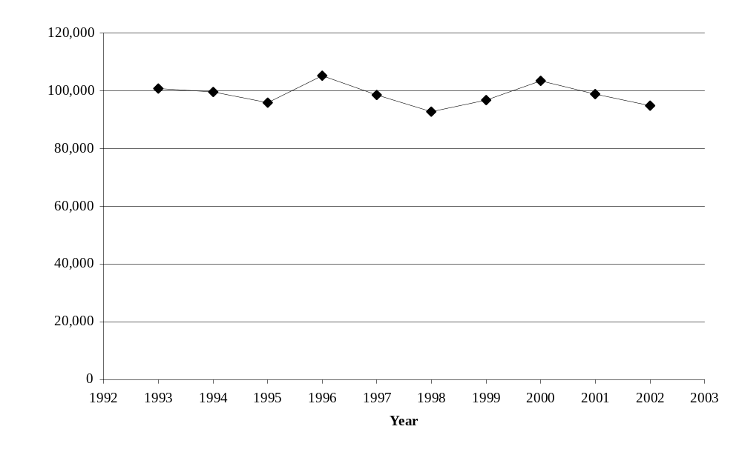
FIGURE 22 Total crashes reported in Minnesota (1993 to 2002).
Note: Minimum property damage reporting threshold changed from $500 to $1,000 on August 1, 1994.

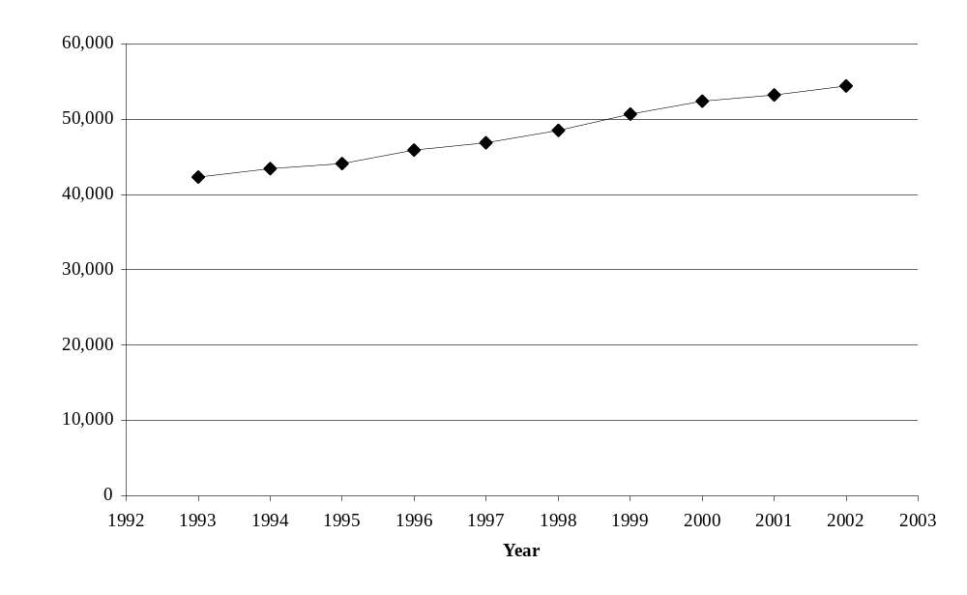
FIGURE 23 Annual vehicle-miles-traveled in Minnesota (1993 to 2002).

Total and Percent Deer-Vehicle Crashes
The total number of DVCs reported and summarized in Minnesota between 1993 and 2002 are shown in Figure 24. Overall, the annual number of reported DVCs in Minnesota decreased from a maximum of 6,517 in 1993 to a minimum of 4,891 in 1997 (a 25 percent decrease). However, from 1997 to 1999 the annual number of DVCs increased. Between 1999 and 2002 the annual number of reported DVCs stabilized and only ranged between 5,309 and 5,596 with an average of 5,496. The overall average annual number of reported DVCs in Minnesota from 1993 to 2002 was 5,481.

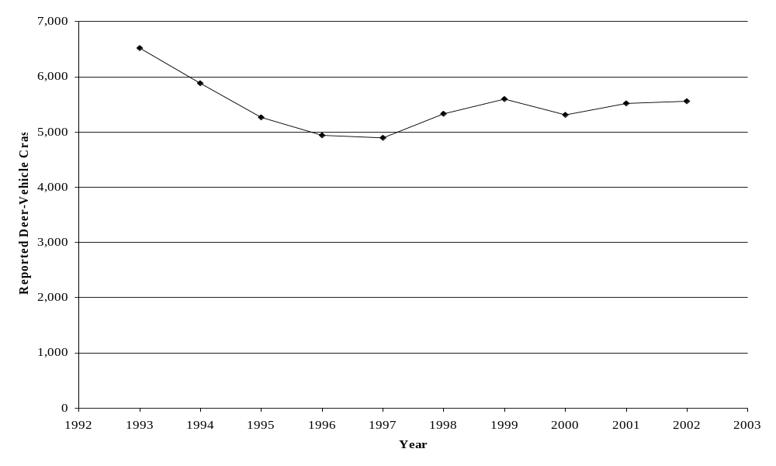
FIGURE 24 Reported deer-vehicle crashes in Minnesota (1993 to 2002).
Note: Minimum property damage reporting threshold changed from $500 to $1,000 on August 1, 1994.

The total crash and DVC data from Figures 22 and 24 were used to calculate the percentage of reported crashes represented by DVCs in Minnesota (See Figure 25). These calculations were conducted for each year from 1993 to 2002. Overall, the percentage of total crashes represented by DVCs in Minnesota generally decreased from 6.5 percent in 1993 to 4.7 percent in 1996. This percentage then fluctuated, but generally increased by 24.7 percent between 1996 and 2002. The maximum annual DVC percentage during
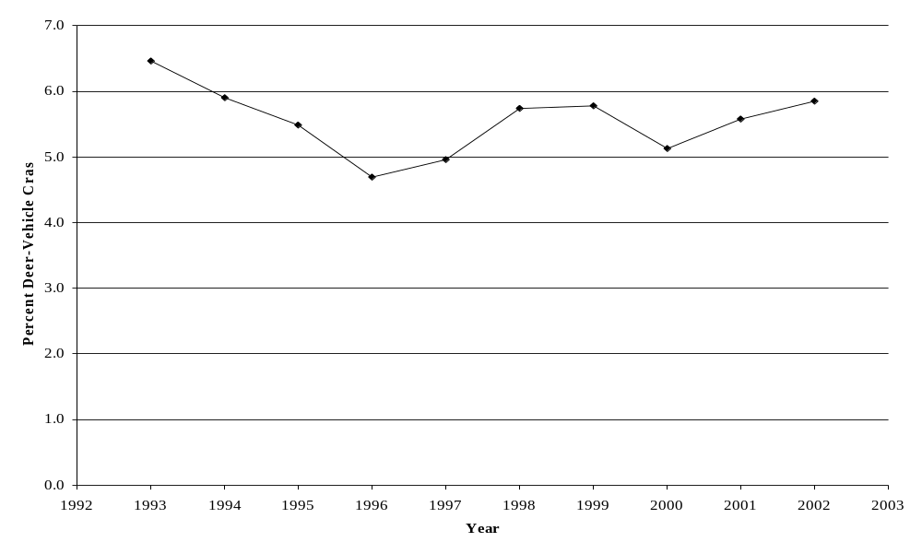
FIGURE 25 Percent deer-vehicle crashes in Minnesota (1993 to 2002).
Note: Minimum property damage reporting threshold changed from $500 to $1,000 on August 1, 1994.

this time period was 6.5 percent in 1993. The DVC percentage calculated for 1998 and 1999 was also 5.7 and 5.8, respectively. The overall average DVC percentage in Minnesota from 1993 to 2002 was 5.6 percent.

Deer-Vehicle Crash Injuries and Fatalities
The annual number of DVC injuries and fatalities in Minnesota from 1993 to 2002 are shown in Figure 26. Overall this safety measure has experienced some fluctuations, but also a general increase from 353 in 1993 to 528 in 2002 (a 49.6 percent increase). The minimum annual number of DVC injuries and fatalities reported during the time period considered was 353 in 1993, but the maximum was 539 in 1999 (See Figure 26). This difference represents about a 52.7 percent increase. The actual number of DVC fatalities and injuries from 1993 to 2002 are shown in Appendix A-4.
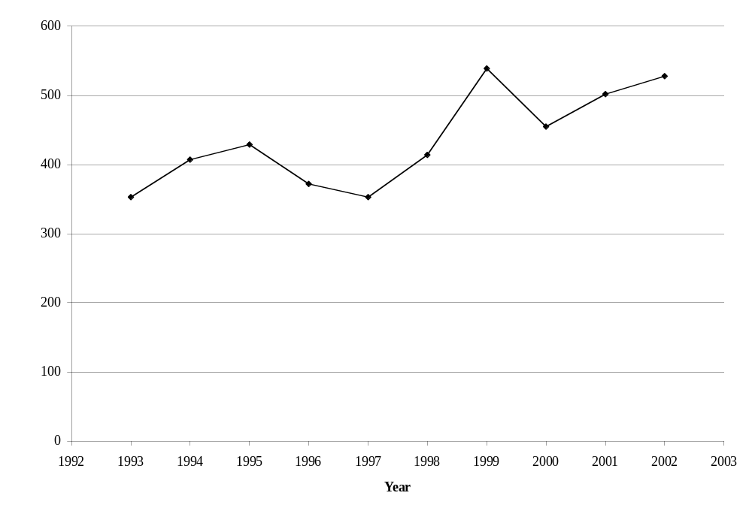
FIGURE 26 Number of deer-vehicle crash fatalities and injuries
in Minnesota (1993 to 2002).

Overall, there were a total of 26 DVC fatalities and 4,326 DVC injuries in Minnesota from 1993 to 2002. The minimum number of annual fatalities was one during this time period and this occurred in 1993 and 1994. However, a maximum of 5 fatalities occurred in 2001 and 2002. It should be noted that fatal crashes were the only collision type summarized in 2003 by MnDOT, and 5 DVC fatalities were also recorded during that year. The fewest number of DVC injuries recorded was in 1997 with 350, and the most was in 1999 with 537. Overall, there was an average of 3 DVC fatalities and 429 injuries reported each year in Minnesota from 1993 to 2002.

Deer-Vehicle Crash Rate
One of the factors related to the occurrence of DVCs is the amount of vehicle travel that occurs in a jurisdiction (e.g. AVMT). A common measure of roadway safety is a crash rate defined by the number of reported crashes per 100 million vehicle-miles-traveled (HMVMT). For this summary the DVC rate was calculated for each year and used the statewide AVMT and DVCs previously described (See Figures 23, 24, and 27). It should be recognized that this calculation is a general statewide measure, and should be recalculated when the DVC safety of individual roadway segments (which could have a DVC rate that is very different) are investigated.

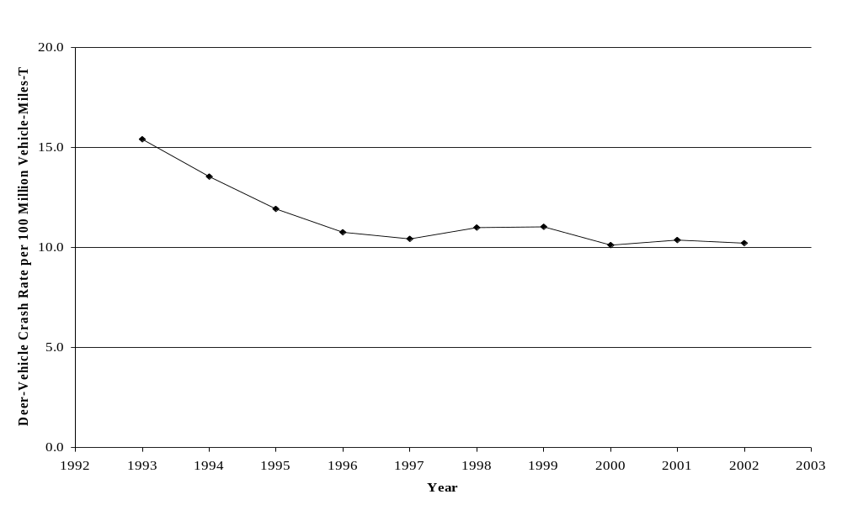

FIGURE 27 Deer-vehicle crash rate per 100 million vehicle-miles-traveled
in Minnesota (1993 to 2002).
Note: Minimum property damage reporting threshold changed from $500 to $1,000 on August 1, 1994.

Not surprisingly, the DVC rate trend in Minnesota is generally the same as that experienced by the total number of reported DVCs (See Figure 24). This similarity is generally due to the consistent increase in AVMT. The statewide DVC rate decreased from 1993 to 1997 from 15.4 DVCs per HMVMT to 10.4 DVCs per HMVMT (a 32.5 percent decrease). However, between 1997 and 2002 the Minnesota DVC rate remained relatively stable. During this time period Figure 27 shows that the DVC rate in Minnesota only ranged between 10.1 DVCs per HMVMT and 11.0 DVCs per HMVMT (with an average of 10.5 DVCs per HMVMT). Overall, from 1993 to 2002, the maximum Minnesota DVC rate was 15.4 DVCs per HMVMT in 1993 and the minimum was 10.1 DVCs per HMVMT in 2000. The overall average DVC rate during this time period was 11.5 DVCs per HMVMT.

Deer Population Estimates and Roadside Carcass Removal Data
Another factor that is related to the occurrence of a DVC is the number, density, and/or movement of the deer population in a jurisdiction. For Minnesota, an annual pre-hunt white-tailed deer population estimate was provided for 1994 to 2003. These estimates are shown in Figure 28 along with the number of DVCs. Overall, the annual deer population estimate for Minnesota has generally increased from 1,004,000 deer in 1994 to 1,253,000 deer in 2003 (an increase of 24.8 percent). The minimum deer population estimate was 797,000 in 1997. During this time, AVMT has increased, but the number of DVCs reported initially decreased and then stabilized.

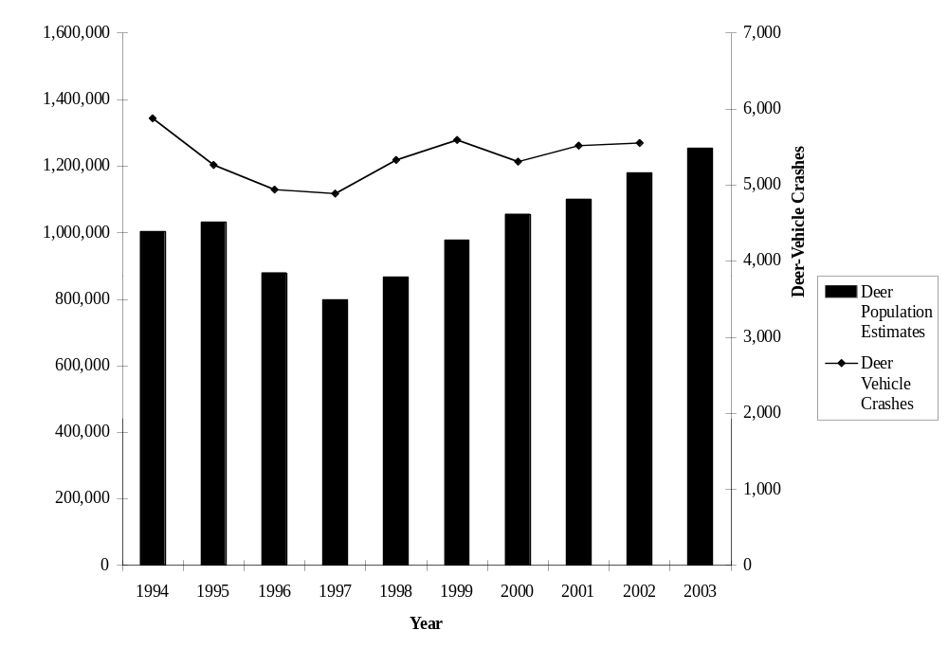
FIGURE 28 Pre-hunt deer population estimates and deer-vehicle crashes
in Minnesota (1994 to 2003).
Note: Minimum property damage reporting threshold changed from $500 to $1,000 on August 1, 1994.

As previously mentioned, roadside carcass removal data were also obtained from the MnDNR for the years 1993 to 2003. The data provided combines the number of statewide salvage or possession permits completed (i.e., those roadside carcasses requested by the public) and the unsalvaged or maintenance removals by MnDOT. Maintenance carcass removals were summarized for the entire state for 1993 and 1994, but the Minneapolis/St. Paul area was not included in the summary values from 1995 to 2003. The annual number of carcasses summarized in Minnesota from 1993 to 2003 are shown in Figure 29 along with number of DVCs reported each year. However, the carcass removal data from 1995 have been excluded due to questions related to its validity. The deer population and carcass data provided by Minnesota are shown in Appendix A-4.

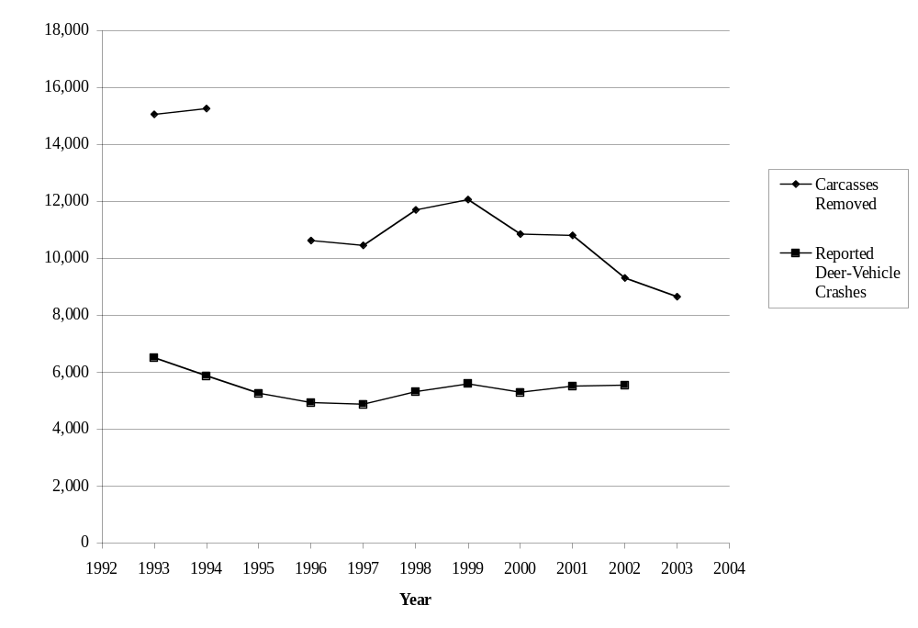

FIGURE 29 Roadside carcass removals and reported deer-vehicle crashes in Minnesota (1993 to 2003).
Note: Minimum property damage reporting threshold changed from $500 to $1,000 on August 1, 1994.
Carcass removal data from 1995 excluded due to questions about validity.
Carcass removal data from 1996 to 2003 does not include the Minneapolis/St. Paul area.

There are typically more DVCs or AVCs occurring in a jurisdiction than the number reported to the police. This pattern also occurs in Minnesota. In 1993 and 1994 the average number of carcass removals summarized for Minnesota was 15,167. As indicated, these two years included maintenance removal data from the Minneapolis/St. Paul area. The ratio between carcass removals and reported DVCs for 1993 and 1994 was 2.3 and 2.6, respectively. From 1996 to 2003, on the other hand, the average number of carcass removals was 10,567, and the carcass removal to reported DVC ratios for 1996 to 2002 (no non-fatal DVC data was available for 2003) ranged from 1.7 to 2.2 (with an average of 2.1). The data during this time period does not include maintenance removals from the Minneapolis/St. Paul area.

Overall, there are several reasons the number of reported DVCs and carcasses removed are different. These reasons include, but are not limited to, the consistency of carcass collection and recording between jurisdictions and from year to year, and DVCs that are not reported (for whatever reason) but result in the death of an animal. Changes in these factors can increase or decrease the ratio of reported DVCs to carcasses removed.

Minnesota Summary
The data provided by Minnesota are included in Appendix A-4. From 1993 to 2002 the average percentage of all crashes reported in Minnesota that were DVCs was approximately 5.6 percent. The annual total number of reported DVCs decreased from 1993 to 1997, but increased somewhat from that year to 2002. The total number of injuries and fatalities due to DVCs, although variable, also increased. Deer are the third most commonly hit object behind striking another vehicle and striking a fixed object in Minnesota (3). An evaluation of the Minnesota DVC-related data showed the following general patterns:

- The annual total number of crashes reported and summarized in Minnesota has fluctuated but been generally stable from 1993 to 2002 (See Figure 22). The total annual number of reported crashes was greatest in 1996 at 105,332, but only 92,926 in 1998. The AVMT in Minnesota has consistently increased during the study time period (See Figure 23).
- There was a decreasing trend in the annual number of DVCs reported in Minnesota from 1993 to 1997, and then an increasing trend from 1997 to 2002 (See Figure 24). The percentage of total crashes represented by DVCs followed a similar pattern. It decreased from 6.5 percent in 1993 to 4.7 percent in 1996, but then increased to 5.9 percent in 2002 (See Figure 25).
- The annual number of fatalities due to DVCs ranged from 1 to 5 between 1993 and 2002. There were a total of 26 DVC fatalities during these 10 years. The annual number of injuries and fatalities due to DVCs has increased from 353 in 1993 to 528 in 2002 (an increase of 49.6 percent). Only fatality crashes were summarized in 2003 and there were also 5 DVC fatalities during that year.
- Similar to the number of DVCs reported, the DVC rate (i.e., the number of DVCs per HMVMT) decreased from 1993 to 1997. However, this safety measure has been relatively stable from 1997 to 2002 (ranging from 10.1 DVCs per HMVMT to 11.0 DVCs per HMVMT). Overall, from 1993 to 2002, the Minnesota DVC rate peaked at 15.4 DVCs per HMVMT in 1993 and was at a minimum of 10.1 DVCs per HMVMT in 2000.
- Minnesota also provided annual deer population estimates from 1994 to 2003 and annual carcass removal numbers from 1993 to 2003 (excluding 1995 due to questions about its validity). Figure 28 shows that the annual deer population estimates have generally increased from 1,004,000 in 1994 to 1,253,000 in 2003 (a 24.8 percent increase). The number of carcasses removed from the roadside, on the other hand, averaged about 2.5 times the number of DVCs reported annually in 1993 and 1994 (when the Minneapolis/St. Paul area maintenance removals were included in the data). This measure averaged about 2.1 from 1996 to 2002 (when the Minneapolis/St. Paul area maintenance removals were not included in the data). The differences between the roadside carcass removal data provided by Minnesota and the reported number of DVCs are shown in Figure 29.

Wisconsin DATA EVALUATION
In Wisconsin motorists must report any motor vehicle crash that results in death, injury or property damage of at least $1,000 (or $200 for government-owned non-vehicle property). However, before January 1, 1996, the minimum property damage threshold for crash reporting in Wisconsin was $500. Comparisons of crash data before and after January 1996 should consider this change. The total annual number of police reported crashes from 1993 to 2003 were collected from the Wisconsin Department of Transportation (WisDOT) for this summary (these do not include self-reported crashes). The number of DVCs and AVMT in the state for 1993 to 2003 were also obtained. All of the data collected from Wisconsin are provided in Appendix A-5.

White-tailed deer population estimates and roadside carcass removal data from 1993 to 2003 were also provided by the Wisconsin Department of Natural Resources (WisDNR). Annual pre-hunt deer population estimates are made by WisDNR for deer management units, and the deer carcass removal data are a combination of the salvage permits issued by the WisDNR (for removal by the public) and the maintenance removals completed by WisDNR contractors. The deer population and carcass data provided by Wisconsin are shown in Appendix A-5.

Total Crashes and Annual Vehicle-Miles-Traveled
The annual total number of crashes reported in Wisconsin from 1993 to 2003 are presented in Figure 30. Overall, the annual total number of reported crashes has been generally stable, but with a decreasing trend after 1995. This decrease may be partially due to the change in the minimum property damage threshold for crash reporting from $500 to $1000 on January 1, 1996. The annual total number of crashes reported in Wisconsin from 1993 to 2003 varies between a minimum of 125,403 in 2001 to a maximum of 148,864 in 1995. Overall, the average annual total number of crashes reported from 1993 to 2003 was about 135,000. The total number of reported crashes has decreased approximately 7.8 percent between 1993 and 2003.

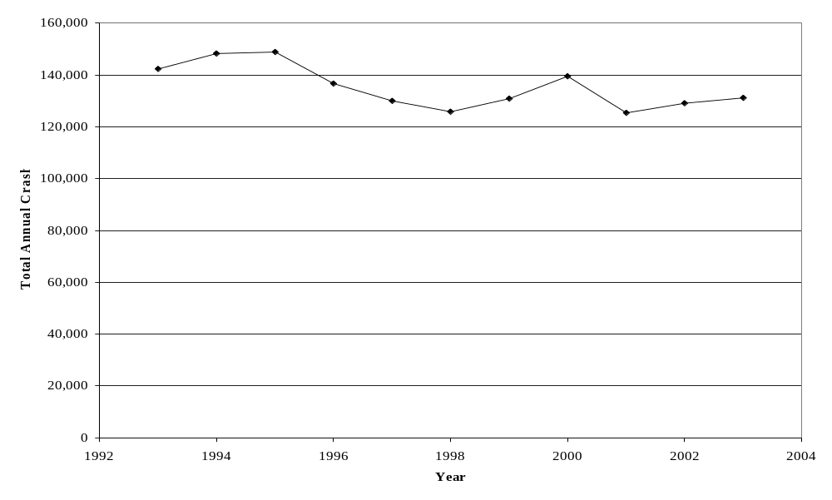
FIGURE 30 Total crashes reported in Wisconsin (1993 to 2003).
Note: Minimum property damage reporting threshold changed from $500 to $1,000 on January 1, 1996.

The total AVMT from 1993 to 2003 in Wisconsin is shown in Figure 31. The number of AVMT in Wisconsin has increased from 48,805 million miles in 1993 to 59,617 million miles in 2003. This increase has been relatively consistent at 2.2 percent per year (See Figure 31). The average Wisconsin AVMT from 1993 to 2003 was 54,795 million miles.

Total and Percent Deer-Vehicle Crashes
The total number of DVCs reported and summarized in Wisconsin between 1993 and 2003 are shown in Figure 32. The annual number of reported DVCs from 1993 to 1995 increased slightly. A total of 22,819 DVCs were reported in 1993 and 23,922 DVCs in 1995 (with an average of 23,772 DVCs during this time period). In 1996 the number of DVCs reported decreased by 16.7 percent (possibly due in some part to the noted change in minimum property damage crash reporting threshold) and then stabilized. The number of DVCs reported was 19,932 in 1996 and 21,666 in 2003 (an increase of 8.7 percent). The average number of reported DVCs from 1996 to 2003 was 20,313. From 1993 to 2003, the maximum annual number of DVCs reported in Wisconsin was 24,575 in 1994 and the minimum was 19,167 in 1997.
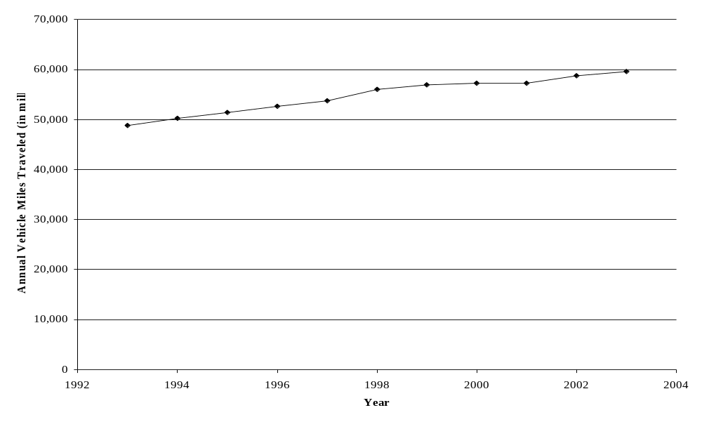
FIGURE 31 Annual vehicle-miles-traveled in Wisconsin (1993 to 2003).

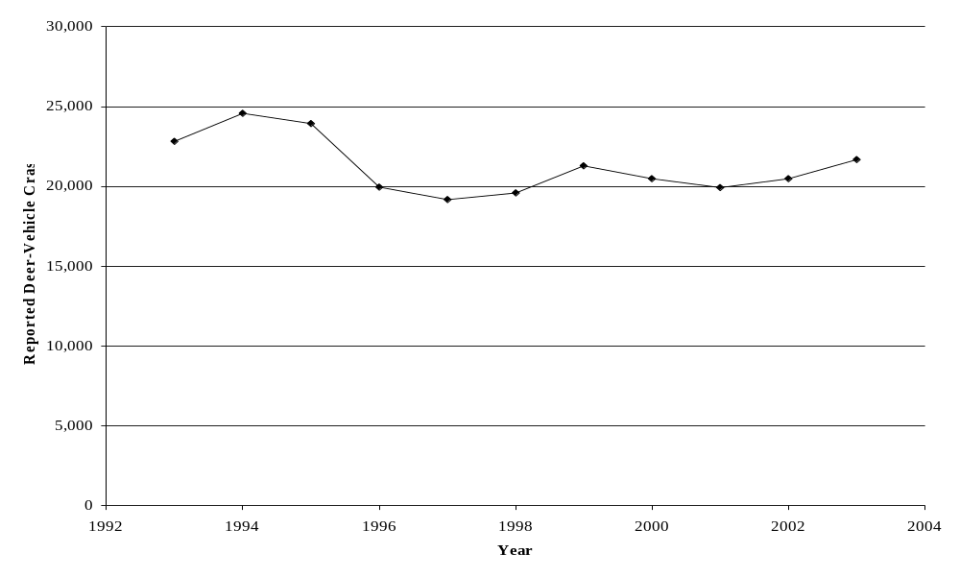
FIGURE 32 Reported deer-vehicle crashes in Wisconsin (1993 to 2003).
Note: Minimum property damage reporting threshold changed from $500 to $1,000 on January 1, 1996.

The total crash and DVC data from Figures 30 and 32 were used to calculate the percentage of reported crashes represented by DVCs in Wisconsin (See Figure 33). These calculations were done for each year from 1993 to 2003. Overall, the percentage of total crashes represented by DVCs in Wisconsin averaged 15.7 percent from 1993 to 2003, but fluctuated from a minimum of 14.6 percent in 1996 to a maximum of 16.6 percent in 1994. The decrease in the DVC percentage between 1995 and 1996 may partly be due to the change in the minimum crash reporting property damage threshold (See Figure 33).

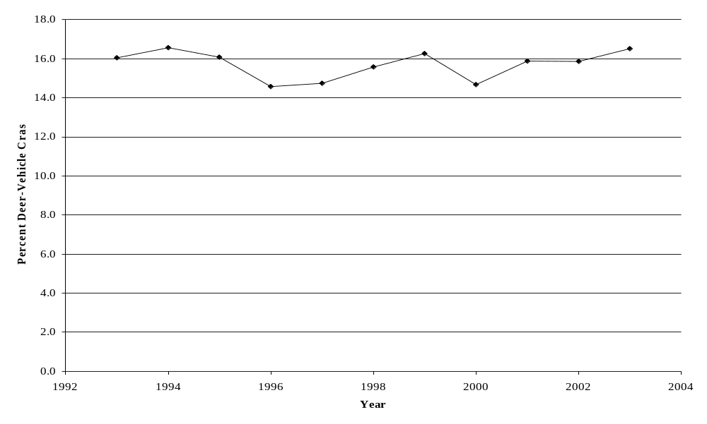
FIGURE 33 Percent deer-vehicle crashes in Wisconsin (1993 to 2003).
Note: Minimum property damage reporting threshold changed from $500 to $1,000 on January 1, 1996.

Deer-Vehicle Crash Injuries and Fatalities
The annual number of DVC injuries and fatalities in Wisconsin from 1993 to 2003 are shown in Figure 34. Overall this safety measure increased from 1993 to 1994, but has remained relatively stable from 1994 to 2003. The minimum annual number of DVC injuries and fatalities reported during this period was 570 in 1993, but the annual DVC injuries and fatalities from 1994 to 2003 only ranged from a minimum of 716 in 2002 to a maximum of 847 in 1999 (with an average of 796). The actual number of DVC fatalities and injuries from 1993 to 2003 are shown in Appendix A-5.

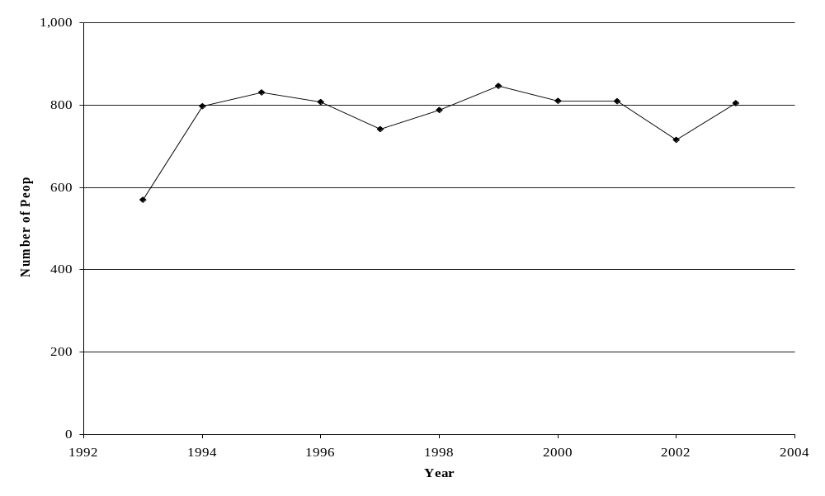
FIGURE 34 Number of deer-vehicle crash fatalities and injuries
in Wisconsin (1993 to 2003).

Overall, there were a total of 70 DVC fatalities and 8,456 DVC injuries in Wisconsin from 1993 to 2003. The minimum number of annual fatalities was 3 during this time period and this occurred in 1993 and 1996. However, a maximum of 13 fatalities occurred in 2003. The fewest number of DVC injuries recorded was in 1993 with 567, and the most was in 1999 with 841. Overall, there was an average of 6 DVC fatalities and 769 DVC injuries reported each year in Wisconsin from 1993 to 2003.

Deer-Vehicle Crash Rate
One of the factors related to the occurrence of DVCs is the amount of vehicle travel that occurs in a jurisdiction (e.g. AVMT). A common measure of roadway safety is a crash rate defined by the number of reported crashes per 100 million vehicle-miles-traveled (HMVMT). For this summary the DVC rate was calculated for each year and used the statewide AVMT and DVCs previously described (See Figures 31, 32, and 35). It should be recognized that this calculation is a general statewide measure, and should be recalculated when the DVC safety of individual roadway segments (which could have a DVC rate that is very different) are investigated.

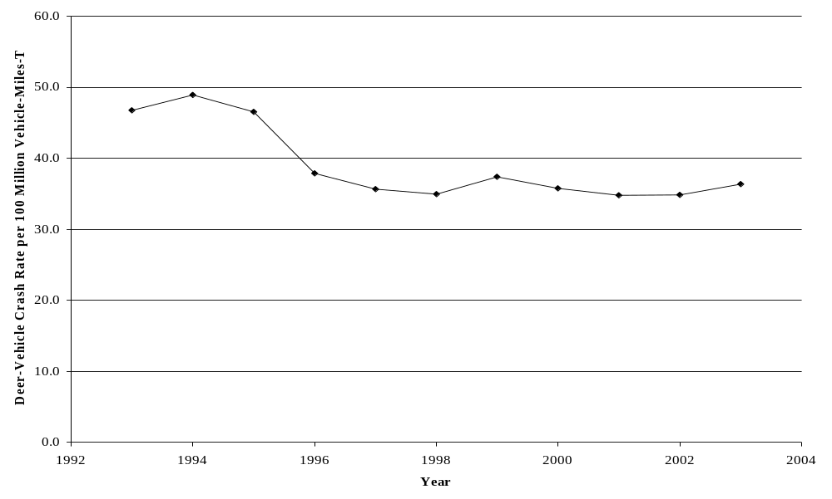
FIGURE 35 Deer-vehicle crash rate per 100 million vehicle-miles-traveled
in Wisconsin (1993 to 2003).
Note: Minimum property damage reporting threshold changed from $500 to $1,000 on January 1, 1996.

Not surprisingly, the DVC rate trend in Wisconsin is generally the same as that experienced by the total number of reported DVCs (See Figure 32). This similarity is generally due to the consistent increase in AVMT. The statewide DVC rate from 1993 to 1995 was relatively stable, and ranged from 46.6 DVCs per HMVMT in 1995 to 48.9 DVCs per HMVMT in 1994 (with an average of 47.4 DVCs per HMVMT during this time period).

In 1996 the DVC rate decreased by 18.6 percent (possibly due in some part to the noted change in minimum property damage crash reporting threshold), and then stabilized. From 1996 to 2003, the maximum DVC rate in Wisconsin was 37.9 DVCs per HMVMT in 1996 and the minimum was 34.8 DVCs per HMVMT in 2001. The average DVC rate during this time period was 36.0 DVCs per HMVMT.

Deer Population Estimates and Roadside Carcass Removal Data
Another factor that is related to the occurrence of a DVC is the number, density, and/or movement of the deer population in a jurisdiction. For Wisconsin, an annual pre-hunt white-tailed deer population estimate was provided for 1993 to 2003. These estimates are shown in Figure 36 along with the number of DVCs. Overall, the annual deer population estimate for Wisconsin has generally increased from 1,152,000 deer in 1993 to 1,663,000 deer in 2003 (an increase of 44.4 percent). The minimum deer population estimate, however, was 1,152,000 deer in 1993 and the maximum 1,818,000 deer in 2000. During this time, AVMT also increased. The number of DVCs reported, on the other hand, was generally stable from 1993 to 1995, decreased from 1995 to 1996 (possibly due to a change in the minimum property damage crash reporting threshold), and then increased slightly from 1996 to 2003.

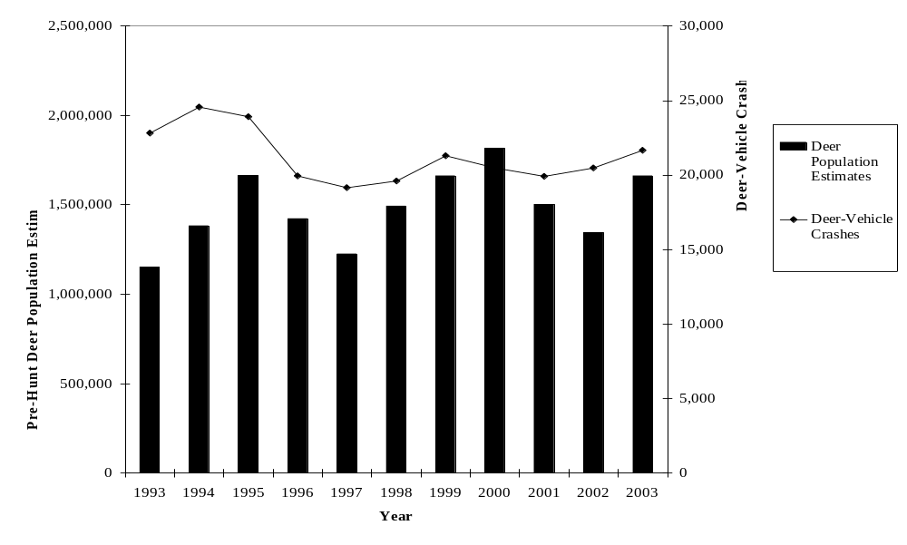
FIGURE 36 Pre-hunt deer population estimates and deer-vehicle crashes
in Wisconsin (1993 to 2003).
Note: Minimum property damage reporting threshold changed from $500 to $1,000 on January 1, 1996.
As previously mentioned, roadside carcass removal data were also obtained from the WisDNR for the years 1993 to 2003. The data provided combines the number of salvage permits issued (i.e., those roadside carcasses requested by the public) and the unsalvaged or maintenance removals completed by WisDNR contractors. The annual number of carcasses removed in Wisconsin from 1993 to 2003 are shown in Figure 37 along with the number of DVCs reported each year. Figure 37 shows that the number of carcasses removed has continued to increase while the number of reported DVCs each year has been relatively stable. The deer population and carcass data provided by Wisconsin are shown in Appendix A-5.

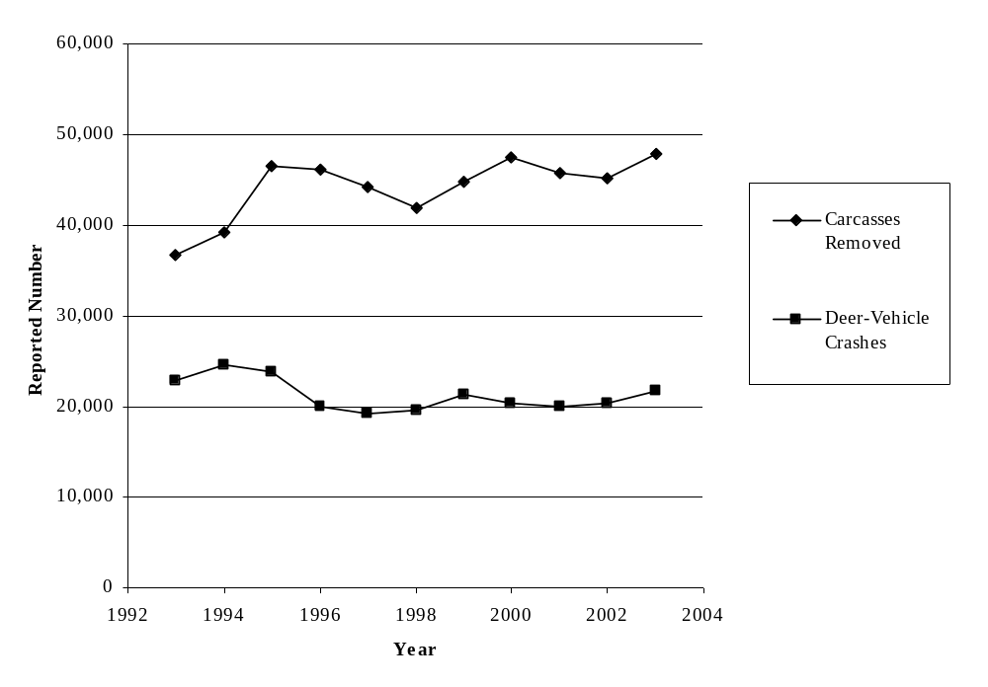
FIGURE 37 Roadside carcass removals and reported deer-vehicle crashes
in Wisconsin (1993 to 2003).
Note: Minimum property damage reporting threshold changed from $500 to $1,000 on January 1, 1996.

There are typically more DVCs or AVCs occurring in a jurisdiction than the number reported by the police. This pattern is especially obvious in Wisconsin, which is one of only a few states that summarize roadside carcass removals each year. The number of carcasses removed from Wisconsin roadways has generally increased from 36,787 in 1993 to 47,841 in 2003 (a 30 percent increase). The average carcass removal to reported DVCs ratio has also generally increased from 1.6 in 1993 to 2.2 in 2003, but averaged 2.1 over this period.

Overall, there are several reasons the number of reported DVCs and carcasses removed are different. These reasons include, but are not limited to the consistency of carcass collection and recording between jurisdictions and from year to year, and DVCs that are not reported (for whatever reason) but result in the death of an animal. Changes in these factors can increase or decrease the ratio of reported DVCs to carcasses removed.

Wisconsin Summary
The data provided by Wisconsin are included in Appendix A-5. From 1993 to 2003 the average annual DVC percentage of all the crashes reported in Wisconsin was approximately 15.7 percent. The annual total number of reported DVCs decreased between 1995 and 1996 (possibly due in part to a change in the Wisconsin crash reporting minimum property damage threshold) and then remained relatively stable from 1996 to 2003. Deer are the third most commonly hit object behind striking another vehicle and striking a fixed object in Wisconsin (4). An evaluation of the Wisconsin DVC-related data showed the following general patterns:

- The annual total number of crashes reported and summarized in Wisconsin has decreased somewhat since 1995 (See Figure 30), but had an increasing trend from 1993 to 1995. The total annual number of reported crashes was greatest in 1995 at 148,864, but only 125,403 in 2001. The AVMT in Wisconsin has consistently increased during the study time period (See Figure 31).
- The annual number of DVCs reported in Wisconsin was relatively stable (with a slight increase) between 1993 and 1995 and then from 1996 to 2003 (See Figure 32). The average annual number of DVCs reported in these two time periods were 23,772 and 20,313, respectively. A 16.7 percent decrease between 1995 and 1996 could be partly due to the change in the crash reporting minimum property damage threshold in Wisconsin (See Figure 32). The percentage of total crashes represented by DVCs, however, has remained relatively stable from 1993 to 2003 (although it did decrease somewhat between 1995 and 1996). The maximum annual DVC percentage was 16.6 percent in 1994 (the DVC percentage in 2003 was slightly smaller at 16.5 percent), and the minimum annual DVC percentage was 14.6 percent in 1996.
- The annual number of fatalities due to DVCs ranged from 3 to 13 between 1993 and 2003. There was a total of 70 DVC fatalities during these 11 years. The number of injuries and fatalities due to DVCs increased from 570 in 1993 to 798 in 1994 (an increase of 40 percent), but then averaged 796 between 1994 and 2003. The annual number of DVC injuries and fatalities reported from 1994 to 2003 has only ranged from 716 to 847.
- Similar to the number of DVCs reported, the DVC rate (i.e., the number of DVCs per HMVMT) in Wisconsin was relatively stable from 1993 to 1995 and then from 1996 to 2003 (See Figure 35). The average DVC rates in these two time periods were 47.4 DVCs per HMVMT and 36.0 DVCs per HMVMT, respectively. The 18.6 percent decrease between 1995 and 1996 could be partly due to the change in the crash reporting minimum property damage threshold in Wisconsin (See Figure 35). Overall, from 1993 to 2003, the Wisconsin DVC rate peaked at 48.9 DVCs per HMVMT in 1994 and was at a minimum of 34.8 DVCs per HMVMT in 2001.
- Wisconsin also provided annual deer population estimates and carcass removal numbers from 1993 to 2003. Figure 36 shows that the annual deer population estimates have generally increased from 1,152,000 deer in 1993 to 1,663,000 deer in 2003 (an increase of 44.4 percent). The minimum deer population estimate was 1,152,000 in 1993, and the maximum 1,818,000 in 2000. The number of carcasses removed from the roadside, on the other hand, increased from 36,787 in 1993 to 47,841 in 2003. The number of carcasses removed was about 1.6 to 2.3 times the number of DVCs reported annually from 1993 to 2003. The average of this measure was 2.1.

RegionAL AND NATIONAL DEER-VEHICLE CRASH SUMMARIES

The 1993 to 2003 DVC- or AVC-related data collected from Illinois, Iowa, Michigan, Minnesota, and Wisconsin were individually described in the previous section of this report. These data have been combined in the following paragraphs in the first attempt to describe and evaluate the DVC/AVC problem in the Upper Midwest. One of the goals of the DVCIC was to more closely define the DVC problem in this region. This report furthers that goal for the years 1993 to 2003.

Some caution is advised in the use and application of the regional data, however, because of the differences in their defining criteria from year to year and state to state. First, it should be recognized that the minimum property damage threshold for crash reporting sometimes differs. For the fives states considered in this report the minimum property damage threshold was $400, $500, and/or $1000. In addition, three of the states changed this threshold at some point between 1993 and 2003. Also, one state did not summarize their reported crash data for the entire state during particular years, and Iowa summarizes AVCs rather than DVCs. Finally, for a number of reasons (e.g., data management system changes) there were also several years of data that either were not available or questionable and needed to be dropped from consideration in this report. All of these criteria have already been defined in detail for each of the five states (See previous section). They are also noted, when appropriate, in the following regional data evaluation.

REGIONAL DATA EVALUATION

Total Crashes and Annual Vehicle-Miles-Traveled
The annual total number of crashes reported and summarized in the Upper Midwest from 1993 to 2003 are presented in Figure 38. The defining criteria for the data plotted in Figure 38 are noted and should be used in its interpretation. More specifically, the data provided by IDOT from 1996 to 1999 does not include non-fatal crashes within the City of Chicago, and the data for 2001 and 2003 does not include Iowa and Minnesota, respectively (See the previous state-focused section of this report for more detail).

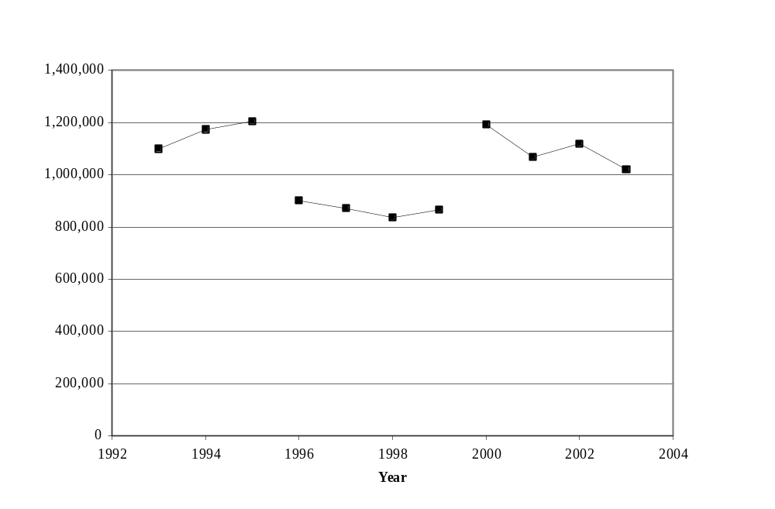
FIGURE 38 Total crashes reported in the Upper Midwest (1993 to 2003).
Note: Minimum property damage reporting thresholds may be different from state to state. Iowa data is for animal-vehicle crashes. Data from 1996 to 1999 does not include non-fatal crashes reported within the City of Chicago. Data from 2001 and 2003 does not include Iowa and Minnesota, respectively.

The crash data in Figure 38 from 1993 to 1995, 2000, and 2002 (those years from 1993 to 2003 when all the reported crash data from all five Upper Midwest states were used) indicate that the annual total number of reported crashes in the Upper Midwest has been generally stable. For these five years, the total annual number of crashes reported in the region ranged from 1,099,343 in 1993 to 1,204,208 in 1995 (with a similar number of crashes reported in 2000). The average annual total number of crashes reported for 1993 to 1995, 2000, and 2002 was about 1,157,465. From 1993 to 1995 an increase of 9.5 percent in total crashes was observed, and from 2000 to 2002 (the 2003 data does not include Minnesota) a decrease of 6.2 percent is shown (See Figure 38). Overall, if the collisions reported in the City of Chicago were available from 1996 to 1999 it would appear that the annual total number of crashes reported in the Upper Midwest would likely have peaked during that time period. Some of the recent decrease in total reported crashes may be partially due to an increase in the Iowa, Minnesota, and Wisconsin minimum property damage threshold from $500 to $1000.

The total AVMT from 1993 to 2003 within the Upper Midwest is shown in Figure 39. The number of AVMT in this five-state region increased from 292,016 million miles in 1993 to 351,077 million miles in 2003. This increase has been relatively consistent at about 2.0 percent per year (See Figure 39). The average Upper Midwest AVMT from 1993 to 2003 was 323,226 million miles.
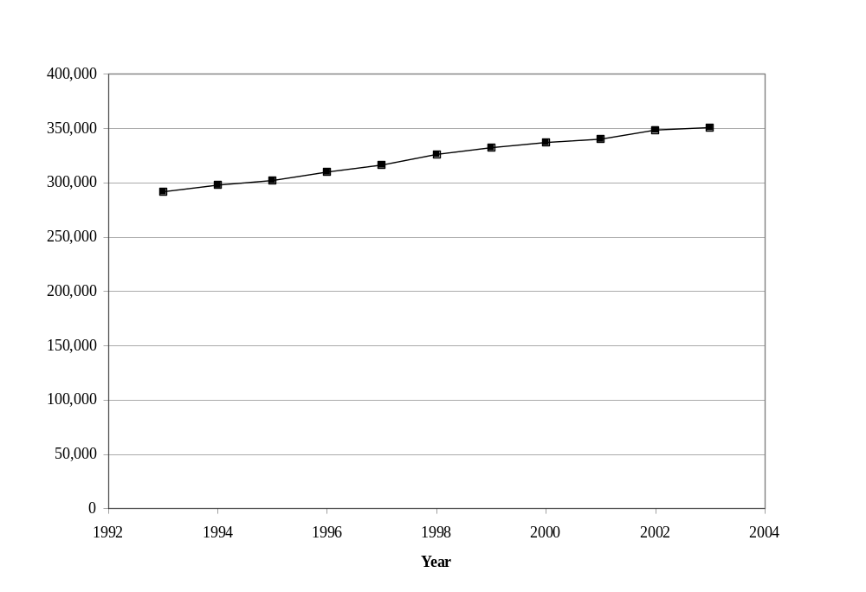FIGURE 39 Annual vehicle-miles-traveled in the Upper Midwest (1993 to 2003).

Total and Percent Deer-Vehicle Crashes
The total number of DVCs reported (or AVCs in the case of Iowa) and summarized in the Upper Midwest between 1993 and 2003 are shown in Figure 40. It is noted, however, that the data plotted for 1996 to 1999 does not include any non-fatal crashes reported within the City of Chicago and the data in 1996, 2001, and 2003 does not include Illinois,
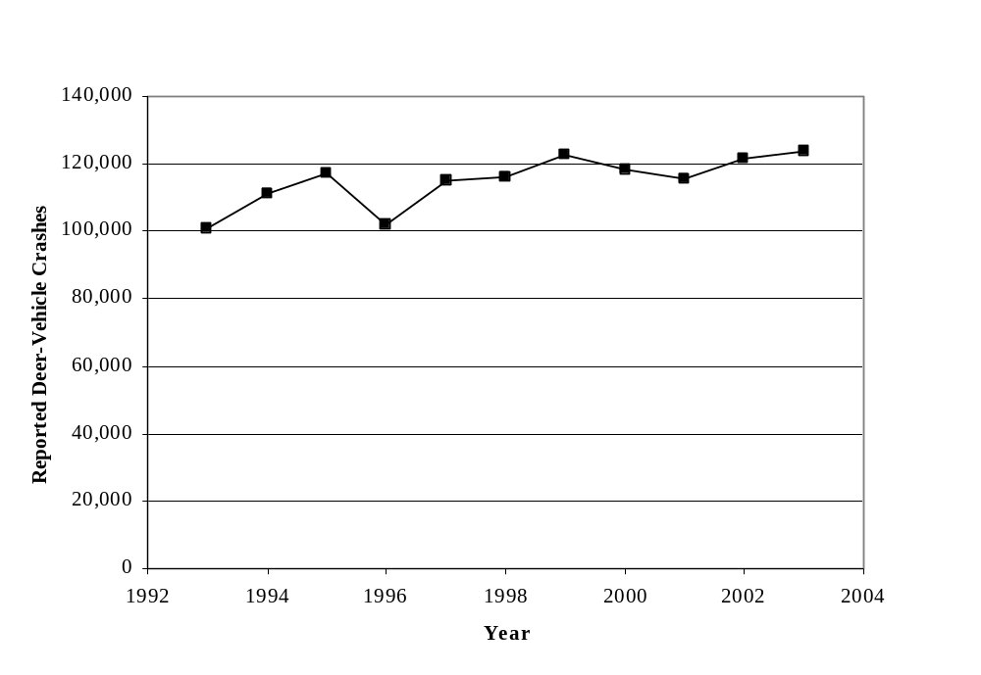
FIGURE 40 Reported deer-vehicle crashes in the Upper Midwest (1993 to 2003).
Note: Minimum property damage reporting thresholds may be different from state to state. Iowa data is for animal-vehicle crashes. Data from 1996 to 1999 does not include non-fatal crashes reported within the City of Chicago. Data from 1996, 2001, and 2003 does not include Illinois, Iowa, and Minnesota, respectively.

Iowa, and Minnesota, respectively. Fortunately, the general trend observed in the number of reported DVCs in the Upper Midwest can be observed despite the missing data. Overall, the annual number of reported DVCs has increased from 1993 to 2003. A total of 100,664 DVCs were reported in 1993 and 117,348 DVCs in 1995 (an increase of 16.6 percent), and from 1995 to 2003 the annual number of reported DVCs increased to 123,482 (a 5.2 percent increase). Overall, there has been a 22.7 percent increase in the annual number of DVCs reported in the Upper Midwest from 1993 to 2003 (this percentage would likely increase somewhat if Minnesota data were available for 2003). The maximum annual number of DVCs reported in the region between 1993 and 2003 was 122,809 in 1999.

The total crash and DVC data from Figures 38 and 40 were used to calculate the percentage of reported crashes represented by DVCs in the Upper Midwest (See Figure 41). These calculations were done for each year from 1993 to 2003. Overall, an
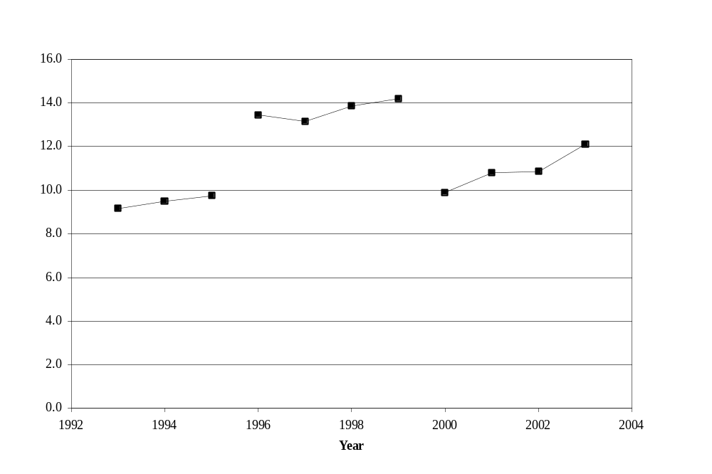
FIGURE 41 Percent deer-vehicle crashes in the Upper Midwest (1993 to 2003).
Note: Minimum property damage reporting thresholds may be different from state to state. Iowa data is for animal-vehicle crashes. Data from 1996 to 1999 does not include non-fatal crashes reported within the City of Chicago. Data from 1996, 2001, and 2003 does not include Illinois, Iowa, and Minnesota, respectively.

increasing trend is shown in this safety measure for the five years when all the crash data are available from all five states (i.e., 1993 to 1995, 2000, and 2002) The DVC percentage from 1993 to 2002 (the last year with data from all five states) went from 9.2 to 10.9 percent (an overall increase of 18.5 percent). The annual increase in the DVC percentage during this time period was 2.1 percent. The data plotted in Figure 41 for 1996 to 1999 does not include non-fatal crashes reported in the City of Chicago, but the annual DVC percentages calculated for this time period also increased from 13.5 to 14.2 percent (a 5.2 percent increase). The annual increase in DVC percentage during these four years was 1.7 percent.

The data plotted in Figure 41 should be interpreted with respect to the data available (See notes in Figure 41). First, some of the increase shown in the DVC percentage for 1996, 2001, and 2003 (when Illinois, Iowa, and Minnesota data, respectively, were not available) is likely due to these three states having a smaller DVC percentage than the states for which data were available (See the previous discussions and figures for these individual states). Second, the impact of not having the non-fatal crash data from within Chicago has a dramatic impact on this regional safety measure. Figures 38 and 40 show that non-fatal Chicago crashes represent a large percentage of the total crashes occurring in the region and that only a relatively small number of these non-fatal crashes are DVCs. It is concluded the change in DVC percentage shown in Figures 4 (for Illinois only) and 41 would likely occur to some extent in any state that has one large urban area and excludes it from its DVC percentage calculations. The larger DVC percentage shown may be representative of the crashes experienced along rural roadways in that state.

Deer-Vehicle Crash Injuries and Fatalities
The annual number of DVC injuries and fatalities (or AVC injuries and fatalities in Iowa) in the Upper Midwest from 1993 to 2003 are shown in Figure 42. Ignoring 1996, which does not include any Illinois data, this safety measure increased from 1993 to 1999 (even without having the injury producing DVCs from the City of Chicago between 1996 and 1999). Ignoring 2001 and 2003 (when data from Iowa and non-fatal DVC data from Minnesota were not used), the number of DVC injuries and fatalities then decreased somewhat from 1999 to 2002. The minimum annual number of DVC injuries and fatalities reported during the time period, when both pieces of data from all five states were available, was 3,900 in 1993. The annual number of DVC injuries and fatalities reported in the region then increased to a maximum of 5,342 in 1999. This difference in DVC injuries and fatalities represents an increase of 37 percent. The decrease in the number of DVC injuries and fatalities reported in the Upper Midwest from 1999 to 2002 was 5.3 percent. The annual number of DVC/AVC fatalities and injuries reported from 1993 to 2003 and used in Figure 42 are shown in Appendix A-6.

Overall, there were a total of 229 DVC fatalities (and 51,609 DVC injuries in the Upper Midwest from 1993 to 2003 (excluding the data from those locations and years noted in Figure 42). The minimum number of annual fatalities during this time period was 12 and
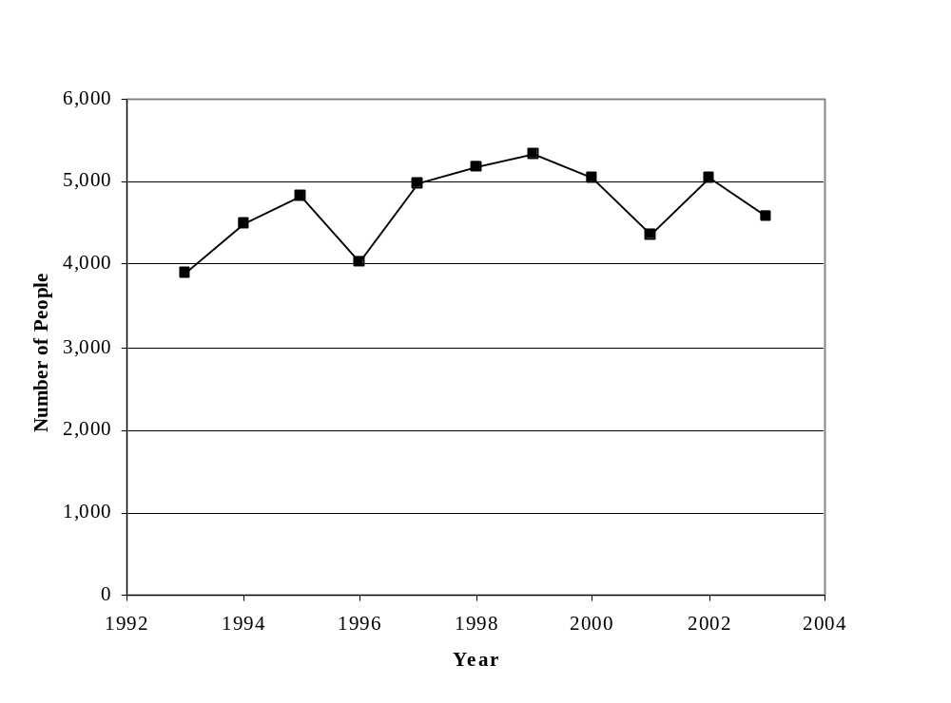

FIGURE 42 Number of deer-vehicle crash fatalities and injuries
in the Upper Midwest (1993 to 2003).
Note: Iowa data is for animal-vehicle crashes. Data from 1996 to 1999 does not include non-fatal crashes reported within the City of Chicago. Data from 1996 and 2001does not include Illinois and Iowa, respectively. Only fatality data were available for Minnesota in 2003.

occurred in 1993. However, a maximum of 45 fatalities occurred in 2003. The fewest number of DVC injuries recorded was in 1993 with 3,888, and the most was in 1999 with 5,324 (even without non-fatal DVC data from Chicago). Overall, a weighted average (by the number of states for which data was available) of 21 DVC fatalities and 4,715 injuries were reported each year in the Upper Midwest from 1993 to 2003.

Deer-Vehicle Crash Rate
One of the factors related to the occurrence of DVCs (AVCs in Iowa) is the amount of vehicle travel that occurs in a jurisdiction (e.g., AVMT). A common measure of roadway safety is a crash rate defined by the number of reported crashes per 100 million vehicle-miles-traveled (HMVMT). For this summary the DVC rate was calculated for each year and used the regional AVMT and DVCs previously plotted and described (See Figures 39, 40, and 43). It should be recognized that this calculation is a general measure, and should be recalculated when the DVC/AVC safety of individual roadway segments (which could have a rate that is very different) are investigated.
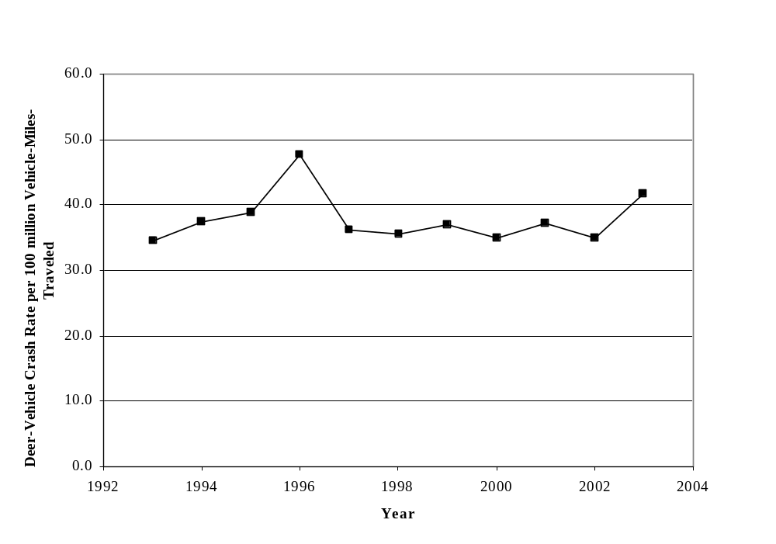
FIGURE 43 Deer-vehicle crash rate per 100 million vehicle-miles-traveled
in the Upper Midwest (1993 to 2003).
Note: Minimum property damage reporting thresholds may be different from state to state. Iowa data is for animal-vehicle crashes. Data from 1996 to 1999 does not include non-fatal crashes reported within the City of Chicago. Data from 1996, 2001, and 2003 does not include Illinois, Iowa, and Minnesota, respectively.

Figure 43 shows that the regional DVC rate trend has been relatively stable from 1993 to 2003. The variability shown in Figure 43 is primarily due to the inability to use DVC data from Illinois in 1996, Iowa in 2001, and Minnesota in 2003. In fact, the large increase in the DVC rate for 1996 shows how much of an impact the exclusion of one state can have on a regional measure of this type. Illinois, with Chicago, represents a relatively large part of the regional AVMT, but a smaller portion of the total reported DVCs. The largest DVC rate when data from all five states were available was 38.8 DVCs per HMVMT in 1995. The smallest calculated rate was 34.8 DVCs per HMVMT in 2002. The overall range of this measure for all five states was only 4.0 DVCs per HMVMT, and the average annual five-state DVC rate was 36.1 DVCs per HMVMT.

Deer Population Estimates and Roadside Carcass Removal Data
Another factor that is related to the occurrence of a DVC is the number, density, and/or movement of the deer population in a jurisdiction. For the Upper Midwest, Iowa provided annual post-hunt white-tailed deer population estimates for 1993 to 2003, and Michigan, Minnesota (except for 1993), and Wisconsin provided pre-hunt estimates. Illinois did not provide deer population estimates.

A combination of the annual statewide deer population estimates are shown in Figure 44 along with the annual number of DVCs/AVCs reported in those particular states. The years for which deer population or DVC/AVC data were not used or available are noted in Figure 44, and only those years for which both pieces of data were available for at least four states are summarized here. For example, the annual deer population estimate for the Upper Midwest increased from 4,359,678 deer in 1994 to 5,091,614 deer in 1995 (an increase of 16.8 percent). It then decreased to a minimum estimate of 4,029,682 deer in 1997 (a 20.9 percent decrease) before increasing to a maximum annual estimate of 5,107,837 in 2000 (a 26.8 percent increase). Deer population estimates for the Upper Midwest decreased by 6.2 percent between 2000 and 2002. The number of DVCs/AVCs reported in the four states that provided DVC/AVC and deer population data, on the other hand, initially increased 7.9 percent from 1994 to 1996, remained relatively stable from 1996 to 2000 (averaging 99,578) and then decreased 2.1 percent between 2000 and 2002. A similar pattern in annual deer population estimates is found if all the data available is plotted separately (instead of just those states in which annual reported DVCs/AVCs were also available as shown in Figure 44), but the annual estimate for the Upper Midwest (not including Illinois) appear more stable after 2000.

Annual roadside carcass removal data from 1993 to 2003 were also obtained from Iowa, Minnesota (excluding 1995), and Wisconsin. The summary below focuses on those years when both DVC/AVC and carcass data were available for these three states. Carcass
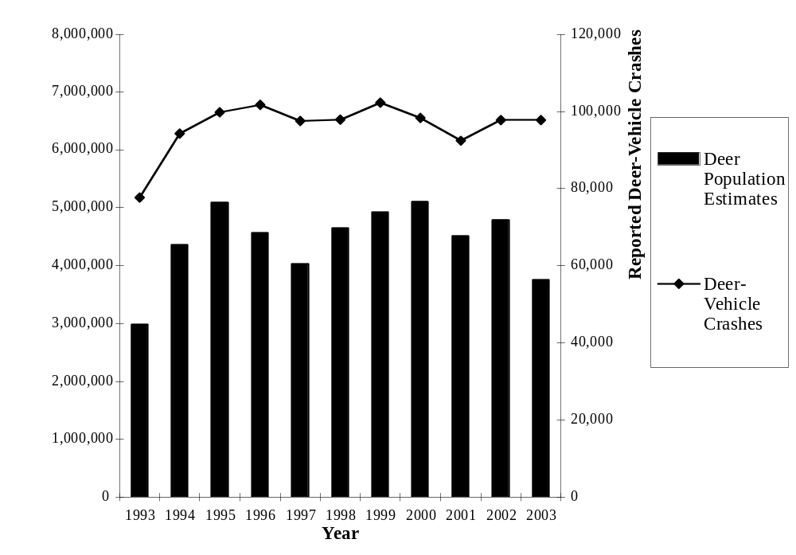

FIGURE 44 Pre-hunt deer population estimates and deer-vehicle crashes
in the Upper Midwest (1993 to 2003).
Note: Minimum property damage reporting thresholds may be different from state to state. Iowa data is for animal-vehicle crashes. Crash and population data does not include Illinois (1993 to 2003), Iowa (2001), and Minnesota (1993 and 2003).
Deer population data is post-hunt for Iowa.

removal data typically includes a combination of the number of salvage permits issued (i.e., those roadside carcasses requested by the public) and the unsalvaged or maintenance removals completed. The annual number of carcasses removed and reported DVCs/AVCs in the Upper Midwest from 1993 to 2003 are shown in Figure 45 for those states that provided both DVC/AVC and carcass removal data. The figure shows that the number of carcasses removed has generally increased from 1993 to 1996 (a 12.6 percent increase) and then stabilized from 1996 to 2000 (averaging 68,015). Both pieces of data were only available from Wisconsin and Iowa in 1995. A decrease in the carcasses removed of 3.2 percent is shown between 2000 and 2002 (data from only two states were available for 2001 and 2003). Figure 45 shows a somewhat different trend for the number of reported DVCs during these years for the states considered. This safety measure increased 3.4 percent from 1993 to1994, but then was relatively stable from 1996 to 2002 (an average of 33,468, excluding 2001). Both DVC and carcass removal data were only available for two states in 1995, 2001, and 2003 The deer population, carcass, and relevant DVC data for the Upper Midwest are shown in Appendix A-6.

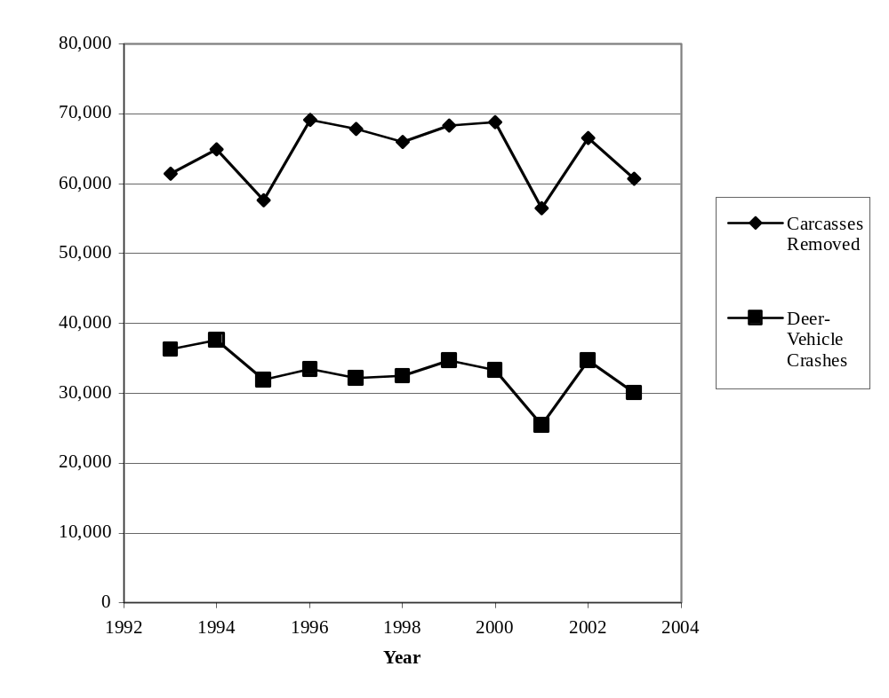
FIGURE 45 Roadside carcass removals and reported deer-vehicle crashes
in the Upper Midwest (1993 to 2003).
Note: Minimum property damage reporting thresholds may be different from state to state. Iowa data is for animal-vehicle crashes. Deer crash and carcass data does not include Illinois (1993 to 2003), Iowa (2001), Michigan (1993 to 2003),
and Minnesota (1995 and 2003).

There are typically more DVCs or AVCs occurring in a jurisdiction than the number reported to the police. This pattern was shown for the individual states described in this report, and also appears in Figure 45 for this regional summary. The crash and carcass data in Figure 45 is for only those states in which both types of information are available. Only two states are represented in 1995 (Wisconsin and Iowa) 2001 (Wisconsin and Minnesota), and 2003 (Wisconsin and Iowa). All the other years include data from all three states that record carcass removals. Overall, from 1993 to 2003 the average carcass removal to reported DVC ratio was 2.0. It ranged from a minimum of 1.7 in 1993 and 1994 to a maximum of 2.1 in 1997.

Overall, there are several reasons the number of reported DVCs and carcasses removed are different. These reasons include, but are not limited to, the consistency of carcass collection and recording between jurisdictions and from year to year, and DVCs that are not reported (for whatever reason) but result in the death of an animal. Changes in these factors can increase or decrease the ratio of reported DVCs to carcasses removed.

Regional Summary
The data provided by the five states in the Upper Midwest region of the United States are included in Appendix A-6. The 2002 (last year that data from all five states was available) DVC percentage (AVCs for Iowa) of all crashes reported in the Upper Midwest was approximately 10.7 percent. The annual total number of reported DVCs (AVCs for Iowa) has increased by about 17.3 percent in the Upper Midwest between 1993 and 2000. An evaluation of the DVC- or AVC-related data from Illinois, Iowa, Michigan, Minnesota, and Wisconsin showed the following general patterns:

- The annual total number of crashes reported and available for the Upper Midwest is shown in Figure 38 (See figure for the data that were not available). Overall, the annual number of crashes reported in the Upper Midwest has been generally stable when data for all five states were available (i.e., 1993 to 1995, 2000, and 2002). For these five years, the total annual number of crashes reported in the region ranged from 1,099,343 in 1993 to 1,204,208 in 1995 (with a similar number of crashes reported in 2000). The average annual total number of crashes reported from 1993 to 1995, 2000, and 2002 was 1,157,465. The AVMT in Upper Midwest has consistently increased during the study time period (See Figure 39).
- Overall, the annual number of reported DVCs (AVCs in Iowa) increased quite quickly from 1993 to 1995 and then continued to increase at a slower rate from 1995 to 2003. An increase of 16.6 percent occurred between 1993 and 1995, and a further increase of 5.2 percent happened between 1995 and 2003. Overall, there has been a 22.7 percent increase in the annual number of DVCs reported in the Upper Midwest between 1993 and 2003.
- The percentage of total crashes represented by DVCs also increased from 9.2 percent in 1993 to 10.9 percent in 2002 (the last year with data from all five states available). It should be noted, however, that this regional percentage increased dramatically (See Figure 41) when the non-fatal crashes from the city of Chicago were not available (e.g., 1996 to 1999) for this calculation. Excluding 1996, due to questions about the DVC data provided by Illinois, the average DVC/AVC percentage for the region was about 13.7 percent for this time period.
- The annual number of fatalities in the Upper Midwest due to DVCs ranged from 12 to 45 between 1993 and 2003.The number of injuries and fatalities due to DVCs increased from 3,900 in 1993 to 5,342 in 1999 (an increase of 37 percent), but then decreased to 4,981 in 2002. A total of 51,609 DVC injuries were reported during the eight years for which this data was used or available (although there were also two additional years when non-fatal crashes from the City of Chicago were not available).
- The Upper Midwest DVC rate (i.e., the number of DVCs per HMVMT) was relatively stable from 1993 to 2003 (See Figure 43). The variability that does appear in Figure 43 is primarily due to the inability to use the crash data from at least one state in 1996, 2001, and 2003. The largest DVC rate in the Upper Midwest, when the crashes from all five states were used, was 38.8 DVCs per HMVMT in 1995, and the smallest was 34.8 per HMVMT in 2002. The average annual DVC rate for all five states from 1993 to 2003 was 36.1 DVCs per HMVMT.
- Four states in the Upper Midwest provided annual deer population estimates for most of the 1993 to 2003 time period. Three states also provided deer carcass removal numbers. For comparison purposes, the annual deer population estimates shown in Figure 44 are only for those in which DVC data were also available (this excludes 1993, 2001, and 2003). The Upper Midwest annual deer population estimates shown in Figure 44 generally follow a cyclical pattern (a similar pattern is also followed when the deer population estimates of all four states are plotted, but with a relatively stable annual estimate past 2000). From 1994 to 1995 there was an increase in the estimated deer population and from 1995 to 1997 there was a decrease. The minimum deer population estimate, when data from all four states were used, was 4,029,682 deer in 1997. The deer population estimate increased from 4,029,682 deer in 1997 to a maximum of 5,107,837 deer in 2000. The number of carcasses removed from the roadside, on the other hand, generally increased from 61,429 in 1993 to 69,148 in 1996 (a 12.6 percent increase) and then stabilized from 1996 to 2000 (averaging 68,015). The number of carcasses removed ranged from about 170 to 210 percent of the DVCs reported between 1993 and 2003 (when data from all three states were used). The average of this measure was about 200 percent.

NATIONAL DATA ESTIMATES

A small number of estimates and evaluations have been completed that focus on the national DVC/AVC safety problem. These activities are discussed in detail within the following paragraphs.

Total Deer-Vehicle Crashes
It has been estimated that more than a million DVCs occur each year in the United States (1). This estimate was based on the results of a 1992 survey in which 35 state natural resource agencies indicated they had experienced 538,000 vehicle-killed deer in 1991. Conover, et al. then estimated the number of DVCs for the entire United States by increasing the recorded 538,000 by the percentage of land represented by those states that have deer but did not respond to the survey (1). This increased the DVC estimate for the United States to 726,000 (1).

There were 35 respondents to the 1992 survey mentioned above but the basis of the statewide DVC estimates from 11 of these responses were undefined and 24 were based on police-reported DVCs or documented roadside deer carcasses (5). The application of police-reported DVC and deer carcass databases, however, has been shown to produce dramatically different DVC estimates (see below) and they also have different defining criteria. The approach used to develop this estimate also assumes that police-reported DVCs and roadside carcasses would occur at the survey respondent rate within the non-respondent states. It has also been estimated that at least 50 percent of all DVCs are not “reported or documented”, and a portion of this appears to have been used to arrive at a final DVC estimate for the United States of over a million crashes per year (1). However, others have used these numbers to arrive at an estimate of more than 1.5 million crashes per year (5). Unfortunately, the original 538,000 DVC estimate was based on both police-reported DVCs and roadside deer carcass data, and it is highly unlikely that the estimated percentage of “unreported” DVCs applies equally to these two databases.

A “reported” DVC often means something different to transportation and natural resource professionals. Department of Transportation (DOT) personnel often estimate reported DVCs by using police-reported crash records (2, 5, 7). Department of Natural Resources (DNR) personnel use this same information and/or estimate “reported” DVCs with a combination of roadside carcass possession/salvage permits and carcass removal data (2, 5, 7). One summary of 26 DOT responses produced a “reported” DVC estimate of approximately 237,000 (7). “Reported” DVC estimates from the 26 DNR respondents in the same states revealed an estimate of about 481,000 (7). The basis for these estimates could be one or more of the databases identified above, but how the databases were used to do the estimates was not documented and they were not consistently applied.

In 1995, the Highway Safety Information System (HSIS) was also used to evaluate the magnitude of the AVC problem in the United States (8). Data from five states (the total number in the HSIS at the time) were evaluated and it was shown that the percentage of all reported crashes that were AVCs increased from 4.7 percent in 1985 to 8.2 percent in 1991 (8). In the five states considered, however, this percentage increased to 21 percent when only two-lane rural roadways were considered (8). Less than 0.2 percent of the AVCs in the HSIS database resulted in a fatality and about 5 percent resulted in injuries (8).

Fatal and Non-Fatal Animal-Vehicle Crashes
Evaluations and/or estimates of fatal and non-fatal AVCs in the United States have also recently been completed (9, 10). The Insurance Institute for Highway Safety (IIHS), for example, considered National Highway Traffic Safety Administration data from 1993 to 2002 and found an annual average of more than 13,700 reported AVCs that produced injured vehicle occupants and 137 AVCs in which someone was killed (9). They also found that the average number of AVC crashes resulting in fatalities increased from 119 (1993 to 1997) to 155 (1998 to 2002) (9).

The IIHS study authors also reviewed the details of 147 fatal AVCs that occurred between 2000 and 2002 within nine states (9). These crashes represented 32 percent of the reported fatal AVCs in the United States during that time period. The characteristics of these crashes were investigated and it was found that deer were involved in 80 percent of the AVCs reviewed (9). About 55 percent of the AVCs involved passenger vehicles and 37 percent motorcycles (9). In addition, 80 percent of these fatal AVCs involved a single vehicle, but 38 percent of the fatal AVCs were motorcyclists coming off their vehicles (9). Another 36 percent of the fatal AVCs were passenger cars hitting the animal and then running off the road, hitting a fixed object and/or overturning (9). Only eight fatal single vehicle AVCs involved a windshield intrusion (9). The fatal AVCs involving multiple vehicles that were reviewed, primarily consisted of an animal struck by one vehicle penetrating the windshield of an oncoming vehicle, one vehicle striking the animal and then colliding with the other vehicle, and/or the animal being struck by two vehicles and the second vehicle running off the road and striking a fixed object or overturning (9). The IIHS researchers concluded that motorcyclists were over-represented (in the United States there are 41 passengers cars registered for every one motorcycle), and that improved use of seat belts and helmets could have prevented many of the AVC fatalities evaluated (9). Between 1994 and 2004 the number of annual AVC fatalities (not fatal AVCs) in the United States has ranged from 131 (in 1994) to 204 (in 2004), representing a 56 percent increase (11).

The United States Centers for Disease Control and Prevention (CDC) has also considered hospital emergency department information about non-fatal AVCs (8). From a sample of 676 emergency department patients it was estimated that 26,647 motor vehicle occupants were non-fatally injured in AVCs (and visited a hospital) within the United States in 2001 and 2002 (10). Approximately 85 percent of these collisions involved large animals (e.g., deer, moose, and elk). In addition, injuries to people 15 to 24 years old were over-represented when AVC injury distributions were compared to those for all other crash types (10). About 54 percent of the large animal non-fatal AVCs considered in the study involved a direct collision with the animal, but it was also found that approximately 64 percent of younger drivers swerved to avoid the animal (10). Almost 30 percent of the non-fatal AVCs (where someone went to the hospital) involved running off the road, about 21 percent hit a tree, pole or guardrail, and 17 percent included an overturned vehicle (10).

Conclusions and Recommendations
The purpose of this report was to define and better understand the magnitude and trends of the DVC/AVC problem in the Upper Midwest region of the United States (Illinois, Iowa, Michigan, Minnesota, and Wisconsin). DVC- or AVC-related data were obtained from these states and individually summarized. The defining criteria of the 1993 to 2003 data summarized are noted for the proper interpretation of figures included in this report. When appropriate, the state data were also combined to evaluate and describe the DVC/AVC problem in the region. Most states have not investigated their DVC/AVC problem to this extent and this is the first detailed regional analysis of this data that has been completed in the United States.

The following conclusions identify the data obtained to create this report and briefly summarize the trends found in these statewide and regional data from 1993 to 2003. Additional details about the data can be found in the individual data summaries found throughout this document. The data used to produce all the figures in this report are also contained in Appendices A-1 to A-6. The recommendations provided in this chapter focus on improvements in the collection and combination of DVC or AVC data.

CONCLUSIONS
- DVC-related data (or AVCs in the case of Iowa) from 1993 to 2003 were obtained from Illinois, Iowa, Michigan, Minnesota, and Wisconsin for this report. The data collected, if possible, included annual total reported crashes, annual vehicle-miles-traveled, DVC or AVC reported crashes, DVC or AVC injuries and fatalities, deer population estimates, and carcass removals (salvageable and/or unsalvageable). The criteria that define these data are also included in this report to allow for proper interpretation of the plots. These criteria can vary from state to state and year to year.
- The total number of crashes reported in the Upper Midwest region from 1993 to 2003 has remained relatively stable. Several states have experienced a stable or increased level of reported crashes and Iowa’s total has generally decreased. AVMT has increased steadily in all five states and regionally from 1993 to 2003.
- Regionally, the number of reported DVCs or AVCs (in Iowa) increased by approximately 23 percent from 1993 to 2003. The growth was relatively quick from 1993 to 1995 and then at a slower rate from 1995 to 2003. The reported DVC/AVC trends in each state, however, were somewhat different. The number of reported DVCs/AVCs in Illinois has increased and this also occurred from 1993 to 1996 in Iowa and Michigan. Minnesota experienced a decrease in reported DVCs from 1993 to 1997 and then an increase. The number of reported DVCs in Wisconsin, on the other hand, has been relatively stable. In several states there have also been time periods of reported DVC/AVC reduction and stability.
- The percentage of reported crashes represented by DVCs or AVCs has generally increased or remained stable in the five Upper Midwest states considered here. The percentage in Illinois, Iowa, and Michigan has increased and has been relatively stable in Wisconsin. In Minnesota the percentage of all crashes represented by DVCs decreased from 1993 to 1996 and then increased. Regionally, the DVC/AVC percentage increased from 9.2 to 10.9 percent from 1993 to 2002 (the last year data from all five states was available). This change is about a 19 percent increase in 10 years.
- The number of DVC or AVC injuries and fatalities reported annually in the Upper Midwest region has varied from state to state. In Iowa and Michigan an increase was observed from 1993 to 1997/1998 and then a decrease. In Minnesota the number of DVC/AVC injuries and fatalities has increased from 1993 to 2002. Illinois and Wisconsin have experienced increases from 2000 to 2003 and 1993 to 1994, respectively, but otherwise have reported annually variable or stable data. Overall, the annual number of DVC/AVC fatalities in the region ranged from 12 to 45 (not including those data excluded and noted in the appropriate figures), and annual DVC/AVC injuries ranged from 3,888 to 5,324.
- The annual DVC or AVC rate per HMVMT was calculated for each state and the region from 1993 to 2003. Not surprisingly, the statewide DVC/AVC rates generally followed the same pattern as the total number or reported DVCs/AVCs in the state. The DVC rate in Illinois increased from 1993 to 2003, and this also occurred from 1993 to 1996 in Iowa and Michigan. The DVC rate in Minnesota decreased from 1993 to 1997 and then was relatively stable. The rate in Wisconsin has remained relatively stable from 1993 to 2003. Regionally, the DVC/AVC crash rate has also remained relatively stable, despite the consistent annual increase in regional AVMT. This outcome is the result of a balancing increase in DVCs/AVCs.
- Four states in the region (Iowa, Michigan, Minnesota, and Wisconsin) provided annual deer population estimates while three states (Iowa, Minnesota, and Wisconsin) provided what data they had on their annual carcass removal activities. The deer population data in three states increased from 1993 to 2003, but the estimates in Michigan increased from 1993 to 1995 and then decreased. Regionally, the annual deer population estimates have been relatively cyclical with an increase shown until 1995, a decrease until about 1997, and then an increase until about 2000 before an apparent decrease. The annual number of carcasses removed from three of the states, on the other hand, increased from 1993 to 1996 but has remained relatively stable from that point. This pattern could be the result of many factors, including programming funding and how the carcass removal data was collected and recorded. Each year there are always more carcasses removed (salvageable and unsalvageable) than DVCs/AVCs reported. The annual ratio of carcasses to reported DVCs/AVCs ranged from about 1.4 to 1.6 in Iowa, 1.7 to 2.6 in Minnesota, and 1.6 to 2.3 in Wisconsin. The average ratio regionally was about 2.0.
- Several national estimates of the DVC or AVC problem have been attempted to quantify this issue nationally. It has been estimated that over one million DVCs occur each year in the United States and these collisions cost the traveling public more than a billion dollars (1). The basis of this estimate appears to be a survey in which the responses were based on police-reported DVC data, roadside carcass data, or some combination of the two. These two datasets can have different defining criteria from state to state and their combination in one estimate may not be appropriate.
- Nationally, it has also been estimated that the percentage of total crashes represented by AVCs increased from 4.7 percent in 1985 to 8.2 percent in 1991 (8). Between 1994 and 2004 the number of annual AVC fatalities in the United States also increased from 131 (in 1994) to 204 (in 2004), representing a 56 percent increase (11). In addition, the Insurance Institute of Highway Safety investigated fatal AVCs and found that many of these crashes involved motorcyclists. Drivers avoiding the animal and then colliding with another object were also represented. The United States Centers for Disease Control and Prevention (CDC) estimated that AVCs resulted in 26,647 people being non-fatally injured and visiting the hospital within the United States in 2001 and 2002 (8).

RECOMMENDATIONS
The following recommendations are based on difficulties or ease with which the data summarized in this report were obtained and combined. Their focus is on the future activities that the authors believe are necessary for a more proper understanding of the DVC or AVC problem both regionally and nationally.

- The proper quantification, estimation, trend analysis, and documentation of DVC or AVC data from individual states, and a combination of the same, requires a detailed knowledge of the criteria that define these data. These criteria are required to properly interpret the data from year to year and state to state. They also help determine what combinations of these data mean. It is recommended that the type of DVC- or AVC-related data collected in each state be investigated along with the defining criteria of these data. An ongoing National Cooperative Highway Research Program (NCHRP) synthesis project is currently advancing this recommendation.
- DVC- or AVC-related data are often collected by multiple agencies within a state. Different bureaus/divisions of individual agencies may also collect different types of DVC- or AVC-related data. Unfortunately, these agencies and bureaus/divisions may not communicate on a regular basis or know they are collecting related data. It is recommended that these groups be identified in each state and that an individual be assigned the task of obtaining and/or summarizing these data each year.
- The interest in the DVC or AVC problem in most states is multidisciplinary. Data related to this problem are also often collected by groups that are not in the public sector (e.g., insurance companies, trucking companies, etc.). It is recommended that statewide committees or coalitions may be of value to help collect DVC or AVC data and properly educate the driving public about the actual magnitude of this problem. The cooperation established by a committee/coalition can result in a common approach to the use and publication of the wide range of DVC/AVC data available in a state.
- The data summary contained in this report for the Upper Midwest has helped explain the DVC/AVC problem in five individual states and the region from 1993 to 2003. It is recommended that this summary be continued into the future and that DVC- or AVC-related data be collected from these five states for those pre-1993 years for which it is available. Preferably, the DVC/AVC trend analysis completed here would be extended to multiple decades. It is also recommended that the number of states included in this summary be increased and that it be made available on the web. No regional or national summaries should be completed without the proper documentation and use of the defining criteria in each state (see previous recommendation).
- It has been suggested in the past that the number of roadside carcass removals could be used instead of police-reported DVCs/AVCs to better define the magnitude of the DVC/AVC problem in a state or nationwide. The carcass removal data from three states were used in this report and showed that many more carcasses are collected than reported crashes. Unfortunately, this type of data does not appear to be generally collected in a large number of states (by county or specific roadway location). The additional data may allow the better identification of locations where DVC/AVC concerns occur, but the locational patterns of carcass removals and reported DVCs/AVCs have never been compared. It is recommended that this type of activity occur and that appropriate suggestions be made about the proper use of carcass removal information if the data patterns differ from those of police-reported DVCs/AVCs. If carcass removal data better defines the magnitude and occurrence of DVCs/AVCs it may be of more value than police-reported data for this type of collision and the implementation of DVC/AVC countermeasures. NCHRP 25-27, an ongoing project, is currently comparing and modeling the crash and carcass data from Iowa.
- This document consists of a summary of DVC/AVC-related data from the five states indicated. These data are also plotted and presented for a regional analysis. It is recommended that the DVC and AVC data summarized and discussed in this report be investigated in more detail. For example, it might be of interest to summarize the data by the roadway conditions during the crash, the time of day, and/or the time of year. The type and number of vehicles involved in the DVC or AVC and the use of seatbelts or helmets would also be informative.
- Finally, it is also recommended that any future reports and articles that focus on the DVC/AVC problem contain the proper terminology for what is being discussed and used. In the past the term “deer crash” or “roadkill” has been used when both carcass and reported crash data are being described. This report has shown that these two datasets are defined differently, produce different results related to the magnitude of the DVC/AVC problem, and may identify different problem locations. This type of confusion can be avoided by the proper definition of the data being used in DVC- and/or AVC-related discussion and evaluations.

REFERENCES
- Conover, M.R., W.C. Pitt, K.K. Kessler, T. J. DuBow, and W.A. Sanborn. Review of Human Injuries, Illnesses, and Economic Losses Caused by Wildlife in the United States. Wildlife Society Bulletin, Volume 23, Number 3, 1995, pp. 407 to 414.

- Knapp, K.K., W. Thimm, and C. Rathmann. Regional Survey of Deer Population, Vehicle Travel, and Deer-Vehicle Crash Information Collection and Management. SPR Project Number 0092-01-11. Report Number DVCIC-01. Deer-Vehicle Crash Information Clearinghouse, Midwest Regional University Transportation Center, University of Wisconsin-Madison, April 2004. Available at www.deercrash.com.

- 2002 Minnesota Motor Vehicle Crash Facts. Minnesota Department of Public Safety - Office of Traffic Safety, St. Paul, MN, 2003.

- 2002 Wisconsin Traffic Crash Facts. Wisconsin Department of Transportation, Madison, WI, 2003.

- Romin, L.A., and J.A. Bissonette. Deer-Vehicle Collisions: Status of State Monitoring Activities and Mitigation Efforts. Wildlife Society Bulletin, Volume 24, Number 2, 1996, pp. 276 to 283.

- Knapp, K.K., X. Yi, T. Oakasa, W. Thimm, E. Hudson, and C. Rathmann. Deer-Vehicle Crash Countermeasure Toolbox: A Decision and Choice Resource. SPR Project Number 0092-01-11. Report Number DVCIC-02. Deer-Vehicle Crash Information Clearinghouse, Midwest Regional University Transportation Center, University of Wisconsin-Madison, June 2004. Available at www.deercrash.com.

- Sullivan, T.L., and T.A. Messmer. Perceptions of Deer-Vehicle Collision Management by State Wildlife Agency and Department of Transportation Administrators. Wildlife Society Bulletin. Volume 31, Number 1, 2003, pp. 163 to 173.

- Hughes, W.E., and R. Saremi. Investigation of Crashes with Animals. Highway Safety Information System Summary Report Publication Number FHWA-RD-94-156. United States Department of Transportation Federal Highway Administration, March 1995.

- Williams, A.F., and J.K. Wells. Characteristics of Vehicle-Animal Crashes in Which Vehicle Occupants are Killed. Insurance Institute for Highway Safety, Arlington, VA, 2004.

- Conn, J.M., J.L. Annest, and A. Dellinger. Nonfatal Motor-Vehicle Animal Crash-Related Injuries – United States, 2001-2002. Morbidity and Mortality Weekly Report, Volume 53(30), pp. 675-678, August 5, 2004.

- National Highway Traffic Safety Administration. Fatality Analysis Reporting System (FARS) data, United States Department of Transportation, National Highway Traffic Safety Administration, Washington, D.C. Available at http://www-fars.nhtsa.dot.gov. Some data also available at www.deercrash.com.

APPENDIX A-1
Illinois Deer-Vehicle Crash and Related Data (1993 to 2003)
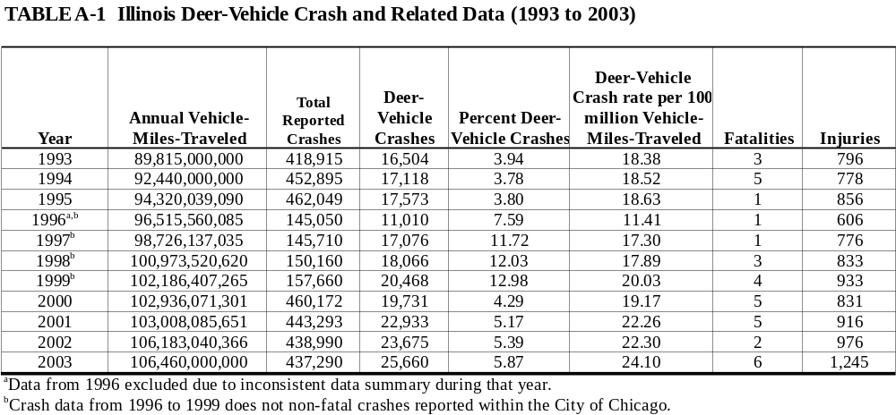

APPENDIX A-2
Iowa Deer-Vehicle Crash and Related Data (1993 to 2003)

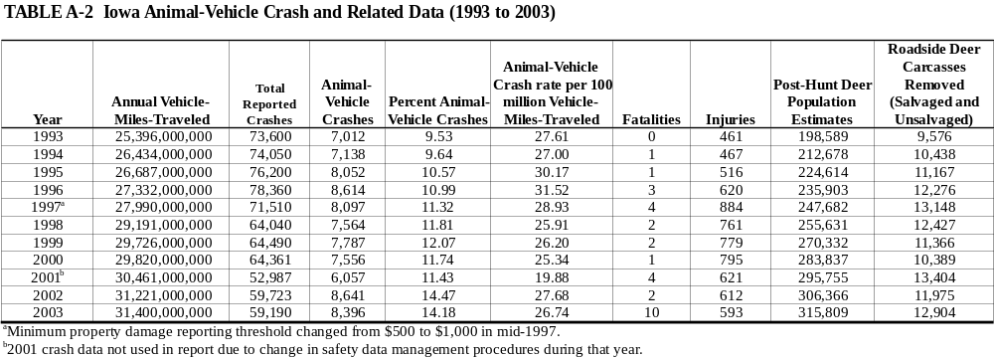

APPENDIX A-3
Michigan Deer-Vehicle Crash and Related Data (1993 to 2003)
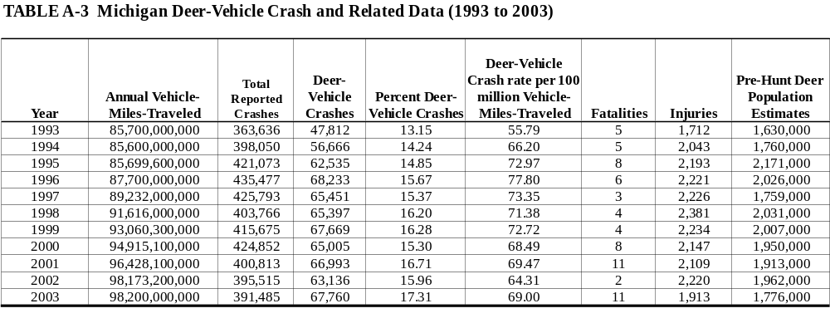

APPENDIX A-4
Minnesota Deer-Vehicle Crash and Related Data (1993 to 2003)

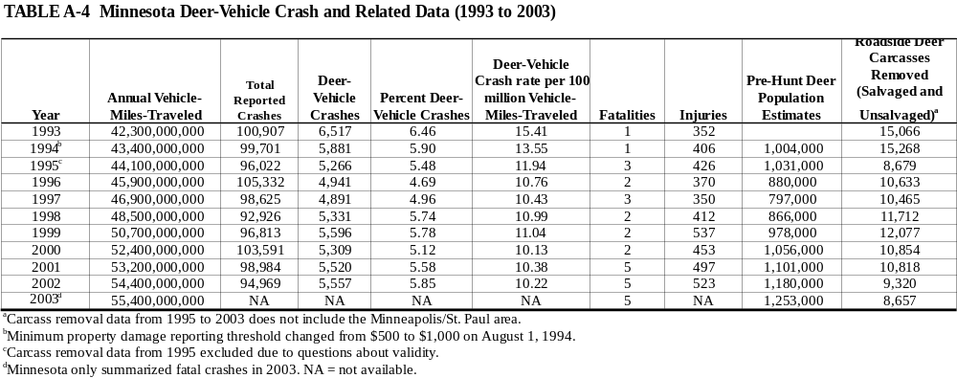

APPENDIX A-5
Wisconsin Deer-Vehicle Crash and Related Data (1993 to 2003)
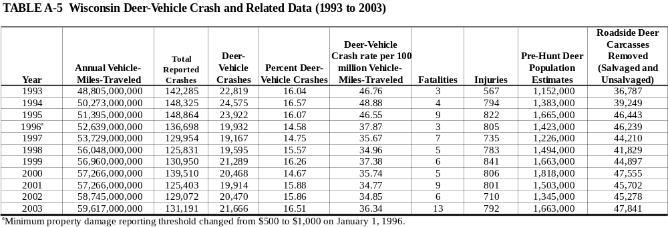

APPENDIX A-6
Regional Deer-Vehicle Crash and Related Data (1993 to 2003)
Illinois, Iowa, Michigan, Minnesota, and Wisconsin


