Hazard Communication

29 CFR 1910.1200

Sample Written Program
The following hazard communication program is provided only as a guide to assist employers and employees in complying with the requirements of the Occupational Safety and Health Administration (OSHA) 29 CFR 1910.1200, as well as to provide other helpful information. It is not intended to supersede the requirements of the standard. An employer should review the standard for particular requirements that are applicable to their individual situation and make adjustments to this program that are specific to their company. An employer will need to add information relevant to their particular facility in order to develop an effective, comprehensive program.
This program provides useful information for public sector employers to meet the requirements of the Texas Hazard Communication Act, State of Texas Health and Safety Codes Chapter 502. For more information about the Texas regulations, visit the Texas Department of State Health Services website at http://www.dshs.state.tx.us.

Provided as a public service by the
Occupational Safety and Health Consultation (OSHCON) Program

Publication No. HS15-002A (1-15)

Revised 01/01/2015
29 CFR 1910.1200

Hazard Communication Program

Table of Contents
- Objective
- Assignment of Responsibility
- Program
- Hazardous Chemical List
- Safety Data Sheets
- Labeling and Pictograms
- Training
- Storage
- Non-Routine Tasks
- Program Compliance
- Attachments
- Acknowledgement of Receipt of Hazard Communication Training
- Sample Hazardous Materials and Chemicals List
- Pictograms and Hazards
- Pictogram Memory Exercise
- Sample Training Roster
- Sample Label
- Sections on a Safety Data Sheet
- OSHA Resources
- DWC Resources

(Company Name)

Hazard Communication Program
- Objective
The objective of this program is to set forth policies and procedures concerning Hazard Communication which will enhance the safety and well being of (Company Name) employees. Furthermore, execution of this program is designed to help (Company Name) comply with the Occupational Safety and Health Administration’s (OSHA) Hazard Communication Standard.
II. Assignment of Responsibility
(Responsible Person Name) is the Hazard Communication Officer and is responsible for insuring that responsible persons noted herein adhere to this program and report properly. (It is encouraged that an alternate or back-up Hazard Communication Officer be assigned in case the primary is not available.)
III. Program
The following items are to be followed to insure compliance with the OSHA Hazard Communication Standard and the safety of our employees.
- Hazardous Chemical List
A list of the hazardous materials and chemicals used in the course of the (Company Name) activities will be maintained and updated by (Responsible Person Name) . This list is to include all substances that require a Safety Data Sheet (SDS).
One copy of this list will be kept in the front of each SDS book and one copy will be kept on file with the Hazard Communication Officer. For each chemical used in the workplace, an SDS sheet must be available on that jobsite.
- SDSs
(Responsible Person Name) will keep all SDSs will in an organized fashion and will place them in (identified and accessible location) for all employees to view at will. A duplicate set of SDS information will be maintained by the Hazard Communication Officer.
SDS books and the Hazardous Chemical List will be maintained and kept up to date by (Responsible Person Name) . As obsolete SDSs are replaced by updated copies, they will be retained for 30 years.
(Responsible Person Name) will verify (insert frequency) that SDSs correctly reflect chemical reformulations, improvements, or updates.
If a hazardous chemical or substance is received without a proper SDS, the receiving person will immediately notify the Hazard Communication Officer. (Responsible Person Name) will immediately contact the manufacturer or distributor of the product. If the manufacturer or distributor is unable to produce an SDS, the Hazard Communication Officer will return the product to the supplier.
(Note: Material Safety Data Sheets (MSDSs) cannot be used after June 1, 2015.)
- Labeling and Pictograms
Each container of a hazardous chemical must be properly labeled with the identity of the hazardous material, the appropriate hazard warnings, pictogram(s), signal word(s), and the name and address of the manufacturer. Appropriate labels must be on all containers, regardless of size. Containers must be approved and recommended for storage and/or dispensing of the particular hazardous chemicals contained in them.
Worn and torn labels must be replaced. It is the responsibility of employees to report inappropriate labels to their supervisor. It is the responsibility of the Hazard Communication Officer to ensure that appropriate labels are in place and that replacement labels are available.
Portable containers of hazardous materials do not require labeling if the materials are transferred from labeled containers and are intended for immediate use by the employee who performs the transfer. Portable containers not immediately used will be emptied (and cleaned when necessary) within (insert time) hours.
- Training
All full- and part-time employees, new hires, and contractors of (Company Name) are required to be trained on the following:
- label elements;
- pictograms;
- SDS format to facilitate recognition and understanding of the product, its required personal protective equipment (PPE) , and first aid requirements;
- the chemicals they will be exposed to;
- locations of SDSs; and
- chemicals in supply lines within the site.
(Note: If required, Department of Transportation (DOT) pictograms and identification placards should also be included in this training.)
Each affected employee working for or associated with (Company Name) is required to review the training material with the Hazard Communication Officer and sign the acknowledgment form, which will be placed in the employee’s file. This training is to be done during the new employee orientation process before the new employee assumes status as an active employee.
Employees will receive training on any new hazardous chemical/material introduced into the workplace before the chemical/material is used or when changes are made to the program.
E. Storage
All storage areas for hazardous substances will be secured, properly ventilated, and identified by signs.

F. Non-Routine Tasks
Before any non-routine task is performed, employees shall be advised and/or they must contact (Responsible Person) for special precautions to follow and (Responsible Person) shall inform any other personnel who could be exposed.
If a non-routine task is necessary, (Responsible Person) will provide the affected employees with information about the activity as it relates to the specific chemicals expected to be encountered:
- specific chemical name(s) and hazard(s);
- personal protective equipment required and safety measures to be taken;
- measures that have been taken to lessen the hazards including ventilation, respirators; and
- emergency procedures.
(Responsible Person) will contact each contractor before work starts to gather and disseminate any information concerning chemical hazards the contractor is bringing into the workplace.
G. Program Compliance
Any direct or intentional violation or non-compliance with this program may result in the termination of the person or persons involved in accordance with company policy.

ATTACHMENT A

Acknowledgement of Receipt of Hazard Communication Training
My signature below acknowledges I have received training concerning Hazard Communications. I understand that this training fulfills the employee training requirement of the Occupational Safety and Health Administration (OSHA) Hazard Communication Standard.
The jobsite and classroom training included the following:
- Understanding the purpose and scope of the OSHA Hazard Communication Standard.
- Explanation of the existence of federal, state and local right-to-know laws.
- Definition of the classification “hazardous chemical.”
- Explanation of situations and elements that must be present for a material to be considered a health hazard.
- Explanation and interpretation of labels, what is required on all containers, and the Hazard Materials Identification System (HMIS).
- Understanding and interpretation of Safety Data Sheets and pictogram(s).
- My responsibilities as an employee of (Company Name) .
- Policies and procedures to follow in case of exposure.
Employee Signature
Date of Training
ATTACHMENT B

Sample Hazardous Materials

and Chemicals List
INDEX NUMBER | PRODUCT | HAZARD CLASSIFICATION SYSTEM (HMIS) | DATE INTRODUCED | DATE DISCONTINUED
1 | Clorox | Health – 3  Fire – 0  Reactivity - 1 | 04-15-1999
2 | WD40 | Health – 1  Fire – 1 | 4-12-1998 | 10-01-2000

Attachment C

Pictograms and Hazards
HEALTH HAZARD  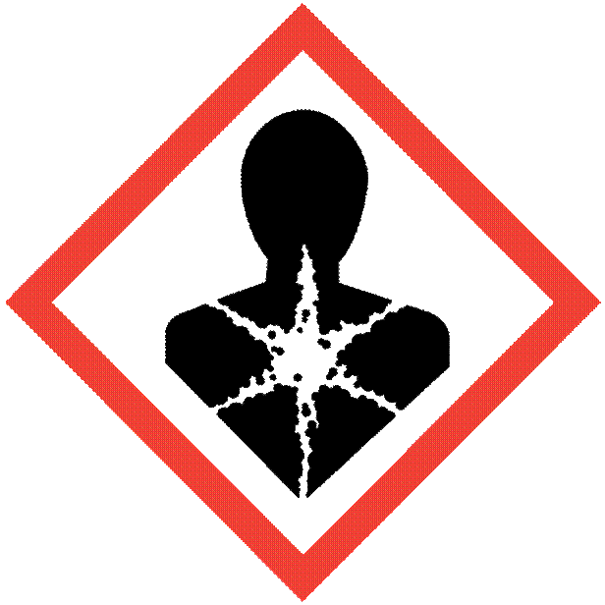 | 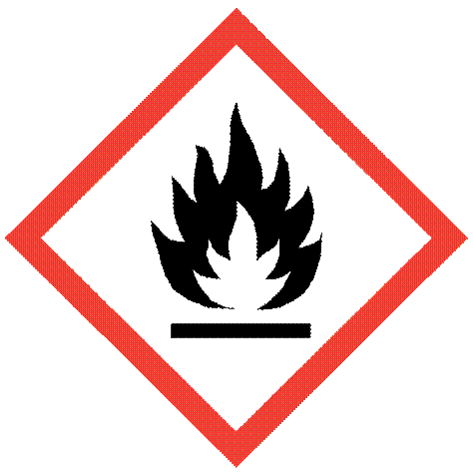  FLAME | GAS CYLINDER
Carcinogen  Mutagenicity  Reproductive Toxicity  Respiratory Sensitizer Target Organ Toxicity  Aspiration Toxicity | Flammable  Pyrophorics  Self-Heating  Emits Flammable Gas  Self-Peroxides | Gases Under Pressure
Class Notes:

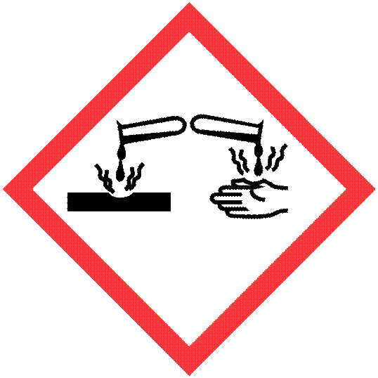  CORROSION | EXCLAMATION MARK* | 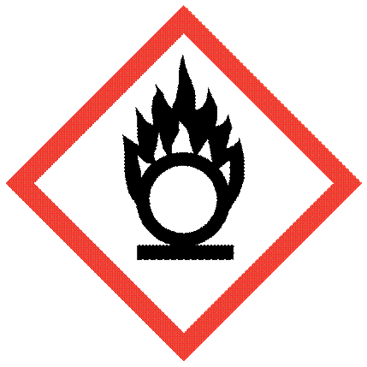  FLAME OVER CIRCLE
Skin Corrosion/Burns  Eye Damage  Corrosive to Metals | Irritant (skin and eye)  Skin Sensitizer  Acute Toxicity  Narcotic Effects  Respiratory Tract Irritant  Hazardous to Ozone Layer  *(Non-Mandatory) | Oxidizers
Class Notes:

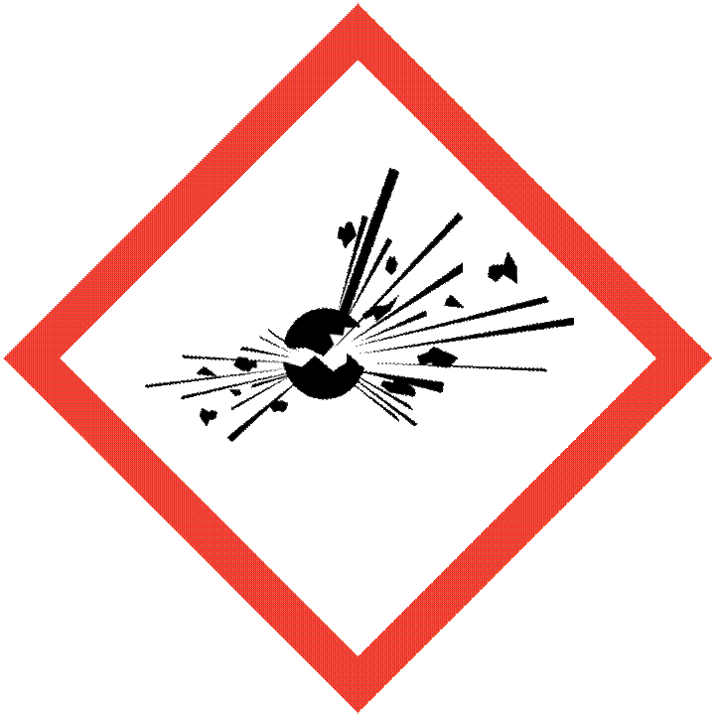  Exploding Bomb | 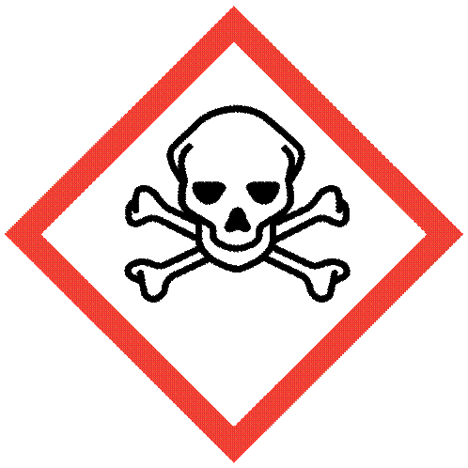  Skull and Crossbones | 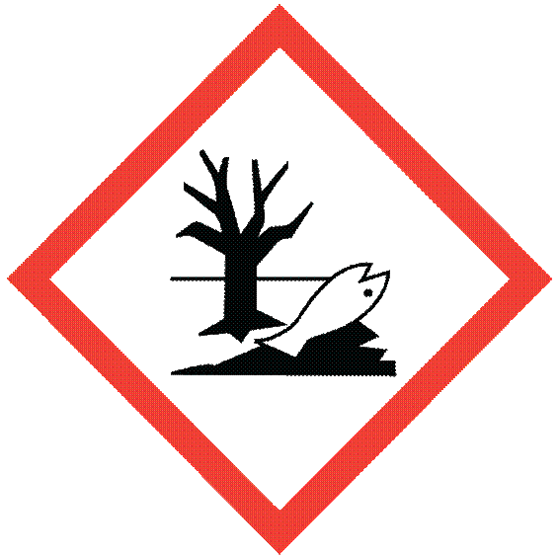  Environment*
Explosives  Self-Reactives  Organic Peroxides | Acute Toxicity (fatal or toxic) | Aquatic Toxicity  *(Non-Mandatory)
Class Notes:

Attachment D

Pictogram Memory Exercise
(Name this Pictogram) (Name this Pictogram) (Name this Pictogram)
(Name this Pictogram) (Name this Pictogram) (Name this Pictogram)
(Name this Pictogram) (Name this Pictogram) (Name this Pictogram)

Attachment E

Sample Training Roster
Date of Training: __________________________________
Items covered: ____________________________________
Instructor: _______________________________________
Print your name, sign and date:
_________________________________________________________________________________________________________________________________________________________________________________________________________________________________________________________________________________________________________________________________________________________________________________________________________________________________________________________________________________________________________________________________________________________________________________________________________________________________________________________________________________________________________________________________________________________________________________________________________________________________________________________________________________________________________________________________________________________________________________________________________________________________________________________________________________________________________________________________________________________________________________________________________________________________________________________________________________________________________________________________________________________________________________________________________________________________________________________________________________________________________________________________________________________________________________________________________________________________________________________________________________________________________________________________________________________________________

Attachment F

Sample Label

Product Identifier
CODE
Product Name
_Supplier Identification
Company Name_
Street Address _
City _________________ State _
Postal Code __________ Country
Emergency Phone Number ___________
Precautionary Statements
Keep container tightly closed. Store in cool, well ventilated place that is locked.
Keep away from heat/sparks/open flame. No smoking.
Only use non-sparking tools.
Use explosion-proof electrical equipment.
Take precautionary measure against static discharge.
Ground and bond container and receiving equipment.
Do not breathe vapors.
Wear protective gloves.
Do not eat, drink or smoke when using this product.
Wash hands thoroughly after handling.
Dispose of in accordance with local, regional, national, international regulations as specified.
In Case of Fire: use dry chemical (BC) or carbon dioxide (CO₂) fire extinguisher to extinguish.
First Aid
If exposed call Poison Center.
If on skin (on hair): Take off immediately any contaminated clothing. Rinse skin with water.

Hazard Pictograms

Signal Word

Danger

Hazard Statement
Highly flammable liquid and vapor.
May cause liver and kidney damage.

Supplemental Information
Directions for use
Fill weight: _____________ Lot Number
Gross weight: __________ Fill Date:
Expiration Date:

Attachment G
SECTIONS ON A SAFETY DATA SHEET
The Hazard Communication Standard (HCS) requires chemical manufacturers, distributors, or importers to provide Safety Data Sheets (SDSs) (formerly known as Material Safety Data Sheets or MSDSs) to communicate the hazards of chemical products. As of June 1, 2015, the HCS will require new SDSs to be in a uniform format that must include the section numbers, headings, and associated information listed below:

Section 1, Identification
Includes product identifier; manufacturer or distributor name, address, phone number; emergency phone number; recommended use; and restrictions on use.
Section 2, Hazard(s) identification
Includes all hazards regarding the chemical and required label elements.
Section 3, Composition/information on ingredients
Includes information on chemical ingredients and trade secret claims.
Section 4, First-aid measures
Includes important symptoms/effects, including acute or delayed and required treatment.
Section 5, Fire-fighting measures
Lists suitable extinguishing techniques and equipment and chemical hazards from fire.
Section 6, Accidental release measures
Lists emergency procedures; protective equipment; proper methods of containment; and cleanup.

Section 7, Handling and storage
Lists precautions for safe handling and storage, including incompatibilities.
Section 8, Exposure controls/personal protection Lists OSHA’s Permissible Exposure Limits (PELs); Threshold Limit Values (TLVs); appropriate engineering controls; and personal protective equipment.
Section 9, Physical and chemical properties
Lists the chemical’s characteristics.
Section 10, Stability and reactivity
Lists chemical stability and possibility
of hazardous reactions.
Section 11, Toxicological information
Includes routes of exposure; related symptoms including acute and chronic effects; and numerical measures of toxicity.
Section 12, Ecological information*
Section 13, Disposal considerations*
Section 14, Transport information*
Section 15, Regulatory information*
Section 16, Other information
Includes the date of preparation or last revision.

Employers must ensure that SDSs are readily accessible to employees.
See Appendix D of 29 CFR 1910.1200 for a detailed description of SDS contents.
*Note: Since other agencies regulate this information, OSHA will not be enforcing Sections 12 through 15 of 29 CFR 1910.1200(g)(2).

Attachment H

OSHA Resources
The following items can be downloaded from the OSHA website at https://www.osha.gov/pls/publications/publication.html or
ordered from OSHA by calling (800) 321-6742:

Hazard Communication: Hazard Communication Wallet Card
OSHA 3658 - 2013
Hazard Communication Standard: December 1st, 2013 Training Requirements for the
Revised Standard Fact Sheet
OSHA FS-3642 - 2013
Hazard Communication Standard: Labels and Pictograms- Brief
OSHA BR-3636 - 2013
Hazard Communication Safety Data Sheets
OSHA 3493 – 2012
Hazard Communication Standard Pictograms
OSHA 3491 - 2012
Hazard Communication Standard: Safety Data Sheets – Brief
OSHA BR-3514 - 2013
Hazard Communication: Steps to an Effective Hazard Communication Program
for Employers That Use Hazardous Chemicals Fact Sheet
OSHA FS-3696 – 2014

Attachment I

DWC Resources
The DWC features a free occupational safety and health DVD loan library. Call 512-804-4620 for more information or visit the DWC website at http://www.tdi.texas.gov/wc/safety/videoresources/avcatalog.html. Some of the DVDs on hazard communication include:
Global Harmonization: Worldwide Hazard Communication, DVD1966ES
Explains what the Globally Harmonized System for the Classification and Labeling of Chemical (GHS) is and why it was created. Discusses basic information about the GHS, including the four parts and ten annexes of the system. Shows how GHS differs from the Hazard Communication Standard (HCS). Reviews labeling requirements, the GHS label elements and the 16 different sections of the Safety Data Sheets. Includes quiz; 15 min.
HazCom: In Sync with GHS, DVD2883
Helps employees understand the new standardized procedure (Globally Harmonized Standard) for communicating chemical hazards. Covers classes of hazards and health risks associated with each class. Discusses labels on shipping containers, workplace labeling, safety data sheets, the written hazard communication plan and the responsibility of the employer. Includes handbook/quiz; 16 min.
Hazardous Chemicals: GHS Classification & Communication, DVD2902
Introduces the Globally Harmonized System for the Classification and Labeling of Chemicals. Focuses on the GHS System itself rather than specific U.S. adoption calendar or issues. Provides a detailed, in-depth review of hazard classification, hazard communication, GHS pictograms, label components, and Safety Data Sheets. 22 min.

