Instructor’s Guide

"Forklift Safety"
Certify & Comply

Training for the OSHA
Forklift Safety Standard
Occupational Safety and Health Administration, Powered Industrial Trucks, Subpart N, including 29 CFR 1910.178

WARRANTY/DISCLAIMER

Advice, graphics, images and information contained in this video is presented for general educational and information purposes and to increase overall safety awareness. It is not intended to be legal, medical or other expert advice or services, and should not be used in place of consultation with appropriate professionals. The information contained in this video should not be considered exhaustive and the viewer should seek the advice of appropriate professionals.

In no event shall Atlantic Training and its trustees, officers and employees be liable for any liability, loss, injury or risk (including, without limitation, incidental and consequential damages, personal injury/wrongful death, lost profits or damages) which is incurred or suffered as a direct or indirect result of the use of any of the material, advice, guidance or services on this video, whether based on warranty, contract, tort, or any other legal theory. ATLANTIC TRAINING TO THE FULLEST EXTENT PERMITTED BY LAW, DISCLAIMS ALL WARRANTIES, EITHER EXPRESS OR IMPLIED, STATUTORY OR OTHERWISE, INCLUDING BUT NOT LIMITED TO THE IMPLIED WARRANTIES OF MERCHANTABILITY, NON-INFRINGEMENT OF THIRD PARTIES’ RIGHTS AND FITNESS FOR PARTICULAR PURPOSE.

TABLE OF CONTENTS

Introduction
- Background
- Course Outline
- Course Review

Preparing for the Session
- Structuring the Presentation
- Creating the Environment / Setting up the Session

Facilitating the Session
- Getting Started
- Facilitating the Discussion
- Review Learning Outcomes

Core Curriculum
- Section 1: Basic Forklift Principles
- Section 2: Pre-Trip Planning
- Section 3: Operating the Forklift Safely
- Section 4: Driving in Dangerous Situations

Course Learning Outcomes
- Key Points to Remember

Supplemental Resources
- Appendix A: Power Point Presentation
- Appendix B: Quiz
- Appendix C: Answer Key
- Appendix D: Training Certificate

Introduction

The instructor guide is designed to be a comprehensive tool for facilitating the course. Thoroughly reviewing this document, as well as all related course materials and resources, will prepare you to teach the course.

Background

Occupational Safety and Health Administration, Powered Industrial Trucks, Subpart N, including 29 CFR 1910.178.

Powered Industrial Trucks, called Forklifts, are very powerful machines. They can be used to raise, lower, carry, stack, and push objects in a variety of settings. To help us use these machines safely, OSHA created the “Powered Industrial Truck” Standard. One of the most significant parts of this regulations deals with training.

Course Outline
This course is organized by sections. Within each section there may be multiple lessons.

The sections in this course are as follows:

- Introduction
- Basic Forklift Principles
- Pre-Trip Planning
- Operating the Forklift Safely
- Driving in Dangerous Situations
- Key Points to Remember
- Conclusion

Course Review

These materials are to be used as guidance for facilitating the presentation. As with any educational program, the facilitator should go through the entire program at least once to become familiar with the content and make sure the program is consistent with company policy and directives.

Preparing for the Session

Structuring the Presentation

- Share the learning objectives with the participants.

- Determine target audience to adjust training if needed.

- Establish plan to actively involve participants in the learning experience.

- Practice training techniques to build rapport with audience.

Creating the Environment / Setting up the Session

- Confirm the training dates, location, and number of participants.

- Ensure the room is set up properly, e.g., tables and chairs are arranged to maximize whole-class and small group interaction without participants needing to turn chairs around, projectors do not block participants’ line of sight, flip charts are convenient to you and visible to participants, and so forth.
- Start on time and stay on track. Keep exercises within their time limits. End discussions when they cease to be productive.

Facilitating the Session

Getting Started

- Introduce yourself as the session leader.

- Circulate the session roster before the training begins.

- Introduce the title of the program (Certify & Comply) and begin playing the Forklift training video.

- If you are using the DVD version of the course you have several options as to how you can move through the program and what employees see.

- The DVD menu has three "selection bars":

- "Play"
- "Scene Index"
- "Contact Info”

- To just play the program from beginning to end, select "Play".

- All of our DVDs, both English and Spanish, are subtitled (similar to closed captioning). If there are hearing impaired employees participating in your training session, or you want people to be able to read the program narration as well as hear it, push the "subtitle" button on your DVD player's remote control or the player's control panel. A print version of the narration will then appear on the screen as the video plays.

Facilitating the Discussion

- After the program has been shown, it is time for the group discussion on the information contained in the session.

- The instructor facilitates the activities and guides the conversation so that learners take away the ability to apply that knowledge in the field and internalize best practices.

- Closely monitor group activities. Walk among groups as they work; answer questions and offer guidance as appropriate. Give constructive feedback during the share-out sessions and discussions.

Review Learning Outcomes

- Check to make sure that all attendees signed the session roster.

- Ensure that each participants completes end of course quiz.

- Distribute course certificates

Core Curriculum
Slide 4

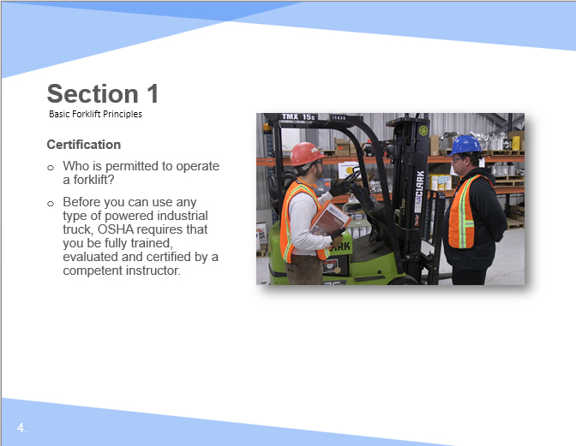

Facilitation Guidance:

Certification

- Who is permitted to operate a forklift?

- Before you can use any type of powered industrial truck, OSHA requires that you be fully trained, evaluated and certified by a competent instructor.

Slide 5

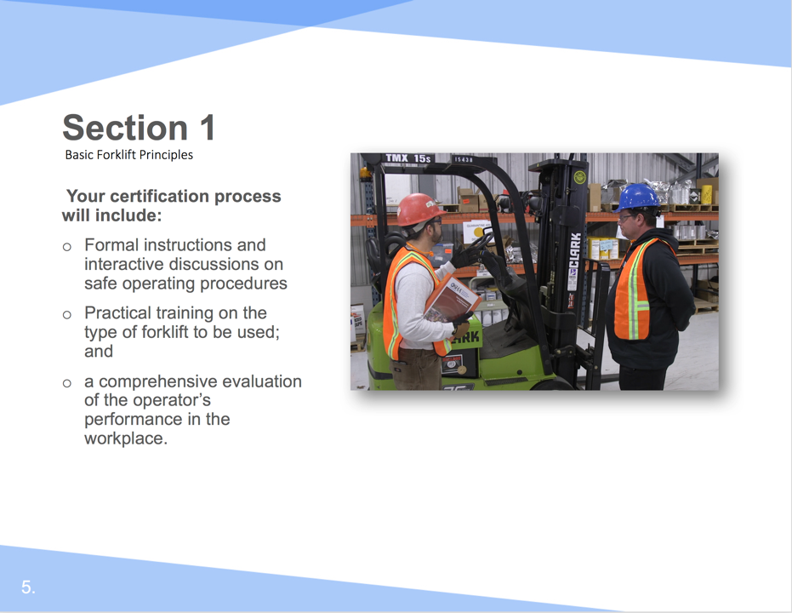

Facilitation Guidance:

Your certification process will include:

- Formal instructions and interactive discussions on safe operating procedures
- Practical training on the type of forklift to be used; and
- A comprehensive evaluation of the operator’s performance in the workplace.

Slide 6

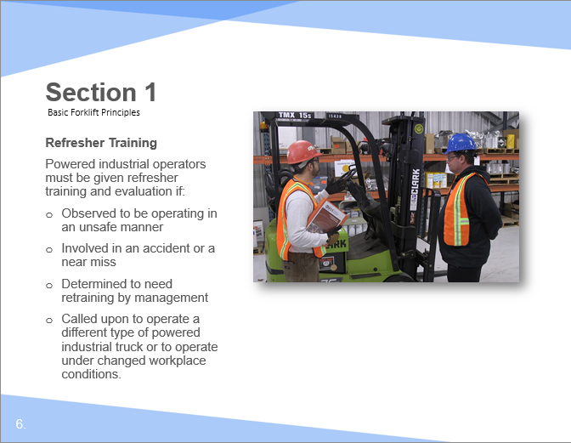

Facilitation Guidance:

Refresher Training

This training may be held at any time according to the following guidelines. The content of the refresher training is identical to the initial training. Powered industrial operators must be given refresher training and evaluation if:
- Observed to be operating in an unsafe manner
- Involved in an accident or a near miss
- Determined to need retraining by management
- Called upon to operate a different type of powered industrial truck or to operate under changed workplace conditions.

Slide 7

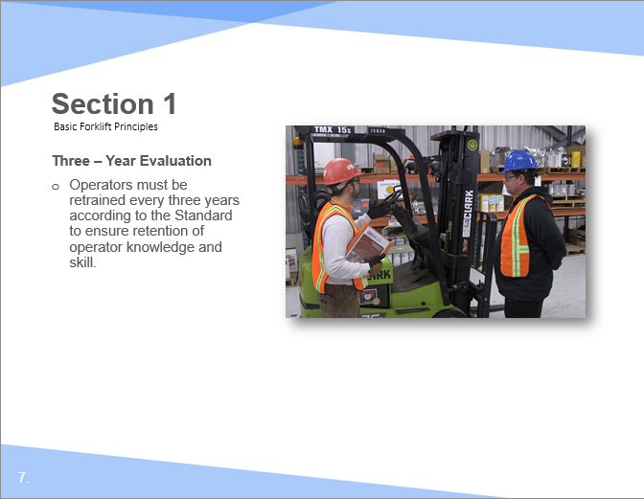

Facilitation Guidance:

Three – Year Evaluation

Operators must be retrained every three years according to the Standard to ensure retention of operator knowledge and skill.

Slide 8

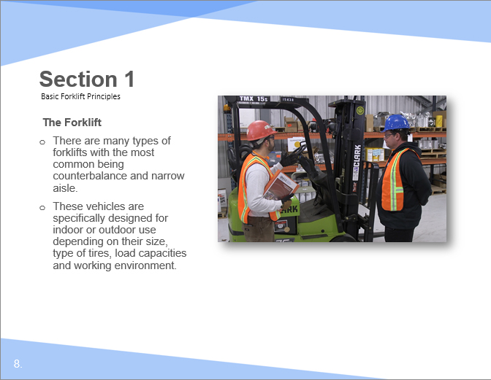

Facilitation Guidance:

The Forklift

There are many types of forklifts with the most common being counterbalance and narrow aisle. These vehicles are specifically designed for indoor or outdoor use depending on their size, type of tires, load capacities and working environment.

Slide 9

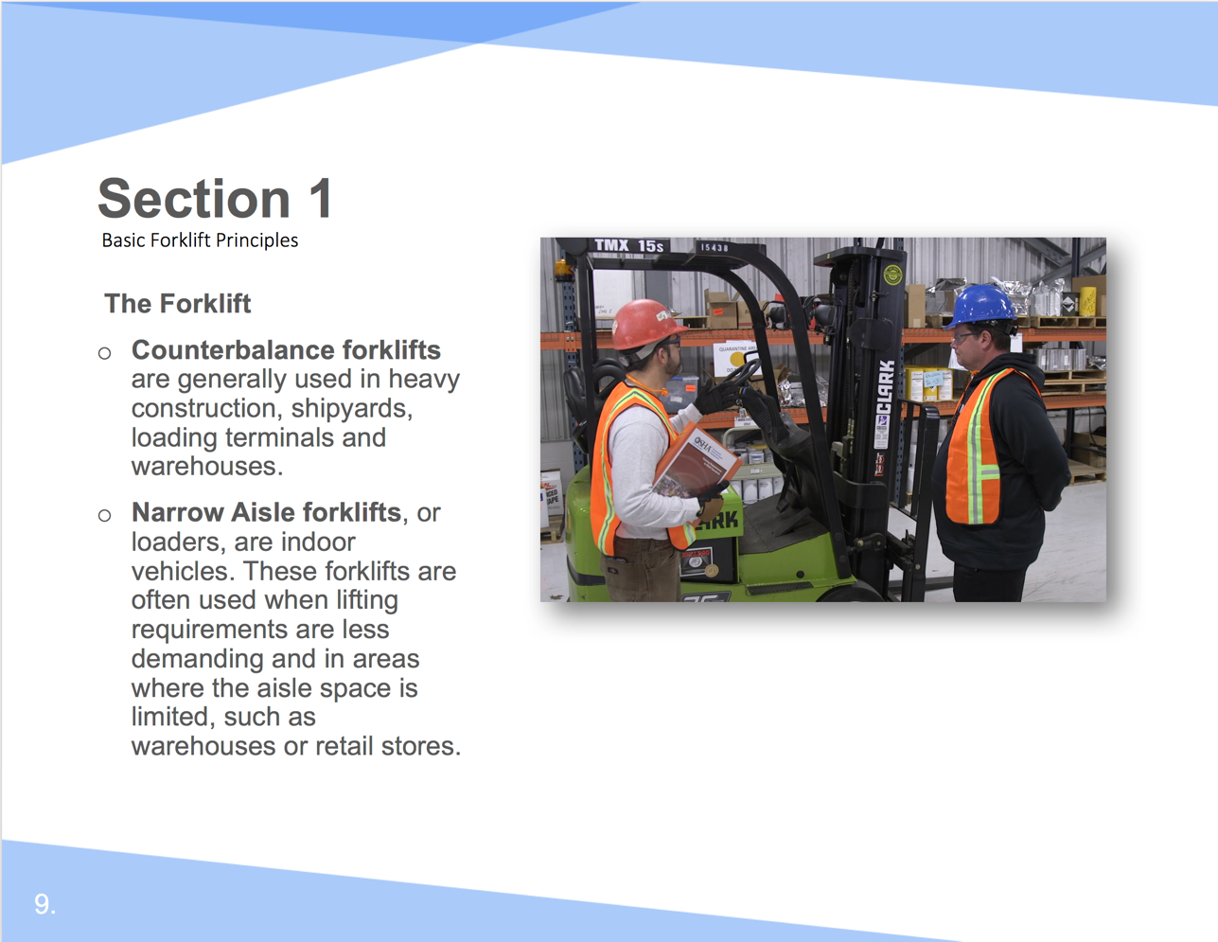

Facilitation Guidance:

The Forklift

Counterbalance forklifts are generally used in heavy construction, shipyards, loading terminals and warehouses.

Narrow Aisle forklifts, or loaders, are indoor vehicles. These forklifts are often used when lifting requirements are less demanding and in areas where the aisle space is limited, such as warehouses or retail stores.

Slide 10

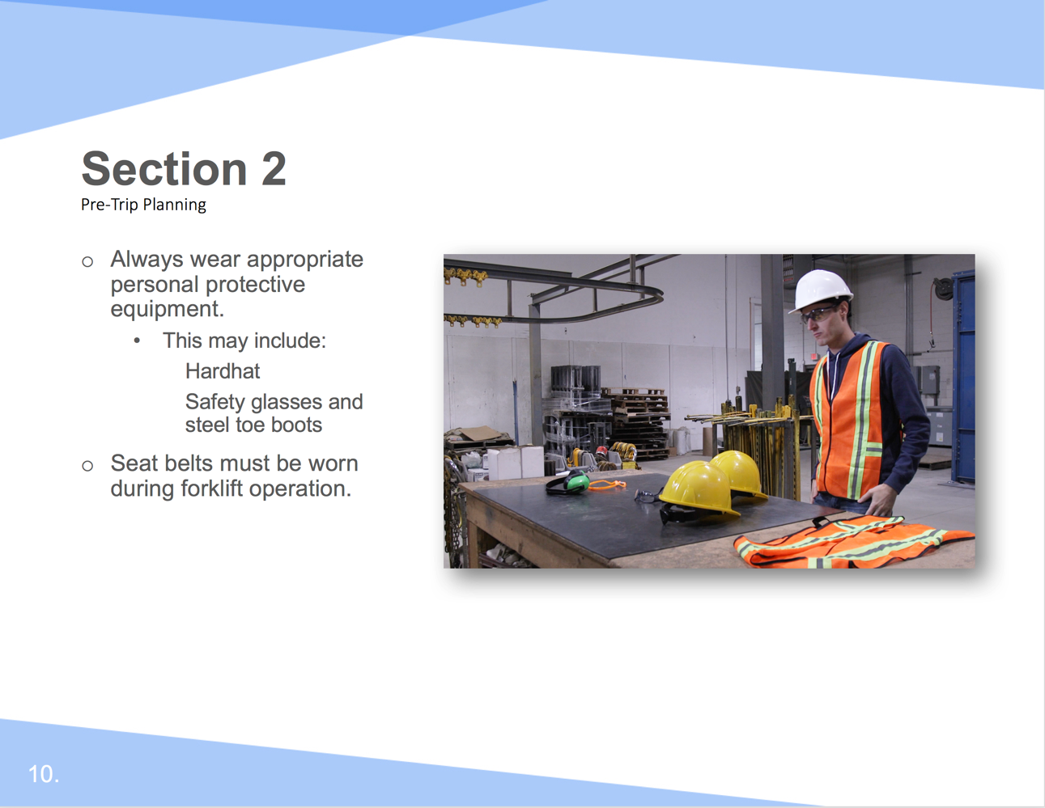

Facilitation Guidance:

- Always wear appropriate personal protective equipment.
  - This may include:
    - Hardhat
    - Safety glasses and steel toe boots
- Seat belts must be worn during forklift operation.

Slide 11

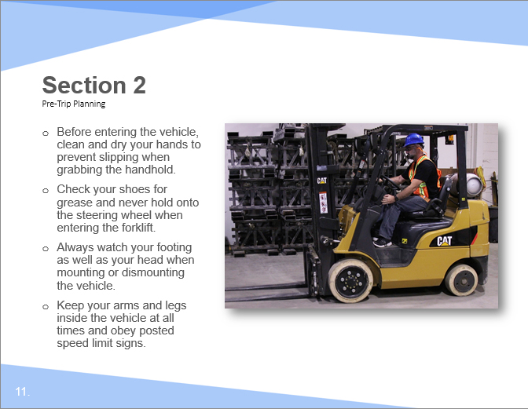

Facilitation Guidance:

- Before entering the vehicle, clean and dry your hands to prevent slipping when grabbing the handhold.
- Check your shoes for grease and never hold onto the steering wheel when entering the forklift.
- Always watch your footing as well as your head when mounting or dismounting the vehicle.
- Keep your arms and legs inside the vehicle at all times and obey posted speed limit signs.

Slide 12

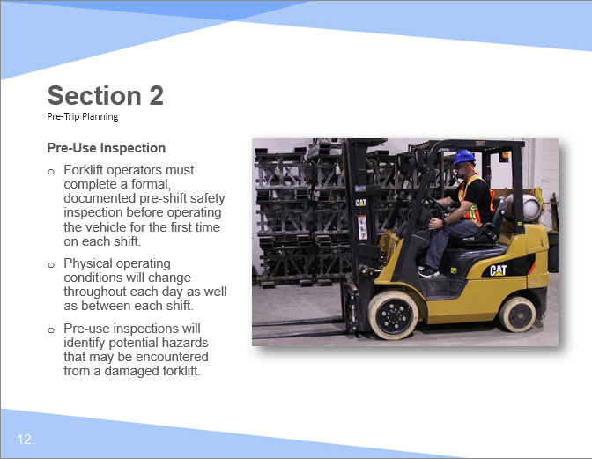

Facilitation Guidance:

Pre-Use Inspection

- Forklift operators must complete a formal, documented pre-shift safety inspection before operating the vehicle for the first time on each shift.
- Physical operating conditions will change throughout each day as well as between each shift.
- Pre-use inspections will identify potential hazards that may be encountered from a damaged forklift.

Slide 13

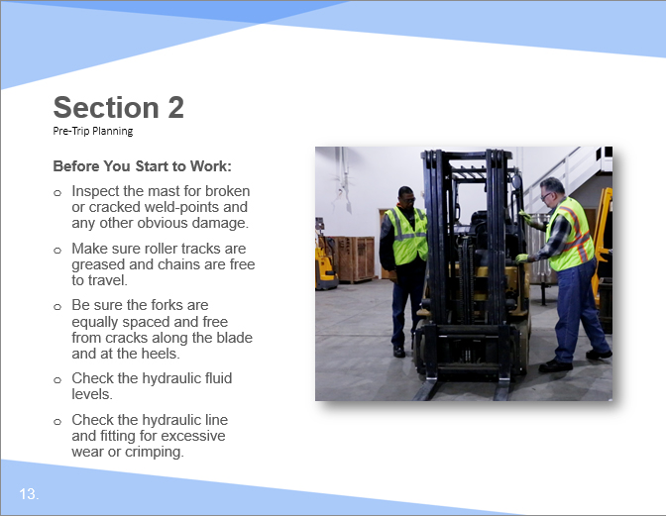

Facilitation Guidance:

Before You Start to Work:

- Inspect the mast for broken or cracked weld-points and any other obvious damage.
- Make sure roller tracks are greased and chains are free to travel.
- Be sure the forks are equally spaced and free from cracks along the blade and at the heels.
- Check the hydraulic fluid levels.
- Check the hydraulic line and fitting for excessive wear or crimping.

Slide 14

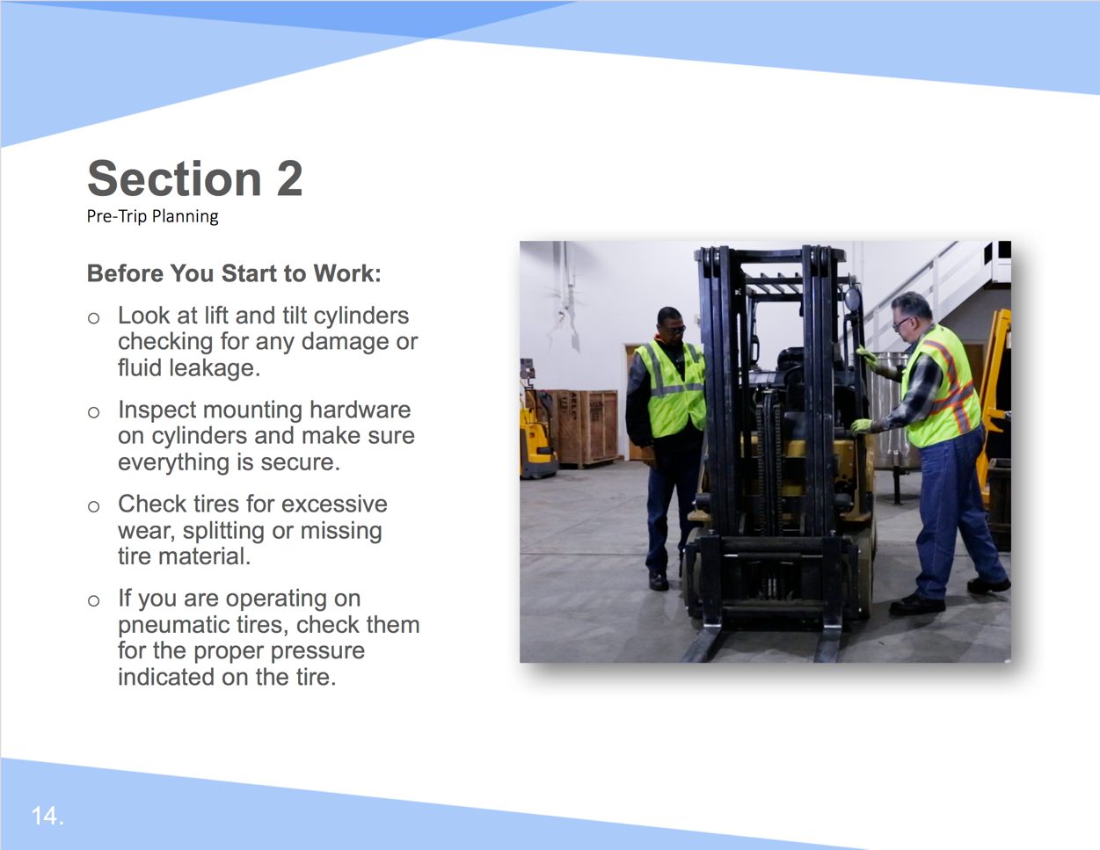

Facilitation Guidance:

Before You Start to Work:

- Look at lift and tilt cylinders checking for any damage or fluid leakage.
- Inspect mounting hardware on cylinders and make sure everything is secure.
- Check tires for excessive wear, splitting or missing tire material.
- If you are operating on pneumatic tires, check them for the proper pressure indicated on the tire.

Slide 15

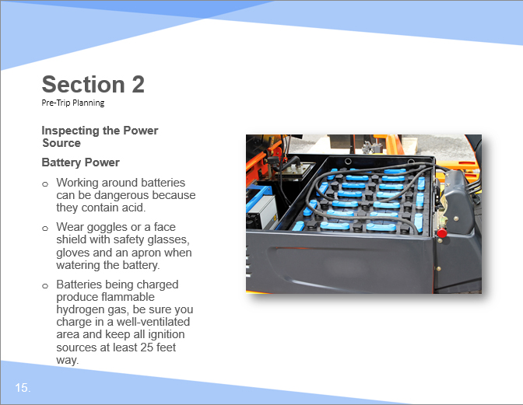

Facilitation Guidance:

Battery Power

- Working around batteries can be dangerous because they contain acid.
- Wear goggles or a face shield with safety glasses, gloves and an apron when watering the battery.
- Batteries being charged produce flammable hydrogen gas, be sure you charge in a well-ventilated area and keep all ignition sources at least 25 feet way;

Slide 16

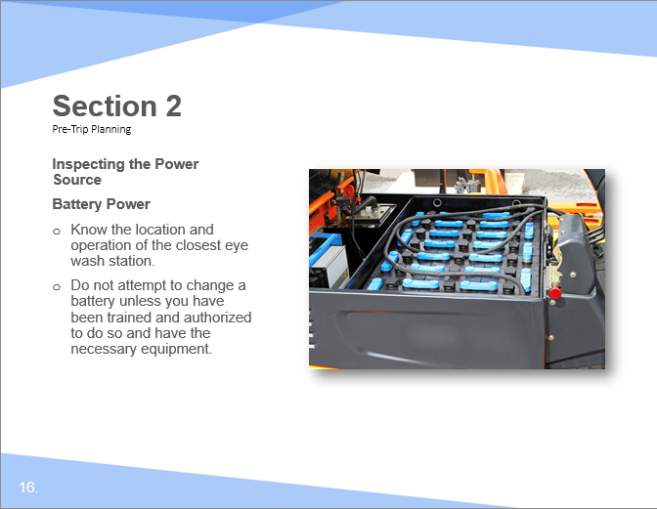

Facilitation Guidance:

Battery Power

- Know the location and operation of the closest eye wash station;
- Do not attempt to change a battery unless you have been trained and authorized to do so and have the necessary equipment.

Slide 17

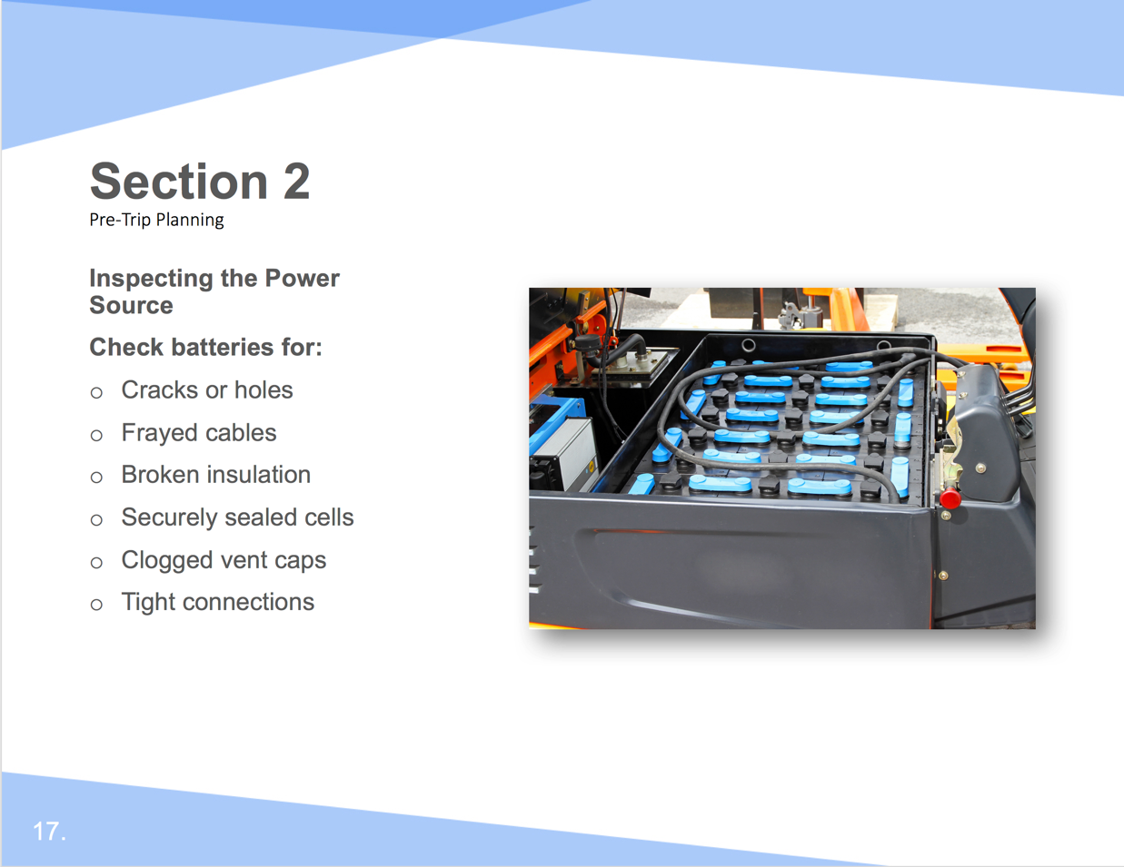

Facilitation Guidance:

Check batteries for:

- Cracks or holes
- Frayed cables
- Broken insulation
- Securely sealed cells
- Clogged vent caps
- Tight connections

Slide 18

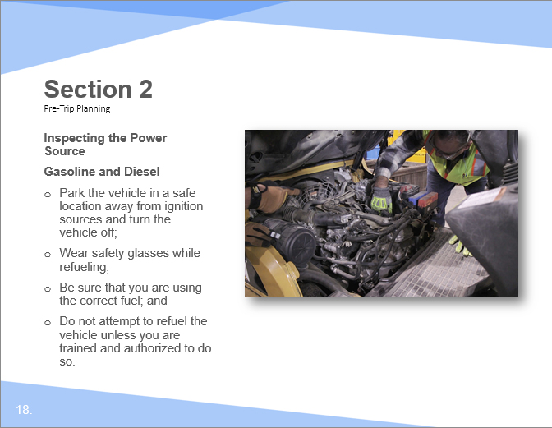

Facilitation Guidance:

Gasoline and Diesel

- Park the vehicle in a safe location away from ignition sources and turn the vehicle off;
- Wear safety glasses while refueling;
- Be sure that you are using the correct fuel;
- Do not attempt to refuel the vehicle unless you are trained and authorized to do so.
.

Slide 19

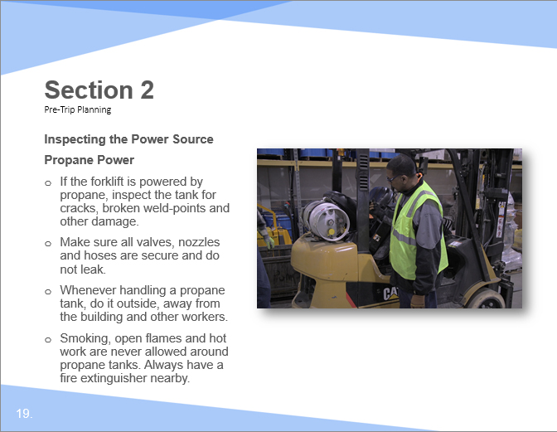

Facilitation Guidance:

Propane Power

- If the forklift is powered by propane, inspect the tank for cracks, broken weld-points and other damage.

- Make sure all valves, nozzles and hoses are secure and do not leak.

- Whenever handling a propane tank, do it outside, away from the building and other workers. Smoking, open flames and hot work are never allowed around propane tanks. Always have a fire extinguisher nearby.

Slide 20

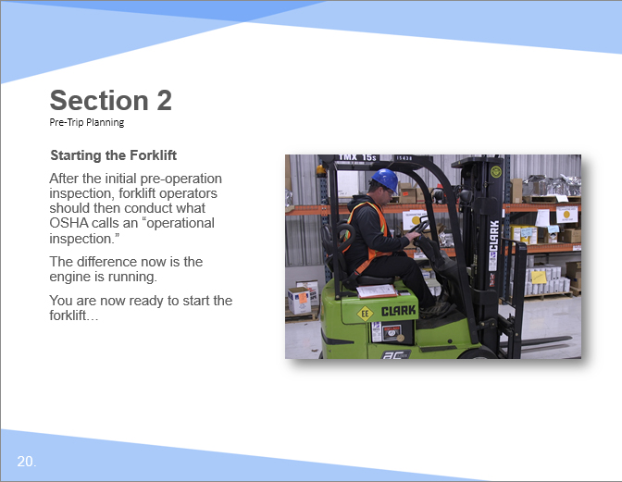

Facilitation Guidance:

Starting the Forklift

After the initial pre-operation inspection, forklift operators should then conduct what OSHA calls an “operational inspection.” The difference now is the engine is running.
You are now ready to start the forklift:

Slide 21

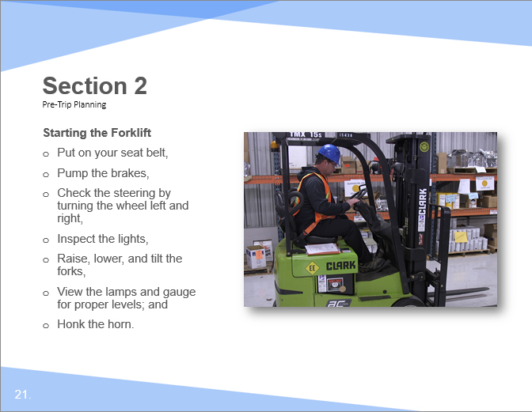

Facilitation Guidance:

Starting the Forklift

- Put on your seat belt,
- Pump the brakes,
- Check the steering by turning the wheel left and right,
- Inspect the lights,
- Raise, lower, and tilt the forks,
- View the lamps and gauge for proper levels; and
- Honk the horn.

Slide 22

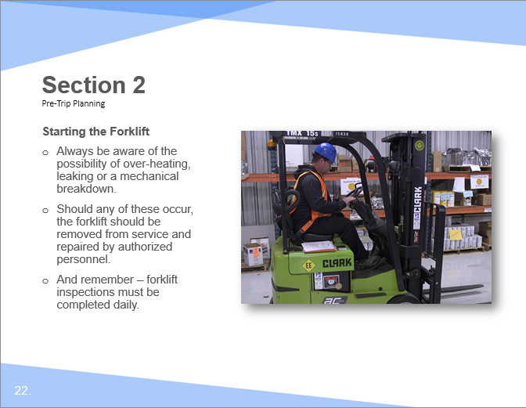

Facilitation Guidance:

Starting the Forklift

- Always be aware of the possibility of over-heating, leaking or a mechanical breakdown.

- Should any of these occur, the forklift should be removed from service and repaired by authorized personnel.

- And remember – forklift inspections must be completed daily.

Slide 23

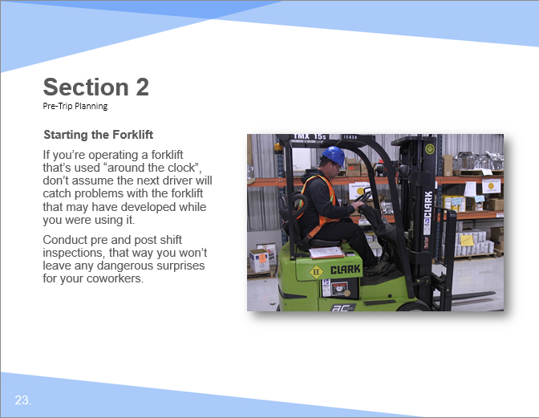

Facilitation Guidance:

Starting the Forklift

If you’re operating a truck that’s used “around the clock”, don’t assume the next driver will catch problems with the truck that developed while you were using it.

Conduct pre and post shift inspections, that way you won’t leave any dangerous surprises for your coworkers.

Slide 24

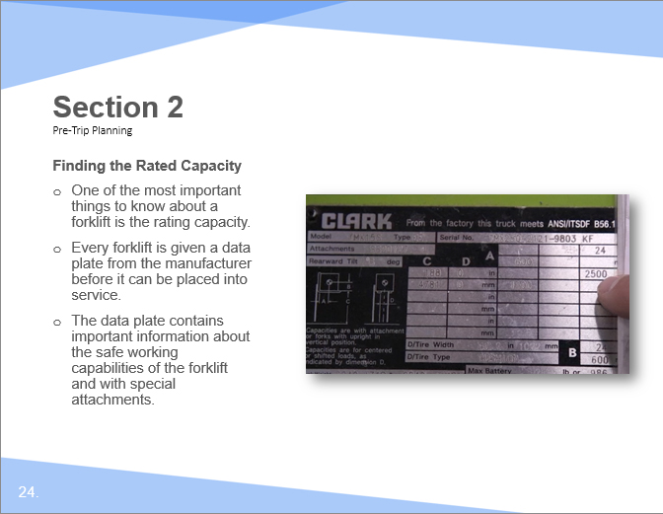

Facilitation Guidance:

Finding the Rated Capacity

- One of the most important things to know about a forklift is the rating capacity.
- Every forklift is given a data plate from the manufacturer before it can be placed into service.
- The data plate contains important information about the safe working capabilities of the forklift and with special attachments.

Slide 25

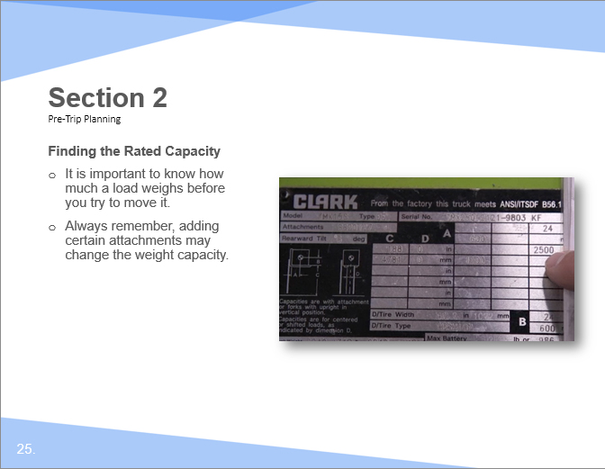

Facilitation Guidance:

Finding the Rated Capacity

- It is important to know how much a load weighs before you try to move it.
- Always remember, adding certain attachments may change the weight capacity.

Slide 26

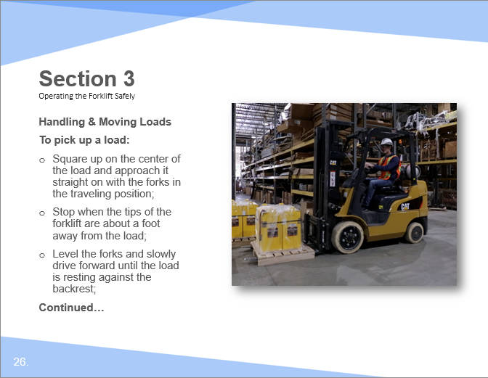

Facilitation Guidance:

Handling & Moving Loads

To pick up a load:

- Square up on the center of the load and approach it straight on with the forks in the traveling position.
- Stop when the tips of the forklift are about a foot away from the load.
- Level the forks and slowly drive forward until the load is resting against the backrest.

Slide 27

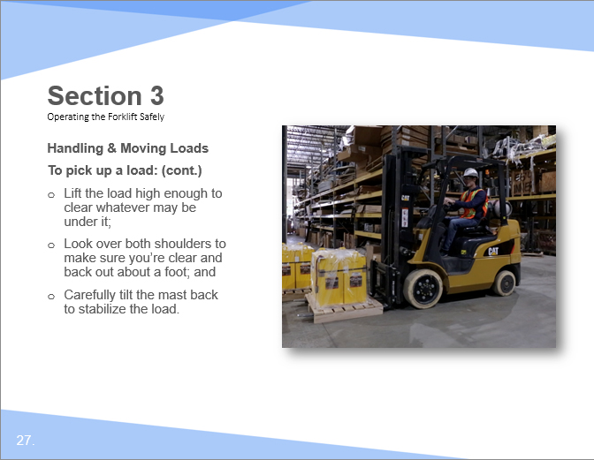

Facilitation Guidance:

Handling & Moving Loads

To pick up a load:

- Lift the load high enough to clear whatever may be under it.
- Look over both shoulders to make sure you’re clear and back out about a foot.
- Carefully tilt the mast back to stabilize the load.

Slide 28

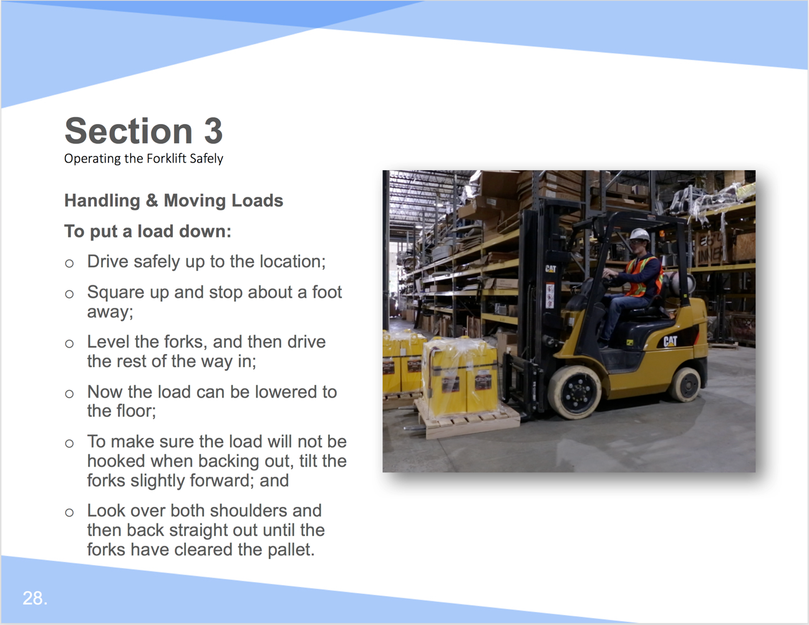

Facilitation Guidance:

To put a load down:

- Drive safely up to the location.
- Square up and stop about a foot away.
- Level the forks, and then drive the rest of the way in.
- Now the load can be lowered to the floor.
- To make sure the load will not be hooked when backing out, tilt the forks slightly forward.
- Look over both shoulders and then back straight out until the forks have cleared the pallet.

Slide 29

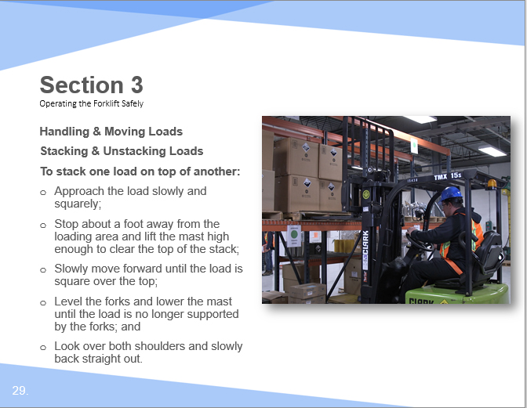

Facilitation Guidance:

Stacking & Unstacking Loads

To stack one load on top of another:

- Approach the load slowly and squarely.
- Stop about a foot away from the loading area and lift the mast high enough to clear the top of the stack.
- Slowly move forward until the load is square over the top.
- Level the forks and lower the mast until the load is no longer supported by the forks.
- Look over both shoulders and slowly back straight out.

Slide 30

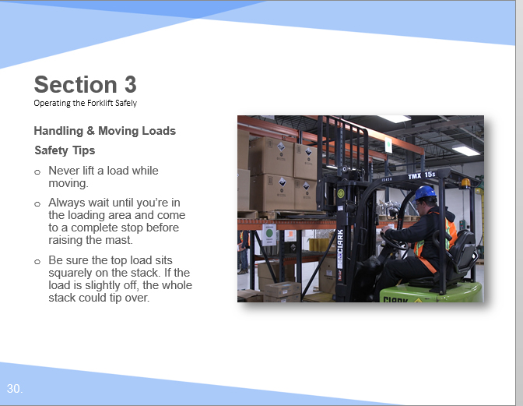

Facilitation Guidance:

Safety Tips

- Never lift a load while moving. Always wait until you’re in the loading area and come to a complete stop before raising the mast.
- Be sure the top load sits squarely on the stack. If the load is slightly off, the whole stack could tip over.

Slide 31

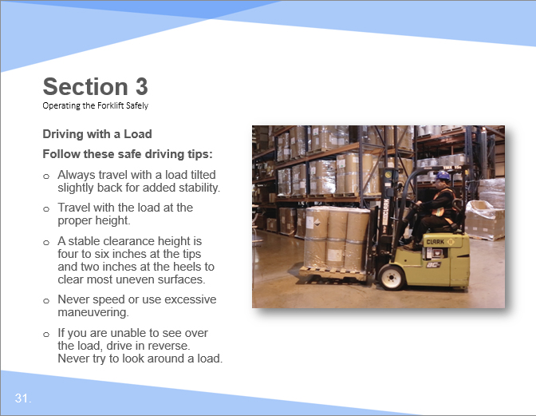

Facilitation Guidance:

Driving with a Load

Follow these safe driving tips:

- Always travel with a load tilted slightly back for added stability.
- Travel with the load at the proper height. A stable clearance height is four to six inches at the tips and two inches at the heels to clear most uneven surfaces.
- Never speed or use excessive maneuvering.
- If you are unable to see over the load, drive in reverse. Never try to look around a load.

Slide 32

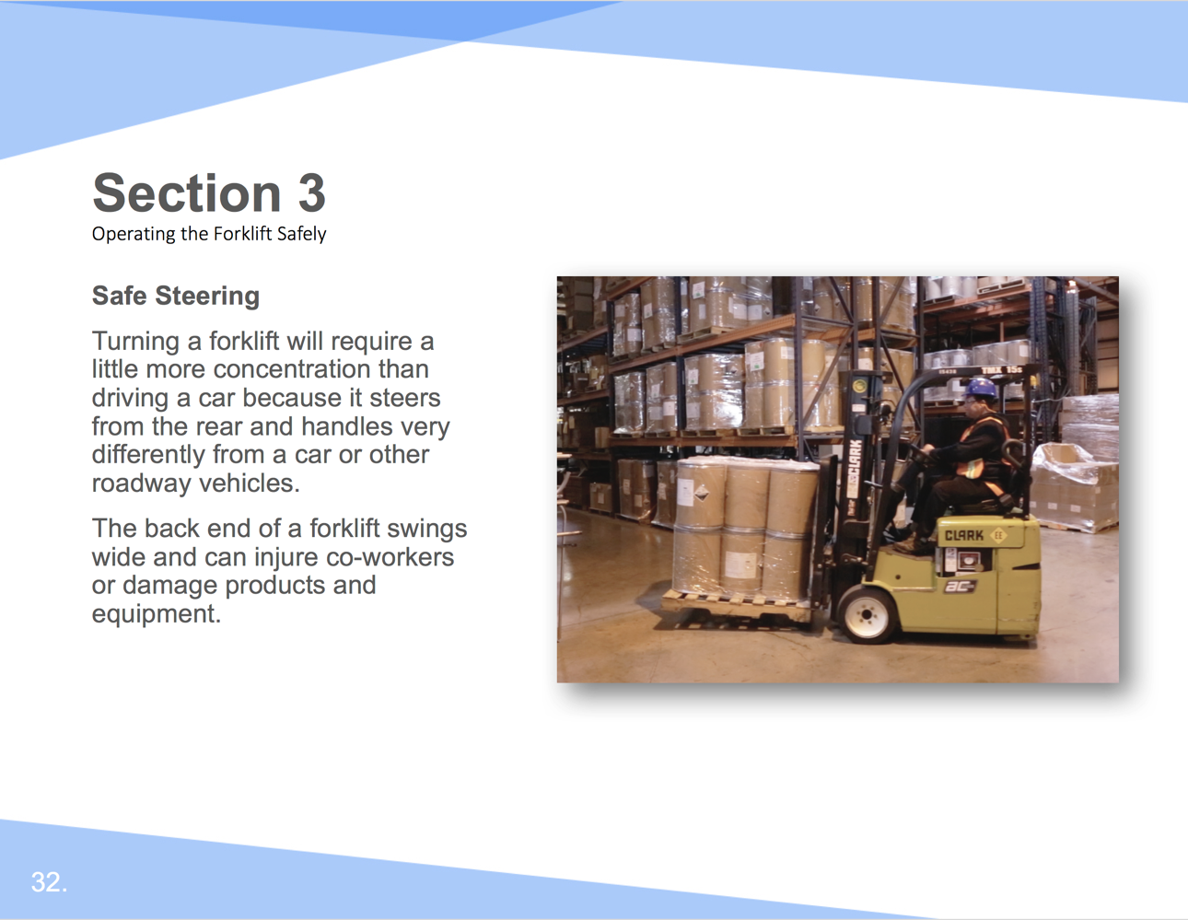

Facilitation Guidance:

Safe Steering

Turning a forklift will require a little more concentration than driving a car because it steers from the rear and handles very differently from a car or other roadway vehicles.

The back end of a forklift swings wide and can injure co-workers or damage products and equipment.

Slide 33

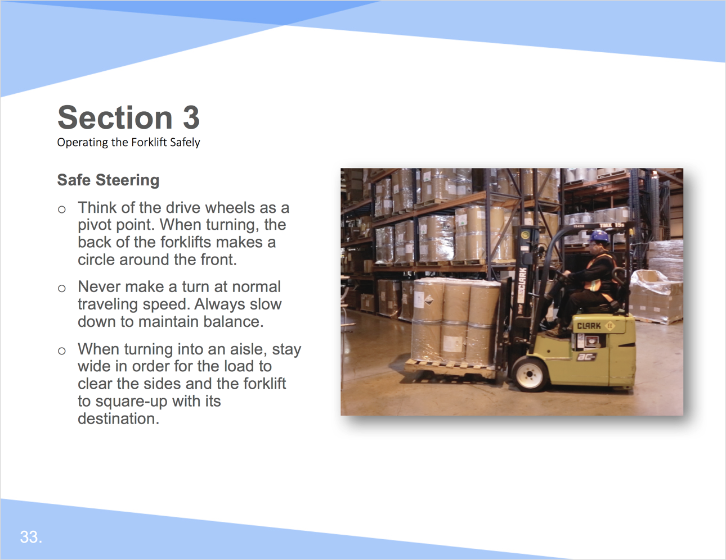

Facilitation Guidance:

Safe Steering

- Think of the drive wheels as a pivot point. When turning, the back of the forklifts makes a circle around the front.
- Never make a turn at normal traveling speed. Always slow down to maintain balance.
- When turning into an aisle, stay wide in order for the load to clear the sides and the forklift to square-up with its destination.

Slide 34

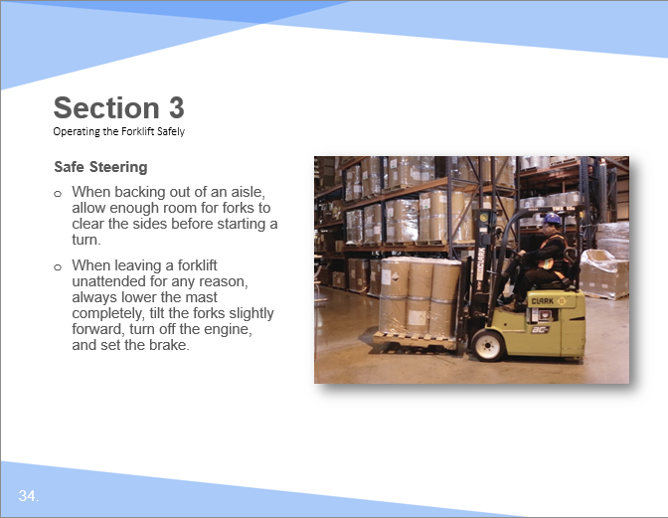

Facilitation Guidance:

Safe Steering

- When backing out of an aisle, allow enough room for forks to clear the sides before starting a turn.
- When leaving a forklift unattended for any reason, always lower the mast completely, tilt the forks slightly forward, turn off the engine, and set the brake.

Slide 35

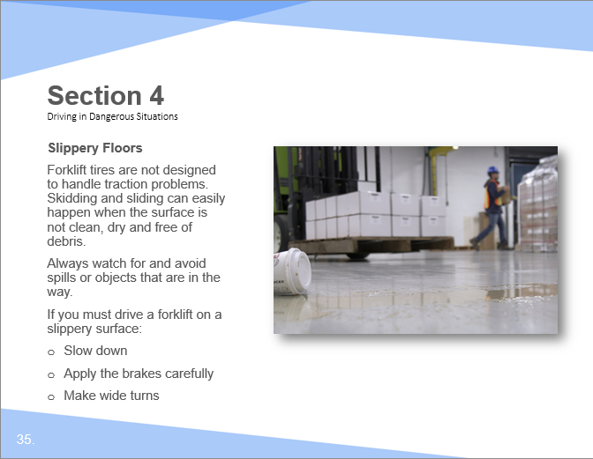

Facilitation Guidance:

Slippery Floors

Forklift tires are not designed to handle traction problems. Skidding and sliding can easily happen when the surface is not clean, dry and free of debris. Always watch for and avoid spills or objects that are in the way.
If you must drive a forklift on a slippery surface:
- Slow down.
- Apply the brakes carefully.
- Make wide turns.

Slide 36

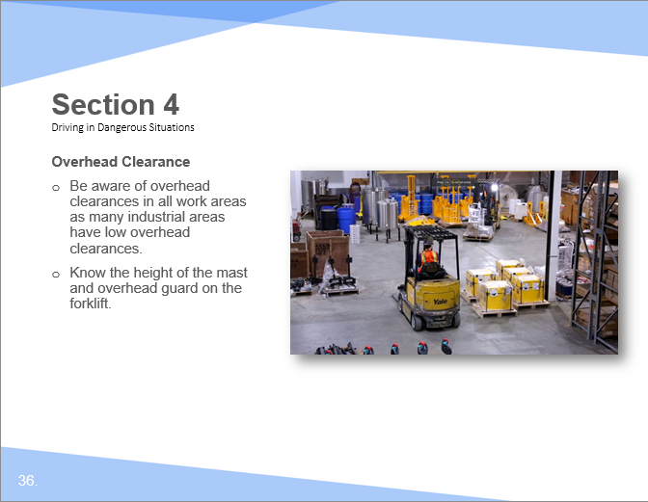

Facilitation Guidance:

Overhead Clearance

- Be aware of overhead clearances in all work areas as many industrial areas have low overhead clearances.
- Know the height of the mast and overhead guard on the forklift.

Slide 37

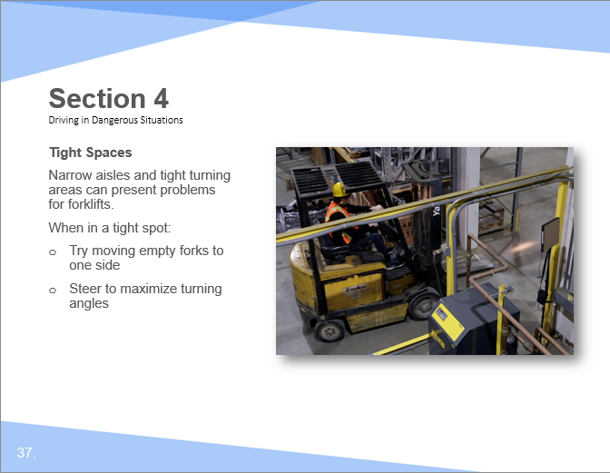

Facilitation Guidance:

Tight Spaces

Narrow aisles and tight turning areas can present problems for forklifts. When in a tight spot:
- Try moving empty forks to one side
- Steer to maximize turning angles

Slide 38

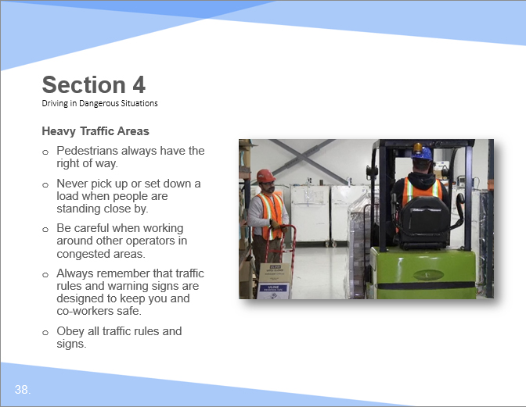

Facilitation Guidance:

Heavy Traffic Areas

- Pedestrians always have the right of way.
- Never pick up or set down a load when people are standing close by.
- Be careful when working around other operators in congested areas.
- Always remember that traffic rules and warning signs are designed to keep you and co-workers safe.
- Obey all traffic rules and signs.

Slide 39

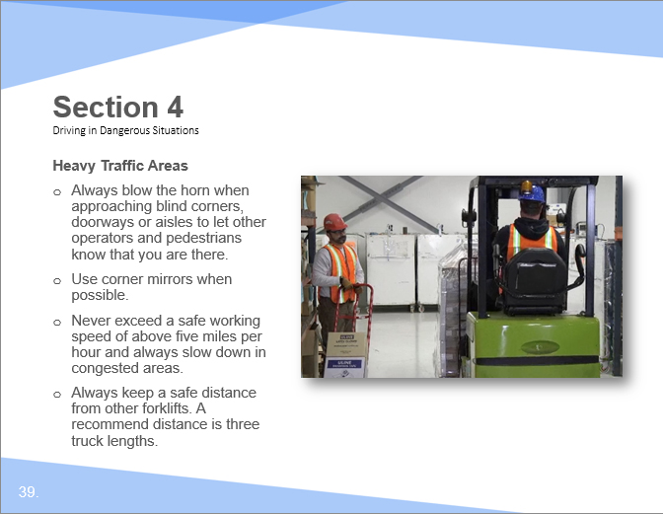

Facilitation Guidance:

Heavy Traffic Areas

- Always blow the horn when approaching blind corners, doorways or aisles to let other operators and pedestrians know that you are there.
- Use corner mirrors when possible.
- Never exceed a safe working speed of above five miles per hour and always slow down in congested areas.
- Always keep a safe distance from other forklifts. A recommend distance is three truck lengths.

Slide 40

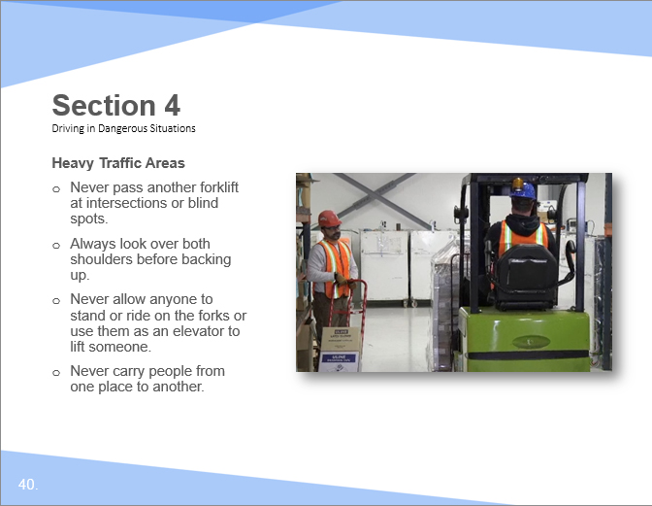

Facilitation Guidance:

Heavy Traffic Areas

- Never pass another forklift at intersections or blind spots.
- Always look over both shoulders before backing up.
- Never allow anyone to stand or ride on the forks or use them as an elevator to lift someone.
- Never carry people from one place to another.

Slide 41

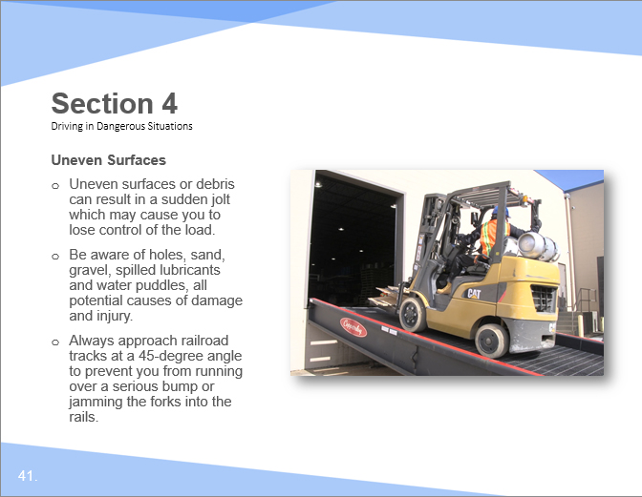

Facilitation Guidance:

Uneven Surfaces

Uneven surfaces or debris can result in a sudden jolt which may cause you to lose control of the load.
- Be aware of holes, sand, gravel, spilled lubricants and water puddles, all potential causes of damage and injury.
- Always approach railroad tracks at a 45-degree angle to prevent you from running over a serious bump or jamming the forks into the rails.

Slide 42

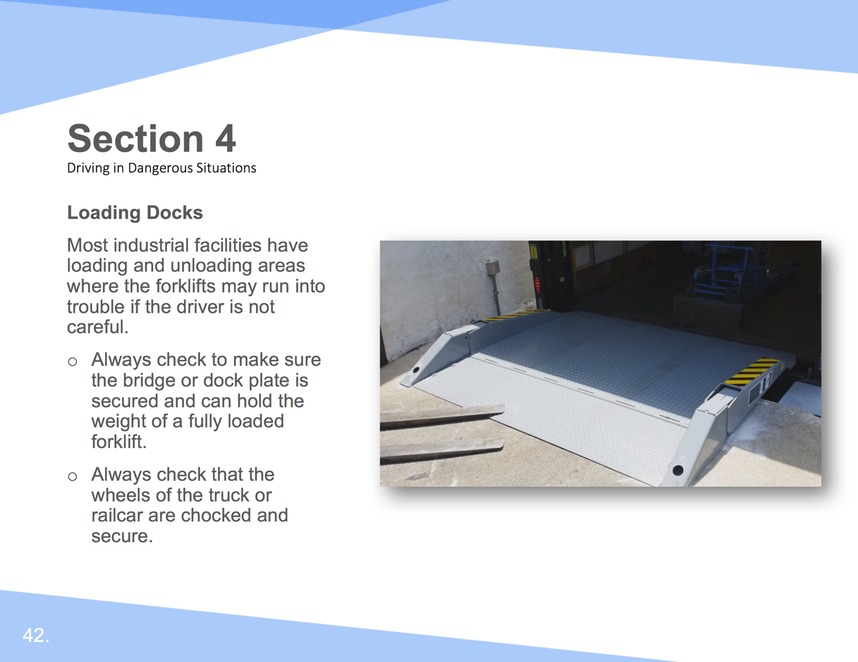

Facilitation Guidance:

Loading Docks

Most industrial facilities have loading and unloading areas where the forklifts may run into trouble if the driver is not careful.
- Always check to make sure the bridge or dock plate is secured and can hold the weight of a fully loaded forklift.
- Always check that the wheels of the truck or railcar are chocked and secure.

Slide 43

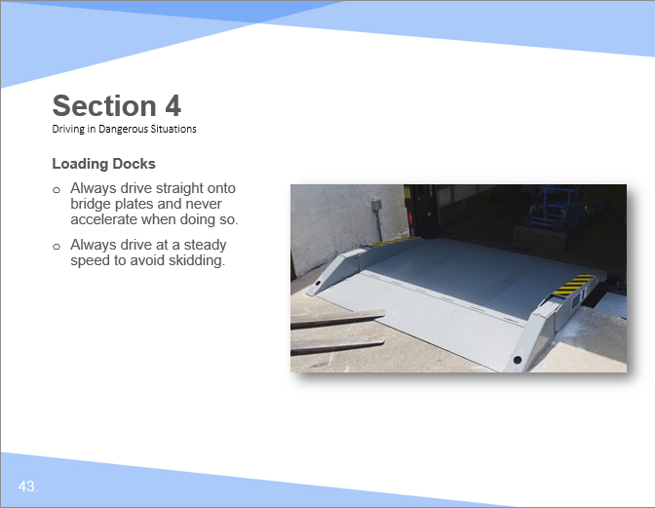

Facilitation Guidance:

Loading Docks

- Always drive straight onto bridge plates and never accelerate when doing so.
- Always drive at a steady speed to avoid skidding.

Slide 44

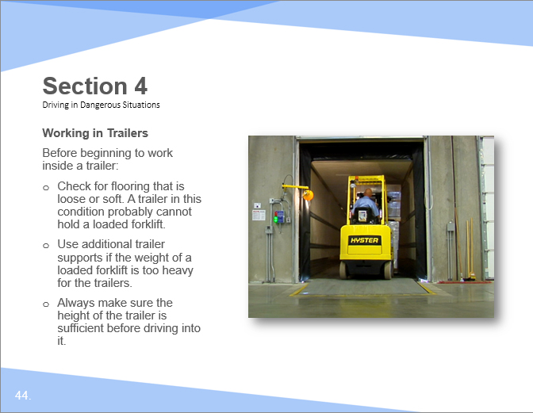

Facilitation Guidance:

Working in Trailers

Before beginning to work inside a trailer:

- Check for flooring that is loose or soft. A trailer in this condition probably cannot hold a loaded forklift.
- Use additional trailer supports if the weight of a loaded forklift is too heavy for the trailers.
- Always make sure the height of the trailer is sufficient before driving into it.

Slide 45

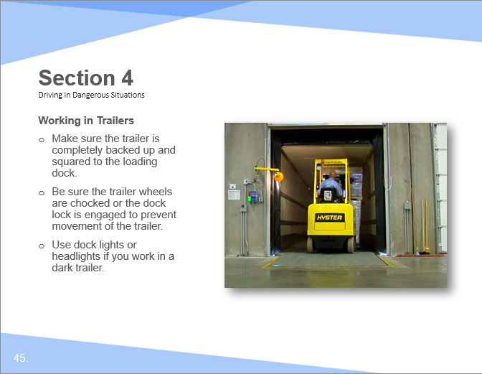

Facilitation Guidance:

Working in Trailers

Before beginning to work inside a trailer:

- Make sure the trailer is completely backed up and squared to the loading dock.
- Be sure the trailer wheels are chocked or the dock lock is engaged to prevent movement of the trailer.
- Use dock lights or headlights if you work in a dark trailer.

Slide 46

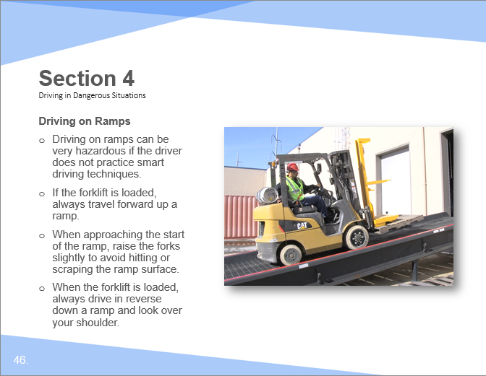

Facilitation Guidance:

Driving on Ramps

- Driving on ramps can be very hazardous if the driver does not practice smart driving techniques.
- If the forklift is loaded, always travel forward up a ramp.
- When approaching the start of the ramp, raise the forks slightly to avoid hitting or scraping the ramp surface.
- When the forklift is loaded, always drive in reverse down a ramp and look over your shoulder.

Slide 47

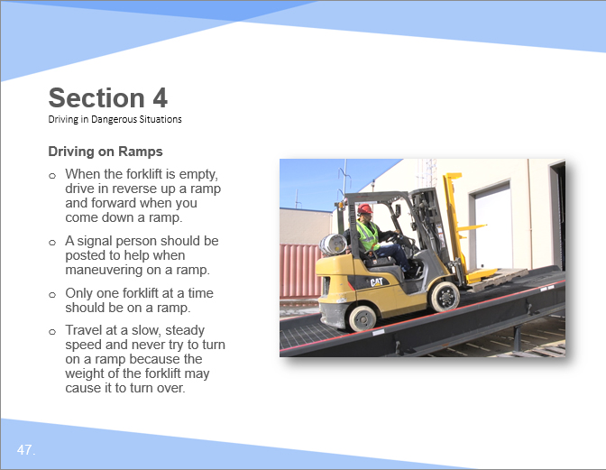

Facilitation Guidance:

Driving on Ramps

- When the forklift is empty, drive in reverse up a ramp and forward when you come down a ramp. A signal person should be posted to help when maneuvering on a ramp.
- Only one forklift at a time should be on a ramp.
- Travel at a slow, steady speed and never try to turn on a ramp because the weight of the forklift may cause it to turn over.

Slide 48

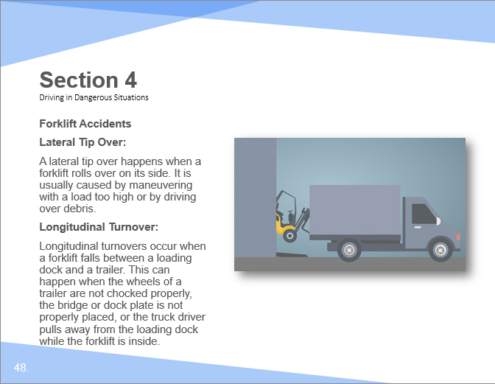

Facilitation Guidance:

Forklift Accidents

Lateral Tip Over
A lateral tip over happens when a forklift rolls over on its side. It is usually caused by maneuvering with a load too high or by driving over debris.

Longitudinal Turnover
Longitudinal turnovers occur when a forklift falls between a loading dock and a trailer. This can happen when the wheels of a trailer are not chocked properly, the bridge or dock plate is not properly placed, or the truck driver pulls away from the loading dock while the forklift is inside.

Slide 49

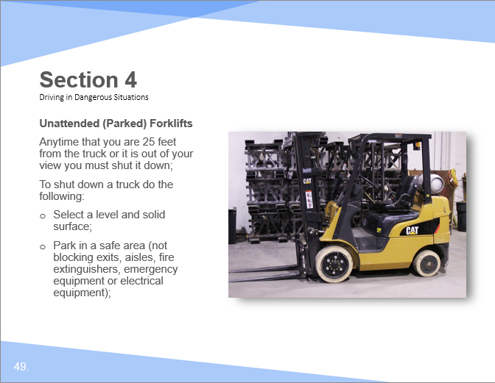

Facilitation Guidance:

Unattended (Parked) Forklifts

Anytime that you are 25 feet from the truck or it is out of your view you must shut it down;
To shut down a truck do the following:
- Select a level and solid surface
- Park in a safe area (not blocking exits, aisles, fire extinguishers, emergency equipment or electrical equipment);

Slide 50

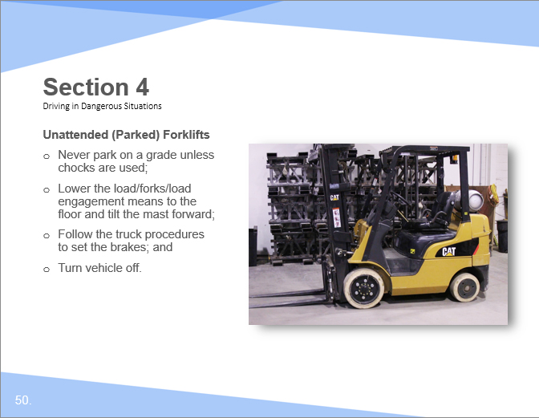

Facilitation Guidance:

Unattended (Parked) Forklifts

- Never park on a grade unless chocks are used.
- Lower the load/forks/load engagement means to the floor and tilt the mast forward;
- Follow the truck procedures to set the brakes; and
- Turn vehicle off

Slide 51

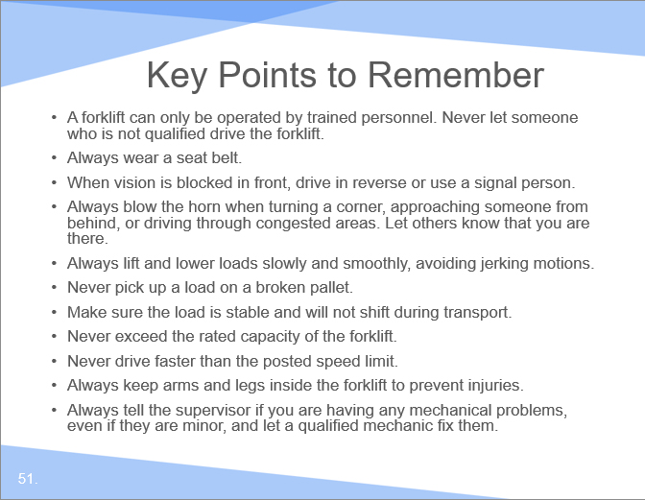

Facilitation Guidance:

Review

- A forklift can only be operated by trained personnel. Never let someone who is not qualified drive the forklift.
- Always wear a seat belt.
- When vision is blocked in front, drive in reverse or use a signal person.
- Always blow the horn when turning a corner, approaching someone from behind, or driving through congested areas. Let others know that you are there.
- Always lift and lower loads slowly and smoothly, avoiding jerking motions.
- Never pick up a load on a broken pallet.
- Make sure the load is stable and will not shift during transport.
- Never exceed the rated capacity of the forklift.
- Never drive faster than the posted speed limit.
- Always keep arms and legs inside the forklift to prevent injuries.
- Always tell the supervisor if you are having any mechanical problems, even if they are minor, and let a qualified mechanic fix them.

Supplemental Resources

