TRAFFIC AND SAFETY INFORMATIONAL SERIES
FREQUENTLY ASKED QUESTION #17

SAFE DRIVING PROCEDURES AT RAILROAD CROSSINGS

Operation Lifesaver

Operation Lifesaver is a nationwide public education program dedicated to reducing crashes at rail crossings. The following driving tips are located at http://www.oli.org:

• Never drive around lowered gates. If a signal is malfunctioning, call 911.
• Never race a train to a crossing.
• Do not get trapped on a crossing.
• Get out of your vehicle if it stalls on a crossing and call local law enforcement for assistance. Only attempt to restart your vehicle if you can post lookouts to warn of approaching trains.
• Watch for a second train when crossing multiple tracks.
• Expect a train at any time. Trains do not always follow set schedules.
• Be aware that trains cannot stop quickly. It takes over a mile to stop the train once emergency brakes are applied. When a train engineer can see you it is too late to avoid a collision.
• Do not misjudge a train’s speed and distance. A train’s large mass makes it difficult to accurately judge its speed and distance.
• Do not operate all-terrain vehicles on railroad tracks.

Drivers that follow these tips will be following safe driving procedures for at-grade crossings between railroad tracks and public or private roadways. The consequences of not following these procedures can be significant. Some at-grade railroad crossing statistics are discussed in the following paragraphs.

AT-GRADE RAILROAD CROSSING STATISTICS

Transportation agencies (railroad and highway) install a series of controls at at-grade railroad crossings. Unfortunately, these controls are sometimes ignored. The consequences of these actions are often fatal if a train/vehicle collision occurs. A study by Shinar and Raz in 1982 observed drivers on rural roads that had different at-grade railroad crossing control strategies. They found that all drivers stopped when the lights flashed, but 40 percent then crossed the tracks while the lights were still flashing. Another study by Meeker and Barr in 1989 found that 67 percent of the drivers actually crossed railroad tracks in front of an approaching train. A more recent study by Meeker supported these findings by showing that 67 percent of all drivers crossed the tracks when only flashing lights were used, but 38 percent of drivers also drove around lowered crossing gates. These studies are based on observations of rural roadway/railroad crossings.

The consequences of making a mistake at an at-grade railroad/highway crossing can be fatal. In 1998 there were 104 collisions at the highway railroad at-grade crossings in Iowa. These collisions resulted in three fatalities and 30 personal injuries. In the United States, there were 431 fatalities at highway railroad grade crossings during 1998. Overall, approximately 64 percent of these fatalities occurred at railroad/roadway crossings in rural areas. These statistics are a summary of the crashes that occurred at highway railroad at-grade crossings with and without active traffic control. The study results mentioned in the previous paragraph may explain some of why this is true.

At-Grade railRoad/Roadway crossing controls

There are generally two types of at-grade railroad/roadway crossing controls: passive and active.

Passive Control Devices: Passive control systems consist of signs, pavement markings, and crossing illumination used to identify and direct driver and pedestrian attention to the at-grade railroad crossing. The drivers a vehicle can then take the appropriate actions. Passive controls can include the following:

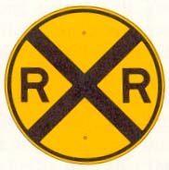
Advance warning signs. These signs are placed in advance of the grade crossing at a distance that varies with the 85th percentile approach speed (see the Manual on Uniform Traffic Control Devices).

A railroad crossing sign, commonly referred to as a crossbuck sign. This sign is normally located at the crossing within 12 feet of the crossing (in both directions) and 6 to 12 feet from the edge of the shoulder or traveled way. At multiple track crossings, the number of tracks should be shown with this sign.
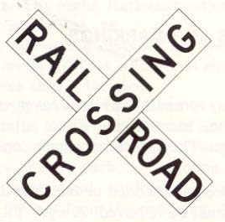

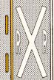
Pavement markings are placed on the approach lanes of the roadway in advance of at-grade railroad crossings where signals or gates are used, or where the prevailing speed of approaching traffic is 40 miles per hour or greater.
“DO NOT STOP ON TRACKS” and “STOP” signs. These signs can be used where detailed engineering studies determine that there is a need.
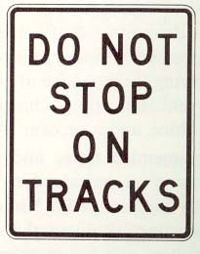

Active Control Devices: Active control devices at at-grade railroad/roadways crossings inform motorists of the presence of trains at or approaching the crossing through the use of flashing lights and gates.
Horizontally mounted alternate flashing lights are used to warn motorists of the presence of a train. Where the speed of trains is 20 miles per hour or greater, their signals must flash for a minimum of 20 seconds before train arrival at the crossing. Bells may also be used in conjunction with the lights.
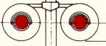
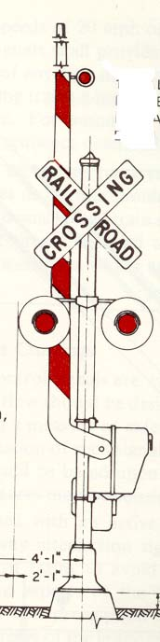
A descending gate arm that extends across the approaching lanes of traffic can be used to block traffic at the crossing. Gates are used in addition to flashing lights. The gate arm should start to descend not less that three seconds after the lights start to flash and ascend not more than 12 seconds after the lights cease operation.

The active control devices described above are also usually combined with all the passive devices described previously.

There are also different gate designs. Dual gates block traffic in the approach lanes of both directions. Four-quadrant gates, on the other hand, block traffic in both directions on both sides of the tracks. This gate design prevents vehicles from driving around the gates (which can occur with dual gate design). Four-quadrant gate design can, however, trap vehicles on the crossing. For this reason, the lowering of the downstream gates lags the upstream gates by a specified delay (so a vehicle can clear the tracks if necessary). In addition, a trapped vehicle detection system would be preferred in providing adequate warning to the train (which can then stop safely).

For more information
For more information, please contact .

